Fair Move
  - Better Public Transport Fares for Melbourne
September 2020

About us

Infrastructure Victoria is an independent advisory body with three functions:

- preparing a 30-year infrastructure strategy for Victoria, which is refreshed every three to five years
- providing written advice to government on specific infrastructure matters
- publishing original research on infrastructure-related issues.

Infrastructure Victoria also supports the development of sectoral infrastructure plans by government departments and agencies.

The aim of Infrastructure Victoria is to take a long-term, evidence-based view of infrastructure planning and raise the level of community debate about infrastructure provision.

Infrastructure Victoria does not directly oversee or fund infrastructure projects.

Aboriginal acknowledgment

Infrastructure Victoria acknowledges the traditional owners of country in Victoria and pays respect to their elders past and present, as well as elders of other Aboriginal communities. We recognise that the state's infrastructure is built on land that has been managed by Aboriginal people for millennia.

Contents

Executive summary 04
Introduction 09
Recommendations 10
Problems facing public transport 12
Problem 1: The public transport system is under strain and out of balance 13
Problem 2: Fare setting objectives are not clearly defined, fares neither encourage the best use of the system nor inform choice 12
Problem 3: Public transport fares are unfair 15
Principles 16
Improving how fares are set 17
Balance multiple outcomes to make the best use of the transport system 18
Consider equity 21
Provide informed choice 21
Transparent fare setting 22
The way forward 22
Fares that reflect the mode of travel 24
Flat fares are simple, but don't make the best use of the public transport system 25
Flat fares are unfair 26
More services alone are not the solution 28
Fares for multimodal trips 28
Fares that reflect the time and place of travel 31
Peak use contributes to an unbalanced network 31
New peak fares 35
Locational peak fares 38
Directional peak fares 41
Will peak pricing make any difference? 41
Ticketing that supports reform 46
Ticketing that reflects fare reform 46
A more flexible ticketing system 46
Open up third-party access to the public transport ticketing system 48
Make the ticketing system easier to use 50
How will users respond to variable fares? 52
How well do users understand fare elements? 52
As complexity increases, comprehension declines 53
Presenting and communicating change 54
The benefits of change 54
Fare reform shifts demands on the transport network 63
Who changes their travel when offered greater choice? 66
Who benefits the most from fare reform? 67
How does fare reform change the cost of public transport? 69
How does public transport demand shift across Greater Melbourne? 72
How does demand across the network change with travel patterns? 74
Where do we go from here? 81
References 83

Executive summary

The COVID-19 pandemic has disrupted almost every aspect of Victorians' daily lives. Stay-at-home orders, social distancing requirements and greater numbers of people working from home mean that public transport use is down and private car use is up.

However, at some point, restrictions on the way Victorians connect and travel will be eased and removed, migration to Victoria will resume and Melbourne's public transport system will be under pressure again. Instead of drifting back to `normal', there is a unique opportunity to undertake fare reform so that when Melburnians return to public transport, the network is better balanced, better managed and operates more efficiently and fairly for the benefit of all Victorians.

While COVID-19 has hit the Victorian economy hard, it has also created greater flexibility in work and commerce, generating behaviour change that can have lasting benefits once the pandemic has passed (such as reduced congestion from more flexible working hours and increased working from home). A well priced public transport network can help lock in some of those benefits and take pressure off the entire transport network.

Public transport fares fall within the broader transport network pricing framework presented in Infrastructure Victoria's previous report Good Move – Fixing Transport Congestion.

In that report, we called for pricing of the entire transport system across roads, public transport and parking. We also acknowledged that this would take some time to implement. In this report, we focus solely on public transport fare reforms that could be implemented in Melbourne in the short to medium term.

Melbourne's public transport system faces three major problems: it is under strain and out of balance (being overcrowded in peak times and underused at other times); fares are not set to encourage the best use of the system or to give public transport users greater choice about how and when they travel; and the current fare structure is unfair. The system also has limited `slack' to cover disrupted services, meaning that cancellations, problems with vehicles, incidents and other delays quickly ripple out across the network, affecting thousands of commuters. These problems are likely to continue even as Victoria rolls out major new transport infrastructure investments.

Fares are a powerful tool for addressing these problems. Fares can be set to make the best use of the entire transport system (roads and public transport). They can provide incentives for people to change their travel behaviour and make the best travel choices for themselves, as well as for the wider community.

Fare reform can also be fair reform. While the top 20% of income earners make up the largest group of public transport users overall, fare reform can significantly improve travel choice and affordability for low income travellers and households.
We propose a fare structure that maximises the use of the public transport network so that it generates the most benefits to Melburnians, whether they use public transport, private vehicles or active transport.

Fares make up only a part of the public transport system, but they have the ability to support Melbourne in getting the most out the infrastructure it has today, as well as the infrastructure of tomorrow, such as Metro Tunnel.

Fares, new infrastructure and service reform can all work together to help meet the growing travel needs of Melburnians.

And right now, while the pandemic continues, fare reform can support social distancing by encouraging off-peak travel and better use of underused services, such as buses.

Our recommended reforms:

Fares that vary by mode of travel

Introduce different fares for each public transport mode to reflect the different costs and benefits of each mode, and to encourage the best use of public transport services. Fares would be lowest for buses and slightly more for trams, with trains being the highest priced of the three modes.

Currently, buses are overpriced and underused, which impacts people on low incomes the hardest – as trains and trams are used disproportionally by people on high incomes. Our research shows that if buses were cheaper than trains and trams, many people would make the switch to buses.

Fares that reflect the time and place of travel

Introduce peak and off-peak fares on trains, trams and express buses in places and at times that are at capacity. Congestion and the cost of expanding the train network in and around the CBD is greater than the rest of the network, so when CBD public transport travel patterns return to pre-COVID-19 levels, we also propose creating a new `City Zone' on the metropolitan train network, covering the CBD, City Loop and Metro Tunnel.

Having different fares for different times and places would encourage travel in the off-peak periods, making more efficient use of the network and reducing crowding. It would also support social distancing on public transport while the COVID-19 pandemic persists.

Consistent with our transport network pricing approach that all modes and routes should be priced, we also recommend removing Melbourne's free tram zone. This free zone fails to price travel in a busy tram corridor that is already at capacity. It is also unfair, as it largely benefits a relatively small group of people – those who live in or drive to the CBD - while all Victorian taxpayers foot the bill, regardless of whether they use the free tram zone or not. There is also no evidence that it increases tourism.

Better ticketing

Alongside this new fare structure, we are recommending ticketing reforms to make the system more convenient and fairer, and allow for the introduction of new digital platforms for planning, booking and paying for travel.

Improving how fares are set

Public transport fare setting needs to balance multiple outcomes to make best use of the network and improve fairness.

This balance needs to be transparent, using clearly defined objectives determined by the Victorian Government, with an independent body to advise on and monitor transport prices (like IPART in NSW).

To see the effects of fare reform over time, we have modelled how things would look in 2031, comparing the current flat public transport fare structure to one that provides stronger incentives for making better use of the network.

Our modelling was done pre-COVID-19, but the outcomes will hold assuming Melbourne's transport patterns return to normal. We are currently doing a range of modelling to investigate how COVID-19 might change the travel and land use of Melbourne into the future, and how transport reforms and infrastructure may need to adapt.

We found that the impacts of fare reform would reach all Victorians, whether through reduced road congestion or less crowding on trains, trams and buses or simply through lower pollution and a cleaner environment.

Ultimately, fare reform means that Melbourne's transport users would be the equivalent of $520 million a year better off in lower cost public transport alternatives, reduced crowding and congestion and better environmental outcomes.

We also found that these benefits can be achieved with little-to-no change in cost recovery levels and fare revenue.

The potential benefits of public transport fare reform we have identified include:

More people using public transport

Substantial shifts to public transport across Melbourne, especially in the middle and outer ring of suburbs.

More people travelling during off-peak

Relieving pressure during peak periods and reducing crowding on trains and trams during peak times, making commuting to the central city safer and more comfortable.

More people using buses

Making buses a more attractive and inexpensive travel choice and getting much better value from Melbourne's underused bus network.

Fewer cars on Melbourne's roads

Decreasing traffic volumes along some of Melbourne's busiest arterial road links, relieving pressure on the road network and reducing vehicle emissions and air pollution.

Most people are better off, especially low income households

Up to 71% of people could pay less to travel on public transport, with people on the lowest incomes paying 26% less for fares on average*. Those who may pay more, such as city office workers who travel into the CBD via train at peak times, would enjoy a more efficient, less crowded and more comfortable service.

* Fare revenue was down in our modelled fare reform. See `How does fare reform change the cost of public transport?' on page 69-71 for a breakdown of who pays less under an approximation of a revenue neutral-fare reform.

While more extensive fare and ticketing restructuring will take time, two fare changes could be implemented immediately by the Victorian Government: introducing peak and off-peak fares and removing Melbourne's free tram zone. While the COVID-19 pandemic continues, these reforms would also support social distancing on public transport by spreading demand across the day and across different modes, and reducing crowding on CBD trams.

A third reform that could proceed now is the appointment of an independent adviser to recommend and review transport prices. This would signal the start of a broader reform process and also provide the government with guidance on future fare-setting objectives and the best way to proceed with greater fare and ticketing reforms.

With Melbourne's public transport network now costing nearly $2 billion to operate each year and fares covering less than 30% of these costs, it is critical to make the best use of this investment by Victorian taxpayers. Introducing the fare reforms recommended in this report would mean that the majority of people would pay less to travel on public transport than they do now, but total fare revenue would be similar. At the same time, the network would be more efficient, more balanced and fairer - producing a better overall return to the wider community and extracting much greater value for all Victorians from their substantial investment in public transport.

The benefits of fare reform

The benefits of implementing fare reform by 2031, compared with what happens if we keep on doing the same thing include:

71% of users pay less

Up to 71% of public transport users pay less to travel on public transport than they do today.*

Paying 26% less

Households on the lowest incomes benefit the most – paying 26% less for fares on average.*

96,000 less car trips

Over 96,000 car trips are taken off Melbourne roads on a typical weekday.

Over 78,000 tonnes cut

Greenhouse gas emissions cut by over 78,000 tonnes per year due to increased public transport use.

30,000 fewer peak train boardings

Crowding on busy train services is reduced, with 30,000 fewer boardings during peak times – equivalent to 27 new High Capacity Metro Trains.

100,000 new off-peak boardings

Over 100,000 new off-peak boardings across trains, trams and buses.

$520 million better off

Fare reform would generate about $520 million in value each year for Victorians through more transport pricing options, reduced crowding and congestion and better environmental outcomes.

Over 56,000 new public transport users

Over 56,000 new public transport users on a typical weekday.

93,000 new bus boardings

Cheaper buses create over 93,000 new bus boardings across the typical weekday.

* This includes the effect of total fare revenue being lower in the modelled Fares Reform scenario than the Current System. See Benefits of Change section on page 54 for detail.

01. Introduction

The current COVID-19 pandemic has brought significant disruption to the way Victorians live. People are unable to connect and travel as freely as they once could, and this has affected the use of Victoria's transport networks.

Public transport use is down, and private cars are currently the preferred mode for social distancing – and this will have flow on impacts across both the public transport and road networks in the immediate future. Travel restrictions, social distancing and greater working from home have dampened the demand for public transport – particularly to the Melbourne CBD.

At some point, however, restrictions on the way Victorians connect and travel will be eased and removed, migration to Victoria will resume and Melbourne's public transport system will be under pressure again. While not currently apparent, Melburnians do not have to cast their minds back very far to recall the significant crowding on trains and trams during peak periods – making journeys uncomfortable, frustrating and unsatisfactory experiences.

The public transport system has limited `slack' to cover disrupted services, meaning that cancellations, problems with vehicles, incidents and other delays quickly ripple out across the network, affecting thousands of commuters. This pressure is likely to continue even as Victoria rolls out its pipeline of new infrastructure investments.

To support people as they return to travelling for work, education and leisure (whether by public or private transport), we need to better manage the existing metropolitan public transport network, particularly at times and points of strain.

Fares are a powerful tool for informing people so they can make the best travel choices for themselves, as well as for society. Fares can provide incentives for people to change their behaviour to make best use of the network; however, this tool has been mostly left unused for metropolitan Melbourne. There are limited incentives to shift trips away from peak times or to encourage greater use in parts of the network with excess capacity, particularly metropolitan buses.

Providing travellers with more alternatives through more variable fares can change the attractiveness of using different modes of public transport at different times. This would increase comfort and safety for public transport users and enable better government decision-making in the timing and selection of future public transport infrastructure. Fare reform should also be fair reform: any changes to fares should be progressive and equitable - making a positive difference in the lives of Victorians and their use of the public transport network, and delivering significant benefits for low income travellers and households.

Fares fall within the transport network pricing framework presented in Infrastructure Victoria's earlier report Good Move: Fixing Transport Congestion (Infrastructure Victoria, 2020). In that report, we called for pricing of the entire transport system across roads, public transport and parking. We also acknowledged that such a framework would take some time to implement – including time to gather the information to implement correctly.

In this report, we focus solely on fare reforms that could be implemented in the short to medium term, ahead of introducing any form of road pricing.

We also focus on how public transport fares can be part of the set of tools used to support social distancing while Victoria deals with COVID-19 and to manage the state's transport network in the post-COVID-19 world.

Research for reform

Infrastructure Victoria has made transport network pricing a core focus of our research program, with the aim of designing a system that is suitable for Victoria, that is effective, efficient, fair and sustainable, and that can attract community support.

Transport network pricing is a system where prices are set to influence how, when and where people use the transport system. Prices can be set to encourage people to travel at times, to places and by modes that provide the greatest benefits relative to the costs. Prices can also be set to take into account factors such as the costs of air pollution and road trauma. Infrastructure Victoria's research shows that making the shift to comprehensive transport network pricing would deliver significant benefits to Victorians.

Fare reform is part of our ongoing research program. The project takes a more detailed look at metropolitan fare reforms that could be implemented in the short to medium term.

This paper focuses on Melbourne's public transport network. Infrastructure Victoria recognises the need for improvements in regional fares and the independent transport pricing advisory body recommended in this paper would be well placed to conduct research into regional fares.

Our final recommendations for the introduction of transport network pricing in Victoria will be made in the 2021 update of our 30-year infrastructure strategy.

02. Recommendations

Infrastructure Victoria's recommendations focus on the metropolitan public transport network. The rationale for these recommendations is discussed in the relevant sections of this paper. Full details of the research and analysis undertaken to prepare the paper and determine our recommendations are provided in the technical report that accompanies this paper.

Improving how fares are set

01. Set public transport fares transparently, using clearly defined objectives.

02. Fare setting objectives should be to make the best use of the public transport network, take equity into account and ensure people are provided with informed travel choices.

03. Immediately appoint an independent body to advise on and monitor transport prices.
Fares that reflect the mode of travel

Fares that reflect the time and place of travel

04. Immediately introduce different fares on each public transport mode to reflect their different costs and benefits and to encourage their best use.

05. Abolish the free tram zone to improve safety and access for those who need it most.

Fares that reflect the time and place of travel

06. Immediately introduce peak and off-peak fares on public transport in places and locations which are at capacity. Modes and zones which are rarely at capacity should have all-day off-peak fares.

07. Consider a new `City Zone' with its own peak price composed of the City Loop service train stations (Parliament, Melbourne Central and Flagstaff, Southern Cross and Flinders Street) and the Metro Tunnel stations (Arden, Parkville, State Library, Town Hall and Anzac). This City Zone would be subject to a specific peak price. Introduction should be contingent on CBD public transport travel patterns returning to pre-COVID-19 levels, with significant crowding during peak times.

08. Introduce directional pricing so that trips in counter-peak directions are not charged a peak fare e.g. those travelling away from the CBD in the morning peak.

Ticketing that supports reform

09. Discontinue myki Passes (unlimited travel over a specified time period for a fixed fee) to facilitate fare reform and remove complexity.

10. Review the level of the daily fare cap when using myki Money.

11. Open up the ticketing system to third parties. Third parties should be enabled to hold accounts for purchasing travel on behalf of travellers, including for Mobility as a Service.

12. Make the ticketing system easier to use for Victorians and visitors by:
a. reducing or removing the myki card purchase fee
b. allowing other inputs for validation through an account-based system (such as credit and debit cards).

13. Develop a set of principles to guide concession design, followed by a review of all discounts, removing or adding concessions as necessary.

Improving how fares are set

Overarching

- Public transport fares should be set transparently and meet stated objectives.
- Fares should make the best use of the public transport network, take equity into account and ensure people are provided with informed travel choices.

Immediately

- Adopt peak and off-peak public transport fares
- Adopt fares that differ by mode
- Appoint an independent body to advise on and monitor transport prices
- Abolish the free tram zone.

0-2 years

- Introduce directional off-peak fares
- Remove myki Passes
- Review daily cap limit on fares
- Develop principles for concessions and review and reform existing ones
- Remove myki purchase fee and change the touch on credit requirements.

2-5 years

- Allow other inputs for validation for myki
- Consider implementing a new City Zone with a specific peak price when crowding increases to pre-COVID-19 levels at peak times.

03. Problems facing public transport

Melbourne's public transport system faces three major problems.

Firstly, it is unbalanced, being under significant strain at peak times and underused in off-peak periods. Secondly, fares do not rectify the imbalance, encourage the best use of the public transport system or provide public transport users with options that vary with price. Finally, current fares are not fair.

Our report Good Move: Fixing Transport Congestion outlined a comprehensive transport network pricing system across all roads, public transport and parking to reduce growing congestion and crowding on Victoria's roads and public transport, as well as getting more out of our transport system.

While such reform would take time to develop and implement, public transport is already priced, so fare reforms could be considered by the Victorian Government in the shorter term.

Fare reform would take the first steps towards achieving the goals of transport network pricing, while also addressing the problems facing Victoria's public transport system. Some immediate fare changes can also contribute to managing the COVID-19 pandemic by helping to achieve social distancing on public transport in Melbourne and improving the health and safety of commuters.

Problem 1: The public transport system is under strain and out of balance

Under normal pre-COVID-19 conditions, the public transport system is both overcrowded and underused. At times of peak use, passengers are crammed on services or unable to board full trains and trams. Reliability suffers as timing or mechanical issues have large flowon effects on the congested network, resulting in high rates of re-routed and late-running services.

Outside the peak times, the network is underused. Buses, trains and trams sit idle in holding yards waiting for the peak periods. On weekends, public transport use is only 41% of its weekday use while roads are congested. At these times, moving any road trips to public transport would have significant benefits.

The peaks and troughs of public transport
Figure 1 Public transport boardings throughout the day
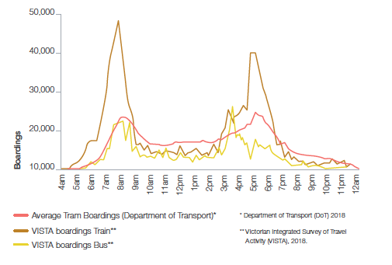
The public transport system is out of balance: overcrowded at peak times and underused outside the peak.

Overcrowding and underuse vary not just by time of day, but also mode. Many metropolitan bus routes have excess capacity, particularly those in the outer suburbs. Modelling undertaken for Infrastructure Victoria estimates that 70% of bus routes run at below a third of their capacity during the AM peak.

Melbourne's bus system is underused

Figure 2 Melbourne bus network performance, 2016
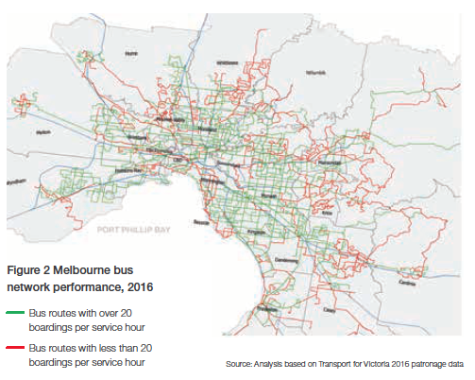
Source: Analysis based on Transport for Victoria 2016 patronage data

Problem 2: Fare setting objectives are not clearly defined, fares neither encourage the best use of the system nor provide choice

Despite the overcrowding and underuse imbalance of the public transport network, fares currently play a very minor role in trying to rebalance the system or in providing people with greater choice.

People who are conducting casual trips around Melbourne face the same price all day as those travelling for time-critical business at peak hours. The only exception is the Early Bird discount for train travel.

There is little-to-no price incentive for those using public transport for non-time critical trips to travel outside the peak. Worse, someone who may wish to use public transport for social or shopping purposes, but who value the trip at less than the current fare, will stay home or drive – even though the trip could be provided for a low cost due to spare capacity in the off-peak periods.

There are two ways in which the current metropolitan fares system doesn't help to reduce imbalances across the network or provide choice: first, in its structure; and second, in the values applied in setting fares.

Currently, the fare structure of the public transport network is relatively flat. The price for metropolitan fares is $4.50 for a two-hour ticket regardless of whether a person is travelling in busy times or quiet times and regardless of mode, distance or trip purpose. Zone 2 provides cheaper fares for travel solely within that zone.

This structure provides little variation in recognising the different costs and benefits that different trips have. The flat price means that some trips are overpriced, while others are under-priced. This results in too many trips taken at some times and on some modes, while too few trips are taking place at other times and on other modes. As an example, short trips to the local shops via bus are priced the same as long commutes to the CBD at peak time via train, failing to reflect either the value to the user or the cost to government in providing the trip.

The objectives for fare setting are currently not clearly articulated. In general, fares have been set to encourage public transport use, but charging a mostly flat fare has likely increased the use of the most popular modes at the most popular times rather than encouraged use across all modes throughout the day.

Some trips are overpriced, others are under-priced and there is little-to-no price incentive to travel outside the peak periods.

Problem 3: Public transport fares are unfair

The issue of equity is currently addressed in the fares system through concessions. Concessions provide a partial solution to the issue but miss out on the very significant benefits that can be provided by variation in fares − and not just discounts on a flat rate.

While there is a perception that public transport is used by or provided for a greater number of users on lower incomes, this is not actually the case. On average, those using public transport have household incomes 8% higher than those who don’t. Those in the top 20%
of income earners (the top quintile of equivalised household income) make up a disproportionate number of public transport users, and make up the largest
group of public transport users overall. However, as shown in Figure 3, different
modes are used by different income groups to different degrees: while trains and tram have higher rates of high income users overall, buses are disproportionally used by those on low incomes – and significantly so.

While high income earners make up a greater share of public transport users during peak periods, the situation is reversed in the off-peak when the lowest 20% of income earners (the bottom quintile of equivalised household income) become the largest users of public transport (Figure 4).

Income levels vary by mode of transport

Figure 3 Public transport users, by weekly equivalised household income quintile

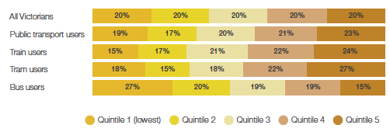
Source: VISTA data 2018, Infrastructure Victoria analysis

Peak travel is largely represented by high income, off-peak by low income

Figure 4 Peak and off-peak public transport users, by weekly equivalised

household income quintile
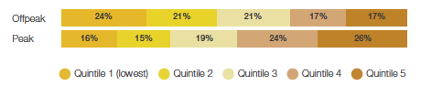
Source: VISTA data 2018, Infrastructure Victoria analysis

Given these patterns of use, it is very clear that prices that vary by mode and time of day may provide significant benefits to low income Victorians, above and beyond those provided by concessions.

For example, making bus fares cheaper than train fares would provide more extensive benefits to low income earners, as almost half of bus users are in households in the bottom 40% of incomes (Figure 4). Making off-peak fares cheaper would similarly benefit low income households. Low income earners make up 45% of those travelling off-peak and less than one third of those travelling in peak.

04. Principles

Infrastructure Victoria first called for transport network pricing in the 2016 30-Year Infrastructure Strategy.

In the same year, we also analysed the case and options for road pricing in The Road Ahead. In 2018's Five Year Focus, we made a number of research-based recommendations for public transport fare reform.

In March 2020, we provided a comprehensive analysis of transport network pricing in Good Move: Fixing Transport Congestion, including five pricing principles that would set a strong foundation for transport network pricing in Victoria.

Our five pricing principles were distilled from Australian and international economics literature on pricing and are designed to ensure that prices are set to yield an efficient outcome (where people travel at times, to places and by modes that deliver the greatest benefits relative to the costs) while also meeting important equity objectives that are essential to gaining community support.

We have applied these principles to setting public transport fares in this report.

The principles are:

Principle 01 All modes, routes and parking are priced

Prices should be the central tool for allocating trips within the transport network. A trip that isn't priced is effectively under-priced, distorting the choice made by travellers to take that trip instead of a more efficient one. This principle also implements the beneficiary pays equity principle.

Principle 02 All costs are priced

Prices should take into account all costs and benefits for trips, including road congestion, public transport crowding, pollution, contribution to road trauma and the costs of raising revenue through taxation. This principle ensures that prices include the social marginal costs linked to externalities related to each mode and trip.

Principle 03 Provide choices, but not too complex

There should be a range of products that provide choices to consumers. It should be possible to use the transport system without it being too hard to choose and make informed decisions.

Principle 04 Different prices for different products in different markets

Prices should reflect demand and cost conditions, and permit different prices to be charged by mode, time of day or location.

Principle 05 Equity

This principle implements vertical equity (where different groups of people are treated differently) and also permits different prices to be charged in different locations where possible. Lower prices are set for groups of people identified as less able to pay.

05. Improving how fares are set

Recommendations

01. Set public transport fares transparently, using clearly defined objectives.

02. Fare setting objectives should be to make the best use of the public transport network, take equity into account and ensure people are provided with informed travel choices.

03. Immediately appoint an independent body to advise on and monitor transport prices.

Our approach to fare reform focuses on achieving three aims: balance multiple outcomes to make the best use of the transport system, improve equity and provide informed choice to users. A fare structure that achieves these aims ensures that the public transport network provides the most benefits to all Victorians.

Balance multiple outcomes to make the best use of the transport system

Price is an effective way of sending public transport users information and providing incentives for making decisions about when and how they travel, taking into account not just their private costs, but also the costs and benefits they might impose on others.

Public transport fare setting needs to balance multiple outcomes to set the right price. Too little use of public transport results in congested roads and high environmental costs. Too much use creates overcrowded and unreliable public transport services as networks struggle to manage demand.

While new infrastructure can be built to accommodate extra demand, this must be balanced against the costs of adding the infrastructure and the alternatives available to meet people's transport needs.

Overall, our approach is to set public transport fares so that they take account of the many different social impacts from public transport use and balance those impacts to ensure the best possible use of Melbourne's entire transport system.

Our focus on balancing multiple outcomes is important because public transport is not a goal in and of itself; rather, it is a means that provides people with travel choices to access employment, social connections and services that they want and need. Fare setting approaches that focus on individual targets alone (such as cost recovery or patronage growth) come at a cost to other important factors, and will always be open to criticism as they prioritise one outcome above others. What is needed is an approach that balances multiple objectives.

Our goal is to recommend a fare structure that maximises the use of the public transport network so that it generates the most benefits to Melburnians, whether they use public transport, private vehicles or active transport. Fares should reflect the costs to society of the different transport options, and then allow individual travellers to choose the best fit for them - implicitly taking into account the costs on society through the fare.

Accordingly, our research uses an approach that balances a full range of outcomes to determine what fare levels should be. Our approach is similar to that used by the New South Wales Independent Pricing and Regulatory Tribunal (IPART, 2015) and seeks to balance the following costs and benefits:

Benefits of additional public transport use

- Reduced road congestion
- Reduced environmental costs
- Reduction in road accidents
- Increased walking

Costs of additional public transport use

- Costs of adding public transport services
- Infrastructure costs
- Public transport crowding
- The impact of taxation on people and businesses to provide subsidised fares

Public transport is not a goal in and of itself; rather, it is a means that provides people with travel choices to access employment, social connections and services.

The process used to balance all these costs and benefits is the measurement of the social cost of additional public transport use (known as the social marginal cost pricing approach).

The social cost is made up of the financial cost of providing an extra public transport trip (new services or new infrastructure needed to provide the trip), minus the benefits to society generated by an extra trip on the network (such as reduced congestion, lower pollution and reduced road accidents).

The gap between these two is the optimal fare, which represents the net cost to society to provide the additional public transport trip (as shown in Figure 5).

This method ensures that the fare level encourages the best use of the entire public transport network. If people are willing to pay the fare (because their personal benefit from the trip is greater than the fare price) then that trip makes everyone better off. If they are unwilling to pay the fare (because their personal benefit from the trip is less than the fare) then they will find an alternative, and society is better off.

How we determined the optimal fare

Figure 5 Optimal fare derived from the social cost of additional trips (illustrative values only)
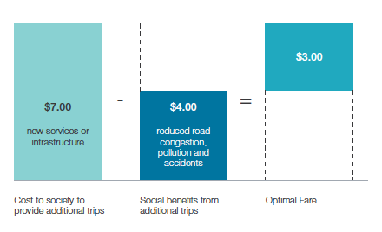
This is a fair way to price public transport as people are paying the cost they impose on society. It also makes the best use of the entire transport system across roads, public transport and active transport.

Our analysis takes into account not just the network as it exists today, but also the pipeline of committed works. Our modelling (2031) and social cost analysis (2026) incorporates future infrastructure such as the Metro Tunnel, West Gate Tunnel and the Cranbourne-Pakenham Line Upgrade.

This method ensures that the fare level encourages the best use of the entire public transport network.

Why is it so important to make the best use of the public transport network?

Making the best use of the public transport network is vitally important because public transport is a very significant investment by Victorians. For example, in the 2017-18 financial year operating costs alone for the Victorian public transport network totalled over $3.25 billion, $2.61 billion of which was specifically for metropolitan Melbourne.

When the capital costs of the network and rolling stock used by the network are factored in, estimates suggest the amount is around $4.91 billion per annum (based on annual depreciation and a weighted average cost of capital of 5.5%).

The vast majority of this expenditure is paid for by taxpayers, not public transport users.
Fares cover 30% of metropolitan operating costs (29.7% in 2017-18) and even less when taking into account the cost of capital (20.8% in 2017-18). The cost recovery for regional services is lower still. Over time, taxpayers have paid a higher and higher proportion of the costs of public transport use, with cost recovery from fares falling significantly over the past decade.

As outlined in Problem 3 on page 15, subsidised fares are on average benefiting those on higher incomes. If Victorians are willing to continue making such a large investment in public transport, government should be making the most of this investment so it produces the greatest overall return to society.

The high level of public transport subsidy is funded through general taxation, and is often justified on the grounds that public transport provides benefits not just to the users of public transport, but also to road users (primarily through reduced congestion), and because it provides a basic level of transport access to people who have limited private transport options.

Our proposed reforms balance the costs of additional public transport with the benefits, while also improving the ability of the network to serve those with limited private transport options (by making it cheaper on average for those on low incomes, and lowering the fares of local tram and bus trips).

Consider equity

While the fare setting approach outlined above encourages public transport use that provides the most benefits to all Victorians, there are also equity implications that must be considered. Additional analysis has been undertaken to determine if the overall benefit from optimal fare setting comes at a high cost to more vulnerable groups.

Each proposed change in fares has undergone analysis that shows which groups of people, by income, are most affected from reductions and increases in fares.

The results are somewhat surprising. We found that in almost every case, a move to a fare that makes the best use of the public transport system is also a fare change that is more equitable. Our research shows existing metropolitan fare levels are much less equitable than they should be, and changes that make the best use of the public transport network will also better serve the needs of most low-income Melburnians.

A move to a fare that makes the best use of the public transport system is also a fare change that improves equity.

Provide informed choice

The final consideration throughout our research was regarding how people might react to a different set of fares.

Prices are only as good as people's ability to understand and use them for decisionmaking. If people don't understand the fares, they will not use them to make decisions. Fares can then no longer help people to make the best travel decision for themselves and society. Fares must be set in such a way that they provide an informed choice to users and do not create confusion.

To understand the effects of different fare structures on people's choices, Infrastructure Victoria commissioned SGS Economics & Planning (SGS) and The Behavioural Insights Team (BIT) to conduct a study examining how people responded to complexity in public transport fares (SGS-BIT, 2020).

We have relied on this research in considering various fare options and in making our recommendations. This is discussed further in the How will users respond to variable fares? section.

Transparent fare setting

Infrastructure Victoria's view is that fare setting should be transparent and have clear objectives.

Our approach is an example of how we believe fares should be set. Public transport fare setting currently lacks clear objectives and transparency, and we believe an independent body should be appointed to advise on and monitor transport prices.

Fares can help manage transport use in the short term and should change as circumstances change. Having an advisory body that regularly monitors, researches and advises the government on transport fares would keep information and research up to date, as well as provide a transparent process for fare setting similar to that facilitated by IPART in NSW.

An advisory body that regularly monitors, researches and advises on transport fares is particularly important in a world that is experiencing significant change due to the ongoing effects of COVID-19. Fare setting can be a powerful tool to help make the most out of the transport system we have today, but further research and analysis is required to apply our proposed approach to the specific circumstances of each location and point in time (see COVID-19: a new set of problems for public transport, page 23).

The way forward

The next two sections of this paper cover the two primary components of our proposed reforms to public transport fares:

(1) fares that vary by mode and (2) fares that vary with the time and place of travel. We focus on these two reforms for two reasons. First, they are the changes that are going to make the greatest improvements in system performance towards achieving the aims outlined above.

Second, the behavioural economics research conducted by SGS and BIT suggests that travellers can respond to these changes in a way that supports achieving the aims. The implications of a forum of former politicians, bureaucrats and decision makers convened by BehaviourWorks (Monash University) for Infrastructure Victoria suggests simply presented and understood reforms are more likely to be socially and politically acceptable.

The SGS-BIT research suggests this will be the case for a combination of peak charging and mode-specific fares. In addition, Victorians will be familiar with these types of fares if they have used public transport in Sydney or several major cities across the world.

COVID-19: a new set of problems for public transport

COVID-19 has changed the social costs of using public transport - and those social costs will continue to change as we transition back to a world either without the disease or a world in which we need to continue to manage the virus because there is no vaccine.

This means that fares should also change with the circumstances when necessary. This kind of ongoing analysis would be a key tasks for an independent transport pricing advisory body.

Actions taken as a result of COVID-19 could put persistent downward pressure on public transport and the demand to travel to previously crowded destinations like the Melbourne CBD. This is largely because the costs of working from home, including communicating between widely dispersed workers, have fallen substantially.

Workplaces have adopted technology that enables staff to access work resources from home and staff have learned to collaborate using video conferencing and other online communication tools, making remote work more viable than it has ever been. The change was also rapid and co-ordinated, with a large proportion of workplaces switching to remote working at the same time, making working from home arrangements more acceptable across industries. Even if COVID-19 is eliminated, various surveys showing increased employee productivity and reduced business costs point to a greater proportion of work taking place remotely for the foreseeable future.

For example, the Australian Bureau of Statistics' census showed in 2016, only 4.2% of people worked from home in metropolitan Melbourne. By early June 2020, 25% of paid workers reported that all their work had been performed remotely. The rate is higher for CBD workers, with 41% reporting that they performed all work remotely (BehaviourWorks, 2020). According to a national survey taken by the NBN in late April, 81% of respondents said the experience of working from home has positively changed the way they think about managing work/life flexibility (NBN, 2020).

During the transition to the postCOVID-19 economy it is likely there will also be a shift in demand across transport modes and travel time. Before COVID-19, some components of the network operated assuming significant crowding for considerable lengths of time. This isn't compatible with social distancing. Travellers who are concerned about the risks of COVID-19 will choose modes and times where it is easier to socially distance. Some of these travellers could shift from peak to off-peak travel and/or shift from public transport to private transport (active transport or motor vehicle). This increases the social benefits from reducing congestion.

Analysis by WSP shows that applying strict social distancing would reduce trams to 13% and trains to 20% of their respective total capacity – and buses to 16% of their seated capacity. This has serious implications for management of the network. Unless prices are used to spread peak demand, trains will be `full' by the time they reach inner urban

areas, with those living closer to the CBD unable to board without breaching social distancing guidelines. This means that both demand and supply side measures are likely to be needed, along with operational changes (such as different boarding and alighting procedures, floor markings, new timetables and extra staff).

In addition, travellers can't be relied upon to sufficiently socially distance on public transport. Even if travellers are concerned about their own risk of catching the virus, they won't take into account how changing their travel plans could reduce virus risks for other travellers. This means additional incentives are needed to get the right level of distancing. A mix of restricted numbers and fare surcharges/ discounts could be the best mix to achieve this.

As restrictions ease, people return to work and patronage increases on public transport, governments around the world are exploring ways to maximise levels of social distancing by encouraging people to travel off-peak.

In July 2020, the NSW Government announced that it would halve public transport fares for three months for Sydney commuters who travel outside peak periods. The move was designed to encourage commuters to `retime their day' after capacity on public transport services was cut due to social distancing. Peak travel times were also extended by an hour and a half in both the AM and PM peaks.

06. Fares that reflect the mode of travel

Recommendations

04. Immediately introduce different fares on each public transport mode to reflect their different costs and benefits and to encourage their best use.

05. Immediately abolish the free tram zone to improve safety and access for those who need it most.

Our research shows that a flat fare system that does not distinguish between travel modes overcharges for some services and hits people on low incomes the hardest.

A better and more equitable approach is to set fares differently for each public transport mode.

Flat fares are simple, but don't make the best use of the public transport system

Melbourne's metropolitan fare system currently charges the same fare regardless of which public transport mode a person chooses to travel on. This system is appealing because it is simple to understand, gives certainty on cost to users and encourages multimode travel.
Hong Kong, London and Sydney, all major international cities with extensive public transport systems, charge separate fees based on which mode is used.

While flat fares have the appeal of simplicity, our research shows that pricing all modes of public transport travel with a single fare contributes to the imbalance in the public transport system, increases road and public transport congestion and reduces equity. This is because each mode is unique - not just in the service it provides, but also in trip purpose, level of crowding, income levels of users and the benefits from reduced road congestion, pollution and increased active transport.

Our analysis shows that the costs on society from increased bus use are much lower than for train use, with trams sitting in the middle (shown in Figure 6).

Additional train travel has high social costs, followed by tram and bus

Figure 6 Range of estimates for the social cost of additional public transport trips during the peak
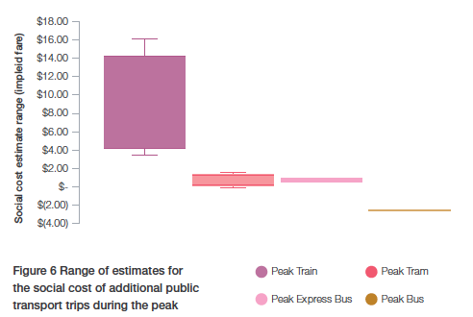
Source: Estimates produced by Infrastructure Victoria using the CIE model for social marginal cost. See Fare Reform Technical Report for details.

The low result for buses is driven by the fact that many bus services are not crowded, and so additional trips can be accommodated without significantly increasing costs. Buses also require much less infrastructure than trains and trams, which require their own network of track and electrification. Despite these lower costs, bus trips generate significant benefits in reduced road congestion and other social benefits.

The outcome of our analysis is clear: fares should be higher for trains than trams, and buses should be the lowest priced mode - and there are clear practical reasons why this is preferable, including differences in trip purpose and distance by mode.

Travel is dominated by work trips, buses for education and shopping

Figure 7 Trip purpose by mode

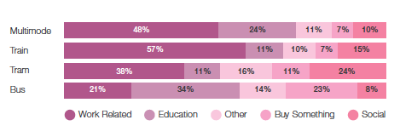
Source: VISTA data 2018, Infrastructure Victoria analysis

Public transport trip purposes are quite different by mode. Train travel is dominated by work trips, while the standout difference for bus travel is the significant share of people using bus trips to buy something, as well as to get to education. Trams are unique in the number of social and recreation trips they provide.

Trip lengths also vary by mode. Research by CIE shows that average trip distances for additional trips on public transport are around 12km for train, 4.5km for bus and 2km for tram (CIE, 2020). Trip quality is also affected by the public transport mode used. Trains are typically time efficient, covering large distances in short amounts of time while trams are much slower, followed by buses which are both slow and indirect.

The result of the current fare structure is that people are charged the same for high cost, high value public transport trips (such as a CBD train trip to work at peak hour) as low cost, low value trips (such as a trip to the local shops).

Flat fares are inequitable

The types of people using each mode also varies significantly.

As discussed previously (see page 15), while public transport is often viewed as a transport choice provided primarily for people on lower incomes, the evidence shows that this is not the case. Using data from the Victorian Integrated Survey of Travel and Activity (VISTA), we have placed people into five levels (quintiles) of household income. The highest quintile
reflects the top 20% of households by income, while the lowest shows the bottom 20% of households.

We found that public transport is used more by wealthy households than poor ones. People who belong to households in the top 40% of incomes make up 45% of public transport trips, while people belonging to the poorest 40% make up only 36%. Analysis of the data suggests that on an average day those using public transport have household incomes that are 8% higher than those who don't.

The current fare system overcharges for bus services from a quality and value point of view, and also hits those on low incomes the hardest.

Public transport is utilised by more wealthy households than poor households

Figure 8 Weekly equivalised household incomes by mode of transport

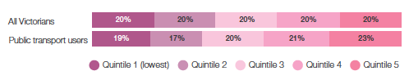
Source: VISTA data 2018, Infrastructure Victoria analysis

Trains and trams are used by more higher income than lower income households

Figure 9 Public transport users by mode, by weekly equivalised household income
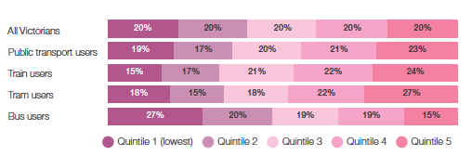
Source: VISTA data 2018, Infrastructure Victoria analysis

The data is even more stark by mode, with trains and trams being used disproportionally by those on high incomes. The only mode that shows an opposite effect is bus. Bus services are used disproportionally by those on low incomes: 47% of trips on buses are made by people in the lowest 40% of household incomes, while only 34% of bus use is made up of those in the top 40% of household incomes.

This shows that the current fare system is not just overcharging for bus services from an efficiency, quality and value point of view, but that it is hitting those on low incomes the hardest.

A move to price buses lower than trams, which are priced lower than trains, would not just make better use of the public transport system, but would also increase equity.

Express bus services

For the purposes of our analysis, we defined bus routes into two categories: express and normal services.

Bus services to the Melbourne CBD are not the same as a typical bus service, and have a profile of benefits and costs more similar to trams. Our analysis shows that these bus services should be charged at a rate similar to trams, and that this is reasonable given the higher level of service they provide, as well as reflecting the higher levels of crowding on these services, especially in peak periods.

For example, the commuter 309 bus route is classified as an express bus in our research due to its servicing of Donvale and Doncaster areas before an express segment of the route along the Eastern Freeway, terminating in the CBD. This is in contrast to a more typical bus service, such as route 280, only servicing the local Doncaster/Templestowe areas.

A full list of express bus route numbers is provided in the `Our Modelling Scenarios' breakout box on page 56. Analysis performed by CIE and Jacobs for Infrastructure Victoria showed that a 30% cut in the fare for normal buses would result in only one in three additional bus passenger trips boarding already crowded peak services. This would, in the main, improve capacity utilisation of the suburban bus network.

For express bus services, additional passengers would be joining already crowded peak services 83% of the time, supporting the argument for peak and off-peak pricing for these uses (CIE, 2020).

More services alone are not the solution

One of the main contributors to the conclusion that bus fares should be low is the high level of unused capacity on existing bus services.

Fares, service frequency and service quality all interact with one another – and it is important to get each one right. Price is only one part of a large number of factors that make up mode selection, including the reliability of service, comfort levels, safety, overcrowding, wait and journey times (SGS-BIT, 2020).

More frequent services without bus service and pricing reform may have limited effectiveness. If a bus trip to the local shops costs the same as a peak period train service to the city, local services will continue to struggle to attract passengers, and cars will remain the preferred method for local trips. Cars will also remain the preferred method for local trips if bus routes are slow and indirect.

Setting the right fares for buses and off-peak trams and trains is one part of the solution, and supports more frequent services: as lower fares attract more passengers, frequent services become more viable for transport planners.

However, fare reform also needs to be accompanied by careful service planning that provides people with the travel options they want, at the times they most need them. Unattractive bus services will suffer from low patronage, and while lower fares would be recommended under our pricing approach, they won't be enough to encourage more travel if the services fail to meet passenger needs in wait and journey time, comfort and reliability.

We have made recommendations about bus service reform in our paper Five Year Focus: Immediate actions to tackle congestion and will be making further recommendations on public transport services and infrastructure as part of the update of our 30-year infrastructure strategy.

Fares for multimodal trips

When moving to fares that are based on the modes used, the obvious question is: how should fares be collected and charged for multimodal journeys? This is known as the level of integration.

The concept of integrated public transport travel is made up of two parts: ticketing integration and fare integration.

Ticketing integration offers users the opportunity to travel across multiple modes of public transport using a single form of payment/ticketing (increasingly a form of smartcard). The benefits of this level of integration are significant and are described further in the Ticketing that supports reform section.

The issue that needs to be addressed is the integration of fares, or how fares are set for journeys made up of multiple modes.

Fare integration can be viewed on a spectrum. At one end of the spectrum is a non-integrated fare structure in which users are charged a separate fare for each mode they use. Each leg of the journey is charged as a separate fare regardless of whether it is made on the same or different modes (for example, two trams would require two fares).

At the other end is full fare integration, where the same fare schedule applies to all modes and there is only one price for all journeys (this is the current fare structure in Melbourne).

In the middle, a range of options exist including charging for each mode individually (but not each leg), discounting the cost of additional modes and charging the highest mode fare for a multimode journey.

The level of fare integration varies from jurisdiction to jurisdiction, and is tied to the level of mode-based pricing in each jurisdiction. In Australia, Sydney is the only major city to price modes separately. However, there is still a level of fare integration in the way fares are calculated. For public transport trips in Sydney, a $2 credit is applied each time a traveller switches modes ($1 for concessional fares). This means that the cost of a journey is still a function of the types of modes used, but not simply a sum of the mode fares.

Our analysis suggests that in the Melbourne context no extra charge should be made for multimode journeys that involve a bus. This provides equity of access to train stations regardless of location, and also acknowledges the low social costs of additional bus services and the benefits of fewer people parking at train stations.

We suggest train journeys that include a tram trip pay an off-peak fare for the tram component. The reason for the additional charge for trams is that additional use imposes a cost on society. Trams also experience significant overcrowding and can sometimes be replaced with active transport, such as walking.

Our analysis found that this type of additional charge is more straightforward for users to estimate and understand than the NSW approach of providing a credit for the next mode use. An alternative is to simply charge the fare for the highest price mode, but this does not give users a price signal to influence choice for each part of their journey (for example, should I walk to the office from the station or take the tram?).

Ticketing integration offers users the opportunity to travel across multiple modes of public transport using a single form of payment.

Removing Melbourne's free tram zone

Consistent with our research, and in line with Principle 1 that `all modes, routes and parking are priced', Infrastructure Victoria recommends the immediate abolition of the free tram zone to improve safety and access for those who need it most.

While people tend to prefer simple fares, this is only one of the factors that influences decisions, behaviour and satisfaction. Comfort, overcrowding, safety and reliability are also relevant factors. Any gain from simplicity may be outweighed by a worsening of these other factors even before the equity of the free tram zone is considered.

The free tram zone includes the busiest tram corridor on the largest tram network in the world – a corridor that is already at capacity – running a service in each direction every 60 seconds at most times of the day (Langdon and Degnan, 2017).
Yarra Trams' submission to the Parliamentary Inquiry into the Extension of the Free Tram Zone showed that patronage increased by 30% in the first year of its introduction, resulting in significantly increased crowding and discomfort – despite adding over 60 new large trams and a small number of additional platform stops (Keolis Downer, 2020).

Dwell times increased significantly at stops, from 7% to 38% depending on location. Any additional trips in the zone will need to be accommodated by more rolling stock (which on some routes cannot be accommodated) or new infrastructure.

Crowding on trams in the free tram zone hinders access for older Victorians, people with a disability, pregnant women and parents with prams and young children – the same people that have the greatest need to access trams in and around the CBD (Travellers Aid, 2020). The need for pricing in this zone is reinforced by the recent impacts of COVID-19, where even moderate levels of crowding on trams are undesirable.

Most people travelling to CBD jobs and services live outside the free tram zone and, if they have already used public transport to get there, extra trips within the zone would already be free. This means the main beneficiaries of the zone are those who drive into the CBD and those who live in the CBD. People who drive to the CBD have above average incomes (Terrill et al., 2019) as do residents of the Melbourne, Port Phillip and Yarra local government areas. It is inequitable that one small proportion of society is benefiting from the free tram zone paid for by all Victorians, while others do not.

Further, there is some evidence to suggest that the free tram zone has encouraged more driving to the outskirts of the CBD where parking is cheaper, and then taking a free tram for the remainder of the journey, increasing both road congestion and crowding on trams (Keolis Downer, 2020). The free tram zone also encourages people to substitute tram trips instead of using active transport, such as walking or cycling. Overall, this may lead to a negative effect on both congestion and the health of individuals.

While some argue the zone benefits the tourism and retail sectors, there is no evidence to suggest that public transport costs deter tourists from staying in Melbourne or that the free tram zone has boosted tourism. International evidence has also failed to find that free public transport attracts tourists or even that general public transport performance substantially affects destination selection (Thompson and Schofield, 2007; Le-Klähn et al., 2014). Any retail benefits to businesses within the free tram zone disadvantage those retail centres outside the zone, and provide CBD businesses with an unfair advantage.

Our ticketing reforms will help make the whole public transport network more accessible for visitors and locals alike. For example, by opening up the ticketing system to accept credit or debit cards directly, as well as lower priced myki cards. Ease of use is more important than cost, and this is evidenced by international tourists being more affected by ease of use than anything else (Thompson and Schofield, 2007; Le-Klähn et al., 2014). Research also showed that international tourists were content with the relatively high price of trams prior to the introduction of the free tram zone (Yang et al, 2016).

It is inequitable that one small proportion of society benefits from the free tram zone paid for by all Victorians, while others do not.

07. Fares that reflect the time and place of travel

Recommendations

06. Immediately introduce peak and off-peak fares on public transport in places and locations which are at capacity. Modes and zones which are rarely at capacity should have all-day off-peak fares.

07. Consider a new `City Zone' with its own peak price, composed of the City Loop service train stations (Parliament, Melbourne Central and Flagstaff, Southern Cross and Flinders Street) and the Metro Tunnel stations (Arden, Parkville, State Library, Town Hall and Anzac). This will be contingent on CBD public transport travel patterns returning to pre-COVID-19 levels, with significant crowding at peaks times.

08. Introduce directional pricing so that trips in counter-peak directions are not charged a peak fare e.g. those travelling away from the CBD in the morning peak.

Peak use contributes to an unbalanced network

Use of the overall transport network in Melbourne is highly dependent on the time of day.

As Figure 10 clearly shows, both public transport and roads have a `peak' period of use that ranges from around 7:30am to 9:30am and then a double peak in the afternoon, likely attributed to school pickups and returning from work trips.

The peak is even more pronounced for public transport, as use in the off-peak periods falls much more heavily than road use. This underuse of the network during the off-peak and highly congested times in the peak shows that the network is imbalanced.

Weekday road and public transport share similar peak periods

Figure 10 Road and public transport use by time of day
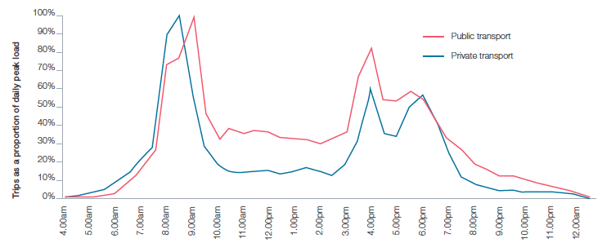
Source: VISTA 2018

The peak for train travel is particularly pronounced close to the CBD. Figure 13 shows that for train travel within the City Loop there is a significant peak within the peak periods (highlighted in red). Occurring within both peak periods, this is an hour in which there is a large increase in touch on/off transactions, from around 1000 transactions per minute up to 1500.

An option for pricing to specifically flatten the peak curve for the CBD was considered, and is detailed in our technical report. We have not recommended this pricing because the practical implementation and complexity trade-offs are considered too great at this time, and because there is some uncertainty in the future levels of CBD train congestion post-COVID-19. Instead, we focus on a single peak period for the morning and evening peaks
(7:30am-9:30am and 4:30pm-6:30pm). Future technology and greater familiarisation
with demand-based pricing could make pricing to flatten the peak curve more
viable in the future.

Peak usage is not just a weekday phenomenon. Figure 11 shows that while there is no pronounced weekend peak for public transport, there is a large single peak for road use during the middle of the day. This has implications for setting fares, as significant road congestion benefits are available when shifting people off roads on weekends, while the public transport network is mostly empty.

Public transport peaks are more pronounced closer to the CBD

Figure 11 Average touch on/off transactions per minute in the City Loop during

peak periods

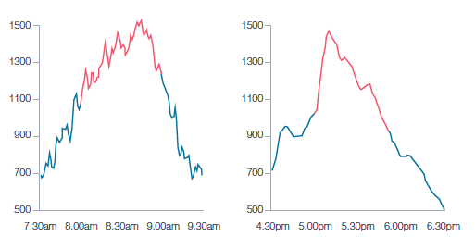
Source: myki touch on/off data, 2019

Transport peaks are different depending on how you travel and the days

you travel

Figure 12 Transport use, weekday and weekend
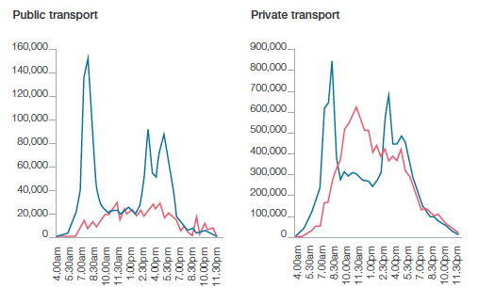
Source: VISTA 2018

Crowding and congestion also varies by location. Figure 13 shows that there is spare capacity at even the busiest times in the extremities of the network, primarily located outside Zone 1 (approximated by blue shading). While not perfect, the existing Zone 2 boundary does correlate strongly with the spare capacity on the network, even during the peak periods.

Train congestion increases closer to inner Melbourne.

Figure 13 Median train line loading, weekday AM peak (8am-9am)
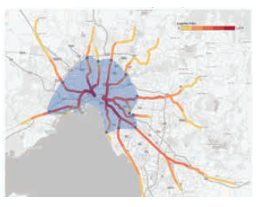
Source: Data and analysis provided by the Department of Transport, Victoria – Weekday data of city-bound trips in May 2019.

Peak Pricing in Victoria

Fig 14 Melbourne public transport usage over time
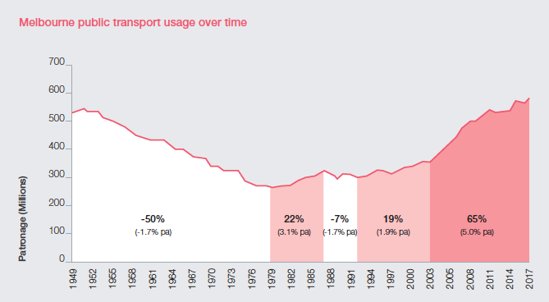
Source: PTV, Melbourne Public Transport Patronage Long Run Series 1945-46 to 2010-11 and Budget Papers.

Public transport pricing based on the time of day in which travel occurs has a long history in Victoria. Before the late 1970s, Melbourne train fares included peak and off-peak fares and were set according to a detailed schedule based on distance. In under ten years, this was all replaced with the much simpler Metro card system, which evolved into today's zonal system (Infrastructure Victoria, 2020).

The current fare system in Victoria only varies by time in two limited cases: the Early Bird ticket in metropolitan Melbourne and V/Line services.

The Early Bird ticket offers free travel on metropolitan trains for all trips completed by 7:15am, while trips on V/Line trains that travel at least three zones and finish in the CBD at peak times are priced higher than other V/Line trips.

A full understanding of the rationale behind the move away from peak and off-peak fares is not readily available, but annual reports for the Victorian Railways Board and Melbourne and Metropolitan Tramways Board suggest it was in part a response to declining patronage and a way to support the introduction of ticket machines (Infrastructure Victoria, 2020).
The rise of the automobile had significant effects on public transport patronage, resulting in broad underuse of the network.

These issues no longer exist: public transport use has surged in the first part of the century and smartcard ticketing technology has been introduced.

Interestingly however, peak prices have not resurfaced for Melbourne's metropolitan fares.

Across the country, a number of public transport systems feature peak fares, including Sydney, Brisbane and Adelaide.

Internationally, the use of peak fares is also mixed: peak fares are a feature in the public transport systems of London, Tokyo and Berlin, while absent from cities such as Auckland, New York, Madrid and Paris.

New peak fares

Peaks across public transport and roads matter for fare setting.

Flat fares give people no financial incentive to shift their time of travel. Without any shift in travel behaviour, the only response available is to provide more services and expand infrastructure, increasing the financial costs associated with the public transport network and contributing to ever increasing levels of imbalance.

The unsynchronised private and public transport weekend peaks demonstrate that significant road decongestion benefits can be realised with increased use of public transport, which is underused on weekends.

However, the synchronised peaks for private and public transport on weekdays are more challenging.

There are significant road congestion benefits in moving people to public transport during this time, yet there are also significant crowding issues on public transport (particularly trains and trams). The costs of increased public transport use in the peak and the benefits of decreased road use need to be balanced.

Modelling and research performed by CIE (in line with our approach, and which takes
into account the complexities of capacity constraints on both the roads and public transport) reveals that the social costs for additional train and express bus use is higher in the peak than the off-peak (Figure 15), and so fares should also be higher at these times (CIE, 2020).

Additional train capacity is extremely costly due to the limited options available for new
train infrastructure in inner Melbourne, usually involving signalling upgrades and tunnelling, the latter of which almost certainly involves expenditure in the billions of dollars. If travellers face fares that reflect the additional costs their behaviour induces, then planners can be more confident that future infrastructure to meet peak demand is of benefit to society and valued by users.

Our research shows that peak fares are warranted for trains, trams and express buses, while flat fares should apply to regular bus services.

Social cost estimates for additional public transport use support peak fares for train and express bus

Figure 15 Range of social cost estimates for additional public transport

use (implied optimal fare)
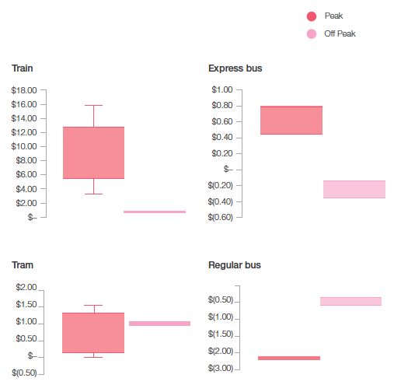
Source: Estimates produced by Infrastructure Victoria using the CIE model for social marginal cost.

These estimates support peak fares for train and express bus, are somewhat inconclusive for tram and suggest that additional bus use has a negative social marginal cost, implying even a zero cost fare for buses could be beneficial in the CIE modelling. See Fare Reform Technical Report and CIE report for details.

The results were less conclusive for additional tram use (Figure 15). However, not all constraints on tram capacity were able to be included in the CIE work, and our view is that the demonstrated overcrowding of trams in inner Melbourne sway the argument firmly in favour of peak fares, at least in the first instance.

The St Kilda Road and Swanston Street tram corridor is one of the busiest in the world, and serves as an excellent case study. The route carries 10 of the 24 tram lines in Melbourne and is particularly problematic as peak frequencies cannot be increased on any of the routes in the corridor (there is a tram every minute in both directions for much of the day), as safety regulations permit only 60 trams per hour (Langdon and Degnan, 2017).

Limited increases in capacity can be made in the short to medium term by increasing the capacity and size of the trams themselves. More substantial increases may require network reconfigurations in some of the nation's most expensive areas (due to the high land value and construction costs in inner Melbourne).

As explained in detail in the Fare Reform Technical Report that accompanies this paper, we have concluded that peak fares are warranted for trains, trams and express buses, but that this is unlikely to be the case for regular bus services (although further research into specific bus services is warranted) (Infrastructure Victoria, 2020a).

The main reasons contributing to the conclusion that there should be flat fares for bus services are the low costs of accommodating new trips during the peak (due to existing capacity on buses at this time and low infrastructure costs for additional services where required) and the significant congestion benefits from reducing private transport use during peak times.

Peak fares are warranted for trains, trams and express buses.

Figure 16 St Kilda Road and Swanston Street (CBD) tram corridor

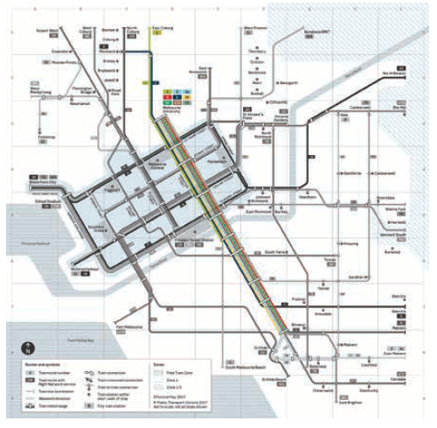
Locational peak fares

The extent of crowding and congestion doesn't only vary by time but also by location.

The extent of crowding and congestion doesn't only vary by time but also by location. Therefore, we propose that the application of peak fares varies across zones.

As discussed previously, the train network is not crowded for extended periods of time within Zone 2. Therefore, trips solely within Zone 2 should be charged off-peak fares.

In addition, because the congestion and the cost of expanding the train network in and around the CBD is greater than the rest of the network, we are proposing the introduction of an additional zone for Melbourne's trains: a City Zone (when travel and crowding returns to near pre-pandemic levels). Trips to (and through) the City Loop stations are the primary contributors to congestion on the network, as evidenced by the need for Metro Tunnel and the line loads presented in Figure 17, which is representative of typical metro lines and shows that loads increase until people get off in the city loop (City Zone).

The Cranbourne line reaches its highest levels of patronage at stations closest to the CBD

Figure 17 Cranbourne Line Load Profile AM Peak 7:30 am-9:00am

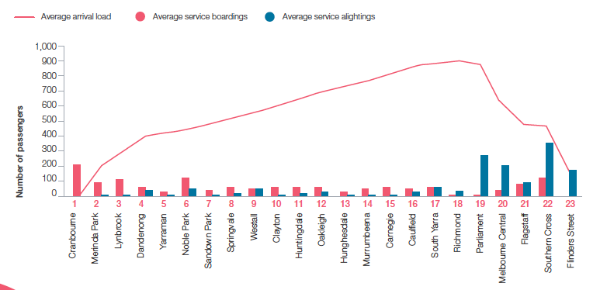
Source: Data and analysis provided by the Department of Transport, Victoria – data of weekday trips in May 2019.

Across a typical weekday, stations like Southern Cross and Flinders Street cater for between 70,000 to 100,000 train passenger arrivals while stations like Parliament and Melbourne Central also cater for high passenger arrivals ranging between 43,000 to 51,000 a day. Compare these with major stations on the metropolitan train network like South Yarra and Footscray station with daily arrival numbers around 15,000 and it becomes clear that the CBD stations cater for some of the highest passenger numbers across the network (Figure 18).

In other words, people travelling into these busy CBD stations at peak times are contributing the most to crowding, congestion and capacity issues.

Inner city stations attract the highest numbers of weekday train passenger alightings

Figure 18 Destination data of inner-Melbourne train stations (overall and zoomed view) Average Daily Alightings
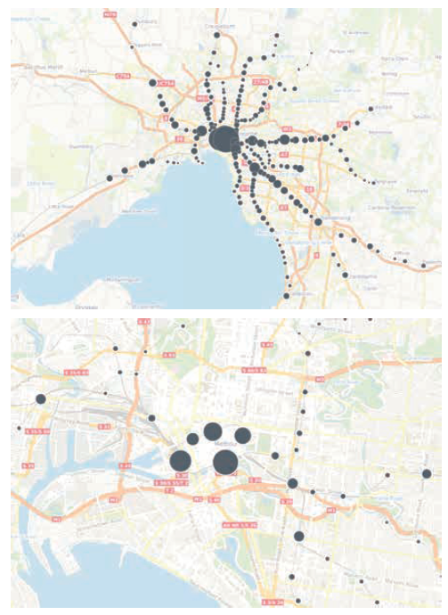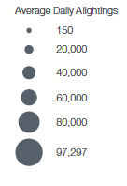

Source: Data and analysis provided by the Department of Transport, Victoria – Average destination data of weekday trips in May and August, 2019.

A new City Zone is proposed to include City Loop service train stations (Parliament, Melbourne Central, Flagstaff, Southern Cross and Flinders Street) and the Metro Tunnel stations (Arden, Parkville, State Library, Town Hall and Anzac). This would further refine the existing metropolitan rail zone system to separately price those areas with the highest levels of congestion: Melbourne's rail lines as they tunnel through the city.

Using the underground tunnelling system and major stations associated with the City Loop (Flinders Street and Southern Cross) to define the new zone will also make it easy for people to remember where the City Zone applies.

City Loop station services are already referenced separately on train services and in timetabling, and typically involves tunnels so people identify this as different and appreciate its higher cost of provision.

This approach means that the metropolitan rail network would have three zones: the City Zone (Melbourne city), Zone 1 (inner Melbourne) and Zone 2 (outer Melbourne).

The additional City Zone is supported by the high social costs of additional public transport travel in these locations. However, due to the effects of COVID-19 (see COVID-19: a new set of problems for public transport, pg 27) there is uncertainty around whether travel patterns will return to pre-COVID-19 levels. We suggest government consider the proposals of a new City Zone post the COVID-19 recovery, determining whether crowding and congestion remain highest at these times and locations.

A new zone in the CBD would only be supported if crowding and congestion are high, and where increased passenger trips will require new infrastructure to be built and maintained in the future to cater for the increasing demand, as was the case pre-COVID-19.

The proposed structure of peak fares across the three zones for train travel is summarised in the table below.

Travel that does not cross into or out of the City Zone is priced at a lower fare, meaning that travel solely within a single zone (and Zone 1/2 trips) are priced lower than those trips that cross into/out of the City Zone. This is because the point of congestion is mostly crossing into/out of the City Zone. In the main, those passengers getting off before the CBD free up space for others to get on during the AM peak. Those getting on and off within the City Zone are contributing less to crowding than those travelling across the City Zone/Zone 1 boundary, which is where crowding is at its highest.

The fare also captures the significant current and potential future costs of increasing capacity in the inner CBD, which has required large scale projects such as the Metro Tunnel (current) and potential future projects such as the City Loop reconfiguration or Melbourne Metro Two.

Table 1 Proposed fare structure

 | Peak (applies weekdays only) | Off-peak (applies weekdays and all weekend)
City Zone + any other zone | High fare | Lowest fare
City Zone only | Medium fare | Lowest fare
Zone 1 only | Medium fare | Lowest fare
Zone 1+2 | Medium fare | Lowest fare
Zone 2 only | Not applicable | Lowest fare

Trips that travel in a counter-peak direction are charged at the discounted off-peak rate ie. travelling away from the city in the AM, travelling towards the city in the PM.

Directional peak fares

Congestion on the public transport network varies not only by location, but also by direction of travel.

For example, in the morning peak, a trip from Box Hill to Flinders Street arriving at 8:30am will be highly crowded, while a trip heading in the opposite direction will be mostly empty.

Because of this, we recommend that peak fares only apply in the directions where there is congestion.

This would deliver benefits in two ways. First, it would encourage people to board mostly empty train services that are running anyway. Second, it would remove car traffic from heavily congested road networks during their most busy times.

Peak fares should only apply in the directions where there is congestion.

Will peak pricing make any difference?

Changing people's behaviour

Analysis shows that the reasons people use public transport are quite different in the peak and off-peak periods. Given people's need to get to work and education on time, will peak fares change behaviour?

Work-related trips make up the majority of peak movements on public transport

Figure 19 Public transport trip purpose
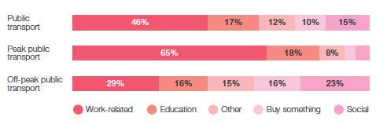
Source: VISTA 2018

While it is true that work and education trips dominate the peak periods, there are still a number of trips taking place for less time-critical tasks. Our analysis using Department of Transport (DoT) survey data found that even for work trips, over half of people said that they are able to shift their time of travel: 54% of those able to shift were able to shift their trip by up to 15 minutes, 38% by up to half an hour, 24% by up to an hour and 13% by more than one hour.

In a survey by BehaviourWorks in May 2020, 60% of people said they were more likely to shift their time of public transport travel if it were discounted in off-peak periods (Figure 20). Interestingly, the price difference was comparable with the impacts of more structural changes in people's ability to manage their own time, such as changes to school drop-off or work times.

More than half of people making work trips say they can shift their time of travel, suggesting that many Melbourne commuters may welcome and respond to off-peak fares.

Ratings of public transport time-shifting measures

Figure 20 – People are more likely to shift their time of travel with a fare discount in off-peak periods
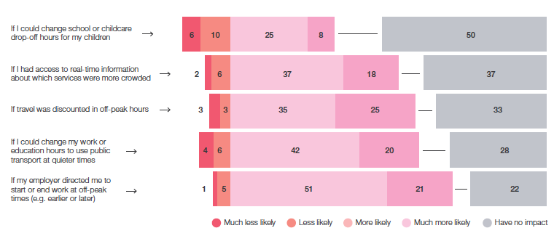
Source: Survey by BehaviourWorks for Infrastructure Victoria. Survey date 19 May 2020

Our modelling (detailed in the chapter benefits of change) shows that peak pricing can change behaviour, and that people will move their time of travel. This suggests that a significant number of Melbourne commuters may welcome and respond to off-peak fares. This conclusion is supported by the BehaviourWorks survey results.

The DoT survey data suggests people are most likely to shift their travel by small time periods, with the vast majority of those able to shift being able to do so by less than 30 minutes. To enable people to shift more easily from the peak to the off-peak, a shorter peak period could also be considered, for example 7:45am-9:15am.

The impacts of COVID-19 have demonstrated that employer and employee arrangements are more flexible than they have ever been, and that people's ability to shift their time of travel has likely increased. Significantly, surcharges at peak times could reinforce measures to encourage social distancing on public transport.

Using time of day pricing to make best use of the network while still encouraging social distancing

While public health experts advise travellers to maintain social distance on public transport, the data show that even when travellers consider the virus, additional measures are required to achieve this.

The Annual Change in Patronage by Day from DoT's `Weekly Patronage Report', May 25-28, 2020 shows that total network patronage had dropped by 10% compared to the same time last year by the start of March, two weeks before the COVID-19 State of Emergency was announced for Victoria. When the State of Emergency was announced, patronage had fallen by 33%. However, the fall in patronage only reached around 80% of the levels required for social distancing after the closure of non-essential activity on March 23.

It is probably most effective to directly restrict the number of travellers per train carriage, tram or bus, to achieve social distancing – but doing so may be difficult or impractical. But if prices remain flat, then the demand for public transport will exceed the available places at certain times.

There is also a significant risk that trains and trams would fill up in the outer and middle suburbs before they even get close to inner Melbourne, and that residents of the city's inner suburbs would be unable to board public transport.

Making it relatively cheaper to travel during off-peak times would provide a financial incentive to encourage those who don't have to travel at peak not to do so. It would also help to reduce crowding: those who need to travel at peak times will be able to do so more safely.

This approach has been taken by the NSW Government, who have increased the off-peak discount and altered the time of the peak periods, as detailed on page 23.

Nearly half of peak public transport use is by the highest income earners. Only a third is by low income households. The reverse is true for off-peak public transport use.

Equity

Our research shows that introducing higher peak fares and discounted off-peak fares should have the overall effect of improving equity.

For modes with peak pricing, the burden of higher prices during peak hours will mainly fall on those with higher incomes. Conversely, those on lower incomes will gain the most from off-peak discounts.

Figure 21 illustrates public transport use by those on different income levels during peak and off-peak periods. In peak times, 50% of public transport use is made by those in the top 40% of household incomes, while only 31% is made by those on the lowest 40% of household incomes.

In the off-peak, the situation reverses, with only 34% of all trips being made by those in top 40% of household incomes, and 45% being made by those in the lowest 40%. The difference between peak and off-peak for trains and trams is even more acute.

Providing people with greater choice by enabling them to trade off travel time and price gives them the opportunity to shift their time of travel if it will make them better off. This trade off may benefit those on lower incomes who have limited financial resources. When very low income earners, for example pensioners, need to travel in peak periods they will continue to be eligible for concession fares at 50% off the full fare price.

Having no peak fares for buses is likely a better option on equity grounds, compared to a peak fare across all modes, and is likely to still make the best use of the network.

Peak fares impact high income households the most, off-peak discounts benefit low income households the most

Figure 21 Public transport users, peak and off-peak, by weekly equivalised household income
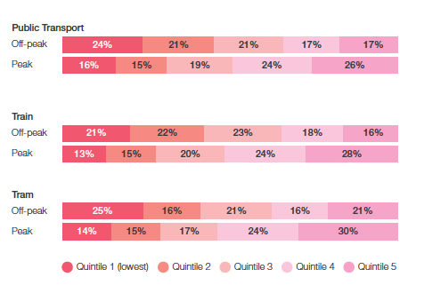

Source: VISTA 2018, Infrastructure Victoria analysis

Peak and off-peak bus use is similarly distributed across income groups

Figure 22 Bus users, peak and off-peak, by weekly equivalised household income

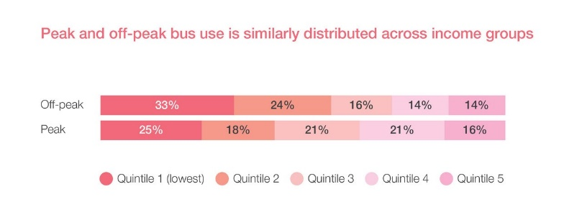
Source: VISTA 2018, Infrastructure Victoria analysis

Our recommended fare structure charges peak fares not just based on time of travel, but also location. The highest fares for peak travel are charged for trips to the CBD at peak times, and these types of trips are disproportionately taken by those on higher incomes. 61% of public transport trips to the CBD at peak times are made by those in the top 40% of household incomes, while only 23% are made by people in the bottom 40% of household incomes (shown in Figure 23).

We also recommend charging off-peak fares for train travel which occurs solely within Zone 2. This also aligns well with equity, given that a large proportion of these trips are taken by those in the bottom two income quintiles (as shown in Figure 24).

While those taking trips solely within Zone 2 are on lower incomes, and while Zone 2 residents are on average on lower incomes that the general population, it is not the case that residents of Zone 2 who are users of public transport are on lower incomes. As Figure 24 shows, Zone 2 residents who used public transport are very similar in income distribution to the overall population, with around 20% in each income quintile. This is consistent with the fact that those using public transport are on average wealthier than those who do not.

Public transport patronage to the CBD is driven by higher income households

Figure 23 Public transport users travelling to the CBD during peak, by weekly equivalised household incomes
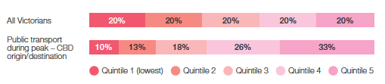
Source: VISTA 2018, Infrastructure Victoria analysis

People traveling exclusively within Zone 2 are typically on lower incomes

Figure 24 Public transport use within Zone 2, by weekly equivalised household incomes
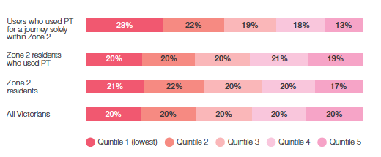
Source: VISTA 2018, Infrastructure Victoria analysis

Looking specifically at public transport users in Zone 2 shows that peak users are better off than the average population, while those taking peak trips to the CBD are significantly better off than the general population. Only 25% of trips being taken at peak times to/from the CBD are by those in the lowest 40% of household incomes, with 58% being taken by those in the top 40% of household incomes.

The highest fares for peak travel are charged for trips to the CBD at peak times, and these types of trips are disproportionately taken by those on higher incomes.

Zone 2 residents who travel into CBD are typically on higher incomes

Figure 25 Public transport users in Zone 2 travelling during the peak, by weekly equivalised household incomes
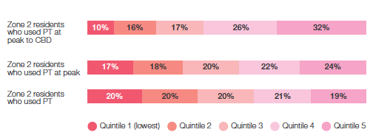
Source: VISTA 2018, Infrastructure Victoria analysis

08. Ticketing that supports reform

Recommendations

10. Discontinue myki Passes (unlimited travel over a specified time period for a fixed fee) to facilitate fare reform and remove complexity.

11. Review the level of the daily fare cap when using myki Money.

12. Open up the ticketing system to third parties. Third parties should be enabled to hold accounts for purchasing travel on behalf of travellers, including for Mobility as a Service.

13. Make the ticketing system easier to use by:
a) Reducing or removing the myki card purchase fee
b) Allowing other inputs for validation through an account-based system (such as credit and debit cards).

14. Develop a set of principles to guide concession design, followed by a review of all discounts, removing or adding concessions as necessary.

We have proposed a range of fare reforms that will make better use of the public transport network, improve road congestion and increase travel choice.

However, these reforms must be accompanied by a ticketing system that aids the new fare structure and makes travel easy.

The 2023 re-tender of the public transport ticketing system presents a good opportunity for wider reform of system.

Ticketing that reflects fare reform

There are two methods for paying for public transport travel using myki.

The first and most popular method is myki Money. Under myki Money, a user pays the fare for each trip, subject to fare caps for travel within two hours (myki Money 2-hour fare) and within a day (myki Money daily fare). The second method is myki Pass, which enables users to pay a fixed fare for unlimited travel within a certain time period (seven days or anywhere between 28 and 365 days).

In terms of ticketing familiarity, myki Pass has been found to be confusing to passengers, with 42% of people on myki Money not knowing of myki Pass. Research has also showed that the pass system is confusing for tourists (Yang et al., 2016) and that 65% of people were not on the optimum ticket.

Not only can myki Pass be confusing, but it also does not support providing incentives for travellers to make the best choice about time, mode and route for each trip they make. The reason for this is that travellers on a myki Pass pay a fixed fee for travel during a given week, month or year, meaning that their travel choices will be unaffected by incentives to contribute to reduced public transport crowding or to support delivery of the best services at the lowest cost (such as peak and mode-based pricing).

The myki Pass also doesn't benefit equity outcomes. Frequency of travel is fairly evenly distributed across the five income quintiles; however, the Pass is only available to those with the cashflow to purchase a large amount of travel in advance. The more paid in advance, the greater the discount.

To support public transport fare reform, we propose that the metropolitan myki Pass be discontinued, enabling all users of the transport network to take advantage of incentives for better use of the system, not just those who do not use it regularly. Similarly, the level of the daily cap for myki Money should be reviewed so that additional trips typically face an additional cost.

A more flexible ticketing system

The current public transport ticketing contract arrangements mean that the ticketing system is relatively inflexible and costly to adjust, a potential barrier to fare reform.

As the Victorian Government prepares for the myki re-tender due in 2023, enhanced flexibility to allow for the development of third-party purchasing platforms, validation, barrier systems and more sophisticated ticketing and fares for public transport should be part of contract discussions.

Victorians would be able to use online platforms (such as a single app) to plan, book and pay for a complete journey in one transaction, covering both public and private transport services.

The transport app that has it all

The Helsinki Regional Transport Authority (HSL) operates public transport within the Greater Helsinki region in Finland, including the local buses, trams, metro trains and ferries.

As an alternative to single use tickets and daily passes, a private operator, MaaS Global, created the Whim app – allowing users planning, validation and payment access to all city transport services including public transport, bike share, car share, ride hail and e-scooters.

Not only was this a step towards improving transport flexibility and choice for consumers (see Reform with MaaS section), but it was also a shift in the way government transport operators could work with private developers and service providers.
Ultimately, HSL introduced one of the world's first open retail interfaces for tickets. This meant that in addition to the ubiquitous journey planner and real-time public transport vehicle data, HSL's new API data sharing agreements allowed for real-time ticketing payments.

With this development, private service providers and developers could make HSL mobile tickets available to their own customers through their own portals, just like Whim.

Sources:

- HSL media release, mobility pilot: https://www. hsl.fi/en/news/2018/hsl-prepares-pilot-newsmart-mobility-services-15387
- HSL media release, OpenMaaS interface: https:// www.hsl.fi/en/news/2018/hsl-make-mobileticketsavailable-openmaas-sales-interface-2april-2018-14846
- HSL developer portal: https://sales-api.hsl.fi/
- Whim app: https://whimapp.com/

Open up third-party access to the public transport ticketing system

Along with recommendations around different fares for different modes and fares that reflect the time of travel, we also recommend improvements to the user experience for all who travel using Melbourne's public transport network.

This will help ensure that the introduction of a more sophisticated and flexible fare structure does not mean it becomes any harder for all travellers – including tourists – to plan, calculate, use and pay for transport services.

To open up the public transport ticketing system, we recommend that the Victorian Government allow third parties to hold accounts on behalf of their customers. This would enable an organisation to integrate public transport trips within their own journey planning, booking and billing system, both simplifying and improving the user experience of a complete journey across modes and service providers (both private and public).

At a practical level, this simply means that Victorians would be able to use online platforms (such as a single app or website) to match, schedule, dispatch, plan and buy transport trips, reducing the need to make multiple bookings, consult maps or check timetables.

Providing access to the ticketing system should be done in the most open way practicable, ensuring that multiple providers have the ability to interact with the system – driving innovation and delivering a better customer experience.

As an example, instead of paying with myki for a train trip and then requesting a connecting rideshare service or booking a car rental through an app, a traveller would have the ability to plan, book and pay for the whole journey in one transaction.

New technology and innovation in ticketing infrastructure that could validate users as they board or alight services should also be part of a plan to improve this user experience.

Opening up third-party access to the public transport ticketing system is a shift away from traditional thinking and a significant change to the way ticketing is provided. It would give Victorians greater information on their travel options, more confidence in the fares applicable to their journey and greater flexibility in how they transact transport services. It would also remove barriers towards emerging frontiers in transport – one of these being Mobility as a Service (MaaS).

Reform with MaaS

Mobility as a Service (MaaS) is a method for people to transition from traditional mass transit and car ownership to transport access on-demand. It is a digital platform in which trip planning, booking, access and payment is integrated across as many (or as few) transport modes as needed, both public and private. It allows a person to easily plan their travel from start to finish, choosing between options such as the fastest, cheapest, easiest or most scenic journey. While journeys can vary in cost and there can be many alternatives, users need never have to worry about working out the details themselves.

MaaS digital platforms are designed not only to provide different options and pricing levels, but also the ability to book a door to door journey on-demand. Platforms may be brokered, run by large transport operators (such as rideshare companies) or operate in an open marketplace. MaaS is seen as having the potential to reduce private car ownership and use, and increase public and active transport use.

The notion of MaaS has been around for a long time. Progress towards MaaS systems has occurred in many aspects of public transport ticketing and travel: today, Victorians can learn about, make choices and interact with transport services through journey planning, live service tracking and digital myki ticketing (and even the release of public transport timetable application programming interface (API) data for developers). The final step is properly integrating the already well-established carshare and rideshare services of the private sector with the mass transit of the public sector, supported by integrated transaction abilities (such as booking, payment and ticketing).

The main benefit of MaaS for fares is that it provides the opportunity to retain pricing efficiency while making journey planning and payment much easier. Ultimately, opening up myki ticketing and removing barriers to MaaS means a greater range of travel planning options for Victorians: options that don't undermine our principles of ensuring the public transport system is efficient, fair and accessible.

Figure 26 MaaS in action

- Integrated and personalised access to transport for customers
- Multiple transport options to suit customer needs for journeys
- Services owned and operated by multiple providers
- Seamless planning, booking and payment with a single customer interface

Source: ITS Australia (2018)

Make the ticketing system easier to use

Any future ticketing system should aim to make interacting with the ticketing system more consistent across modes and zones.

There are a series of drawbacks with the current ticketing system when it comes to user experience. Bundled with fare reform, we believe improved user experience can enhance the attractiveness of public transport for all Victorians, as well as improve the transport experience for visitors.

There is a high upfront cost to entering into the myki system – while this is somewhat arbitrary for the frequent commuter, it is a large barrier for casual users as well as tourists attempting to access public transport. A full fare myki card costs $6 and the user must then pay the actual fare amount in addition to the cost of the card. A full fare daily trip costs up to $15 with purchase of the myki card included. This essentially acts as a barrier to entry. myki mobile on Android devices, where the digital myki card is free, solves this issue of high entry costs for some smartphone users; however, complete rollout to all smartphone devices is yet to occur.

myki is also currently restricted to the physical card or digital card with the Google PayTM app. Future improvements could also accept other inputs for validation, including direct contactless payment such as credit and debit cards. This is similar to Sydney's Opal smartcard system (an `Open Loop' ticketing system) (Streeting and Howe, undated). Through an account-based system, travellers could also use multiple forms of ID to touch on and off through a myki account, enabling greater convenience.

The PTV app and journey planner can also be improved to make trade-offs clear between price, time and mode of travel. For example, the current Journey Planner does not display peak and off-peak fares for V/line journey options even though the costs vary significantly by service. This hides information from the user that could help them make the best choice on journey time.

The current messaging around touch on and off behaviour in Melbourne is also confusing. Any future ticketing system should aim to make interacting with the ticketing system more consistent across modes and zones.

The current system of ticketing and data collection can be further leveraged to gather insight into transport travel patterns, which could be applied to enhancing the network's performance and user experience.

This system can be improved by implementing smart technology such as sensors that better enable collected data suitable for transport analysis.

Concessions are an important part of the pricing of essential services, like transport, that give people access to education, health and social engagement.

Discounts

Victoria offers a range of concessions and discounts on metropolitan public transport fares.

Concessions are an important part of the pricing of essential services like transport that give people access to education, health and social engagement. Concessions that target those with low access to financial resources are the main contribution to improving equity. Some concessions also enable free travel for those people who are unable to interact with the ticketing system.

The current Victorian set of concessions and free fares benefit a range of groups within the community.

These have evolved over time and were introduced in response to specific concerns.

There are currently three types of concession fares:

1. A 50% discount for certain cohorts (e.g. pensioners, students, Health Care Card holders).
2. Free travel for certain cohorts, including on certain days of the year (e.g. children under five years of age, veterans, carers).
3. Free travel for all travellers on certain days of the year.

Within these categories sit a large range of discounts and concessions. Some of these are inconsistently applied, have no obvious economic or social benefits, or have questionable equity benefits. A detailed list of concessional and free travel arrangements is included in our Fare Reform Technical Report.

We believe that to make the best use of discounts on public transport, the Victorian Government should develop a set of principles to guide concession design, and then review all discounts against this set of principles, removing or adding concessions as necessary.

09. How will users respond to variable fares?

A fare structure that in theory generates the greatest benefits from the public transport network is only as good as people's ability to understand and respond to it.

The aim for our fare recommendations is to provide people with an informed choice that reflects the costs and benefits of additional public transport use, so that they can respond to the price incentives and choose the best method of travel for themselves, as well as a method of travel that most benefits society.

While a fare structure can be created that achieves this aim, once it is perceived as `too complicated' or too difficult to navigate, some people switch off and either ignore the price signals or even avoid public transport entirely, both of which have serious consequences.

How well do users understand fare elements?

Research commissioned by Infrastructure Victoria tested a range of fare elements for user comprehension and understanding, as well as combinations of fare elements. Specifically, SGS Economics & Planning and the Behavioural Insights Team researched the fare elements of peak pricing, mode-based pricing, distance and zones (SGS-BIT, 2020).

The analysis consisted of:

- An online experiment designed to test how a panel of public transport user types from across society responded to different levels of complexity in transport fares. A total of 2011 people participated in the experiment.
- User consultation (focus groups and phone interviews) engaging with public transport users on their understanding of, and behaviour in response to, pricing complexity. In total, 39 people were interviewed or participated in a focus group.
- Expert consultation with five academics and policy makers to uncover additional insights and how these may apply in Victoria.
- A comprehensive literature review to find the most relevant research on how people engage with complex pricing structures.

The analysis confirmed that people have a general preference for simple fares, but that this is only one of many factors directly influencing user decision-making and behaviour. Other factors include the reliability of service, comfort levels, safety, overcrowding, price, wait times, transport mode and journey times.

The research found that modal and peak charges were relatively easy to understand for participants in both the experiment and user consultation. Distance charges were the hardest element to understand.

For this reason, and due to a low level of evidence that distance pricing significantly contributes to the social cost of additional public transport use, we have not included distance based fares in our recommendations. A detailed discussion on the merit of distance based fares is provided in the Fare Reform Technical Report accompanying this paper.

As complexity increases, comprehension declines

Zones for trams and buses add an unnecessary level of complexity with little benefit, while train zones have significantly greater merit, making them worth the complexity trade-off. SGS and BIT also found that as complexity increases, comprehension declines. Combining multiple elements in the one fare structure resulted in a decline in comprehension. Most users could handle two elements in the one fare, but three elements seemed to be a tipping point, especially when the third element was a distance charge.

This has implications for policy making, as the marginal gains from adding new fare elements must be weighed against the cost of making the overall fares system too complex. A small gain in efficiency might not be worth the high cost of disengaged users.

While zones are better received than straight distance charges, they are still less intuitive. We found that for trams and buses, zones were probably an unnecessary level of complexity with little benefit, while train and express bus zones showed significantly more merit and were worth the complexity trade-off.

Given people's limited ability to comprehend too many elements in a fare system, those elements included in a fare system must be selected carefully. People can only handle so much complexity, which means policy makers must choose wisely.

If there can only be a few complexities in the fare system, it is vital that those complexities are chosen based on how well they assist in getting the most out of the public transport network. This is why, on top of the issues with myki Pass for peak and mode-based fares, we recommend removing myki Passes. They add a layer of complexity that can cause confusion, while doing nothing to better manage use of the public transport network.

The research also found that people could generally be grouped as `problem solvers' (those who are happy to do the maths) and `intuitors' who take a less calculated approach and rely more on mental shortcuts – simple rules of thumb that allow a person to approximate what the right answer is.

The majority of people are intuitors, so designing a fare system that is logical and that can have rules of thumb applied to it is important. This explains why features such as mode (am I getting on a bus or a train?) or time (is it a busy time?) were more easily understood and better influenced decision making than distance. Distance is less intuitive, particularly for visitors, as not all people have a strong understanding of the distances between stations, stops or even general locations across Melbourne.

As complexity increases, comprehension declines

Figure 27 Online experiment: reported difficulty of understanding (out of 5) Source SGS-BIT(2020)
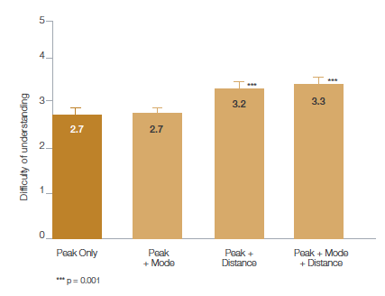
Source SGS-BIT(2020)

Presenting and communicating change

The SGS-BIT research shows that the way fares are framed and presented can often be just as important as the actual changes themselves, and that the framing and presentation of fare changes will impact comprehension.

This is an important consideration for government in implementing any fare reforms. Strong messaging and clear visual clues will aid any reform. This will lead us back to the debate about touch off for trams.

In researching and recommending fare reform, we have used the findings from the SGS-BIT research, as well as other behavioural research, to help strike a balance between comprehension, ease of use and making the best use of the transport network. These findings provided the basis for our consideration of informed choice as an important element of our approach to reform (see page 21).

Our use of the SGS-BIT research findings for each of our recommendations is detailed in our Fare Reform Technical Report (Infrastructure Victoria, 2020a).

10. The benefits of change

Undertaking fare reform is not only about `the numbers', such as increases to boardings and service volumes; it is about delivering practical and quantifiable benefits to individuals, households and the broader community and improving the performance of Melbourne's public transport network.

To analyse the effects of fare reform, we have used the Melbourne Activity and Agent Based transport model, the MABM. Some of the MABM's greatest strengths lie with its ability to test the impacts of policy and pricing reform, especially across our public transport network.

Infrastructure Victoria's recent work on transport network pricing, Good Move: Fixing Transport Congestion, demonstrated the value of whole-of-network analysis, incorporating all aspects of road transport, public transport and parking. Our new work on public transport fares continues to model the impacts across the whole network, but focuses in greater detail on the network impacts and changes to public transport travel patterns across the state.

Across all our work on transport network pricing, Infrastructure Victoria recognises the importance of an approach that analyses the benefits and the challenges that come with reform for people. That means considering how public transport fare reform influences the travel patterns of people across different socio-demographic levels based on their income, where they live, how they travel (car or public transport) and why they travel (work, education, leisure and so on). This ensures that our analysis considers both the engineering capacity constraints across the network, but also the impact of reform to the lives of Victorians and their experience of travelling on the network.

While some of the recommendations in this paper are designed to be implemented in the short term, we also see value in considering the long-term impacts of public transport fare reform and have reported results on the MABM run for the year 2031. This gives us an insight into how demand on the network due to population growth, employment and infrastructure provision will play out and how public transport fares can be used to complement many of the transport infrastructure projects expected to be in operation by 2031 and earlier.

It is also in line with the work completed by the CIE, which was modelled in 2026 and included completion of the Metro Tunnel.

Travel in Greater Melbourne by 2031

By 2031, over 17.6 million trips are expected to occur across Greater Melbourne.
Despite investment in major public transport infrastructure projects, an expected 12.3 million of those trips (or 70% of all trips) will be made by private vehicle. Public transport will account for roughly 13% of all trips or approximately 2.3 million trips across the network.

Our analysis found that even though public transport makes up only 13% of all trips, reformed fares have the ability to improve the experience for all transport users as well as increase the public transport options available to travellers.

Fare reform impacts reach all Victorians, whether through reduced congestion on the roads from people switching from private vehicle to public transport or less crowding on our trains, trams and buses from people adjusting their trips, shifting out of the busiest peak periods.

Ultimately, fare reform would generate about $520 million in value each year for Victoria through more transport pricing options, reduced crowding and congestion and better environmental outcomes (See `Our modelling scenarios', p.64-65).

Underpinning all of these travel movements is the city's transport infrastructure. In Greater Melbourne alone, there are 17.9 million kilometres of roads, 2,100 train services, 7,000 tram services and 37,000 bus services transporting Victorians around the city and suburbs on a typical weekday.

Cars could still be the most popular way to get around Greater Melbourne by 2031

Figure 28: Mode share across Greater Melbourne by 2031 under the Current System

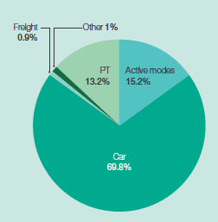

Our modelling scenarios

We modelled two main scenarios, both based in the year 2031.

The first scenario follows on from the current set of myki public transport fares set in Victoria, referred to as the Current System scenario. The second scenario introduces some of the fare reform recommendations outlined in this paper, referred to as the Fare Reform scenario.

Price setting in our illustrative scenarios

The Fare Reform scenario replaces the current flat public transport fare structure with a fare structure that provides stronger incentives for making better use of the network. The structure is based on the recommendations in this research paper and is outlined in Table 2.

The levels of fares are illustrative and were set with the constraint that fare revenue should not significantly change as a result of the reforms. This was done to show that significant fare reform could be done without adversely affecting fare revenue. In practice, government will have flexibility around the level of cost recovery alongside any proposed fare reform.

A model was compiled using VISTA (Victorian Integrated Survey of Travel and Activity) data and previous modelling outputs to ascertain what fares would result in levels of fare revenue similar to those generated by the current fare structure. Our MABM modelled levels of fare revenue using the Fare Reform scenario were down 14.4% compared to the Current System scenario.

This means that while we attempted to apply fare reform prices that would lead to government collecting an identical amount of revenue as under the current structure, there is a 14.4% difference between the two scenarios in the year 2031. Lost revenue from myki Pass and Early Bird ticketing was not included in the Current System scenario, however, so the level of revenue in the Current System scenario is over-estimated. This means the difference is smaller in practice, and we estimate that it is likely less than 11%.

Under the Fare Reform scenario, each mode has its own fare with buses being the cheapest, followed by trams, with trains being the most expensive of all three modes.

Buses are categorised into two categories, express and normal. Express buses are those that run direct CBD services and a selection of higher frequency and higher patronage services (for more detail, see Express bus services breakout box on page 32) consisting of routes 302, 303, 304, 305, 309, 318, 905, 906, 907, 908, 200 and 207. Normal buses refer to the rest of the metropolitan bus network.

Our modelling of public transport fares differs from that completed for Good Move: Fixing Transport Congestion. This is because more detailed analysis on public transport fares has been completed alongside modelling fares without road pricing and leaving parking charges as they are.

Additionally, distance-based fares have been replaced with zonal fares for their ease of understanding and more effective targeting of the social costs of additional public transport use. Because of the overlap with distance, mode and zonal based fares, short trips remain typically low cost, while longer trips tend to have a higher cost.

For trains, we propose a new zone to the metropolitan zone system, the City Zone, based on stations within and close to the Melbourne CBD. The City Zone covers Flinders Street and Southern Cross stations, and all City Loop and Metro Tunnel stations. Travel during the quieter non-peak peak periods is generally cheaper than during the peak, except for normal buses where a single fare is charged across the day. The Early Bird train ticket has also been replaced with an off-peak ticket. These refinements are summarised in Table 3.

All proposed fares are shown at a per-trip basis, as opposed to the current default myki Money two-hour fare.

The Fare Reform scenario includes additional surcharges and discounts offered based on how, when and where you travel. If you travel on a train during the most congested morning and afternoon peaks, you pay a higher fare. If you travel on a train during the peak, but in the opposite direction of most commuters, you only pay the cheaper off-peak fare.

Finally, trips using multiple modes are generally not penalised, with the user only paying the highest fare accrued from any of the individual modes used. The train-tram combination is the only exception to this rule, where a small surcharge is applied reflecting the capacity constraints of the heavy and light rail networks. Table 4 summarises these criteria.

Table 2 Fare structures modelled: Current System and Fare Reform scenarios

Model 1: Current system

- All modes have the same prices
- Price reflects some congestion elements based
- Concession prices available for all trips
- Same price all day in Melbourne – except for Early Bird free train travel and within the Free Tram Zone

Model 2: Fare reform

- Each mode has a different price
- Three metropolitan zones: Zone 1, on zones travelled through (Zone 2 or Zones 1/2) Zone 2 and a new City Zone
- Peak and off-peak fares
- Concession prices available for all trips

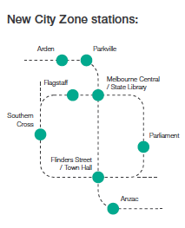

Table 3 Illustrative per-trip prices from the Fare Reform scenario
 | Train | Train | Tram | Tram | Express Bus | Express Bus | Bus
City Zone + any other zone | $5.00 (peak) | $2.50 (off-peak) | $2.50 (peak) | $1.25 (off-peak) | $2.50 (peak) | $1.25 (off-peak) | $1.25 (all times)
City Zone only | $4.00 (peak) | $2.50 (off-peak) | $2.50 (peak) | $1.25 (off-peak) | $2.50 (peak) | $1.25 (off-peak) | $1.25 (all times)
Zone 1 only | $4.00 (peak) | $2.50 (off-peak) | $2.50 (peak) | $1.25 (off-peak) | $2.50 (peak) | $1.25 (off-peak) | $1.25 (all times)
Zone 1+2 | $4.00 (peak) | $2.50 (off-peak) | $2.50 (peak) | $1.25 (off-peak) | $2.50 (peak) | $1.25 (off-peak) | $1.25 (all times)
Zone 2 only | $2.50 (peak) | $2.50 (off-peak) | $2.50 (peak) | $1.25 (off-peak) | $1.25 (peak) | $1.25 (off-peak) | $1.25 (all times)

Table 4 Fare Reform scenario details

Fare reform discount and surcharge criteria

- Peak fares apply: weekdays 7.30-9.30am and 4.30-6.30pm, off-peak discount applies all other hours
- Directional discount: pay off-peak fares on train, even during peak times if you travel against peak flow direction (away from CBD in AM, towards CBD in PM)
- Multimodal trips: to encourage these trips, user only pays the highest fare of any of the individual modes travelled except for a train-tram combination, where an additional $1.25 fee applies.

Table five below shows the current pricing structure, representing our Current System scenario.

In our modelling and as part of our analysis, we will generally refer to four time periods across the day:

- AM peak 7.30-9.30am
- Off-peak (day) 9.30-4.30pm
- PM peak 4.30-6.30pm
- Off-peak (night) 6.30pm-7.30am (next day)

Table 5 Current 2020 year fares, based on a myki Money 2-hour full fare
 | Train | Tram | Express Bus | Bus
Zone 1 only | $4.50 | $4.50 | $4.50 | $4.50
Zone 1+2 | $4.50 | $4.50 | $4.50 | $4.50
Zone 2 only | $3.00 | $3.00 | $3.00 | $3.00

What about me?

Here are some everyday examples to help illustrate the changes under our Fare Reform scenario and how they may impact Victorians.

University student

Travels by train on concession, peak hours, non-peak direction: South Yarra Station to Caulfield Station.

- Current System $4.50 per day
- Fare Reform $2.50 per day
- Saving $2 per day (44% decrease)

Takes the train with a concession fare to attend university. With Fare Reform, because their travel is against the peak flow direction, they also enjoy discounted off-peak train fares. Their fare is cheaper as they are using services that can accommodate significant further patronage growth.

CBD office worker (inner Melbourne household)

Travels by train on city zone charge, peak fares: Hawthorn Station to CBD.

- Current System $9.00 per day
- Fare Reform Parliament Station $10.00 per day
- Extra $1 per day (11% increase)

Takes the train into the CBD from the inner suburbs for work. As they are travelling into and out of the City Zone during the peak, they pay slightly higher fares with Fare Reform. Higher fares are applied as their location of travel represents one of the most congested areas of the metropolitan train network. However, unlike with the current system, there now exists an incentive to change to a cheaper, and less busy period of travel. This choice incentivises some workers to shift their travel but also improves the travel experience of those that can afford to pay a higher fare (typically well-off on higher income earners) who continue to travel during the peak and experience reduced crowding and greater service reliability.

CBD office worker (with tram-train combination)

Travels by train and tram on city zone charge, peak fares, multimodal tram fare: Clifton Hill Station to Southern Cross Station (CBD).

- Current System $9.00 per day
- Fare Reform $12.50 per day
- Extra $3.50 per day (39% increase)

Takes the train into the CBD before taking a short tram trip to their office. Under Fare Reform, this additional short tram leg also incurs a small additional fee. Overall, they pay a higher fare to account for the fact that this commuter is travelling during the time of the day where passenger volumes are at their highest and is using the two most expensive modes. Although their fare is one of the highest increases under the Fare Reform scenario, they benefit from less crowded and more reliable services (as other travellers with lower-value trips and flexible commutes may have adjusted their time and mode of travel). Again, these
users also have the option to shift their time of travel out of the peak or walk their tram trip should they wish to save on transport costs.

Nurse

Travels by tram off-peak: Moonee Ponds to Parkville hospital precinct.

- Current System $9.00 per day
- Fare Reform $2.50 per day
- Saving $6.50 per day (72% decrease)

Takes the tram during off-peak periods to go to work. Under Fare Reform, they benefit from cheaper mode-specific fares and an off-peak discount, reflecting the fact that their service has additional capacity available for use without significant infrastructure or service improvements.

Retail worker

Travels by bus on cheap bus fares: Caulfield (local street) to Chadstone Shopping Centre.

- Current System $9.00 per day
- Fare Reform $2.50 per day
- Saving $6.50 per day (72% decrease)

Takes the local bus to a part-time job at Chadstone Shopping Centre. With Fare Reform, buses become one of the cheapest forms of transport, reflected in this user's large saving in daily fares. There is no peak or off-peak fare for this bus service, so this worker is free to travel at the time that best suits their work needs.

CBD entertainment

Travels by train off-peak fare: Pascoe Vale Station to Flinders Street Station (CBD)
- Current System $9.00 return trip
- Fare Reform $5 return trip
- Saving $4.00 per day (44% decrease)

Takes the train into the CBD from the outer suburbs during the evening peak. As there is ample capacity on Melbourne’s train network heading into the city during the PM peak, travelling in the opposite direction of most commuters, they receive the directional discount (off-peak price) for their journey. Compared with the current system, they have greater incentive to take public transport into the city for evening dining and entertainment through heavily reduced fares.

Hospitality worker

Travels by train on peak train fares: Pakenham Station to Richmond Station.

- Current System $9.00 per day
- Fare Reform $8.00 per day
- Saving $1.00 per day (11% decrease)

Takes the train from Pakenham to Richmond station during peak periods. Currently they pay $9.00 per day. This changes to $8.00 under the Fare Reform scenario. As they get off the train at Richmond Station, outside the City Zone, they do not incur the additional City Zone charge.

Elderly shopper

Travels by bus on concession, cheap bus fare: Footscray (local street) to Footscray Plaza shopping centre

- Current System $4.50 per day
- Fare Reform $1.25 per day
- Saving $3.25 per day (72% decrease)

Takes the local bus service from their home to Footscray Plaza shopping centre. While they received a concession on their current myki, a return trip (daily) would cost $4.50. After fare reform, as they are taking a bus (the cheapest form of public transport), their daily fare reduces significantly to $1.25.

CBD shopping day

Travel by tram on off-peak tram after removal of the free tram zone: CBD (east) to CBD (west)

- Current System free
- Fare Reform $1.25 per trip
- Extra $1.25 per day

Takes the tram into the CBD on the weekend to visit Bourke Street Mall for shopping and dining. Under Fare Reform, off-peak fares apply to all weekend travel so their trip is significantly discounted. This is because public transport demand is not as high as it is during the weekday peaks. Compared to prices under the current system, the new fare applicable is only a fraction of what they would originally pay under the current system.

Fare reform shifts demands on the transport network

Fare reform takes 96,000 car trips off Victorian roads every work day, with most of these trips transferring to the public transport network.

Under our Fare Reform scenario, travel during peak periods into the Melbourne CBD by train is more expensive than under the current myki system. For almost all other types of travel, it is cheaper for Melburnians to get around. This section outlines the impact on the transport network as a result of reforming fares. All figures within this section represent trips on a typical weekday.

The Fare Reform scenario makes taking public transport cheaper for around 71% of users who continue to use public transport in Greater Melbourne. Fare Reform also resulted in a 5.6% increase in public transport users, with 56,620 new public transport users on a typical weekday when compared to the Current System. All figures in this section represent trips on a typical weekday.

Our modelling also shows that a proportion of the population is willing to make the shift
across to public transport from private cars due to more attractive fares. In the morning
peak alone, some 18,200 car trips are taken off the roads (similar to the number of cars travelling across the Swan Street Bridge towards the city in a day), while during the course of the off-peak (day) period, over 50,500 car trips are removed from the network. Overall, more than 96,000 car trips are taken off Victorian roads every day – that’s more than the number of cars that travel through the Burnley Tunnel over a 24 hour period.

Most of these trips are transferred onto the public transport network. Figure 29
represents this reduction in car trips and increase in public transport use throughout
the day.

This change from private vehicle to public transport isn’t the only impact on the
network as a result of fare reform. Victorians also change the mode of public transport
they use, with changes to bus, tram and train boardings across the day.

For trains, fare reform introduces an additional higher priced City Zone, along
with discounted off-peak fares. Across the busiest morning and afternoon peak
periods, trains experience over 30,000 less boardings.

The largest reduction is experienced during the afternoon peak, with a 7.4% reduction
in boardings. As a result of cheaper fares outside of the peak, boardings increase
during the off-peak (day) and off-peak (night) periods by 2.3% and 3.1%, respectively (approximately 17,000 more boardings combined). This can be seen in Figure 30.

Car use goes down while public transport use goes up

Figure 29 Change in car and public transport use from Current System scenario to Fare Reform scenario
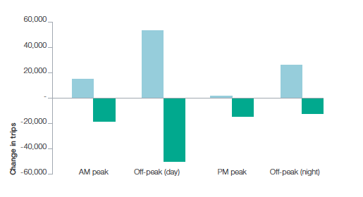
Daily bus boardings go up by over 93,000, as buses are now one of the cheapest forms of transport available.

The tram network experiences an overall increase of over 20,000 new boardings across a typical day. This is most likely caused by tram fares being cheaper in general, with non-peak tram fares being almost up to 75% cheaper in comparison to current levels. While tram boardings decrease during the peaks (due to peak tram fares and additional fares for tram travel with train travel), boardings outside of the peaks increase between by 4-5%. This can be seen in Figure 31.

The final mode to consider is the bus network – specifically, normal and express buses. As shown in the fare table (Table 3), express buses feature peak and off-peak pricing while normal buses are on a single fare. As a result, there is higher boarding demand on the express bus mode during non-peak periods (increasing by over 14% during the off-peak (day)) compared to a smaller increase in boardings during peak periods where higher fares are charged – though still lower than fares in the current system. Normal buses experience consistent increases regardless of the time period. These results are shown in Figure 32. Overall, over 93,000 additional bus boardings occur under the Fare Reform scenario during a typical weekday.

In summary, these changes in boarding numbers demonstrate the relationship between prices and people's willingness to shift to different time periods or modes. Essentially, through variation of fares, travellers are offered greater choice. This is discussed in detail in the following section.

City Zone and peak pricing helps with peak spreading on trains

Figure 30 Change in train boardings from Current System scenario to Fare Reform scenario
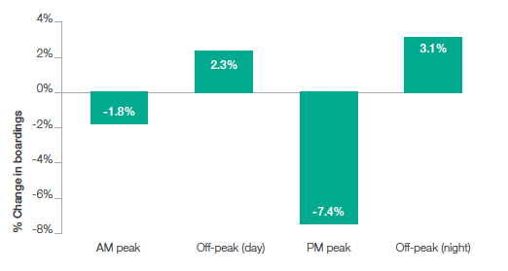

Tram boardings increase overall

Figure 31 Change in tram boardings from Current System scenario to Fare Reform scenario
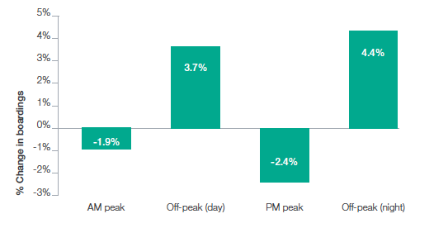

All buses experience an increase in boardings at all times of day

Figure 32 Change in bus boardings from Current System scenario to Fare Reform scenario

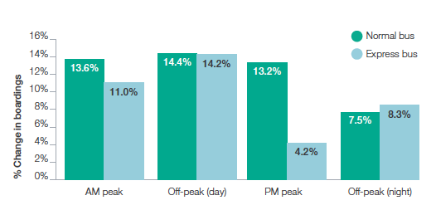
Who changes their travel when offered greater choice?

One of the clear benefits of fare reform is that Victorians have greater choice in the cost of their travel. While the cost of driving a private vehicle may remain the same with or without fare reform, most public transport services become more affordable.

To help demonstrate the equity impacts of fare reform, we use a definition called equivalised total household income (HIED), following guidelines from the Australian Bureau of Statistics. By dividing the population equally into five income groups based on HIED called quintiles, we are able to determine the effects of fare reform on the lowest group, highest group and all groups in between.

As discussed in the previous section, we have demonstrated that public transport begins to become more attractive through improved fare choice, resulting in increased boardings across Greater Melbourne. But who is contributing to the extra public transport trips? Figure 33 illustrates that it is overwhelmingly those in the lower equivalised household income quintiles contributing to this increase in boardings.

Note that unlike the introduction of pricing reform such as road pricing, the lowest income quintile continues to have the choice of travelling via private vehicle or active for no change in cost.

Lower household income groups represent the greatest public transport uptake

Figure 33 Change in public transport trips from Current System scenario to Fare Reform scenario
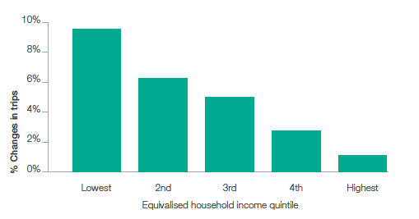
As a result of fare reform, these Melburnians now also have the option to take public transport, which previously may have been prohibitively expensive for the type of trip they wished to take.

The modelling also likely under-reports the benefits for this group, as they are now also able to make new trips which were previously too expensive, and the MABM does not have the capability to model new trips.

With fare reform, most public transport services become more affordable, benefiting lower income households the most.

Who benefits the most from fare reform?

Does mode-specific pricing unfairly disadvantage certain groups of the population?

Under the Fare Reform scenario (see Table 3), trains are the most expensive mode of transport (although prices are still lower than the current system with the exception of travel to/from the City Zone in the peak periods), followed by trams and express buses and finally normal buses being the cheapest mode.

As illustrated in Figure 34, our modelling has found that the lowest income quintile sees the greatest percentage increase in normal bus boardings (+32%), followed by express buses and trams. Train boardings reduce by around 1% across all income quintiles, most likely influenced by the higher cost of trains compared to other modes.

In terms of the benefits associated with fare reform, the graph shows that it is the lower income quintiles who benefit the most (noting that within the MABM, many of these lower income earners financially benefit the most as they take up the option to save money and shift their mode or time of travel). Understandably, it is the highest income quintile that represents the smallest percentage change in boardings as these people will most likely be the least price-sensitive when it comes to fares.

Lower household income groups respond most to fare reform

Figure 34 Change in specific public transport mode patronage from Current System scenario to Fare Reform scenario
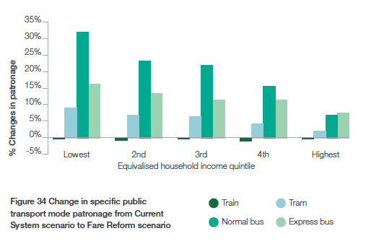
These results show averaged boardings across the full 24-hour period. But how do different income groups respond to fares at different times of the day, specifically peak fares?

The highest income earners represent the smallest changes in boardings – most likely because they are the least price sensitive.

All modes except for normal buses have a built-in peak fare surcharge in the Fare Reform scenario. Similar to how modespecific pricing benefits the lowest quintiles the most and highest quintiles the least, peak and non-peak pricing follows a similar trend.

Figure 35 shows the increase in boardings as a result of peak surcharges on the five income quintiles. Off-peak travel (attracting the cheapest fare) induces the greatest increase in demand from the lowest quintiles (+13%) while also increasing peak travel (+3%). The most likely cause of increased peak travel for the lower income quintiles is that there is no peak fare for normal buses, and express bus and tram fares are also lower than under the Current System, resulting in higher service utilisation.

One of the drawbacks of looking at peak and off-peak fares through averaging is that it mixes the impacts of fares that increase for some modes (CBD train travel) and fares that reduce for other modes (tram and express bus).

Figure 36 shows the current levels of AM peak train trips into the CBD. Under the Current System, individuals in the highest income quintile are five times more likely than the lowest income quintile group to be travelling on a train into the CBD during the morning peak. For context, during all other times of the day (excluding the morning peak), individuals from the highest income quintile are only two times more likely than the lowest income quintile group to be travelling on a train into the CBD.

If fare reform were to be implemented, Figure 37 shows that the largest shift of
trips out of the AM peak is from those in the middle three quintiles, or the lowest quintile
based on proportional shift (%).

This is driven by their higher sensitivity to price, with many people taking advantage of the savings that the new price incentive provides to shift their trip, but some also shifting due to the higher peak pricing for CBD trains in the peak than under the Current System scenario.

Based on average daily fares, Melbournians on the lowest incomes end up paying 26% less for fares on average than they do today.

Lower household income groups respond most to off-peak pricing

Figure 35 Change in peak and off-peak travel from Current System scenario to Fare Reform scenario

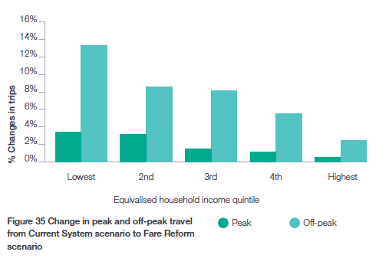
High income households currently make up the largest proportion of train trips into the CBD

Figure 36 Number of train trips during the AM peak (7.30am-9.30am) that travel into

the CBD under the Current System
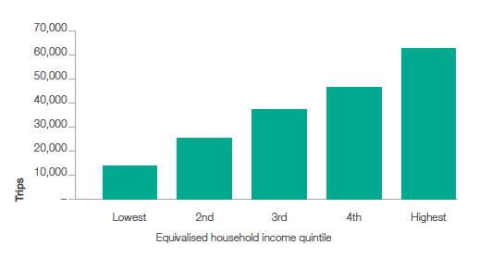

People with average household income travelling by train to the CBD change their travel behaviour the most

Figure 37. Change in train trips into the CBD for the AM peak from Current System to Fare Reform on a typical weekday (percentage shows the proportional decrease from Current System scenario to Fare Reform scenario)
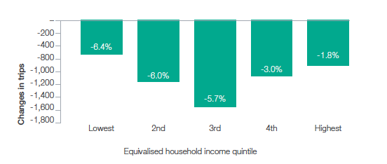

In summary, through fare reform users are provided with greater choice in how and when they travel through the variation of prices by time of day and mode. The reforms increase public transport usage, primarily on modes and times where this increased patronage can be best accommodated.

Those on lower incomes benefit the most from fare changes, with a significant increase in public transport trips for those on lower incomes, as well as lower fares paid on average. Lower fares in the off-peak, especially on buses and trams, makes public transport a viable option for travellers that may have never have considered taking public transport. New trips which were previously too expensive will also be generated. Due to the limitations of MABM they are not shown in the results, underestimating the benefits of reform.

How does fare reform change the cost of public transport?

The previous section demonstrated the increased patronage that occurs, especially from lower income quintiles, as a result of fare reform. While the fare table clearly shows many cheaper alternatives compared with myki travel today, our analysis determines how this affects the average daily public transport fares people would pay under the Fare Reform scenario.
It should be noted that there are no explicit distance-based fares under the Fare Reform scenario. The only proxy for distance based fares is the current metropolitan zone system, to which we have added the new City Zone as part of fare reform. In effect, this is the connection linking how far you travel with how much you pay. With fare reform, travel solely within a zone is cheaper than travelling through multiple zones. Therefore, for example, those who live in areas of Zone 2 (typically the middle to outer areas of metropolitan Melbourne) have the opportunity to take advantage of lower fares should they only travel within their zone.

As discussed, fare revenue was slightly down under the Fare Reform scenario. Figure 39 shows the changes in fare paid between the Current System and Fare Reform scenarios after approximately adjusting for the difference.

Figure 38 shows that by shifting to more sophisticated fares, almost all travellers in the bottom three quintiles, no matter where they live, end up paying less for public transport than they would without reform. There is also a clear pattern in which higher income earners end up saving the least or paying slightly more than they do today.

The reason most people can pay less while still generating similar levels of revenue is that there are 5.6% more people (an additional 56,620 per week day) using public transport under the Fare Reform scenario compared to the Current System, so average fares can be lower to generate similar levels of revenue.

As a result of fare reform and cheaper fares across tram, bus and off-peak trains, there are two shifts that can occur. First, users of public transport who have other public transport options may have an incentive to switch to cheaper modes. Secondly, users may shift to public transport from other modes entirely, such as from private vehicles.

As indicated earlier, there is a significant shift of users from private vehicle to public transport under the Fare Reform scenario.

People can pay less while still generating similar levels of revenue as more people are using public transport under the Fare Reform scenario.

Low income earners pay less for public transport under fare reform

Figure 38 Change in average daily public transport fare by household income and location from Current System to Fare Reform scenario
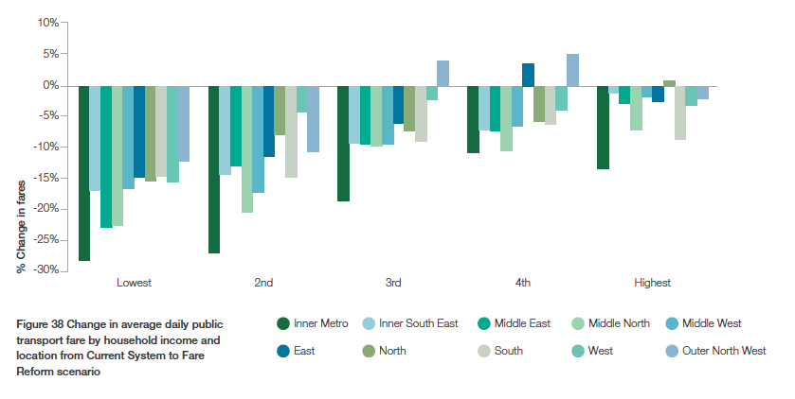
Figure 39 plots this shift on a graph, demonstrating that of private vehicle drivers who shift to public transport, the highest proportion again comes from those in the lowest income quintiles, reducing in percentage as the quintile group increases.

While at first, a 2.5% shift doesn't seem like a huge change - given the large number of car trips made each day across Greater Melbourne - it represents another 23,748 car trips taken off roads across the city (more than the average daily traffic for Queens Bridge in Melbourne City), for the lowest income quintile alone.

Fare reform generates the greatest shift from car to public transport for lower income groups

Figure 39 Percentage of car trips that shift to public transport from Current System scenario to Fare Reform scenario

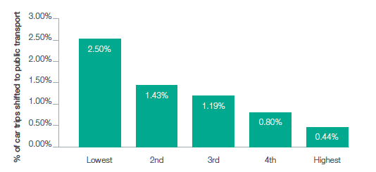
How does public transport demand shift across Greater Melbourne?

We've demonstrated that public transport use generally increases as a result of Fare Reform, but which areas in Melbourne experience the greatest increases or decreases in demand? The following analysis uses Local Government Area (LGA) boundaries.

Figure 40 maps out the average change in public transport boardings across Greater Melbourne during the peak periods (both AM and PM). Shades of blue demonstrate a percentage increase in public transport boardings while shades of red demonstrate a decrease in public transport boardings.

The middle and outer ring of LGAs such as Kingston City, Manningham City, Hume City, and Wyndham City all see public transport boardings growth of above 6%. Knox City sees particularly high boarding growth of around 13%. This is most likely linked to increased use of bus services in the area, or an increase in demand along the Belgrave train line that intersects the Knox City LGA.

Figure 41 compares the boardings across Melbourne during the non-peak periods (during the middle of the day and during the night).

The key message from Figure 40 is that most LGAs across Melbourne (except for the inner city LGAs and some outer LGAs with limited connections to metropolitan public transport services) experience an increase in public transport boardings under the Fare Reform scenario. As a result of discounted non-peak travel and the introduction of the new City Zone for trains, it is the Inner Melbourne LGAs that experience a general decline in boardings during peak periods (between 1-7%).

This reduction is perhaps also due to the fact that these LGAs already exhibit some of the highest public transport mode share percentages, meaning that most residents who can take public transport do so already, while others are either changing to active transport (and possibly private vehicle use) or simply changing their time of travel (into non-peak periods).

Boardings generally increase across the whole of Greater Melbourne outside of peak periods. Some of the LGAs that experience the greatest uptake of public transport are Manningham City, Knox City and Casey City. Boarding increases in these LGAs all record growth levels above 10%. Manningham has one of the highest percentage increases in boarding outside peak periods, recording a 12% increase in boardings. This is most likely linked to high use of the Doncaster Area Rapid Transit and the cheaper express bus fares predominately servicing the area.

Melbourne's middle and outer ring of suburbs see sizeable shifts to public transport use of between 6-13% under the Fare Reform scenario.

Figure 40 Percentage change (%) in public transport boardings during peak periods from Current System scenario to Fare Reform scenario
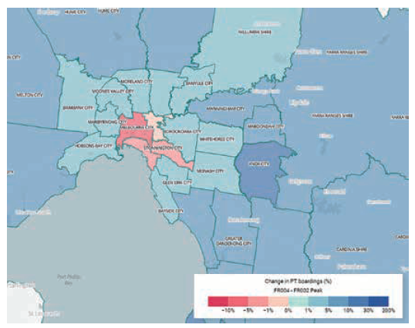

Figure 41 Percentage change (%) in public transport boardings outside peak periods from Current System scenario to Fare Reform scenario

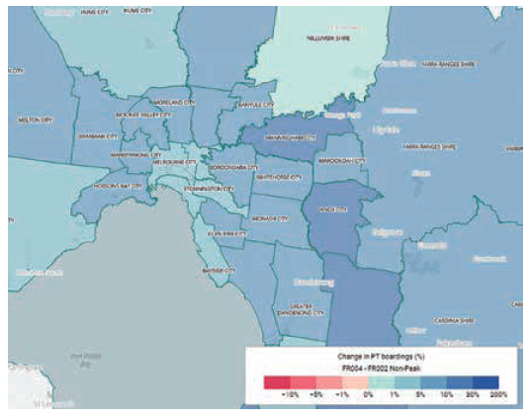
How does demand across the network change with travel patterns?

The Fare Reform scenario demonstrates how Melburnians might shift their travel patterns by changing how they get to their destinations and when they arrive. This section explores the effects of fare reform not on individuals, but on the transport network infrastructure.

One factor to keep in mind during the following section is that within the model, people only make trips that are feasible based on individual time and mode preferences and conditions. This means the model attempts to recreate the experience of travel across the network from the time it takes for a service to reach its destination to the number of people, or capacity, each service provides.

No traveller is assigned to a trip that is infeasible, such as attempting to board a tram already at capacity.

While the model continues to demonstrate an improved transport network as a result of Fare Reform, there may be some modes, routes and times of the day where additional services will be required to accommodate a shift in travel patterns.

Rail

The most distinctive shifts in behaviour across the rail network happen across both temporal and spatial aspects. Peak fares manage demand during the busy periods of the day while the introduction of the City Zone also adjusts traveller demand.

The average number of people who travel by train along each section of track every hour (passenger volumes – average hour) is shown in Figure 42 and reinforces the large magnitude of trips heading into the inner city during the AM peak period. The darker the line colour, the more people who travel along that section of rail during an average hour.

By 2031, under the current system, over 183,000 train trips are expected to be made in the AM peak into the CBD, Docklands and Southbank areas of Melbourne alone.

Therefore, high volumes travelling through the Metro Tunnel, City Loop and around Richmond, South Yarra and North Melbourne stations are expected.

Figure 42 Current System scenario: 2031 train passenger volumes (average hour) during AM peak 7.30am-9.30am
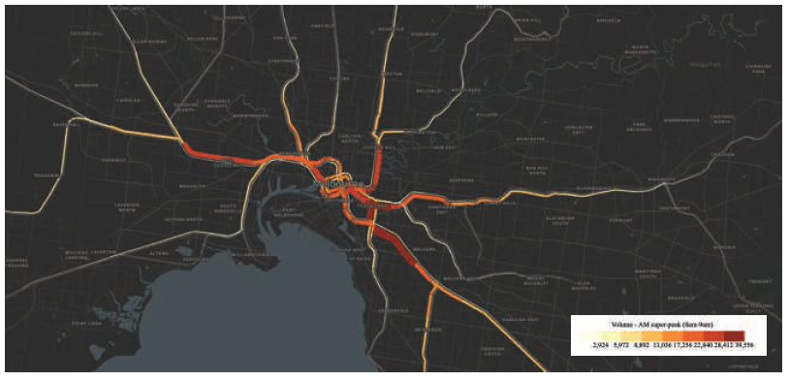

Figure 43 Change in train passenger volumes (average hour) during AM-peak from Current System scenario to Fare Reform scenario
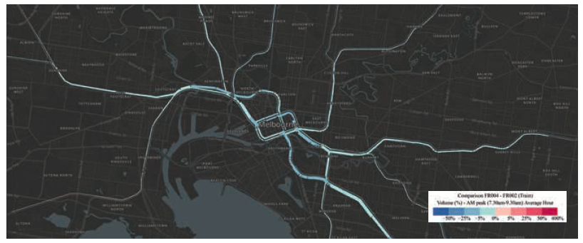

The main intention of peak train fares is to shift travel away from the morning peak (and especially travel into the City Zone) into either peak shoulders or non-peak periods.

Figure 43 and Figure 44 show that as a result of Fare Reform, train volumes successfully shift out of the peak periods with some users shifting into non-peak periods.

Represented by the shades of blue (percentage decrease) in Figure 43 above, train volumes are down across much of the network during the AM peak, with the largest reductions around stations in the City Loop, Metro Tunnel and Richmond Stations. The thicker the line here, the greater the change in number of travellers. Reductions in patronage vary from around 5-7% across these links.

Interestingly, patronage in the outer sections of the metropolitan train network experiences a slight increase, shown by the dotted circles in Figure 44. This is perhaps due to cheaper Zone 2 fares (even during peak periods) and users who may board city-bound trains but alight prior to the busier sections of the network - ultimately benefiting from cheaper daily fares.

Figure 44 Change in train passenger volumes (average hour) during AM peak from Current System scenario to Fare Reform scenario (Greater Melbourne)
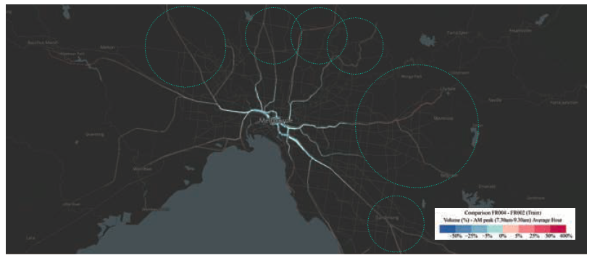

In contrast, Figure 45 shows the change in train volumes during off-peak periods as a result of fare reform. Attracted by significantly cheaper fares ($2.50 with off-peak discount), induced additional patronage occurs across the network and in both inbound and outbound directions. In stark contrast to the 5-7% reductions during the AM peak, some links in the off-peak periods experience increases of over 11%.

The effect of peak fares is to shift train travel away from the morning peak and into non-peak periods.

Figure 45 Change in train passenger volumes (average hour) during off-peak (night) from Current System scenario to Fare Reform scenario
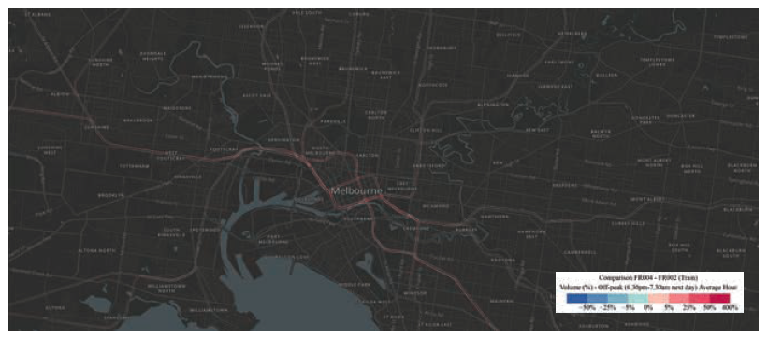

Tram

Tram volumes across the city follow a similar pattern to those across the metropolitan train
network. Volumes increase on city-bound services along most major tram routes as
they approach the Melbourne CBD.
While both peak and off-peak fares for trams are still cheaper with fare reform than under the current system, peak and off-peak pricing still influences people’s travel patterns and decisions made through the course of the day, as shown in Figure 46 and Figure 47.

Comparing the tram volume change from the Current System scenario to Fare Reform scenario for both AM peak and Off peak (day) periods gives further insight into how demand is spread across Melbourne’s tram network. For the AM peak, outer sections of most tram lines experience an increase (red lines) in boardings while some inner city sections experience a decrease (blue lines). Some of this shift is expected to be related to trams being cheaper than trains and therefore attracting trips that have been substituted to tram from train.

Another explanation is that because there is now an additional multimodal fee for boarding a tram after a train, more train commuters are simply walking to their destination instead of crowding out CBD trams. While under the current system the Swanston Street/St Kilda Road corridor is one of the busiest tram corridors, sections of this corridor actually experiences a decrease in patronage of over 20% as a result of fare reform during the morning peak.

This decrease could potentially be related to commuters either shifting mode or shifting their time of travel to the non-peak periods in order to pay a slightly cheaper fare, or again, reduced tram use with train due to the additional multimodal fare. However, it should also be noted that patronage along sections of the Swanston Street/St Kilda Road corridor also
experience increases of over 10%, 80 especially during off-peak periods.

Figure 46 Change in tram passenger volumes (average hour) during AM peak from Current System scenario to Fare Reform scenario
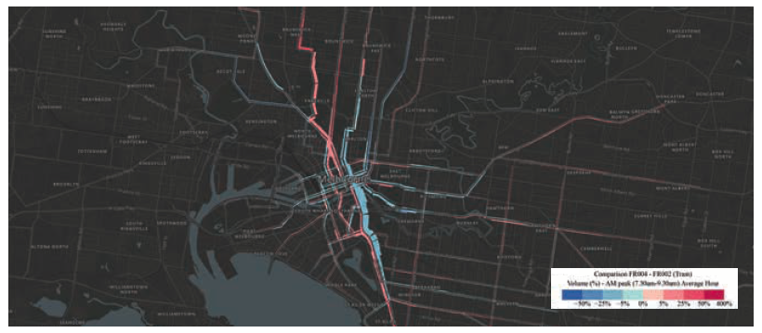

Figure 47 Change in tram passenger volumes (average hour) during Off-peak (day) period from Current System scenario to Fare Reform scenario
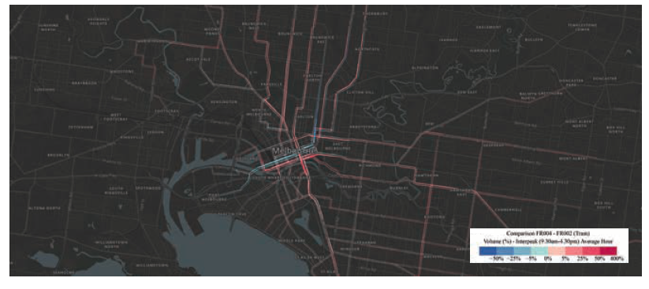

One of the issues that comes with increased boardings, especially during peak periods, is that if trams are already nearing capacity during these periods, crowding can become problematic, leading to services operating at crush capacity - where commuters can no longer get on a service.

Our transport modelling considered the capacity of vehicles, whether train, tram or bus. Ultimately, much of the increased patronage on tram services is catered for by routes and services that are relatively uncongested in the MABM.

Crowding can mean services operate at crush capacity – and commuters can no longer board a service.

Bus

The final mode where fare reform improves pricing is across the normal bus and express bus network. As distinct from the largely radial train and tram networks, the bus network plays a predominately orbital role when patronage volumes are shown on a map (Figure 48). This is with the exception of the high-volume DART services that run along the Eastern Freeway, serving CBD commuters in Doncaster and surrounding suburbs. Another notable service is the 601, a shuttle between Monash University Clayton Campus and the nearby Huntingdale Station, which carries over 2,300 travellers in the AM peak alone.

Figure 48 Current System scenario: 2031 bus passenger volumes (average hour) during AM peak
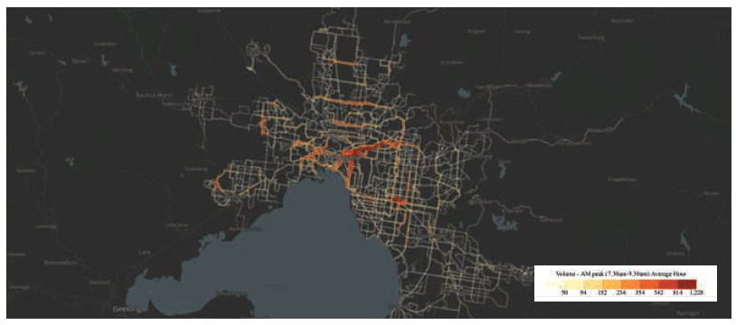

Figure 49 Change in bus passenger volumes (average hour) during a 24 hour period from Current System scenario to Fare Reform scenario

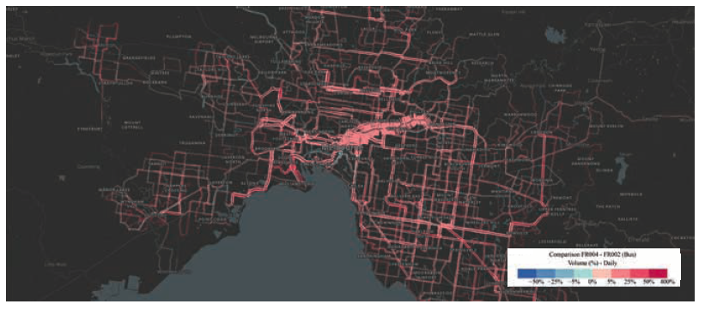
As expected, when both express bus and normal bus fares are made considerably cheaper, patronage across the bus network grows significantly, shown in Figure 49. Such a large increase in use could contribute to localised crowding on some routes.

The relatively low cost of additional buses (compared to trams and trains) means that additional services could be deployed with a service uplift to help alleviate crowding and meet demand along such corridors.

With both express and normal bus fares made considerably cheaper, patronage across the bus network grows significantly.

Roads

As described in earlier sections of this paper, car trips reduce across Greater Melbourne by over 96,000 when comparing the Current System with the Fare Reform scenario. Figure 50 represents this change in road volumes on a spatial level. Busy links that see a decrease in traffic include major arterial roads such as St Georges Road in the north, Dandenong Road and St

Kilda Road in the south east, and inner city links such as Footscray Road and Racecourse Road. There are however certain links that also experience increases in traffic, like the Monash Freeway – whether this relates to re-routed freight, private vehicle changes from fare reform or internal variations within the MABM remains unclear.

This illustrates an important point around the limitations or influence of public transport pricing. While it can influence behaviour on the roads, until there is a direct price for using the roads (as explored in Good Move: Fixing Transport Congestion), there will always be localised adjustments and imbalances across the road network.

Figure 50 Change in number of vehicles on each road link between Current System scenario and Fare Reform scenario – 24 hour period

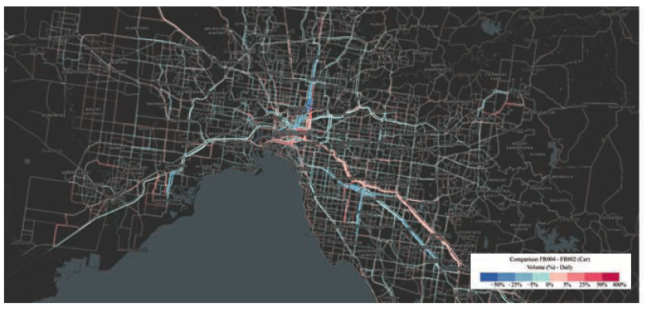
11. Where do we go from here?

This paper outlines the significant benefits that come from public transport fare reform for metropolitan Melbourne. In determining the next steps towards fare reform, it is important to reinforce that fares should be set to achieve desired objectives, recognising that multiple outcomes have to be balanced to get the price right.

This is important when devising improvements to the current fare structure and also in assessing proposed reforms that may achieve one aim but fail to achieve other, equally important aims.

We suggest three fare objectives to benefit all Victorians:

Set fares to make the best use of the public transport network, take equity into account and ensure people are provided with informed travel choices.

The reforms and suggested immediate next steps in this paper support achievement of these objectives.

In moving towards fare reform, the Victorian Government will need to set its own objectives. The recommendations in this paper each stand by themselves, and do not rely on each other in order to be effective. This gives government the flexibility to select and sequence fare reforms from our list of recommendations to support its objectives.

However, there are four obvious reforms that we believe the government could proceed with immediately. Indeed, at a time when Victoria needs to support social distancing on public transport, it is important that they proceed swiftly.

The reforms that can proceed immediately are:

01. Introduce peak and off-peak fares.

02. Adopt fares that differ by mode.

03. Appoint an independent advisory body to monitor, review and advise on transport prices. This advisory body would play an important role in monitoring the effects of COVID-19 on travel and how fare reform should proceed in light of significant change, as discussed on page 27.

04. Abolish the free tram zone to improve safety and access for those who need it most.

These reforms could then be followed over the next two years by a set of reforms to fares and ticketing that, in the first instance, provide stronger incentives for travellers to make better use of the system - such as by encouraging the use of currently underused components of the network. Ticketing reforms, such as removing myki Passes would complement the fare reforms and make them more effective, as well as removing inefficient barriers to the use of the public transport system. The equity of the system could also be improved by developing consistent principles for concessions and reviewing and reforming existing concessions.

Reforms that expand how travellers pay for travel are likely to be more complicated and take longer, although we recommend these reforms should occur within two to five years.
References

BehaviourWorks Australia survey for Infrastructure Victoria (15 June 2020).

Centre for International Economics (CIE) (2020), Estimating the social marginal cost of public transport in Victoria, 24 June 2020.

Independent Pricing and Regulatory Tribunal (IPART) (2015), A new methodology for setting fares: Public transport fares in Sydney and surrounds, Transport – Methodology Paper, September 2015, available from https://www.ipart.nsw.gov.au/ files/sharedassets/website/trimholdingbay/transport_ methodology_paper_-_a_new_methodology_for_setting_ fares_-_september_2015.pdf

Infrastructure Victoria (2016), Victoria's 30-Year infrastructure strategy, available from www.infrastructurevictoria.com.au

Infrastructure Victoria (2016a) The Road Ahead, available from www.infrastructurevictoria.com.au

Infrastructure Victoria (2018), Five Year Focus: Immediate actions to tackle congestion available from, www.infrastructurevictoria.com.au

Infrastructure Victoria (2020), Good Move: Fixing Transport Congestion, available from www.infrastructurevictoria.com.au

Infrastructure Victoria (2020a), Public Transport Fares Technical Report, available from www.infrastructurevictoria.com.au

Infrastructure Victoria (2019), Inquiry into Expanding Melbourne's Free Tram Zone –
Infrastructure Victoria Submission, available from www.infrastructurevictoria.com.au

ITS Australia (2018), Mobility as a Service in Australia: Customer insights and opportunities, available from https://cms. its-australia.com.au/assets/images/ITS-A-MaaS-Report_ WEB.pdf

Jacobs (2020), Estimating the social marginal cost of public transport in Victoria: Transport modelling methodology and assumptions report, available from www.infrastructure.victoria. com.au

Keolis Downer (2020), Inquiry into Expanding Melbourne's Free Tram Zone: Background report from Keolis Downer, submission to the Economy and Infrastructure Inquiry into expanding Melbourne's free tram zone, Parliament of Victoria.

King, Dave and Mark Streeting (2016), Ticket to Ride: Reforming fares and ticketing for sustainable public transport, available from https://www.ttf.org.au/wp-content/uploads/2017/01/TTF-Ticket-to-Ride-Fare-and-ticketing-Paper.pdf

Kunstler, Breanne, Liam Smith and Conor Wynn (2019), Applying a network pricing solution: Can transport network pricing be an acceptable alternative to Victorians and current decision makers?, BehaviourWorks Australia, Monash University. August 2019.

Langdon, Naomi and Russell Degnan (2017), Why can't we just?...The challenges of transforming Melbourne's tram network into a modern, efficient, accessible light rail network, Conference paper at the 2017 Australian Institute of Traffic Planning and Management Conference. Available at https:// www.aitpm.com.au/2017-transport-planning-streampresentations

Le-Klähn, Dien-Trinh, Regine Gerike and C. Michael Hall (2014), `Visitor users vs. non-users of public transport: The case of Munich, Germany', Journal of Destination Marketing & Management, 3(3), 152-161.

NBN Co., 26 May 2020, `Australian COVID-19 Behavioural Change Survey: 8 in 10 experiencing better work/life flexibility', available from https://www.nbnco.com.au/corporateinformation/media-centre/media-statements/behaviouralchange-survey

Ortmann, Andreas and Vinayak Dixit (2017), Nudging towards a more efficient transportation system: A review of non-pricing (behavioural) interventions, available from www.infrastructurevictoria.com.au

SGS Economics and Planning and The Behavioural Insights Team (SGS-BIT) (2020), How people respond to complexity in public transport fares, May 2020.

Streeting, Mark and Douglas Howe (undated), Contactless Payments and Open-Loop Ticketing, available from https:// www.lek.com/sites/default/files/insights/pdf-attachments/LEK_ Mastercard_Contactless_Payments_Mark_Streeting.pdf

Terrill, M., G. Moran and J. Ha (2019), Why it's time for congestion charging, Grattan Institute.

Thompson, Karen and Peter Schofield (2007), `An investigation of the relationship between public transport performance and destination satisfaction', Journal of Transport Geography, 15(2), 136-144.

Travellers Aid (2020), Submission to the Inquiry into Expanding Melbourne's Free Tram Zone.

WSP (2020), Public Transport and COVID: How to transition from response to recovery, available from https://www.wsp. com/en-AU/insights/covid-19-and-public-transport-fromresponse-to-recovery

Yang, Yan, Graham Currie, Alexa Delbosc and Victoria Peel (2016), `The urban public transport experience of Chinese tourists in Melbourne', Proceedings of the Australasian Transport Research Forum, 16-18 November 2016.
This publication may be of assistance to you, but Infrastructure Victoria and its employees do not guarantee that the publication is without flaw of any kind or is wholly appropriate for your particular purposes and therefore disclaims all liability for any error, loss or other consequence that may arise from you relying on any information in this publication. You should seek appropriately qualified advice before making any decisions regarding your particular project.

Printed on 100% recycled paper

September 2020

© Copyright Infrastructure Victoria 2020

Except for any logos, emblems, trademarks, figures and photography, this document is made available under the terms of the Creative Commons Attribution 3.0 Australia licence. It is a condition of this Creative Commons Attribution 3.0 licence that you must give credit to the original author, who is Infrastructure Victoria.

This document is also available at infrastructurevictoria.com.au.

ISBN 978-1-925551-64-8 (pdf/online/MS word)

This is a classic example of how disruptions can lead to behaviour change. See Ortmann and Dixit (2017) for more detail.
See CIE (2020) for discussion of the results and Jacobs (2020) for a description of the modelling.
VISTA 2018 analysis carried out by Infrastructure Victoria
This principle states that those who use (or benefit from) a service should pay the full cost of using that service. Conversely, those who do not benefit should not have to pay.
As measured in analysis performed by CIE and Jacobs for Infrastructure Victoria, which modelled the impacts of a fare change and then valued the impacts of the change using accepted transport impact valuations (CIE, 2020).
How does public transport benefit New Zealanders, The NZ Transport Agency and public transport, 2013 https://www.nzta.govt.nz/assets/ resources/public-transport-information-pack/docs/ public-transport-information-pack.PDF.
This was part of the research for Good Move: Fixing Transport Congestion (Infrastructure Victoria, 2020)
(Kunstler et al, 2019)
https://www.transport.nsw.gov.au/news-andevents/media-releases/new-off-peak-travelsavings-start-today
There is a tension between the preservation of mode fares and the shift towards simpler fares with respect to distance travelled (King and Streeting, 2016).
https://www.infrastructurevictoria.com.au/ wp-content/uploads/2020/03/Inquiry-intoExpanding-Melbourne%E2%80%99s-Free-TramZone.pdf
This is from the 2016 Census as reported by LGA
Melbourne Public Transport Patronage Long Run Series 1945-46 to 2010-11
Department of Transport survey data analysed by Infrastructure Victoria
Quantum Research (2017) PTV Customer Tracker, Quarter One (July to September)
Quantum Research (2017) PTV Customer Tracker, Quarter One (July to September)
Department of Transport Survey, 2019
Seven day myki Pass compared to monthly myki Pass and 365 day myki Pass and Commuter club.
https://www.ptv.vic.gov.au/footer/about-ptv/digital-tools-and-updates/mobile-apps/
https://www.ptv.vic.gov.au/tickets/myki/buy-a-myki-andtop-up/
https://blog.masabi.com/blog/what-is-account-basedticketing
A fare table showing peak and off-peak fares is available under the details of a journey once price is clicked on.
A good example of this is the City of Melbourne's Pedestrian Counting System, providing live, on-demand data from various pedestrian counters around the city. http://www.pedestrian.melbourne.vic.gov.au/#date= 17-07-2020&time=13
The discussion in this section is based on SGS-BIT(2020) unless stated otherwise.
Note that regional fares are not discussed as part of the fare reform proposals in this paper, mostly due to the spatial limitations of the MABM covering minimal areas of regional Victoria. Other limitations of the MABM are discussed in Infrastructure Victoria (2020a).
For strategic planning, major public transport projects incorporated in the modelling include the Metro Tunnel, Melbourne Airport Rail Link, Melton electrification, Wyndham Vale extension and Fishermans Bend Tram Link. Various road projects include North East Link, West Gate Tunnel, Mordialloc Bypass and upgrades to the M80, Monash Freeway and Calder Freeway. The inclusion of these projects is for modelling purposes only and they do not necessarily represent Infrastructure Victoria's recommendations or commitments from the Victorian Government.
Note that active transport also represents a large percentage of all trips (15.2%). This includes walking and cycling trips.
The modelling was carried out by Veitch Lister Consulting. All figures within this section are Infrastructure Victoria analysis derived from modelling results.
It is important to note that the approach taken here is not an implicit criticism of the approach taken in Good Move: Fixing Transport Congestion. Instead it is an adaptation in response to (1) a focus on changes that can be made relatively quickly and easily (2) assuming that road pricing is not in place.
Further technical specifications for the modelling of these fare elements are in Infrastructure Victoria (2020a).
This includes the effect of total fare revenue being slightly lower in the Fare Reform scenario than the Current System scenario, see page 56 for details.
Note that while it doesn't look like many additional trips occur on public transport during the PM peak, there is a material shift between public transport modes during this PM peak, most notably to bus services.
For a detailed description of equivalised total household income (HIED), see: https://www.abs.gov.au/ausstats/abs@.nsf/Lookup/2901.0Chapter31502016
An increase to the fare paid was applied to all users to approximate the case of revenue-neutral fare reform. This gives an indication of who would benefit from revenue-neutral fare reform. However, this does not take into account the change in trips that may be induced by an increase in fares or the different mode and trip types across regions which would affect the results, most likely in a minor way. See Infrastructure Victoria (2020a) for original output.

