Good Move
  - Fixing Transport Congestion
  - March 2020

About us

Infrastructure Victoria is an independent advisory body with three functions:

- preparing a 30-year infrastructure strategy for Victoria, which is refreshed every three to five years
- providing written advice to government on specific infrastructure matters
- publishing original research on infrastructure-related issues.

Infrastructure Victoria also supports the development of sectoral infrastructure plans by government departments and agencies.

The aim of Infrastructure Victoria is to take a long-term, evidence-based view of infrastructure planning and raise the level of community debate about infrastructure provision.

Infrastructure Victoria does not directly oversee or fund infrastructure projects.

Aboriginal acknowledgment

Infrastructure Victoria acknowledges the traditional owners of country in Victoria and pays respect to their elders past and present, as well as elders of other Aboriginal communities. We recognise that the state's infrastructure is built on land that has been managed by Aboriginal people for millennia.

Contents

Executive summary: 5
Transport network pricing by the numbers: 7
Options for Government: 9

01. Introduction: 12
Victoria's transport system under pressure: 12
We need a new approach: 13

02. Three big problems that are getting worse: 16
Problem 1: Longer and more variable travel times due to congestion and crowding: 15
Problem 2: Traditional solutions are not enough: 17
Problem 3: The current system provides few incentives and isn't fair: 18

03. How people pay around the world: 22
Key elements of reforms: 22
Results of the reforms: 24

04. Transport network pricing is the best solution: 27
Five pricing principles: 27
Pricing can manage congestion across the whole network – and other problems: 29
Pricing can provide choices and improve fairness: 31
Pricing conditions can help gain community acceptance: 32

05. How transport network pricing can work in Melbourne: 37
Modelling transport network pricing: 38
Pricing delivers highly positive outcomes for Melbourne: 46
Impacts on fairness can be managed: 57

06. Parking pricing reform: 65
Current pricing is inefficient: 65
A new approach to pricing parking: 66

07. How we'll get there: 68
Reducing congestion is the objective: 69
Transport network pricing reform is a necessary, fair and effective way to achieve this objective: 70
Trials: 71
Delivering benefits from transport network pricing: 71
Delivering benefits through expanding and reforming public transport: 73
Packaging with other reforms and investments: 74

08. What happens next?: 77
Options for Government: 77
Next steps: 79

Appendix – Classifying households by income group
References: 81

Executive summary

Victoria’s transport network is struggling to meet demand, with congested roads and crowded public transport. Our population is projected to grow bigger and faster, so the pressures on our transport system will only get worse.

There needs to be a change to the way Victorians use the transport system if we want to reduce congestion and get the most out of our big infrastructure projects. A change to transport pricing will motivate and incentivise people to make that change. This was one of the top recommendations in Victoria’s 30-year Infrastructure Strategy in 2016 and has been a key focus of our research program over the past four years.

Our research has now evolved considerably with the inputs of enhanced modelling, international case studies and direct access to community opinion.

It is now clear that the community is open to changing their travel behaviour. For the first time, Victorians have identified the conditions under which they would do so. These conditions are practical, fair, easy to implement and give unprecedented opportunity to make a change.

Our work also shows that network-wide change to the pricing of roads, public transport and parking is required to motivate the community to change their behaviour to get the most out of our current transport system, as well as investment in new infrastructure projects.

Transport network pricing means a shift away from traditional thinking. We need
to replace fixed upfront charges (such as registration) and uniform fares with flexible charging according to time of day, mode and location to drive behaviour change.
If we make this change, it can be accepted by the community and provide an effective reduction in congestion.

The community’s views are amplified throughout industry with an increasing chorus of voices calling for change. Community support, economic evidence and the calls for reform from industry show that the time to start changing the way we pay for transport is now.

There are three big problems with our current transport pricing system – problems that can all be addressed if we change the way we pay and change the way we travel. This paper explores the problems, the solution, the community view and options for government on the pathway to change.

The first problem is congestion and overcrowding on public transport mean longer and more variable travel times, resulting in frustration and lost productivity. With transport network pricing, our work shows average speeds in inner Melbourne during the morning peak are around
one third faster.

Secondly, we know that the accepted solution of building new roads and expanding transport services is necessary, but not enough to fix congestion.
To make the most of existing and new assets and services we need a complementary pricing system with inbuilt flexibility around time and mode of travel. This is validated by community sentiment, with one in four people saying they could change the time or mode of travel. What we need to do is incentivise them to make that change.

The third problem is that there is no incentive for people to change their behaviour. If they did change, the whole network would benefit – congestion would be reduced, all modes of transport would be fully utilised and demand would be spread throughout the day not just during the peaks. Currently, pricing doesn’t consider the mode or the distance travelled, meaning many people pay more even though they don’t travel far or often. It’s unfair and doesn’t get the most out of the transport system.

This paper explores an illustrative approach to changing Victorians’ travel behaviour through various pricing scenarios across roads, public transport and parking.
Our approach is not intended to provide a definitive prescription of what pricing changes should be. We expect that further refinements would be made to the pricing model before it is implemented.

What our approach clearly shows is that under all the illustrative scenarios, most Victorians are better off in terms of price and choice and driving conditions also improve.

Governments have invested heavily in our transport system, providing more choices and more services. We need to now complement that with network-wide pricing reform.

In a scenario that includes concessions and additional subsidies to make sure the system is fair, up to 85% of people could pay less for transport.

For those who pay a little more because they continue to drive long distances, their travel time will be faster and more predictable. People can make their own decisions and balance what is most important to them – mode, time, distance or cost.

We've taken an illustrative approach and looked at a number of different options for change. Like the community, we think the best model will include discounts and concessions for the vulnerable and disadvantaged. Even with these concessions and some additional Government subsidies for public transport, these costs are offset by a more efficient and better utilised transport system.

The best approach will start from congestion busting, not revenue raising.

This is what our work shows and international experience validates.

Cities such as Stockholm, London, Milan and Singapore have all introduced transport network pricing with sustainable results – reduced congestion, improved average car speeds and decreasing emissions.

We know long-term sustainable change is not easy, so we've identified a number of options for the Victorian Government to consider starting.
Some can be done right now – such as reviewing and trialling variations in public transport fares across all modes of transport.

We also support the introduction of distance-based pricing for electric vehicles, with the proviso that the significant health and environmental benefits of electric vehicles are considered as part of any reform.

Parking is also a significant consideration. We believe there is merit in supporting the proposed local trial of demand-based charging in the CBD. Trials of demand-based charging could also be conducted at some new and existing car parks at railway stations and park-and-ride hubs.

Government could also increase and extend the parking levy to include Windsor, South Yarra, Richmond and Prahran. It could conduct a full-scale trial of cordon charging in inner Melbourne and other congestion hot spots.

Other options are explored further in this paper.

We think that planning for change should begin now in order to reap the benefits of changed behaviour and avoid unnecessary costs. Planning for change also gives people greater certainty, so they can make choices about where they live and what are the most efficient and cost-effective ways to travel around our city.

Ultimately we need to make the most of what we have. Governments have invested heavily in our transport system, providing more choices and more services. We need to now complement that with network-wide transport pricing reform because it is necessary, effective and fair and motivates a willing community to change the way they travel.

Transport network pricing by the numbers

What happens if we keep doing the same thing?

If we don't change, things will get worse:

3.5 million extra trips

Congestion will increase, with an extra 3.5 million trips being made every day across the city's roads and public transport networks by 2030.

Time & money

Congestion and travel time variability on key freight routes around Melbourne will make it more expensive for businesses to move goods to customers, suppliers and export gateways. By 2046, around one third of all freight transport in Victoria is expected to occur in congested conditions.

878k extra trips each day

Train, tram and bus trips will grow by 76%, which means 878,000 extra public transport trips each day. Despite this, Melbourne will still be a car-dominated city. More than 70% of trips in 2030 will be by car.

30 mins

The proportion of Melburnians living within 30 minutes of their place of work will continue to decline, as increasing congestion makes it harder to access jobs and services across the city and increases travel time variability.

$10.2 billion in time, operating costs and pollution

The cost of congestion, including time, operating costs and extra pollution, will escalate to $10.2 billion in 2030 – up from $4.6 billion in 2015. On average, congestion is expected to cost Melburnians an extra $1,700 per year by 2030.

In some city areas, amenity and livability will decline due to congestion on arterial roads or truck traffic through local streets, making these areas less attractive to live or invest in.

Sources: Infrastructure Victoria (2016, 2018)

What happens if we make a change?

Under transport network pricing with discounts:

Up to 85% of people pay less

Up to 85% of Victorians better off – most Victorians will be paying less than they do today for transport

Majority of users will experience lower costs

While some travellers who travel long distance from Outer Melbourne might pay more, they are from the high-income bracket – the majority of middle- and low-income experience cheaper transport costs

Removing 168,000 trips a day

Up to 168,000 car trips taken off Victorian roads every day – reducing pressure on the road network

40%+

Over 40% of the original drivers stop driving into the inner cordon – shifting to public transport

Almost 110,000 new bus boardings

Almost 110,000 people shift to buses – influenced by the fact that buses are now the cheapest form of public transport

Up to 25% speed increase

Up to 25% speed increase – within the inner Melbourne cordon

8% reduction of time in peak congestion

Around 8% reduction of time Victorians spend in congestion in our busiest peak periods

Options for Government

Infrastructure Victoria has identified a range of options for the Victorian Government to consider ahead of network-wide transport pricing reform. These options allow Government to test, validate and refine new ways to pay for transport to ensure it is efficient and fair, addresses congestion, helps manage demand and gets the most out of our transport system.

Public Transport

01.
Commence randomised control trials of changes to public transport fares
- Specify public transport fares that vary by time, location and mode.
- Sample of treatment and control groups of travellers selected and treatment group travel according to new fares.
- Sample includes variety of income groups including low income and vulnerable Victorians.
02.
Introduce variable pricing for all public transport trips
- Fares draw on results of randomised control trials.
- Public transport fares that vary by time, location and mode applied to all public transport.
- Fares designed to encourage efficient use of the network while meeting equity objectives.

Roads

03.
Conduct a randomised control trial of a large sample of motorists including different types of road pricing options targeting congestion across Melbourne
- Specify a set of road pricing options that operate differently across Melbourne.
- Sample of treatment and control groups of drivers selected with the treatment group driving based on the new prices.
- Sample includes variety of income groups including low income and vulnerable Victorians.
04.
Apply demand managing tolls to all new freeways, bridges and tunnels
- Tolls applied to new freeways, bridges and tunnels that manage demand.
- Tolls set to achieve a congestion target and periodically/regularly revised to achieve and maintain the target congestion rate.

05.
Introduce distance-based road user charge for electric vehicles
- Distance based charge, in comparison with fuel excise, should recognise health and environmental benefits from electric vehicles.
- Registration and stamp duty costs should be reduced or removed to support efficient use and adoption of electric vehicles.

06.
Conduct a full-scale trial of cordon charging in inner Melbourne and other congestion hot spots
- Trial would reflect learnings from trial and implementation on new major road infrastructure (options 3 and 4).

07.
Price the use of all roads in the Melbourne Metropolitan area
- Extension of road pricing with a main aim to reduce congestion applied across all roads.

Parking

08.
Expand and increase the existing car parking congestion levy
- Expansion of Category 2 levy area to include Prahran, Richmond, South Yarra and Windsor.
- Revenue sharing arrangements with each local council covered by the levy.
- Regular review and revision of levy dependent upon level of congestion.

09.
Trial dynamic pricing of selected areas of on-street and off-street council parking
- Dynamic pricing features prices that vary by time and across the sample locations aiming for a certain number of spots in the sample areas to remain vacant at all times.
- Time restrictions relaxed on parking spots in the sample area.
- Prices regularly reviewed and revised to achieve and maintain the targeted vacancy rates.

10.
Trial dynamic pricing for a selection of new and existing carparks at railway stations and park and rides
- Dynamic pricing of parking spots, as described in option 9 applied to a sample of new and existing carparks at railway stations and park and rides – the sample should first include carparks at stations that already have good public transport connections to them (or additional station connections) like buses and/or on-demand services.

11.
Apply dynamic pricing to all on-street and council controlled parking with prices set to target a certain number of places remaining vacant at all time.
- Dynamic pricing as described in option 9 applied to all council controlled parking spots.

12.
Apply dynamic pricing to all parking at all railway station and park and ride carparks
- Dynamic pricing as described in option 9 applied to parking at all railway stations and park-and-ride facilities.

01. Introduction

Victoria's transport system is struggling to meet demand and with a growing population, this is expected to worsen in future.

- Travel is taking Victorians longer. Congestion on the roads and crowding of public transport means longer, less comfortable journeys with increasingly unpredictable travel times. This is expected to cost the state $10.2 billion by 2031.
- The traditional solution is to build new infrastructure and expand public transport services, but this alone is not enough to ease congestion. To get the most out of our assets, both existing and new, we need a complementary pricing system and a change in people's behaviour.
- We need a new approach. Our research shows that comprehensive reform to how we pay for roads, public transport and parking is the single most effective way of reducing congestion and getting the most out of our transport system.
- As congestion increases in Australia's growing cities, there are many in industry joining us in a call for change.
- We have outlined a range of options for government to implement over the short, medium and longer term to make sure we get the most out of our transport system and government investment in expanded services and new build projects.

Across Victoria, transport services and infrastructure are struggling to keep up with rising demand. As the state's population continues to grow, we need a new approach to ease the pressure on our roads and public transport services. We need to provide an efficient, well-managed transport network that allows people and goods to move around easily.

Victoria's transport system under pressure

Travel is taking longer, with more variable travel times. On public transport, peak travel is more crowded for longer, making travel less comfortable. This reduces the productivity of the economy and amenity for those near transport networks.

Vulnerable Victorians who are less able to travel in crowded conditions, or people who need reliable travel (for example, those with caring commitments), have less access to jobs and amenities.

Investment in transport infrastructure has proven to not be enough to address these problems.

While roads and public transport in inner Melbourne are overused, other parts of the network (such as regional and outer-suburban buses) are underused. In some places, key roads are used for free or cheap parking instead of higher value uses such as bus, tram and bicycle lanes, or wider footpaths. These are all symptoms of Victoria's underperforming transport network and some of them will only get worse as Victoria's population increases.

These problems are well known, but the tools and investments used so far are not enough to fix them.

We need a new approach

Infrastructure Victoria has examined these problems in previous papers and reports. We've identified actions to tackle congestion in the short term, including overhauling the bus network, introducing off-peak fares and expanding and increasing Melbourne's car parking levy.

Transport network pricing was one of the top three recommendations in Victoria's 30-year infrastructure strategy, published in December 2016. A change to transport pricing will motivate and incentivise people to change they way they use transport.

Our research consistently shows that comprehensive transport network pricing is the most effective solution to reducing congestion in Victoria. Changing the way we pay for transport can reduce congestion and crowding, help us get the most out of our road and public transport networks, and make sure transport investments deliver the greatest benefits to Victorians.

International experience shows that introducing transport network pricing is challenging but possible. Decisions have to be made about what types of journeys will cost money, how much to charge and how to set up and maintain a system that is both efficient and fair. We need community support or at least public acceptance for this system.

This probably means reducing or removing existing charges as we introduce new ones. We need to address privacy concerns and choose the right technology. We also need to set up the right market and governance structures and a smooth way to transition from our existing system to network pricing.

We've made transport network pricing a core focus of our research. We want to design a system that's suitable for Victoria, that's effective, efficient, fair and sustainable, and that can attract community support.

What is transport network pricing?

Transport network pricing is a system where prices are set to influence how, when and where people use the transport system.

While user charges already exist on some parts of Victoria's transport network (for example, fares are charged to use the public transport system and tolls apply on some roads) these give people and businesses few incentives to make more efficient choices about transport mode or the time or location of travel.

Currently, there are almost no incentives for public transport users or drivers to reschedule their trips away from peak periods where possible.

Under transport network pricing, prices can be set to encourage people to travel at times, to places and by modes that provide the greatest benefits relative to the costs. Prices can also be set to reflect externalities, such as the costs of air pollution and road trauma.

Importantly, transport network pricing can also incorporate measures to ensure fairness.

Many voices are calling for transport pricing reform

As congestion increases in Australia's rapidly growing major cities, more groups are calling for congestion charges and greater use of transport network pricing.

Grattan Institute -- 2019

Citing international evidence that `congestion charging works', Terrill et al. (2019a) recommends a cordon charge around the Sydney and Melbourne CBDs, which could mean up to 40% fewer cars entering the CBD in the morning peak periods and improvements in car travel speeds across the citywide road network. This will be more efficient and effective than continuing to rely on a massive infrastructure building program that costs millions of dollars.

City of Melbourne -- 2019

The City of Melbourne is calling for efficient, equitable transport pricing (City of Melbourne, 2019). Priority outcomes sought in the council's Transport Strategy 2030 include advocating for a road user pricing system and supporting effective public transport pricing to manage demand.

Infrastructure Partnerships Australia (IPA) -- 2019

IPA has called for distance-based road user charging for electric vehicles ahead of a potential decline in revenue from the fuel excise (Infrastructure Partnerships Australia, 2019).

Productivity Commission -- 2017

Continuing to push for road pricing reform in its Five-Year Productivity Review, the Commission restated its call for broader road pricing along with the phasing out of current road-related fees and charges (Productivity Commission, 2017).

Infrastructure Australia -- 2016

Infrastructure Australia called for a public inquiry into road user charging in its Australian Infrastructure Plan (Infrastructure Australia, 2016).

What does transport network pricing offer Victoria?

Infrastructure Victoria's research and analysis – and our review of transport pricing around the world – shows that a well-designed transport network pricing scheme can:

- Reduce congestion and crowding as travellers who can make low value trips are encouraged to shift to other modes or times of travel to save money, freeing up the system during peak periods.
- Get the most benefits from the transport infrastructure currently being built.
- Postpone the need for expensive and disruptive large-scale infrastructure projects as we make better use of the infrastructure we already have.
- Make it more likely that our major transport investments are the most efficient choices.
- If combined with governance reform, provide a funding source to improve the financial sustainability of the existing network, reducing pressure on general revenue.

To summarise, transport network pricing helps us make better use of our transport network – which enables us to spend our time and money on better things than being in transit.

02. Three big problems that are getting worse

We see three major problems with Victoria's transport system.

- The first problem is congestion and crowding, with Victorians experiencing significant congestion on roads, trains and trams. This means trips take longer, are less comfortable and less reliable, which costs people and businesses time and money.
- The second problem is that the accepted solution of building new infrastructure to ease congestion won't solve congestion unless we take other steps. To make the most of existing and new assets and services we need a complementary pricing system with inbuilt flexibility around time and mode of travel.
- The third problem is that there are no incentives in the current system for people to change their behaviour. Our current pricing system is simple enough, but it doesn't encourage people to make different choices about the time, route, mode or quality of their trip. This means that even as congestion worsens, people are not motivated to change their behaviour.

Our road and public transport network has three major problems that are likely to get worse as Victoria and Melbourne continue to grow rapidly.

Problem 1: Longer and more variable travel times due to congestion and crowding

As more and more people and goods move around the city, we're seeing more congested roads along with more crowded trains and trams. This congestion means travel takes longer, is uncomfortable and unreliable, and costs businesses and the community money. It also means that small shocks, such as a freeway crash or cancelled train, quickly affect thousands of travellers throughout Melbourne.

Infrastructure Victoria's 2016 report The Road Ahead documented congestion in Melbourne then and in the thirty years to come. Cars in 2016 were crawling through morning peak hour traffic at an average speed of 38kph. With most major arterial roads in metropolitan Melbourne operating at close to or above optimal capacity, over 30% of all car trips included travel through congestion.

Congestion is likely worse by now, with continued population growth. We have projected that by 2046 conditions would deteriorate even further, with more than 50% of car trips in the morning peak including travel through congestion. The city's western suburbs would be as congested as inner Melbourne is today, and the northern suburbs would be even worse.

Infrastructure Victoria's 2018 report Five-Year Focus provided more details of the problems we can expect even by 2030. For example, in the outer areas of Melbourne, the peak would effectively expand by about five hours a day.

We also demonstrated how road congestion affected buses and trams. Across the city, bus services in 2016 were becoming less reliable and fewer services were running on time. Average tram speeds, especially during peak periods, were declining.

Public transport was also projected to get more crowded by 2046, with more than 30% of public transport trips being undertaken in crowded conditions. Poor public transport performance can mean that more people choose to travel by car, which, in turn, creates even more congestion.

Because on-street parking in Melbourne is generally cheaper than off-street parking, drivers cruising for cheaper parking spaces also make congestion worse. Compared to other countries, Australia's on-road car parking spaces also take up a significant amount of road space (Terrill et al, 2019a).

Overall, using large amounts of Melbourne's street space for parking adds significantly to congestion while only benefiting a relatively small number of people (City of Melbourne, 2019).

As the city's population grows, failing to tackle congestion and crowding means that – even with a number of planned major road and rail projects – most Melburnians can expect to spend more time sitting in traffic, travelling on crowded trains and trams, and waiting longer for buses.

Compared to other countries, Australia's on-road car parking spaces also take up a significant amount of road space

Problem 2: Traditional solutions are not enough

One option to support a growing population is building more transport infrastructure. This has been the solution traditionally taken by government and supported by Victorians.

The right additional and upgraded transport infrastructure is needed to support the efficient transport of people and freight around Victoria. This is especially the case given Victoria's population is likely to grow substantially over the next 30 years.

However, economic theory and evidence reported in Duranton and Turner (2011) confirm that expanding roads and public transport (especially roads) only relieves congestion temporarily. This is because providing more transport capacity attracts extra demand (known as `induced demand'). While the extra capacity improves travel times at first, eventually travel times increase as more people use the new infrastructure and congestion increases again.

This has been the experience in Melbourne, where each new major road has eventually become regularly congested during peak times. Road projects are mostly justified on the congestion benefits lasting a certain amount of time as well as providing other efficiency benefits. But in many instances in Victoria those efficiency benefits have not been fully realised because the new or upgraded roads have become too congested at peak times too quickly.

When the population of Victoria, and especially Melbourne, continues to grow into the future we will not get the most out of new infrastructure unless it is combined with transport network pricing and behaviour change.

Getting the most out of new infrastructure requires effective transport network pricing

Building more roads causes more traffic

Extensive research has found that traffic expands with road capacity. However, a question remains as to which way the causality runs. Are roads built to match demand or does demand expand to meet supply?

Duranton and Turner (2011) apply sophisticated econometric methods to data to generate causal estimates of the effects of road construction on traffic. They find that for urbanised areas within the US, expanding the interstate highway system leads to proportional expansions in road traffic.

The expansion results from new traffic, not that diverted from local roads. The results for major urban roads show a lower correlation. These are just correlations though.

Duranton and Turner also estimate the causal impact of expanding public transportation (buses). They find that expanding public transport (buses) does not have any effect on traffic volumes, consistent with traffic expanding in a similar way to that following road expansion. It isn't possible to build your way out of traffic congestion.

Research shows that for urbanised areas within the US, expanding the interstate highway system leads to proportional expansions in road traffic. (Duranton, Gilles and Matthew A. Turner (2011) "The fundamental law of road congestion: Evidence from US Cities", American Economic Review, 101(6), 2616-2652)

Problem 3: The current system provides few incentives and isn't fair

Today's transport prices provide very limited incentives for Victorians to make efficient choices. They only offer a `one size fits all' model.

This isn't the case when Victorians travel in other ways. We're used to making choices about travel – airfares, hotel rooms, Airbnb, Uber – that involve balancing quality, convenience and price. The outcome not only more closely matches consumer demand, but also achieves a more efficient outcome.

The current system of transport pricing tends to be cheap rather than fair. Victorians are used to vulnerable people and families receiving discounts on utilities like energy and water. Current prices on roads don't offer this. Some road user charges are applied to all road users irrespective of their status and of when, how often or how far they drive.
More specifically, user charges for metropolitan public transport via myki tickets are only for access, with no change in fare for distance travelled or mode used. Fares are flat rates for two hours or a day across two zones with almost no variation by time of day. Travel wholly within Zone 2 is cheaper. There are also myki Passes which provide cheaper daily fares when bought for multiple consecutive days (up to a year).

Regional public transport fares are more complex. While there are distance-based, time-of-day fares for V/Line services, there are no common principles for how these fares are set. This results in inconsistencies, such as people in different places paying very different fares to travel the same distance.

While there are concession fares for low income and vulnerable Victorians, this simplistic fare structure means people making short trips on less expensive modes are cross-subsidising other travellers – there is limited application of the `beneficiary pays' approach.

hypothecated to investment in roads, so it is essentially a road user charge – similar to the GST on fuel but less transparent. It is also becoming less universal as a de facto road user charge.

The number of electric and hybrid vehicles on the roads is increasing and expected to become a larger share of the fleet every year. There is no allowance, in the fuel excise, for ability to pay, unlike charges for energy and water utilities. The fuel excise is also becoming less fair as electric vehicles and, to some extent, more fuel efficient vehicles are mainly purchased by Victorians with high incomes.

The Victorian Government sets or regulates a number of payments for travel in private vehicles. Most of these payments aren't explicitly linked with using a service – they are effectively taxes (stamp duty) or tax-like fees (registration and licence fees, compulsory TAC charges). While there are concession rates in some cases, again, there is limited application of the `beneficiary pays' approach. And sometimes the fairest thing to do is for those who don't benefit not to have to pay for those who do.

The Commonwealth Government levies a fuel excise at 41.8 cents for every litre of fuel, charged as part of the price of petrol. This tax varies with road use, albeit based on the vehicle's fuel efficiency. Revenue raised by the fuel excise is not

Car parking availability and prices are important to people's travel decisions. Currently, most local government-provided on-street parking is free, although a significant proportion of parking spaces have time restrictions (with fines for breaching them). There is some priced parking in high demand areas. Parking spaces at public transport stations (trains and park-and-rides on high capacity bus routes) are free and in high demand.

So, again, travellers have limited choices to trade off price for convenience, or even availability. Much parking is allocated on the first come, first served basis. Making a product that is in high demand cheap doesn't guarantee that it will go, in a fair way, to low income and vulnerable Victorians.

Travellers have limited choices to trade off price for convenience, or even availability.

What's wrong with how we pay for transport now?

There are several problems with the way we currently pay for transport:

- Metropolitan public transport fares provide very little opportunity to trade price for mode quality/trip time/route as fares are largely identical across mode/time/route, even though there are significant differences in cost and demand.
- Some regional public transport charges are inconsistent for different types of travel and users.
- There are few incentives for people to change their travel behaviour to reduce congestion. Some charges are not clear to people when they use the infrastructure.
- The wide availability of free and cheap parking, irrespective of the cost of providing it, is an incentive for people to drive, rather than use public transport.
- The fuel excise makes no allowance for people's ability to pay. This will become increasingly unfair as more people start driving high price electric or fuel efficient vehicles.
- Road charges, like registration, stamp duty and TAC, are fixed rather than linked to how much transport infrastructure people actually use or how far they travel. Arguably infrequent users pay too much and frequent users not enough.

`Cheap' doesn't equal `fair'

Making things cheap for everyone doesn't necessarily benefit vulnerable people if the transport system is crowded.

Unless a product is supplied to meet the demand at zero price, access to that product will be rationed in some way. The question is whether the way the zero priced product is rationed is fairer than that resulting from being charged for it. Charging means the beneficiary of the product pays and the result is, at least, economically efficient.

When it comes to transport, we can't ensure equity through low or zero priced fares. First, unless supply is expanded to meet the demand at low or zero prices then access to the infrastructure will have to be rationed another way. Congestion and crowding on our transport networks suggests we are not close to meeting peak demand.

If the way we currently ration access favours low income/vulnerable Victorians, then this can help to create a fair outcome.

For example, if congestion makes travel times longer and lower income/vulnerable Victorians have a relatively lower value of time, they will make greater use of transport than if we use prices to ration access.

But whether this happens can vary depending on time, location and transport mode. For example, if congestion makes travel more physically demanding, this may mean vulnerable Victorians travel less than they would if there is pricing. Similarly, if parking is allocated on a first come, first served basis, train station parking may be more likely to be taken by workers without dependent children than those with children who don't or can't leave home as early.

These examples suggest that keeping prices low for all Victorians doesn't automatically result in a fair outcome: first come, first served isn't necessarily fair when it comes to transport.

Public transport pricing reform

The last major reform to public transport pricing in Melbourne occurred over about a decade between the 1970s and 1980s.

Before the late 1970s, Melbourne train fares included peak and off-peak fares and were set according to a detailed schedule based on distance. Tram fares also varied with distance. This shows that Melburnians have successfully used sophisticated public transport pricing before.

In under ten years this was all replaced with the much simpler Metro card system, which evolved into today's zonal system. The new system had the advantage of covering multi-modal travel but removed many incentives to make better use of the system – incentives widely used around the world as shown on page 25.

So why did these changes take place? Annual reports for the Victorian Railways Board and Melbourne and Metropolitan Tramways Board (MMTB) suggest they were in part a response to declining patronage and a way to support the introduction of ticket machines.
But the decline in patronage doesn't necessarily mean that the system had become too complex or that Melburnians had become unable to cope with the pricing structure. It's more likely the decline in demand for public transport was linked with the rise of cheap cars, the building of major highways and limited investment in public transport in the rapidly growing suburbs. The MMTB reports even include television as a culprit!

Whatever the primary reason, responding solely with simpler public transport pricing was unlikely to be the most efficient and effective approach.

Are there still good reasons to have a very simple ticketing system? With electronic tickets replacing physical tickets, the incentive to save money on printing physical tickets has disappeared.

Electronic tickets also enable different prices across modes (as well as by distance and time) in a flexible way not possible with the paper tickets of the early 1980s.

The next version of myki can escape the constraints associated with paper tickets. We need further research to see the effects on demand, by mode and time of day, of introducing a more sophisticated ticketing system. `Mobility as a service' apps, such as RACV's Arevo product for Melbourne, can make travel decisions much easier if the pricing system is more sophisticated.

Introducing road pricing along with more sophisticated public transport prices will encourage the most efficient use of all modes of transport throughout the day. It could also facilitate travellers making a more substantial and sustainable contribution to funding public transport.

Introducing road pricing, along with more sophisticated public transport pricing, will encourage the most efficient use of modes of transport throughout the day.

03. How people pay around the world

International case studies show that changes to transport pricing have delivered sustained results in reducing congestion in cities like Stockholm, London, Milan and Singapore.

- These cities have enjoyed reduced congestion, improved average car speeds and decreasing emissions.
- These examples show that successful reform of transport pricing requires greater investment in public transport services, giving people a genuine choice in their mode of travel.

Transport pricing reforms have been successfully implemented in major global cities like Stockholm, Milan, London and Singapore. How other cities have proceeded with this reform gives some guidance about how transport network pricing could be designed and implemented in Victoria.

We summarise these reforms in Table 1.

Key elements of reforms

For road pricing and parking prices, all of the reforms that have been adopted at scale are location-based (London, Melbourne, Milan, San Francisco, Singapore and Stockholm).

In each of these places, congestion was a major issue. But not all the proposed location-based pricing reforms have been implemented. For example, cordon schemes in Edinburgh and Manchester were rejected in referendums.

A second design feature of road pricing reforms is that either a cordon was placed around the congested areas or – as in London – area charging was used. People were charged for entering the cordon during peak times but not during the off-peak. In London and Stockholm, there were some exemptions. On the I-95 Highway in Florida, congestion pricing is applied to some of the lanes, called `HOT' lanes.

A third feature, seen in London and Stockholm, is that additional public transport was provided to accompany the introduction of pricing, even though in both of these cities the relevant areas already enjoyed relatively good public transport.

Only two non-location specific road pricing schemes have been proposed and neither fully implemented. In Oregon, state-wide distance-based charging was introduced as a pilot but has not yet progressed substantially. Nationwide road pricing in the Netherlands was proposed but dropped before it could be implemented after a change of government (D'Artagnan Consulting, 2018).

Table 1: Selected transport pricing reforms around the world

Scheme | Main features
Road usage charges implemented
Singapore Electronic Road Pricing | Major roads tolled to achieve congestion targets  Tolls regularly revised to match outcomes to targets
London Congestion Charge | Area charge for central London  Applies weekdays during the day (a single charge)
Stockholm Congestion Tax | Cordon charge for central Stockholm  Applies during the day (different charges at different times)
Milan Area C Charge | Cordon charge for central Milan  Single charge upon entry during the day
OReGO (Oregon) | Pilot of whole-of-network distance-based charging
I-95 HOT Lanes (Florida) | Some lanes of the I-95 highway feature dynamic pricing set to manage congestion based on speeds and density
Road usage charge proposals not (yet) implemented
Edinburgh | Cordon scheme – not implemented after rejected in referendum
Manchester | Cordon scheme – not implemented after rejected in referendum
Netherlands | Nationwide pricing dropped after change of government
New York City | Cordon charge for lower Manhattan – still to be introduced
Hong Kong | Cordon scheme for Hong Kong island – still to be introduced
Parking charges
Melbourne Congestion Levy | Parking levy in central Melbourne
SFpark (San Francisco) | Demand-responsive pricing of on-street parking
Perth station parking | Priced parking at railway stations

Results of the reforms

The evidence is clear – congestion charging on roads reduces congestion.

Introducing road user charges in London, Milan and Stockholm has been effective. Despite large population growth in London, congestion had not worsened ten years after the reforms. In central Milan, the first year of the new scheme's operation saw traffic decrease by 30% and average speeds increase by about 12%. In Stockholm, traffic inside the cordon decreased by about 20% and this has been sustained. As a result of implementing the HOT lanes, the Florida Department of Transport has measured an increase of travel speeds by 200% on the free lanes and up to 300% on the express lanes.

Parking charges have also had an effect. In San Francisco, progress was made over time towards achieving occupancy targets and reducing cruising for parking. The supply of long-term parking places fell following the introduction of the Melbourne Congestion Levy by 2.7% despite growth in employment and office space in the CBD (Victorian Department of Treasury, 2010). Analysis by Infrastructure Victoria (2018) of outcomes after levy increases and an expansion of the levy zone showed more reductions in long-term parking spaces, which meant about 3,900 fewer vehicles in the morning peak. We would need two freeway lanes to accommodate 3,900 extra vehicles at a likely cost of over $1 billion.

Because there hasn't been an at-scale introduction of more comprehensive road charging, the only evidence on its effects comes from pilots conducted in Oregon and Melbourne. In Oregon, distance charges reduced the amount of driving, including during peak periods. The Oregon pilot included some peak charging in Portland (the largest city in Oregon), which also reduced driving in peak times.

Though it wasn't an official trial, Transurban's Road Usage Study of Melbourne, as described on page 26, trialled a mixture of location-specific and general charges on a sample of drivers in Melbourne (Transurban, 2016). The report on this study and further independent analysis by Martin and Thornton (2017) revealed some promising results relating to the social acceptance of road pricing and the impacts of different types of road pricing, including on low income Victorians.

How have these different road user charging schemes changed over time? In most cases, there haven't been many changes. Stockholm and London have made only a few changes to the charges with prices set for considerable periods. Two notable exceptions are Singapore and San Francisco. Charges in these cities are reviewed regularly and adjusted to meet average speed/occupancy targets (Pierce and Shoup, 2013). In San Francisco, while prices could be varied to attempt to achieve parking occupancy targets, minimum and maximum price caps were also set (SFMTA, 2014).

The areas covered by the charges have also tended to remain the same. Milan and Stockholm have not made any significant changes to the areas covered by the cordon. London extended the cordon area to the west, but this was abandoned following the election of Boris Johnston as mayor in 2008.

Parking reforms in San Francisco and Melbourne are probably the most successful in terms of being expanded. In 2018, San Francisco's SFpark system was expanded from a pilot of demandresponsive pricing to operate at full scale, while Melbourne significantly expanded the area covered by its congestion levy in 2015. Singapore has refined its road pricing system and is planning to replace a gantry system with a GPS-based system in the near future.

A recent example of parking pricing reform comes from Perth. In 2014, Perth introduced a weekday flat fee of $2 to park at train stations. People who park at the station can pay using a `SmartParker' card and must validate their card on the bus or train from the station on the same day to avoid a penalty. This helps stop non-commuters parking at the train station (before the charge, many station carparks were full by 7:30 am on weekdays).

Public transport pricing around the world

Many examples of public transport pricing around the world are more sophisticated than what we have in Melbourne, yet remain logical and simple to use. Although each public transport fare structure is unique to the city it operates in, it's good practice to consider elements of public transport fare structures from both interstate and around the world.

Take Sydney, for example. The Opal card (Sydney's equivalent to myki) charges fares based on distance, time and mode. The greater the distance travelled, the higher the fare. Metro/train and ferries are more expensive while buses and light rail are slightly cheaper. Travel on metro/ train services outside of peak times is also rewarded with a 30% discount. The independent regulator, IPART, sets maximum fare increases across metropolitan and regional transport.

Like Sydney, Tokyo metro fares depend on the distance travelled. Most local trains charge a basic fare, as do some express services.

However, when travelling on Limited Express services (stopping at only major stations) and Shinkansen (bullet train) services, higher fees are charged for the premium service and the reduced journey time.
The London Underground follows a similar principle to charging based on distance, charging by the number of zones travelled. Travel on the Underground between certain zones is also cheaper during offpeak periods.

For an international fare structure similar to Melbourne's, we can look to Los Angeles. Typical fares are sold as either a one-way two-hour unlimited transfer pass or day passes (1,7 or 30 days) to use across all Metro rail and bus services – similar to myki Money and myki Pass. Premium services like express bus lines do cost more.

The Los Angeles model has also recently integrated bike share into the system, allowing the Metro card to be used to access the docked bike share system.

At its current size and density, Melbourne remains unique with its largely fixed fares. As explored in this paper, this is not always for the benefit of all Victorians.

Trials across Melbourne – the Melbourne Road Usage Study (MRUS)

In 2016 Transurban released a study of usage-based road charging, capturing the responses of 1,635 private light vehicle motorists from across Greater Melbourne (Transurban, 2016).

The study looked at five different user-pays charging systems. These ranged from charging per trip, charging per kilometre and a flat fee. Systems focused on congestion included a cordon charge and a time of day charge – some of the most commonly used charges around the world. These different systems weren't just trialled on Transurban's toll roads, but across the whole Victorian road network.

One of the biggest outcomes of the study was the preference of participants before and after experiencing road-user charges. Before the study, 85% of participants were comfortable with the current road funding system in Australia.

After experiencing one of the alternative options for paying, 60% said they preferred shifting to a user-pays system. The issue of privacy and information security was also largely overcome, with participants' openness to trialling new technology resulting in 84% becoming comfortable with the GPS technology used.

An independent analysis of the MRUS data at the University of Melbourne by Martin and Thornton uncovered more detailed effects of the variety of road user-pays charging systems used in the trial (Martin and Thornton, 2017).

They found that kilometre-based charges can reduce driving, but don't adequately target congestion. Alternatively, congestion-focused systems such as cordon charges paired with distance-based charges lead to a bigger change in the number of trips taken.

They also found off-peak trips that are non-work commutes were some of the most price sensitive trips. These represented over 80% of the total reduction in trips.

From an equity perspective, these results demonstrated that on average 65% of low income households would be better off under road user charges based on distance. 66% would be better off under time-of-day distance charges and 69% would be better off with cordon charges. Martin and Thornton argue that despite opposition around fairness and equity, congestion-based charges could be a fairer and more efficient way to pay for road use.

04. Transport network pricing is the best solution

Our research shows that the design and implementation of transport network pricing across roads, public transport and parking is the most effective way to ease congestion. A new pricing model should be underpinned by five key principles.

- These principles lead to a pricing system that effectively manages congestion and doesn't create additional demand.
- Transport network pricing also improves fairness for vulnerable people by providing incentives to choose off-peak services or cheaper modes and extends discounts.

- The community is also open to change, under the right conditions. Our community consultation and work with former decision makers has helped identify specific conditions to help build community acceptance for changing how we pay for transport.

To get the most out of Victoria's transport network, we need to consider new ideas. This means changing the way we pay for travel in Melbourne and changing the way we travel.

Although the international examples show transport pricing reform can gain public acceptance, be implemented and effectively reduce congestion, each is limited or context-specific in some way. It is worth digging deeper and wider for guidance on how to design and implement transport network pricing in Victoria.

To support the analysis of how to design the reforms, Infrastructure Victoria has reviewed the deep and extensive research base around transport pricing. To support our analysis of how to gain public acceptance for these reforms, we have drawn on our consultations with a community panel and the reflections of former decision makers.

Our aim is to propose a set of features that would fit any transport pricing reforms aimed at reducing congestion, providing more travel choices and improving the speed, comfort and reliability of travel across the city, as well as features that have the best chance of winning community support.

Five pricing principles

To be successful, transport pricing must be efficient and fair.

Infrastructure Victoria has developed five pricing principles – distilled from the Australian and international economics literature on pricing – that would set a strong foundation for transport network pricing in Victoria. These principles are stated and described in Table 2.

Adopting these principles would ensure that prices are set to create an efficient outcome – where people travel at times, to places and by modes that provide the greatest benefits relative to the costs – while also meeting important objectives around fairness that are essential to gaining community support.

Transport network pricing is the best solution

Table 2: The five principles of transport network pricing

Principle 1 All modes, routes and parking are priced

Prices should be the central tool for allocating trips (including for parking) within the transport network. A trip that isn't priced is effectively underpriced, distorting the choice made by travellers to take that trip instead of a more efficient one. This principle also implements the beneficiary pays equity principle.

Principle 2 All costs are priced

Congestion, pollution and contribution to road trauma are all included in the price. This principle ensures that prices include the social marginal costs linked to externalities related to each mode and trip.

Principle 3 Provide choices but not too complex

There should be a range of products that provide choices to consumers. It should be possible to use the transport system without it being too hard to choose.

Principle 4 Different prices for different products in different markets

Prices should reflect demand and cost conditions, and permit different prices to be charged in different locations where possible. Prices can differ by mode, peak versus off-peak and by local demand and cost conditions.

Principle 5 Equity

This principle implements vertical equity (where different groups of people are treated differently) and also permits different prices to be charged in different locations where possible. Lower prices are set for groups of people identified as less able to pay and in places where demand from low income users is higher.

Pricing can manage congestion across the whole network – and other problems

Most academic and policy analyses of transport pricing look at public transport, road use and parking in isolation. We have analysed the pricing of each mode of transport and parking simultaneously for three reasons.

First, public transport and road use are substitutes for one another, and road use and parking complement each other. So the price of each mode affects demand for the others. Second, choices about each set of transport products are linked with externalities, so an efficient outcome in each market requires getting the prices right in all of them. Third, because there are relationships across the different modes, this means that relying on prices in only one market is unlikely to be effective and may distort outcomes in other markets.

Congestion is the key market failure affecting the travel experiences of Melburnians. The absence of a price mechanism to ration access to road, public transport and parking assets
means they are overused. This inefficient congestion, whether on roads or public transport, means people are travelling when the costs, including the costs placed on other travellers, exceed the benefits.

In practice, this means people take longer to get places, squeeze onto packed trains and trams or choose not to travel at all. Extensive economic analyses have been done looking at congestion on roads (for example, see Hau (1992) and BITRE (2015) for estimates for Melbourne). Congestion on and around public transport has been theoretically analysed (Turvey and Mohring, 1975) but not empirically.

Reducing congestion means reducing the amount of travel that takes place – particularly at certain times. Some Melburnians need to change the mode, time or maybe even the destination of their trips so as not to contribute to congestion.

Less congestion as a result of congestion charging does not induce demand back onto the roads (as happens when road or public transport capacity increases due to new investment or technology advances). This is because the congestion price is faced by all drivers, current and potential, and this price can be set to achieve a target road speed/level of congestion. In other words, the less congested roads don’t attract additional drivers as they have already chosen not to drive at that price.

Using prices to manage congestion is advocated not only by economists but also by government and private sector bodies such as Infrastructure Australia, the Productivity Commission and the RACV, and by the 2010 Henry Tax Review and 2015 Harper Competition Policy Review.

Using prices has an important advantage over subsidies or other methods used to change behaviour. These other methods often require government to find out who is making inefficient trips and who is able to change their behaviour for the least cost. This is extremely difficult for government to do as this information is usually private.

If too few people, or the wrong people, are targeted or subsidised the policy won’t be effective. If too many people are subsidised the program will take up resources that could be better used to deal with other problems.

One of the main advantages of using pricing as an incentive to guide travel choices is that the government does not need to specifically target or subsidise individual travellers or trips to change their behaviour. Each person can choose whether to continue to travel at congested times or not based on the costs (including the congestion price) and benefits of doing so compared with changing the time or mode of their trip.

Driving on the roads increases the probability of others on the road being involved in an accident (see Clarke and Prentice, 2009 for a review of this literature). Road pricing can take this – and other negative environmental externalities, such as air pollution – into account, and help to reduce them.

Pricing to reduce congestion, crowding and other negative externalities will be most effective if trips that contribute the most to these externalities are assigned higher prices. This is difficult to do with simple bulk tickets which, for a price, offer unlimited travel on all modes at all times. Such tickets are also less equitable if credit-constrained low income travellers cannot afford the upfront fee. Such tickets, like the Commuter Club ticket, may need to be reconsidered as part of public transport pricing reform.

Similarly, any road pricing component of transport network pricing reform will be more effective if a broader set of vehicles are included, such as taxis and ride-share vehicles. Optimal prices for road-based public transport would also incorporate road usage charges reflecting all costs and benefits associated with them.

Introducing road pricing that reflects congestion and other externalities, to complement public transport will be more efficient than attempting to reduce driving by increasing cheap public transport. Reducing driving by only increasing public transport will distort the public transport market (and possibly other markets), even if even if an efficient outcome is achieved in terms of driving. This is because while it's likely that reducing driving will increase demand for public transport, it's highly likely that an efficient outcome will lead to changes in other markets over time, such as markets for labour and different goods and services.

In other words, people respond to road pricing not only by increasing their use of public transport but also by changing the origin and destination of their trips and what they do in their trips. They don't only swap a trip by private motor vehicle with an as close as possible trip by public transport – particularly in the long run.

Some Melburnians can change the mode, time or maybe even the destination of their trips so as not to contribute to congestion.

Cross-mode impacts

As well as considering the externalities and other issues associated with each mode, it is important to consider cross-mode impacts. Depending on the trip, different modes can complement or be substitutes for each other.

Basso and Silva's (2014) analysis of simulation models for London, England and Santiago, Chile featuring buses for public transport illustrates what can happen. As well as choosing a congestion toll for roads, the transport planner in these models must choose – for the sole form of public transport (assumed to be buses) – fares, capacity, frequency, number of stops and their capacity, and the share of the road that is bus-only. Travellers can choose which mode and route to use and whether to travel during peak or off-peak times.

Introducing a congestion toll results, in these models, in lower bus fares as increased demand for buses enables lower prices to be charged.

Another striking finding from this analysis is that rather than finding that public transport prices (in the absence of congestion pricing) increase during peak demand, they are lower in peak compared with off-peak. In other words, the efficient pricing system results in lower bus prices for peak services compared with off-peak services.

The possible reason for this result is that peak travellers respond to higher prices by changing mode rather than changing travel time. Peak public transport prices are low in order to reduce costly road congestion. Prices are high off-peak because if travellers substitute roads for buses it doesn't matter, as there is no significant congestion.

This analysis shows two things. First, the coordination of road and public transport prices can yield better outcomes. Second, it is important to use evidence about how people actually respond to prices rather than assumptions about what seems reasonable.

Pricing can provide choices and improve fairness

While it may seem obvious, it's important to state that Melburnians could not drive as much as they do if there wasn't car parking at both ends of the journey. Driving and parking are complementary: you can't do one without the other.

Parking is managed in Melbourne in different ways. We have focused on the high demand car parking provided by state and local governments, both on and off-street.

For the most part, this parking has time restrictions to ensure some level of turnover. But setting the price for parking to achieve other outcomes, such as reduced congestion, has generally not been considered.

Shoup (2006) reports on six studies for five cities that estimate the share of traffic cruising for parking and finds the share varies from 8 to 74%. There is strong evidence from San Francisco that dynamic parking prices -- prices set and charged to achieve a minimum vacancy level – can reduce congestion linked to cruising. The implications are particularly important for Melbourne given the city's many tram and bus routes that run along shared traffic streets with high demand for parking.

Different prices for trips that differ by mode, distance and time provide travellers with opportunities to trade off each of these elements for a price that suits them.

For example, a traveller may find that taking an off-peak bus provides the cheapest fare, and change their plans accordingly. On some days, a traveller will prefer to pay a higher price to take a quicker and more timely trip. On other days, they will prefer to save some money.

As well as setting different prices by mode, distance and time, charging different prices for different types of consumers may also lead to improvements. Setting a lower price for lower income Victorians while maintaining full prices for other Victorians is not only fairer, it can improve economic outcomes. It means that more people can access transport than if one set of prices applies to everyone.

To prevent free-riding, a concession card must be necessary for travellers buying cheaper tickets. Alternatively, where incomes are lower in a geographically separate market, such as in regional towns, prices could also be set at a lower level.
Even without an official indicator of travellers' willingness to pay, transport service providers can design products with different price-quantity-quality combinations to appeal to different types of travellers.

Quantity discounting (such as lower costs per trip when a greater number of trips are made) is probably the most relevant example, although others could emerge. For example, it may be optimal to provide more comfortable bus travel with guaranteed seating at a higher price on some routes. Looking ahead, it may be possible to embrace mobility-as-a-service with a subscription model that includes public transport, road transport and parking.

Differentiated pricing may also improve equity in other ways. Different prices by mode, distance and times can mean those who benefit from each component of the system make a greater contribution to its cost, consistent with the beneficiary pays principle of equity.

Even without an official indicator of travellers' willingness to pay, transport service providers can design products with different price-quantity-quality combinations to appeal to different types of travellers.

Pricing conditions can help gain community acceptance

While most economists agree on the need for transport network pricing, economic reasoning alone has not persuaded policy makers to adopt these reforms or communities to welcome them.

So we have looked closely at the conditions that need to be met before a government is likely to introduce transport network pricing, along with the conditions that will make it acceptable to the broader community. Unless these conditions are satisfied, it's unlikely that transport network pricing will be introduced.

Economic theory suggests that introducing road pricing needs to be accompanied by some form of compensation for road users (Hau, 1992). This is because for all road users, the private benefits of travelling, even in congested conditions, exceed the costs (including private congestion costs). Although this surplus increases as a result of the introduction of efficient road pricing, current road users will be worse off:

- Those who are priced off the road are worse off as they are travelling at a different time or by a different mode that was ranked lower than driving on congested roads.
- Those who remain on the roads are paying more to do so.

Returning the proceeds of road pricing to the original road users would compensate them for the change. But we need to make sure this compensation is delivered in a way that does not distort the incentives provided by network pricing to use transport at particular times in particular locations. For example, reducing tolls or fares would weaken the incentives and worsen congestion. We will discuss specific examples of compensation in sections 5 and 7.
But is compensation the only issue preventing widespread support of road pricing and public transport fare reform? To identify the potential barriers to gaining public acceptance for transport network pricing, Infrastructure Victoria did two things. First, we convened a panel of community members to explore the conditions under which they would be willing to accept transport network pricing. Table 3 on page 35 shows the eight conditions required for public acceptance based on the work of the community panel.

Second, BehaviourWorks Australia (BWA) convened a forum of former politicians, bureaucrats and political advisors to discuss how to make the proposed reforms more attractive to the community and current decision makers. It also discussed alternative policies or modifications that might make the proposed policies more acceptable. Forum participants agreed to take part on the basis that their affiliation and identity would remain anonymous to accommodate and frank and meaningful discussion. This panel will be referred to as the BWA forum.

Over a three-hour structured forum, participants highlighted implementation strategies, policy refinement tools, and public education and promotion techniques. Concepts discussed ranged from clear messaging, staging the reform, and allowing the community to familiarise themselves with proposed changes.

Participants also highlighted several considerations around the degree of leadership required and the sensitivity of Victorians to how change is implemented. The BWA forum discussed perceptions of `winners and losers', and identified that appropriate messaging may help people to accept or understand that any `loss' may only be short term.
We have looked closely at the conditions that need to be met before a government is likely to introduce transport network pricing, along with the conditions that will make it acceptable to the broader community.

We discuss transport network pricing implementation in Section 7.

Infrastructure Victoria has organised the community panel's conditions into three groups: pricing, transition and governance (see Table 3 below). In some respects these groups reflect the five economic principles we gave the panel. Both recommend that transport network pricing provide choices but not be too complex. Both also call for consideration of equity.

The community condition that is likely to create the most tension with the economic principles is the first one: locality must not be a disadvantage. The economic principles imply that if costs increase with distance or differ across locations or modes (the availability of which may differ by location) this should be considered when setting prices. The community condition doesn't necessarily rule out distance-based charging.

If distance-based charging results in some benefits or is compensated for in a way that means people in particular locations are no worse off, distance-based charging would be consistent with this condition. But there would be tension with the economic principles if, under the previous, non-distance-based system there had been substantial cross-subsidisation of travellers from particular regions and the compensation or benefits don't cover the increase in charges.

This paper focuses on the community conditions around pricing and the transition to transport network pricing. Infrastructure Victoria is currently doing further work around Transport Network Governance which will respond to and incorporate these conditions. For now we would like to note that we also see a very important role for an independent regulator of transport pricing. IPART in New South Wales provides an ongoing example of some of the type of work that a Victorian regulator of transport pricing could do. This will be analysed and discussed more extensively in future work.

Seeking community views on transport network pricing

Changing the way Victorians pay for transport is a major reform that requires extensive planning and community input. To inform our research, we convened a community panel in 2019 to get input on the things that need to be considered before any proposed change to the way we pay for roads and public transport.

The panel of 38 Victorians worked together over four weeks to consider the question: Under what conditions, if any, would the community accept a change in the way Victorians pay for roads and public transport?

Panelists were independently recruited through a process that combined random selection and stratification to ensure we included a cross-section of the community.

Throughout the consultation, panelists met three times and attended two webinars. They were provided with background information on current transport system operations, funding and charges and heard from a range of speakers on various aspects of transport network pricing.

At the final session the community panel provided a report which identified eight conditions under which they would accept a change to the way they paid for roads and public transport (see Table 3).

The panel’s conditions highlighted the importance of fairness, equity and transparency when considering such a complex reform.

To read the community panel report visit infrastructurevictoria.com.au

Table 3: Community conditions for transport network pricing

Condition | Description
Pricing  - Locality must not be a disadvantage  - Pricing must be simple, transparent and provide options  - Equity and social inclusion | This set of conditions relates to transport network pricing itself.  Any change in transport prices should not disadvantage people systematically based on where they live. There should also be a cap on charges for transport use.  Users should be able to understand the new pricing system, but it should also provide choice based on ability to pay, time of travel and the transport options available.  There should be a safety net for concession holders, low-socio-economic cohorts and regional/rural Victorians because paying for transport should never be a barrier to accessing services. Any changes also need to address the unfairness faced by those Victorians who are affected most negatively by the current pricing system.
Transition  - Trial introduction  - Network pricing needs to come with service improvements | This set of conditions relates to the transition to transport network pricing.  The community panel recommended a trial introduction of the system. Specifically, a real-world trial of any transport pricing changes should occur before full-scale implementation to find unforeseen barriers and challenges.  In addition, transport network pricing needs to come with service improvements, particularly when it comes to any increase in prices. This could include improvements in the quality, frequency or speed of trips. It may also include providing a choice of alternative transport options that did not exist before.
Governance  - Open and transparent change  - Transparency of revenue and expenditure  - Independent regulator for pricing | This set of conditions relates to the governance of transport network pricing.  Any change should be open and transparent. The community must have appropriate chances to voice concerns and provide input to shape reform. The openness and transparency of the decision-making process is critical in making sure the public has confidence in and general ownership of the reform.  This condition recognises that full clarity about any government proposal is necessary to minimise public scepticism of the changes and that poor public understanding will lead to community resistance.  Revenue and expenditure should also be transparent. Under transport network pricing, the government must ensure revenue from the transport system (from both private vehicles and public transport) is clearly stated. The community also needs to know where the revenue is being spent to maintain trust and ensure government is accountable for all spending and investment.  There should be an independent regulator for pricing. The community panel saw great value in the creation of an expert independent body to ensure government accountability, transparency and adequate community consultation when proposing a change to transport pricing.

05. How transport network pricing can work in Melbourne

We tested our approach to understand and illustrate the potential outcomes for Melbourne under a hypothetical transport pricing system.

- We applied the five principles of good pricing and included the conditions identified by the community in our work.
- Our work shows significant benefits from the introduction of a network-wide pricing model.
- Up to 85% of Victorians could pay less under transport network pricing with discounts including a safety net of concessions and discounts for the vulnerable and disadvantaged.
- A cordon charge would significantly reduce congestion and improve travel speeds by discouraging people from driving through inner Melbourne.
- Different prices for public transport based on mode and time of day would motivate Melburnians to change their behaviour to cheaper times or modes.

Summary of benefits of long-term reform of transport network pricing

Travelling around Melbourne would be considerably different to what we experience now and particularly what it would be like with projected population growth.

A much greater share of travel would take place on public transport. It is likely that the frequency and quality of service, as well as public transport infrastructure, will have been expanded to enable this. Driving will also be faster and times more certain.

Overall productivity will have increased by reducing the time lost in congestion and, we believe, liveability also improved. Better peak management also means some major transport infrastructure projects may have been delayed, freeing up funds for use on ther projects that make life better for Victorians.

Key findings

Our modelling of the direct effects of the price changes proposed in the illustrative TNP and TNP with discounts scenarios of transport network pricing shows that:

- Putting a price on roads during peak periods leads to substantial increases in road speeds in the cordon area during the morning peak.
- Differentiating transport modes by price leads to substantial shifts to the cheapest modes.
- The largest impacts of an inner Melbourne cordon fall on those from the surrounding areas, not the outer areas.
- There is mixed evidence of large shifts in the use of public transport by time due to pricing. This may reflect large effects from the inner Melbourne cordon price.
- Adding equity measures reduces the costs on those that travel long distances but does somewhat reduce the efficiency of the system.
We have applied the pricing principles and community conditions set out in Section 4 to illustrate an approach to transport network pricing for Melbourne that could reduce congestion, provide more choices and be fairer than the current system.

Modelling transport network pricing

To analyse the effects of illustrative different types of transport pricing we have used the Melbourne Activity Based (transport) Model (MABM) – one that is used to model the impacts of non-build solutions to transport problems. Using this people-focused model, we have looked at what Victorians might pay on a typical day, who would benefit, who would be worse off and how best to incorporate fairness within the system. All the analysis that follows is based on MABM modelling conducted by KPMG.

Because we see transport network pricing as a long-term reform we have reported results run on the 2031 version of Melbourne, taking new transport projects and forecast population growth into account.

Note that the 2031 version includes as completed the following transport infrastructure projects: North-East Link; Eastern Section of the Outer Metropolitan Ring Road; West Gate Tunnel; Mordialloc Bypass; Westall Road extension; Metro Tunnel Project; Fishermans Bend Tram Link; and upgrades to the M80, Tullamarine, Calder and Monash freeways as well as various public transport and road improvements in the growth areas.

The modelling accounts for capacity constraints. Individuals faced with transport system capacity constraints adjust their mode or travel time.

As there are no `real-world' examples of comprehensive transport network pricing, we have tested three illustrative scenarios to see how Victoria's transport network would work in 2031, with and without transport network pricing. These three scenarios are presented in Table 4 (see page 39).

The first scenario is the current set of road charges and public transport fares, referred to as the Current System.

The second scenario is an illustrative example of transport network pricing which implements the principles stated in Table 2. This example is referred to as the Transport Network Pricing system (TNP).

The third scenario supplements the TNP example with a set of measures to meet the concerns raised by the community panel as reflected in Table 3. This illustrative example is referred to as the TNP with discounts system.

Running the MABM requires assuming each price in the scenarios. We proposed a set of prices to achieve two goals. First, they needed to be as consistent as possible with the economic principles and community conditions presented in Section 4.

Second, the total revenue raised under TNP should, as closely as possible, equal the total revenue raised when applying the current fares and charges in 2031. This means the fares and charges under TNP will return the same revenue as earned from myki, registration, TAC, car stamp duty and fuel excise. In both TNP scenarios these existing charges are not applied.

This enabled us to focus solely on a change in the pricing structure between the Current System and TNP scenarios. The TNP with discounts scenario returns less revenue than the other scenarios – a decrease of approximately $1.4 billion, meaning total annual revenue from transport reduces from $7.5 billion to approximately $6.1 billion.11 None of the TNP scenarios change the structure of existing tolls on Melbourne's roads, they will continue to operate and be charged in addition to any TNP charges. These prices are illustrative rather than estimates of the actual optimal prices.

In the TNP and TNP with discounts illustrative scenarios, all road users in Melbourne are charged $0.155 per kilometre according to the distance they travel.

The inner Melbourne cordon charge would apply to all vehicles entering the cordon area during the AM and PM peaks. We have modelled a cordon charge of an additional $1.00 per kilometre travelled within the cordon. The cordon area used for the TNP and TNP with discounts scenarios is defined in Figure 2 (see page 45). It is important to note that this cordon is also illustrative. Either a narrower (as used in Terrill et al. 2019a) or a broader cordon could be applied in practice depending on implementation costs, congestion reduction benefits and impacts on surrounding areas.

The values we assumed for public transport prices are reported in Table 5. Concession holders pay 50% of these prices.

Five pricing principles

- All modes, routes and parking are priced
- All costs are priced
- Provide choices but not too complex
- Different prices for different products in different markets
- Equity

Table 4: The Current System and two examples of transport network pricing

Model 1: Current System | Model 2: Transport network pricing (TNP) | Model 3: TNP with discounts
Public transport  - All modes have the same prices  - Price reflects distance travelled based on which and how many zones are travelled through (two zones in and around Melbourne and 13 regional zones)  - Concession prices available for all trips  - Same price all day in Melbourne except for early bird special on trains and Free Tram Zone  - Off-peak discount for V/Line travellers going across at least three zones  - Free train station and Doncaster Park-and-Ride parking  Private motor vehicle road transport  - Direct charges: Registration, TAC, road user charge for freight  - Indirect charges: fuel excise, stamp duty, Melbourne Congestion Levy  - Parking: Priced in some locations, time limits or free elsewhere  - Tolls: Charges apply to motorists using CityLink and EastLink toll roads | Public transport  - Each mode has a different price  - No zones: price for all modes is the sum of a flagfall and a per kilometre distance charge with peak pricing applied within the cordon  - Concession prices available for all trips  - Off-peak discounts available at all locations on all modes  - Public transport parking charged based on two zones  Private motor vehicle road transport  - All existing charges are removed and replaced with new direct charges  - Direct charges: distance-based charge across all of Victoria  - Surcharge on distance-based charge or entering inner Melbourne during peak periods  - Parking: at all stations and Doncaster Park-and-Ride is priced  - Tolls: Existing tolls do not change and continue to apply in addition to TNP charges | Public transport and private motor vehicle road transport  Same as Model 2: TNP System plus three equity measures:  - Quantity discounting: discount applied to per-kilometre charge 50% once total expenditure across all modes (both public and private transport) passes a threshold of $10  - Cap on daily spending for concession holders of $5  - 20 free travel days a year per person (for all Victorians)  - based on two zones

NB: Peak times are defined as 7am - 9am and 3pm - 6pm. All other times are treated as off-peak. Concessions are applied to all people under 18, over 65 and tertiary students between 18 and 25.
Table 5: Transport prices in the TNP and TNP with discounts scenarios (before any discounts or concessions)

Mode/service | Price
Cars | - All day: $0.155 per kilometre  - Additional AM & PM peak cordon charge:  - $1.00 per kilometre (within the cordon)
Trains | - Peak: $1.70 flagfall and $0.09 per kilometre  - Off-peak: $1.50 flagfall and $0.07 per kilometre
Trams | - Peak: $0.90 flagfall and $0.06 per kilometre  - Off-peak: $0.70 flagfall and $0.04 per kilometre
Buses | - Peak: $0.50 flagfall and $0.06 per kilometre Off-peak: $0.30 flagfall and $0.04 per kilometre
Train station and Doncaster Park-and-Ride parking charges | - Zone 1 stations: $3.00 flagfall  - Zone 2 stations: $1.00 flagfall

These scenarios are only illustrative as they are not set to optimise transport network performance. An optimal transport network pricing system would require the body responsible for setting prices to perform detailed analysis, possibly based on trials, of the potential consequences of different prices by route and mode, e.g. to minimise rat-running and make best use of each mode of public transport and the roads.

The TNP example partially implements the first and second pricing principles in that all modes, including roads, are priced with distance, time-of-day and mode-specific prices. Congestion pricing is applied to road use and peak period charges are also applied to public transport fares. Parking associated with public transport is also priced. That said, we have not tried to set fares that will fully recover operating and capital costs or systematically account for environmental externalities.

Differences in the flagfalls across modes reflect the fourth principle. Trains are the most expensive, followed by trams and then buses. The per kilometre charge is also higher on trains compared with trams and buses. On all public transport modes and in all locations, the flagfall and per kilometre charges are higher during peak than off-peak periods. There is no free tram zone or early bird free travel.

This system provides much more choice than the Current System.

Providing concession prices for public transport reflects the fifth principle of equity. In practice, there is no reason why it could also not be applied to road use charges.
The TNP with discounts example incorporates changes that primarily respond to the community panel's concerns about location not being a disadvantage, particularly for people with low incomes. We make three `safety net' refinements to the TNP model: quantity discounts, a daily spending cap for concession holders and a certain number of free trips each year.

Each of these refinements, by dampening the incentives provided in TNP, risk losing the efficiency gains achieved by TNP. We have chosen to illustrate how some of the concerns might be addressed and to estimate the efficiency losses from doing so. Similar to the price system itself they are not necessarily optimal ways to achieve fair outcomes.

We are also conscious that we currently have very little information on how low income and vulnerable Victorians respond to transport price changes and so include in Section 8 suggestions on how to address this.

The first refinement re-introduces quantity discounting with a 50% lower per-kilometre distance charge after daily total spending across all modes passes a certain threshold. We have modelled a threshold of $10 for non-concession holders and $5 for concession holders. Quantity discounts can improve efficiency if prices are above marginal operating costs. If prices are below marginal costs efficiency is reduced as the discount encourages trips for which the benefits are less than the costs of providing the transport.

The other refinements introduce a small number of free trips per year for all Victorians and a cap on daily spending for concession holders, effectively making additional trips after the cap free. We have modelled 20 free travel days a year per person and a daily spending cap of $5 across all modes for concession holders. A system with free trips is less efficient because the prices for these trips are below marginal cost. In effect, these changes reduce the efficiency of the transport system.

Table 6: Summary of safety net refinement measures of TNP with discounts scenario

TNP with discounts

- 50% discount once daily total spending passes $10 for non-concession holders
- A daily cap on travel spending of $5 for concession holders
- 20 free travel days a year per person, for all Victorians

While these refinements will reduce the difference between the charges paid across different locations, whether they improve equity depends on whether distance travelled is correlated with disadvantage.

If distance is correlated with disadvantage, the TNP with discounts scenario will improve equity more than TNP. Daily caps are targeted directly at concession holders; the other measures would apply to all Victorians. As the number of free trips is limited, this is unlikely to have a substantial impact on demand.

If distance travelled is not correlated with disadvantage, as suggested by analysis undertaken by the Bureau of Infrastructure, Transport and Regional Economics (BITRE,

2016), then quantity discounts to all may worsen equity outcomes. BITRE's examination of long commutes found that distance commuting tends to be positively correlated with income. In other words, this suggests that while there may be a concentration of disadvantaged Victorians in a particular area, those travelling long distances to and from the area may not be disadvantaged.

The equity measure of 20 free travel days a year would be particularly beneficial to regional users because their most expensive travel days are likely to be more expensive than Melburnians'.

These free travel days could be especially important in making sure regional Victorians don't have to pay a premium to visit Victoria's most important cultural, sporting and health assets, many of which are located within central Melbourne.

Regional Victorians would also benefit greatly from the $5 daily cap on travel spending for concession holders, particularly because the proportion of Victorians older than 60 is higher in regional and rural areas than in Melbourne (41.1% versus 30.9%). Concession holders – such as seniors accessing central Melbourne's hospitals or students accessing Melbourne's universities – could travel hundreds of kilometres in a day and only ever pay $5 in transport charges.

Figure 1: Regions of Melbourne
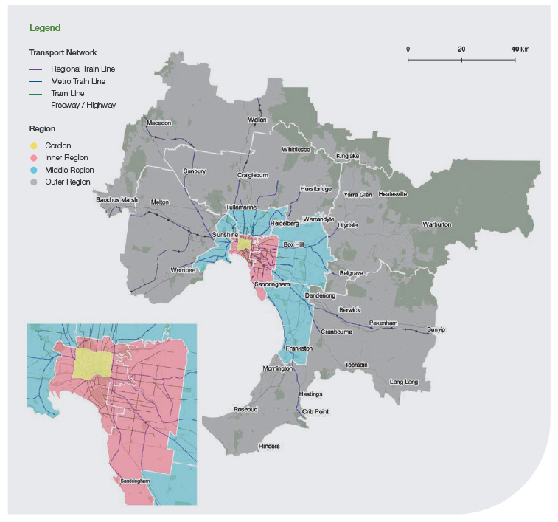

We modelled 11 regions within Greater Melbourne as illustrated in Figure 1. The regions defined in our modelling originate from boundaries as provided in the 2017-2050 metropolitan planning strategy, Plan Melbourne. We have further refined these regions to get greater resolution and clarity into how Greater Melbourne moves using the MABM.

To simplify the presentation for some analyses we group them into three: Inner, Middle and Outer, as illustrated by the different colours across the 11 regions.

The Outer area includes some of the most rapidly growing suburbs of Melbourne and is also where much future population growth will occur. It would be easier and more efficient to get transport network pricing in place before this growth happens so the population can take this into account when deciding where to live. As we will see, this would also minimise the number of people who have higher transport costs resulting from transport network pricing (or minimise the budgetary cost of addressing location-based inequities).

In the MABM, it is assumed that everyone takes the same trips under both systems. Travellers respond to the new prices by changing mode or the time when they travel.

The MABM also does not model land use changes in response to pricing changes. Hence the responses reported by the MABM can be interpreted as minimum estimates as it does not allow for changes in trips or broader economic changes from transport network pricing reform.

Figure 2: Inner Melbourne cordon as modelled
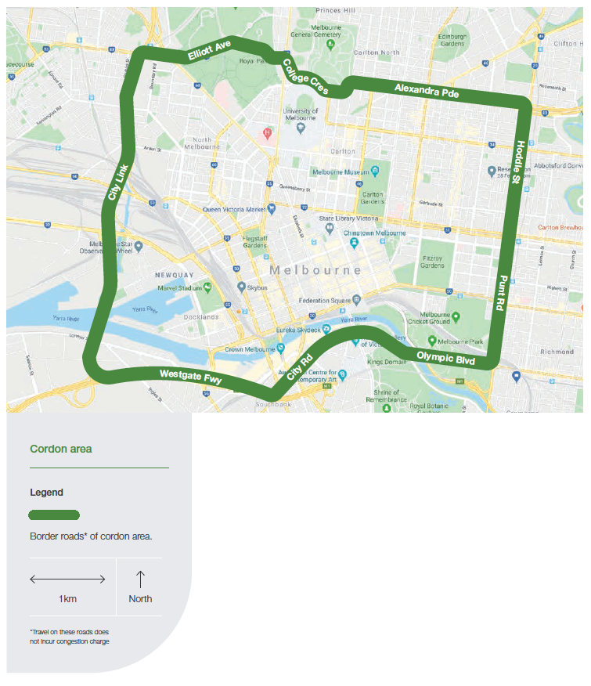
Our analysis compares transport network pricing with existing transport costs set by the state government, plus fuel excise. Under the current system, this includes fuel excise, registration, compulsory TAC charge, stamp duty and public transport fares.

Because registration, the TAC charge and stamp duty vary with the type of car, a standard type of car is assumed for all individuals simulated in the model. Under TNP, this includes the road distance charge, the cordon charge, public transport fares and parking charges at train stations and at the Doncaster Park-and-Ride.

Using a standard car means that the analysis probably overestimates the stamp duty for low income earners and underestimates it for high income earners – but stamp duty is a relatively small component of average daily transport costs.

A cordon charge would significantly improve travel speeds by discouraging people from driving through inner Melbourne.

Pricing delivers highly positive outcomes for Melbourne

Our modelling shows there could be substantial benefits from introducing transport network pricing in Melbourne.

Improved travel experiences through reduced congestion

Introducing a cordon price in inner Melbourne (Figure 2) substantially reduces congestion in the inner cordon area and improves travel experiences as show in Figures 3 and 4.
Figure 3 shows the average speed in the inner cordon area under the Current System and for TNP.

Figure 4 shows the effect of the cordon price by reporting the percentage change in vehicle kilometres travelled (VKT) in the inner cordon area by time period under TNP compared with the Current System (for 2031).

Figure 4 reveals where the improvement in speed is coming from. During the peak periods there are reductions in the vehicle kilometres travelled in the cordon. Interestingly, during the inter-peak, but not the off-peak, there is also a non-trivial reduction in vehicle kilometres travelled. This could reflect the fact that other trips associated with work travel (like doing shopping during the day) are also being switched to public transport. This is less the case for trips after work.

During the AM peak, average speeds are 36% faster, more than halving the difference between the AM peak and off-peak speeds.

As Figure 3 shows, during the AM peak, average speed increases by 36% (7kph) more than halving the difference between the AM peak and off-peak speeds. There is an about 10% reduction in time spent in peak congestion. Speeds also improve in the PM peak, although this is less striking as there is less of a gap to begin with.

Figure 3: Cordon average speeds TNP vs Current System

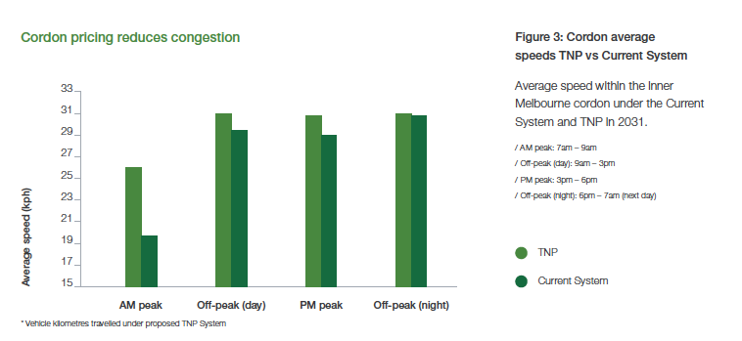

Figure 4: % change within cordon of VKT* (per day)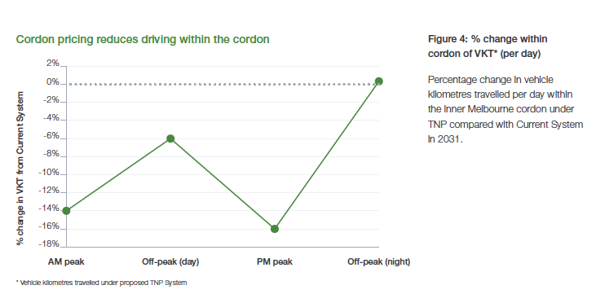

Effects of road pricing on the use of roads and public transport

Figures 5 and 6 show the effects of transport network pricing on road and public transport use in general i.e. not just within the cordon. These results indicate that introducing road pricing across

Melbourne has a substantial effect, decreasing private vehicle trips and increasing public transport use across the network.

There is about a 1.7% reduction in the number of car trips and a 2.5% reduction in VKT (representing a reduction of over 196,000 car trips and a reduction of over 3.6 million VKT per day). This means a 7% increase in the number of public transport trips (representing over 180,000 new public transport trips). Active transport does not change to any substantial degree.

Figure 5: Private vehicle use (per day)
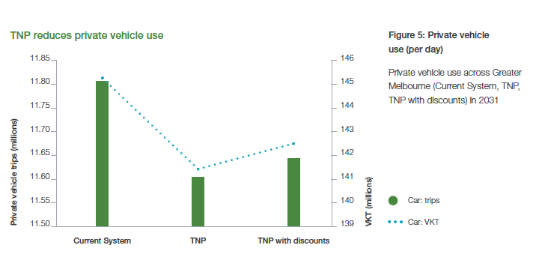

Figure 6: Public and active transport use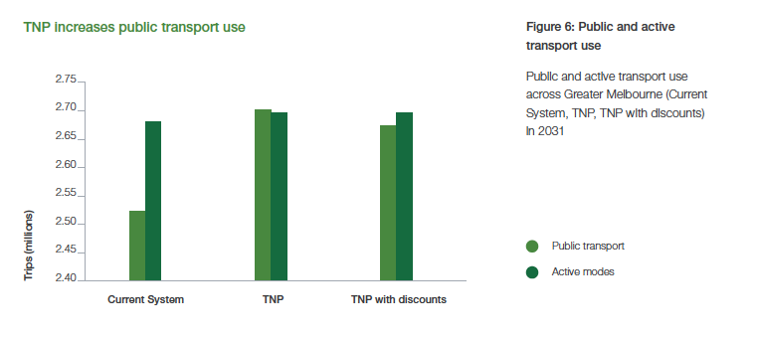
More travel choices

The results show that Melburnians could respond to transport network pricing by changing mode and time of travel if offered more choice when `shopping' for travel within Melbourne.

While people make these choices to benefit themselves, they also benefit others by using the transport system more efficiently. The Current System, while very simple, does not give people the option to seek out cheaper fares by taking the bus or tram instead of the train, or to get to the inner city more quickly by private vehicle (or commercial and freight vehicle) by paying a premium via a cordon charge.

Effects of differentiated pricing on mode choice

Although road pricing increases travel on all modes of public transport (Figure 7), making buses cheaper leads travellers to make greater use of buses as reported in Figure 8, showing a substantial increase in bus patronage of almost 130,000 new boardings.

Effects of peak pricing on time of travel

Figures 9 and 10 show the changes in boardings and vehicle kilometres travelled for the four periods of the day under the two new scenarios compared with the Current System.

For buses (noting that most bus trips in Melbourne will not cross the CBD cordon), Figure 9 shows boardings increase at a faster rate for the off-peak (day) compared with the AM and PM peaks. There is a considerably smaller increase in off-peak bus trips.

Figure 7: Change in person trips by mode
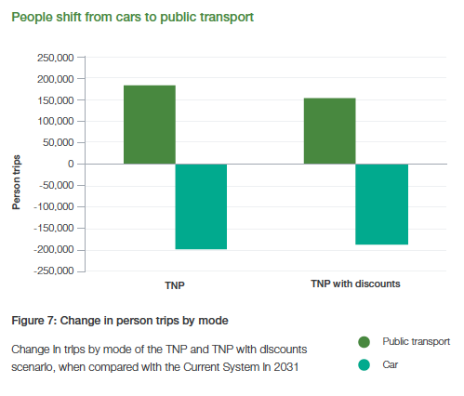

Figure 8: % increase in travel by public transport mode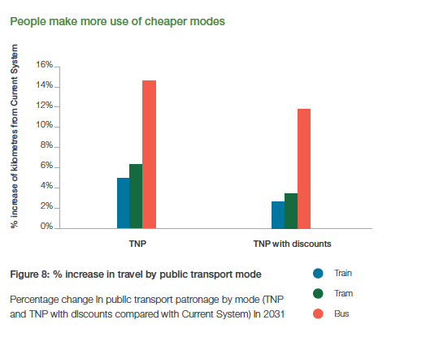
Figure 9: % change in public transport boardings by mode and time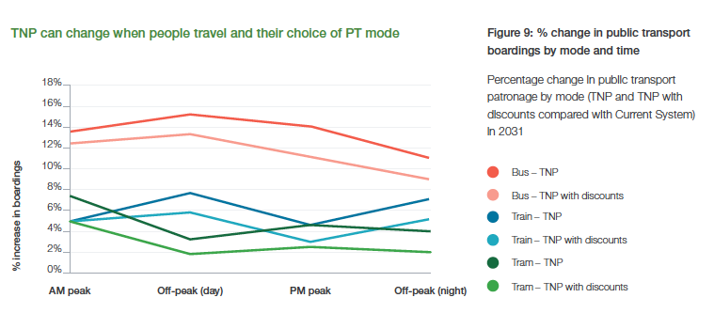

Figure 10: % change in passenger kilometres by mode and time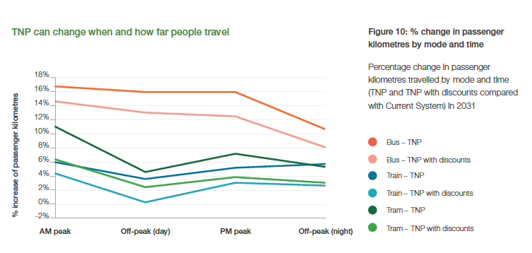
Although road pricing increases travel on all modes of public transport, making buses cheaper leads travellers to make greater use of buses.

The increase in passenger kilometres is greater than boardings. This is consistent with the increase in boardings during peak being for longer trips. It is also consistent with the peak cordon price affecting long commuter trips to and from the city.

For trains, there is a larger increase in boardings outside peak times. In contrast, passenger kilometres show a greater proportionate increase during peak times. This is also consistent with the long trips to the CBD shifting from cars to trains, with people making more efficient use of the network. The proportional increase in kilometres travelled during the inter-peak
is smaller than the proportional increase in boardings, suggesting that travellers are switching to trains for short trips.

The effect is more muted for the TNP with discounts case, suggesting people are possibly shifting to cars when given a discount compared with TNP.

The direction of effects on boardings for trams are the reverse of those for trains and buses. There is a greater than proportionate increase in boardings during the peak periods than the off-peak. This is consistent with the cordon having a large effect on the demand for trams – most of which run much closer to the CBD.

This suggests that although it costs more to travel on trams during peak than off-peak,
any disincentive to travel during peak times is overwhelmed by commuters switching
to trams to avoid the cordon price. The greater increase in kilometres travelled during the peak period suggests it is mainly longer trips that are being switched.

The increase in tram use may also be partially due to adding parking charges to train station car parks. While reduced congestion on the roads is likely to improve tram reliability, there may be a need to expand the tram fleet.

Our modelling shows the cordon price and other transport price changes lead to a 40% to 50% reduction in the number of people driving within the cordon.

Figure 11: Number of people driving into inner cordon area by home location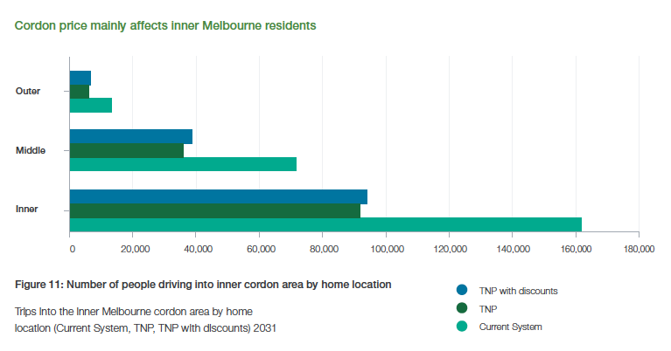

The proportional increase in kilometres travelled during the inter-peak is smaller than the proportional increase in boardings, suggesting that travellers are switching to trains for short trips.

The effects on buses are positive as these changes involve better use of an underutilised asset -- one that is relatively cheap to expand.

Figure 11 confirms that TNP reduces the incentive to drive within inner Melbourne. Our modelling shows the cordon price and other transport price changes lead to a 40% to 50% reduction in the number of people driving within the cordon.

As the number and destination of trips does not change, this is the origin of the shift to public transport.

Before we explore this result in more detail, note that Figure 11 shows that the number of people affected is much greater within inner and middle Melbourne.

Even under the Current System, relatively small numbers of people travel to the inner city, even with all the population growth that will occur there.

Figure 12 shows this in more detail. Under the Current System nearly 18% of travellers who start their journey in inner Melbourne drive within the cordon.

In the surrounding middle regions, this falls to between 3% and 8%. Around 3% of travellers starting from the outer west, north-west and northern regions drive within cordon. In all other regions the share is between 1 to 2%.

Figure 12: Cordon driving entries by home location, Current System 2031
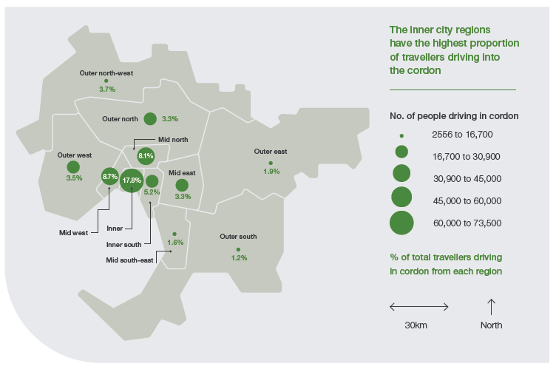
Figure 13 shows that under TNP, in almost all regions except for those next to the inner Melbourne region, the share of those driving to the cordon (and paying the cordon charge) falls to between 0 and 2%. The numbers involved are always below 17,000.

While reduced congestion on the roads is likely to improve tram reliability, there may be a need to expand the tram fleet.

Figure 13: Cordon driving entries by home location, TNP 2031

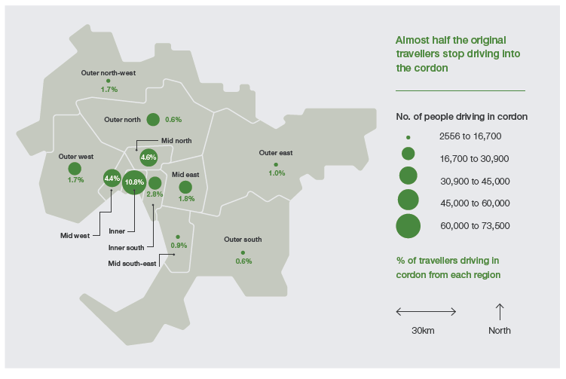
Impacts on fairness can be managed

Who has to pay more after the shift to more efficient transport network pricing is a central concern when thinking about public acceptance. Related to this is the community panel’s concern that no one should be disadvantaged based on location when transport network pricing is implemented.

In the first section we have analysed, for the TNP scenario, who will end up paying more. We then analysed the extent to which the set of discounts proposed in Table 4 deal with any problems as captured by the TNP with discounts example. We also checked to make sure that addressing inequity by location does not undo all the gains in travel speeds or change the shift to public transport.

Who bears the costs of transport network pricing and where do they live?

We have compared transport costs under the Current System and under the two examples of transport network pricing. The specific charges included are all Victorian Government charges, Commonwealth Government fuel excise, public transport fares and parking charges (at stations and park-and-rides), along with the distance and cordon charges under the new systems. Because we work with averages, charges linked with road use make up the largest component and this largely varies with distance. Not surprisingly, transport costs increase with distance from the CBD because the further out people live the further they drive.
One of the community panel’s main concerns was that people should not be disadvantaged because of their location. We have focused on this concern and interpreted this very conservatively in that average transport costs do not rise. Community panel members indicated they were willing to pay more to travel more as long as they got more for
what they paid.

Under the TNP scenario, the goal of not increasing average transport costs is not met. People living in the outer suburbs have increased transport costs.

Figure 14 shows the growth rate in average daily costs between the Current System and TNP for the three regional groups across the four income groups. All households in the model are classified into three income groups: Low, Middle and High. In addition, average costs
are calculated for all concession holders. We discuss how the classification was done in an appendix.

Before presenting these results it is useful to note three things. First, because most travel is by car the changes in average daily costs are determined by changes in the cost of driving. Secondly, because fixed charges have been replaced by distance charges, charges now increase with distance travelled. Thirdly, distance travelled increases with income. So, from any neighbourhood, high income earners travel the furthest, on average, and have the highest travel costs.

These results show two broad patterns. First, people living in inner Melbourne
pay less under TNP than under the Current System. This is because inner Melburnians, irrespective of income, do not drive as far as other Melburnians.
Low income earners in the middle Melbourne region also pay less under TNP. However, high and middle income earners in inner and middle Melbourne pay more and all residents in outer Melbourne pay more. This is because, on average, they travel further.

In general, under TNP, with a distance-based pricing system, transport costs increase more for higher income earners.

Figure 14: % change in average daily transport costs (TNP)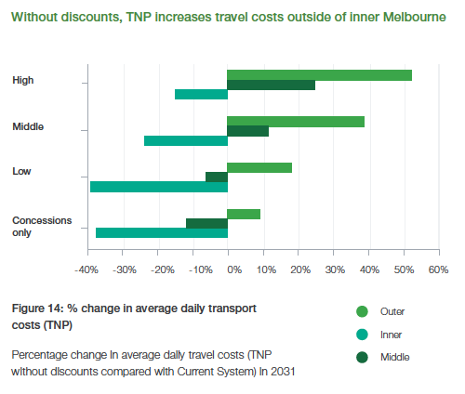
Figure 15 provides more detail on the different geographical impacts of TNP. Circles show the change in average daily travel cost for each of the 11 regions. The larger the circle, the more travellers are affected. The colour of the circle, on the spectrum from blue to red, shows how much average daily transport costs change from – 50% (blue) to + 51% (red).

On average, all regions in inner Melbourne have lower transport costs in a world with TNP without discounts. Average daily transport costs increase in the south-eastern suburbs, but by less than 10%. The greatest increases in average travel costs are in select areas of Outer Melbourne. However, the number of people affected is relatively small (95 and 140 thousand in the outer north-west and outer east respectively).

Note this is for 2031, after a decade of substantial population growth. If we carried out this change now, a much smaller number of people would be affected.

This suggests that it is important to make these changes sooner rather than later. This will allow people to consider them when they decide where they live and work. They will also be relevant to decisions in these areas about services, their frequency, and investments in transport infrastructure.

More generally, it is useful to reform ahead of demand, just as it is sometimes argued that it is cheaper and easier to build infrastructure ahead of demand. This is even more the case for pricing reforms. The consequences of getting pricing reforms wrong if demand doesn't eventuate are likely to be less than getting infrastructure wrong. It is a lot easier to correct a price than to deal with a piece of infrastructure that is no longer needed.

The final dimension we consider for its impact on fairness is whether TNP is more unequal than the current pricing system. To analyse this, we calculated the ratio of the average daily cost of the people receiving concessions to those in the high income group for each of the
11 regions.

Under the Current System, the ratio ranges from 0.36 to 0.46; under TNP, the ratio ranges from 0.22 to 0.37. This suggests that low income earners pay much less relative to high income earners under TNP.

Those who travel less pay less under TNP.

Figure 15: Change in average daily travel costs (TNP compared with Current System) in 2031

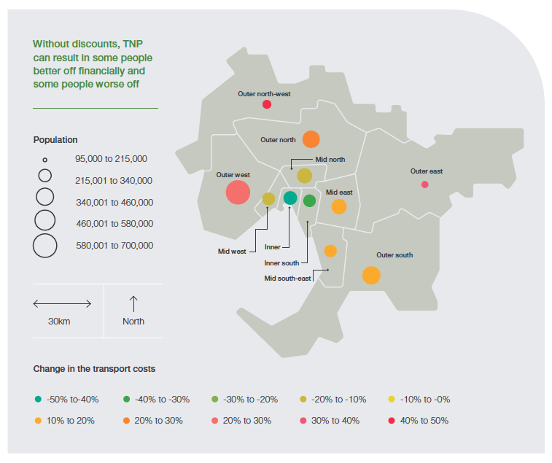Supporting fairness with a spatial safety net

The TNP with discounts scenario supplements the TNP prices with measures meant to reduce the effect of distance on transport costs.

The results from modelling the TNP with discounts scenario are reviewed in this section. In Figure 16, we compare the change in average daily transport costs for income groups across the three broad regions, as we did in Figure 14.

Figure 16 shows that with TNP with discounts the average daily transport cost for low income earners is lower under transport network pricing than under the Current System. Indeed, only middle and upper income earners in the outer areas will have higher average daily transport costs. This is because some are choosing to pay more to continue to drive, but in less congested conditions. Concession holders and low income earners across Melbourne will have lower average daily transport costs.

Figure 17 further highlights that this set of discounts, in our illustrative example, largely manage any disadvantage linked with location.

While under TNP Melbourne residents outside the inner suburbs had greater average daily transport costs, under TNP with discounts, it is only the relatively small number of people affected in the outer north-east and north-west that still have higher average daily transport costs.

Note that on average, in other areas within the ‘outer’ group, like the outer south and outer west (including Cranbourne, Mornington, Werribee, Sunbury and Mernda), average daily transport costs fall.

Under TNP with discounts, the average daily transport cost for low income earners is lower under transport network pricing than under the Current System.

Figure 16: % change in average daily transport cost (TNP with discounts)
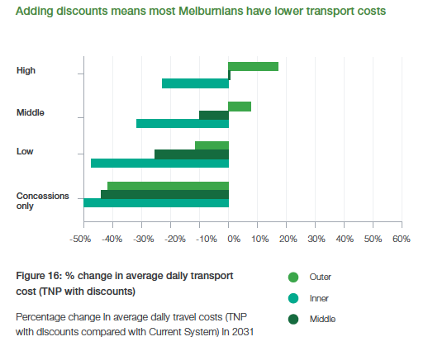
Up to 85% of people could pay less under TNP with discounts.

Figure 17: Change in average daily travel costs (TNP with discounts compared with Current System) in 2031

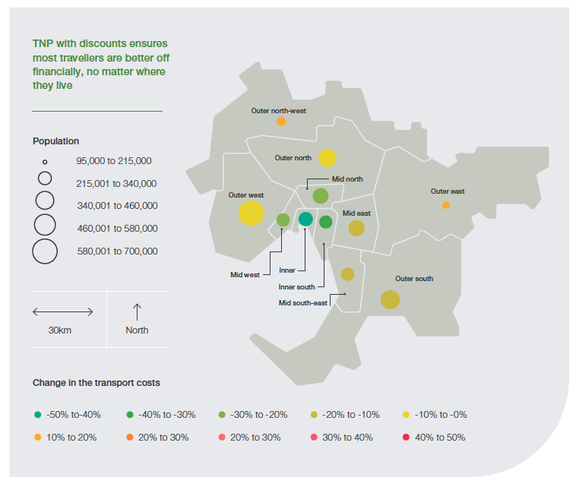
Supporting fairness doesn't eliminate the efficiency gains

In this section we analyse whether adding the discounts on distance travelled eliminates the efficiency gains found with TNP.

In particular, we focus on the effects on travel within the inner Melbourne cordon. This is because one of the objectives of TNP is to reduce congestion there.

Figure 17 shows the change in average daily travel costs (TNP with discounts compared with Current System) in 2031.

Figure 18 replicates Figure 3 while adding average speeds in the cordon by time of day if TNP with discounts is applied.

We can see that outside of the AM peak there is almost no difference between average speeds in the cordon under TNP and TNP with discounts.

Figure 18 shows that in the AM peak, the gain in speed from cordon pricing is reduced by a quarter and there is still an 8% reduction in time spent in peak congestion. Nevertheless, the bulk of the gain remains.

Figure 19 explores the differences between the TNP and TNP with discounts examples in more detail by looking at impacts by time of day on vehicle kilometres travelled.

The pattern is similar to what we saw for average speeds. There is a smaller decrease in vehicle kilometres compared to TNP.

The number of car trips still falls by around 168,000.

Under TNP with discounts there is still a more than 40% reduction in the number of people driving within the cordon – particularly from inner and middle Melbourne (Figure 11).

This could mean that there are a lot more drivers that start their journey from these regions. It is also likely that even with quantity discounts, it is still better value to use public transport for long trips from outer areas into inner Melbourne.

Figures 6 to 10 show we get similar, though a bit smaller, effects on public transport under the TNP with discounts scenario. For example, we still get about 110,000 new bus boardings.

Figure 18: Cordon average speeds – all scenarios Average vehicle speed within inner Melbourne cordon
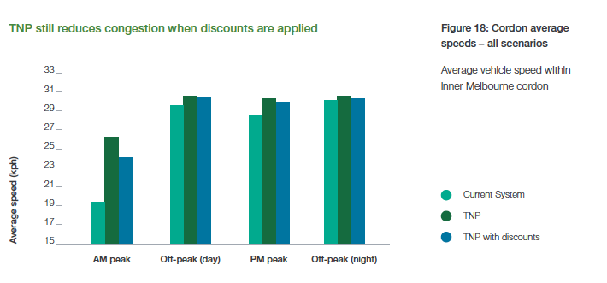

It is also likely that even with quantity discounts, it is still better value to use public transport for long trips from outer areas into inner Melbourne.

Figure 19: % change in VKT* within cordon
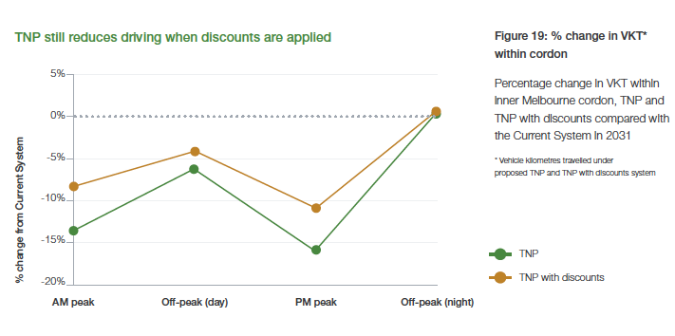
06. Parking pricing reform

Driving and parking go hand in hand. Most parking across greater Melbourne is currently free, with 96% of trips resulting in free parking. This abundance of cheap parking encourages people to drive.

- The road space taken up by parked cars could be put to better use, by providing space for free-flowing traffic, bus, tram or bicycle lanes and wider footpaths.
- To get the most out of our transport system, we need a new approach, where all parking must be priced, along with roads and public transport.

Each example of transport network pricing we have modelled (see Section 5) included pricing parking at train stations and park-and-ride facilities. Our view is that parking must be priced alongside roads and public transport to deliver an effective, efficient and fair transport pricing system.

Current pricing is inefficient

Currently, several factors combine to deliver inefficient outcomes in on-and off-street parking in Melbourne.

The first factor is that local government policies have kept the price of parking
low or free, imposing time restrictions instead. At present, 96% of trips in Greater Melbourne end in free parking (City of Melbourne, 2019).

More than half (55%) of people who regularly drive during the weekday peak have access to free, time-unlimited parking and just 17% of those who regularly drive during the weekday peak pay for parking (Infrastructure Victoria, 2018). These figures show that the price of parking across the city – and especially in the inner city – does not reflect the cost of providing it.

One reason local councils do not make greater use of pricing parking could be that the revenue does not justify the collection and enforcement costs. Where parking is priced, there is only very limited variation in pricing over time and location, instead of an efficient system that would vary prices across locations and over time.

‘Free’ parking is actually expensive as it uses a considerable amount of increasingly valuable land. As noted by the City of Melbourne (2019), free or low cost on-street parking comes at a significant opportunity cost for the city, taking up space that could be used for higher value purposes that would benefit many more people (City of Melbourne, 2019).

The City of Melbourne (2019) has also pointed out that while on-street parking is a ‘premium product’ that provides a high level of convenience by being located directly adjacent to the footpath, it is generally cheaper to park on rather than off-street. One effect of the low price of on-street parking means drivers cruise looking for cheap on-street parking, contributing to traffic congestion.

The responsiveness of car parking to prices is shown by when Melbourne CBD parking is in highest demand. It is not a weekday when thousands come to the city to work and shop, but rather, Sunday (Taylor, 2018). There are two notable differences about Sundays: first, public transport services are not as frequent and second, all on-street parking is free (although there are still time restrictions).

Another factor contributing to inefficiency is that minimum parking planning provisions for commercial and large-scale residential buildings artificially increase parking supply in some locations.

Minimum parking provisions have been criticised extensively (see, for example, Shoup 2005) but continue to be used in Melbourne – particularly in suburban Melbourne (Taylor and van Bemmel-Misrachi, 2017). A related issue is the compulsory bundling of parking rights with property. This reduces land use flexibility, increases property prices and generally overlooks the fact that some buyers may prefer to pay less for a property without parking rights.

Currently, parking at train stations, bus stops and park-and-ride locations are free. These spaces are often occupied all day and are reported to regularly fill up early on weekdays. In some areas, parking spills over into nearby residential streets. Free parking is allocated on a first come, first served basis, which may be inefficient and unfair. For example, parents dropping their children at school often cannot use train station car parks because they are rationed on a first come, first served basis rather than willingness to pay.

Overall, the abundance of free and cheap parking in Melbourne gives many people
an incentive to drive rather than use public transport. Previous community research
by Infrastructure Victoria found that many people who sometimes used a mode of transport other than driving did so because parking at the end of their trips was a problem (Infrastructure Victoria, 2018).

Free parking is allocated on a first come, first served basis, which may be inefficient and unfair.

A new approach to pricing parking

Our preferred model is that, as part of transport network pricing, all parking is priced and that prices vary over time and across locations. This would apply to car parks attached to railway stations and park-and-ride carparks. This may sound impractical but time varying demand-responsive pricing is being implemented at scale in San Francisco.

There would also be no minimum or maximum parking planning provisions.

One advantage of pricing all parking is that it complements road pricing. Pricing literally all road space creates a clear signal about the best use of the land – whether it is for free-flowing traffic, parking, bus and tram lanes or footpath extensions. Developing clear price signals around road space will become even more important if there are substantial technological changes associated with transport, such as autonomous vehicles. Autonomous vehicles or mobility-as-a-service changes are going to require more road space to pick up and drop off passengers.

Another advantage is that parking linked to public transport is priced, which would be more efficient and fairer than current arrangements, and also reflect the value of the land where these car parks are located.

Given Melbourne's extensive network of public transport services that share traffic lanes with drivers cruising for parking, dynamic parking pricing could improve the efficiency of these services and improve traffic flow. Roads such as Swan Street in Richmond, Chapel Street in South Yarra/Prahran/Windsor, Smith Street in Collingwood and Burke Road in Camberwell are good candidates for trialling the San Francisco approach.

While we could only apply simple parking charges in our modelling, public transport car parking is another good candidate for dynamic parking pricing, allowing those who benefit most from this parking to access it.

Dynamic parking pricing could also be highly beneficial in popular precincts where the demand for government-provided parking fluctuates considerably (such as Melbourne's beach car parks in summer, the Lygon Street precinct on Saturday nights or Richmond and East Melbourne on-street parking during events). Prices would be set to encourage a minimum level of parking vacancy so that customers and visitors always have the option to visit these areas by car.

San Francisco's demand-responsive parking pricing

In San Francisco, demand-responsive parking prices are set to achieve an occupancy target to eliminate cruising for parking.

Generally, when more than 85% of on-street parking spaces are occupied, people will have difficulty finding a park, indicating that the price is too low. Rather than charging the same hourly rate all day, the San Francisco system (SFpark) adjusts prices per city block to achieve occupancy rates of between 60% to 80% during defined pricing periods. Prices are adjusted no more than once per month and announced ahead of time so drivers know them.

A pilot of the SFpark scheme showed that prices actually went down more than they went up, reflecting the fact that for the majority of the day parking is underused. The pilot also showed increased sales for local businesses, reduced cruising for parking spaces and fewer parking fines issued (SFMTA, 2014).

SFpark is now being rolled out across San Francisco on a large scale.

07. How we'll get there

We think there are three steps to building social acceptance of transport network pricing.

- Firstly, identify the objective as reducing congestion. Overseas experience has demonstrated that focusing on congestion-busting as the primary objective has been effective in building social acceptance for change.
- Secondly, make the case for transport network pricing as an effective solution to reduce congestion, and assist the community to understand and accept that pricing reform is a necessary complement to building more infrastructure.
- Thirdly, deliver and demonstrate the benefits of the reform. Expanded public transport and reforming existing charges will help to demonstrate benefits to the community of a change in how we pay.
- By making the case for transport network pricing as an effective and fair solution for congestion, then delivering and communicating the resulting benefits, governments can build community acceptance for a change to how we pay for transport.

There are now several examples of successful transport pricing reform. We draw on these to suggest three steps to developing social acceptance for introducing transport network pricing in Victoria and to highlight policies that enable and complement it.

The first step is to specify the main objective of the reform. The second step is to provide the best solution to achieving that objective. Because our proposed solution is about changing behaviour rather than accommodating it, the third step is to credibly deliver the benefits from the reform.

The measures discussed in this section draw on the conditions identified by the community panel and the BehaviourWorks Australia (BWA) forum (see Section 3), along with the experiences of successful – and unsuccessful – reforms overseas (see Section 4).

There are several dimensions to the problem that we will not address – not because they are not important, but because they have been thoroughly analysed elsewhere. First, one of our principles is that all costs be priced. This includes any negative externalities such as carbon emissions or the contribution to road trauma. There is a well established methodology for doing this (see for example Parry and Small, 2005).

Second, there are important privacy issues as transport network pricing requires greater information on when, where and how individuals travel to provide benefits for behavior change.

Privacy issues and suggestions on how to address these legitimate concerns have been extensively analysed by the National Transport Commission (2019) and Terrill et al. (2019b).
To improve and support the move to a new transport network pricing system, there may be significant governance and regulatory issues that need resolving. While these have been addressed during the implementation in other jurisdictions, Infrastructure Victoria is carrying out ongoing research on the Victoria-specific dimensions of this issue.

Third, if there is substantial diffusion of mobility-as-a-service (MaaS) and autonomous vehicles, there could be substantial though variable implications for the pricing of transport infrastructure. Autonomous vehicles are analysed extensively in Infrastructure Victoria's report Automated and Zero Emissions Vehicles Infrastructure Advice (2018).

Transport network pricing reform ahead of this development would leave us better equipped to handle any potential negative outcomes e.g. due to traffic proliferation. Similarly public transport network pricing reform could include measures that support getting the most of MaaS by enabling private and public sectors to more easily interact, and could also ensure that pricing of MaaS is complementary and doesn't undo the efficiency benefits of transport network pricing reform. It is not possible to be more concrete until the nature and extent of the diffusion of these technologies becomes more definite.

Fourth, the focus on congestion means that the focus is also mainly on transport around greater Melbourne. There are important issues around public transport pricing in regional Victoria – these will be subject to more extensive analysis in ongoing work at Infrastructure Victoria.

Finally, there may also be significant technological requirements of a new system. Some of these are also addressed in Terrill et al. (2019a) but this is a rapidly developing area best addressed in future work. It is worth noting for now that the technology exists to implement the systems we have considered in this paper.

Reducing congestion is the objective

In Section 2 we outlined three key problems facing Melbourne’s transport network: congested roads and public transport, ineffective solutions, and lack of choice and equity.

The approach presented in this paper addresses each of these problems. However, to improve the community’s acceptance of transport pricing reform, it is important to focus public communications on a single clear and important objective. That objective should be reducing congestion. It is the main problem facing the transport network now and it is only going to get worse.

Reducing congestion was the main objective associated with the successful introduction of road pricing in London, Milan, Singapore and Stockholm. Melbourne’s parking levy was also motivated as part of a way to address congestion in inner Melbourne. The BWA forum also saw congestion as the sort of problem a political party could seek a mandate on, with a set of solutions included in an election campaign.

Making reducing congestion the objective of reform supports making the transport system more adaptable as supply and demand change. If congestion reduces more than expected, prices can be reduced. If congestion reduces less than expected, prices and/or services and infrastructure need to be increased.

Data collected in congestion pricing will help us make more efficient decisions about investment in transport. Singapore has used average speed targets to refine
its road pricing over time and space. San Francisco has used vacancy rate targets
in setting parking prices. This led to average parking prices falling – outside of peak times, prices could be lowered to make more efficient use of parking.

Finally, it is also worth noting that the need to fund the transport system has been used as an alternative argument to support transport pricing reform. This was the motivation for the pilot road pricing scheme in Oregon and the proposed congestion pricing system for New York City.

Once generally accepted, funding has been part of the motivations for further reforms to the Stockholm congestion charge (Eliasson, 2014).

Infrastructure Partnerships Australia has argued for applying a distance-based charge to electric vehicles to complement the fuel excise for general revenue paid by petrol and diesel driven vehicles (Infrastructure Partnerships Australia, 2019).

To date, there are no examples of transport pricing reforms motivated by financial constraints proceeding to full scale. Indeed, for Victoria, most pricing reforms, such as eliminating the distance-based elements on metropolitan public transport and introducing the free tram zone, have probably increased the financial support metropolitan public transport needs from general revenue. And this revenue is collected, in part, from people who do not use the system.

The funding argument would probably be stronger if the revenue collected was solely returned to the transport system. But most of the revenue collected from travellers goes to general revenue rather than being hypothecated to the transport system.
Returning revenue to the transport system requires significant governance reform, which is the focus of ongoing work at Infrastructure Victoria.

Transport network pricing reform is a necessary, effective and fair way to achieve this objective

We have already shown that transport network pricing is a necessary, effective and fair way to reduce congestion. Our modelling suggests an inner Melbourne cordon charge would substantially increase average travel speeds in inner Melbourne. International experience also shows introducing road pricing reduces congestion.

However, it is not enough for transport network pricing reform to be one way to reduce congestion. It has to be accepted as the best way. In Victoria, the alternative with popular support, is the expansion of the road network (new freeways or adding lanes to existing ones) or public transport. This is encouraged by major projects often being described as `congestion-busting'.

As we argue in Section 3, economic theory and empirical evidence suggests adding capacity alone does not significantly reduce congestion beyond the short run. Investment in transport infrastructure and services need to be complemented by pricing reform for congestion to be reduced.

An interesting similarity across cities that have successfully reformed transport network pricing is that large expansions of the road network or, to a lesser extent, public transport would have been either physically impossible or prohibitively costly. There is very little space for new freeways through central London or Milan. Melbourne faces the same challenges of valuable, limited space above ground.

Trials

One approach that has been shown to help convince people that transport network pricing is a necessary, effective and fair solution to reducing congestion is a full-scale trial.

There are several international examples of how this can work. Milan already had experience with a pollution control scheme that had similar effects to congestion pricing. In Stockholm, a full-scale trial was very effective as part of gaining social acceptance for transport network pricing reform (Eliasson, 2014). Winslott-Hiselius et al. (2009) show that before the trial, media coverage was largely negative, but after the trial it was overwhelmingly positive.

The full-scale trial was followed by a referendum, which voted for congestion pricing. Referendums without preceding trials were held in Edinburgh and Manchester; these were not successful. This may have been because, without a full-scale trial, people could not see the benefits.

Oregon and San Francisco also began with pilot schemes of distance-based road user charging and demand-responsive parking pricing (Pierce and Shoup, 2013). The Oregon trial was opt-in, while the San Francisco pilot was conducted across a small set of locations. San Francisco's parking pricing program was eventually fully rolled out. Although Oregon's road pricing program has not proceeded to full scale, other states such as California and Washington also conducted trials of distance-based charging.

The Melbourne Road Usage Study provides a Melbourne-specific example of how trials can help build social acceptance of transport network pricing reform. As described earlier, at the start of the study 85% of participants said they were comfortable with the current funding system. After experiencing alternative road-charging options, 60% said they preferred a user-pays system (Transurban, 2016).

Delivering benefits from transport network pricing

Even if people accept that transport pricing is a necessary, effective and fair solution to congestion, they will be more likely to support its introduction if they believe there will be social or even personal benefits that will flow from its adoption.

While the discussion below focuses on economic benefits, examples of more general benefits include more time with family, better health and environmental outcomes, and easing some of the negative side effects of population growth (Kunstler et al., 2020).

A credible promise that sufficient benefits will flow from transport network pricing is the third part of achieving social acceptance. The feasibility of doing this is shown by the examples of civic leaders in political parties being elected in London and Stockholm with congestion pricing as part of their policies (Eliasson, 2008; Leape, 2006).

A key component of this step is identifying the type of travellers who will be directly impacted by the change to transport network pricing (Kunstler et al, 2020). This includes those who will change their behaviour and those who won't, potentially paying higher prices.

Social acceptance requires that a substantial number of these travellers benefit from the reform. Benefits and the way the policy is communicated should be targeted at this group (Kunstler et al, 2020). It is also important that the broader community doesn't perceive that they will be worse off.

How do we know that there are people out there who will respond to transport network pricing and change their behaviour? International experience, described earlier, shows that enough people respond to the introduction of congestion pricing on roads to achieve significant reductions in congestion. But what about Melbourne?

Polling conducted by Infrastructure Victoria found that a quarter of those surveyed could change the time of their journeys, or avoid at least some journeys taken during peak times. Furthermore, about a third reported they could choose another mode of transport than driving during peak times (Quantum Market Research, 2017). In addition, when the Tullamarine Freeway was shut, analysis showed about 20 to 40% of commuters must have been able to change their behavior (Kunstler et al, 2020).

Polling by Infrastructure Victoria found that 25% of people surveyed could change the time of their journeys, or avoid at least some journeys taken during peak time.

A first step in communicating the benefits of transport network pricing is demonstrating that it works. As we have discussed, a full-scale trial is a potentially effective way to do this.
Not only does it show how the reformed system will work, this demonstration targets the travellers that will use this reformed system. The remainder of this section focuses on other ways to benefit those affected by transport network pricing as part of building social acceptance. There are also a number of other changes, that address other problems, which might also help with social acceptance.

Delivering benefits through expanding and reforming public transport

One way to deliver benefits to increase public acceptance is to package transport network pricing with other benefits that also improve the efficiency of the system. Expanding and reforming public transport is the most important element of this. This is an example of targeting benefits to those whose behavior can change in response to reform (Kunstler et al., 2020).

If we are to reduce driving to reduce congestion, travellers need confidence that there are satisfactory alternatives for their journeys to work, school and other activities. Our modelling shows that road pricing encourages greater use of public transport. Having a transport pricing system accompanied by public transport improvements was one condition the community panel required for accepting transport network pricing.

In London and Stockholm, increased demand for public transport from introducing congestion charging was anticipated and increased services were provided. In Stockholm, as well as conducting a trial, there was also a significant expansion of public transport explicitly linked to the congestion charge. Adding extra services as part of a trial of pricing reform could also send an important signal to the community that any shift to full network pricing would be accompanied by service improvements.

Expansion of the public transport system would require expenditure, but as it is for high demand periods and locations it would also deliver some funding over time.

Reforming public transport pricing also has an important role to play in creating other benefits through providing more choice with respect to price. For example, making buses on average cheaper than other modes creates opportunities for Victorians to save money travelling while making more efficient use of the network.

Adopting demand-responsive parking pricing will also change demand for public transport. Our modelling shows that introducing peak pricing results in increased demand for off-peak services. Introducing pricing at train station car parks could increase the demand for feeder public transport services as well. With all this in mind, it is clear that reforming transport network pricing is likely to require complementary changes in the level and even type of public transport services provided.

There are several reasons why pricing reform could proceed in public transport ahead of road pricing reform. First, travellers are used to paying for public transport and so are likely to be more accepting of more targeted public transport pricing.

Second, it is likely that public transport pricing reforms will not significantly affect road use because relatively few trips are made using public transport.

Having peak pricing on public transport before beginning road pricing could reduce initial costs of transitioning to full reform. Smoothing the peaks of travel consumption reduces the need for additional peak public transport services for those substituting away from private motor vehicles. To the extent there is substitution across different modes in response to differential pricing, additional services for particular modes may be required e.g. more frequent bus services.

One limitation of reforming public transport prices first is that it is likely that public transport prices will need to change again when road pricing is introduced. Nevertheless, Victorians will be better prepared to adjust to road prices as congestion on public transport will be reduced and they will also be used to responding to more sophisticated incentives when making transport choices. The BWA forum also highlighted the importance of staging the introduction of transport network pricing.

Packaging with other reforms and investments

While the primary focus on transport pricing reform is to reduce congestion, this reform can also occur in a way that addresses the lack of incentive to change behaviour and unfairness in the existing system.

We have identified several ways to create supporters for reforming transport pricing by targeting compensation for those most directly affected. The first example, most applicable to congestion pricing associated with particular areas, is to return the funds to improve the affected area. The congestion pricing revenue could be used to fund more transport or general improvements to the area.

Shoup (2005) argues, and illustrates with case studies, for returning parking revenue to improve the surrounding neighbourhoods (commercial or residential). This approach could be applied to wherever demandresponsive pricing of parking is introduced. This was also highlighted by the BWA forum – in particular linking it to the provision of additional transport infrastructure. A similar approach was taken with London's Ultra Low Emission Zone.

Another approach applies to reforming public transport pricing. Ideally, compensation for introducing congestion pricing on public transport would target existing commuters. In this case, they can be identified as this information is captured by myki. For example, with the introduction of congestion pricing all those who had done at least a year of regular trips on public transport during peak hours could receive a fixed sum of money. Doing this for road travel would be more challenging.

Transport network pricing reform provides an opportunity to shift to a more user-pays system which also enables more targeted incentives to reduce congestion. The Victorian government could replace registration, TAC and stamp duty fees with a distance-based charge as one way of doing this. Those who currently do not drive often or far would benefit from this change as highlighted in our modelling.

Fairness would be improved if the concessions already available to low income and vulnerable Victorians for water and energy could be extended more comprehensively to road transport.

Similar benefits could also go to those making short trips if we move to distance-based pricing for public transport.

The application of a distance charge could be made simpler and fairer if, with the cooperation of the Commonwealth Government, the fuel excise was replaced with direct road user charging. Fairness would be improved if the concessions already available to low income and vulnerable Victorians for water and energy could be extended more comprehensively to road transport.

More generally, a similar pattern of incentives, associated with distance and time of day, could be included in road user pricing but at lower levels.

An example of a reform in a related area that could support the introduction of transport network pricing on roads is reforming the fuel excise in response to its decline with the diffusion of electric and low fuel consumption vehicles. This was a central motivation for the pilot of distance charging in Oregon, where a fuel excise directly funds roads. Infrastructure Partnerships Australia has recently argued for a distance-based charge to be applied to electric vehicles in Australia in anticipation of declining general revenue from the fuel excise.

Indeed, if combined with replacing the fixed charges, distance-based charging for electric vehicles could be extended in a similar form to hybrid vehicles voluntarily on an opt-in basis.
More generally, making participation voluntary can assist with social acceptance by, at least initially, limiting participation to those that benefit. In other words, to begin reforming transport pricing more generally without creating losers, one strategy is to make participation voluntary. Any person who chooses to switch to a new form of transport network pricing must have perceived that they will be better off than under the existing form of pricing.

However, opt-in approaches have several limitations if it is not possible to target incentives only to those who will change their behaviour. For example, travellers who would have travelled off-peak anyway will switch to a system with cheaper off-peak fares without any change in their travel patterns. For reduced congestion, enough travellers in peak must change their behaviour.

One way to encourage a switch is to begin with opt-in participation and then switch to opt-out participation in the new system. That is, after some time, transport network pricing becomes the default option, so travellers must choose to remain on the current system. For example, existing myki cards could be opt-in but any new myki card will be opt-out.
While there has been no trial of opt-in/ opt-out transport network pricing, research in the energy sector (Nicholson et al., 2018) suggests that making a package opt-out rather than opt-in increases its uptake.

The final example of how transport network pricing could be packaged with other reforms is to link it with major service changes or infrastructure investments (Kunstler et al, 2020). For example, a large-scale bus reform, as proposed in Infrastructure Victoria's Five Year Focus report, coinciding with the opening of Melbourne's Metro Tunnel, could be the ideal time to introduce an inner Melbourne congestion charge.

The service improvements associated with the Metro Tunnel could reduce the potentially negative impacts of the charge. A second example is applying charges to new car parking at railway stations of park-and-ride stops along with improvements to bus services connecting to these stations.

One way to encourage a switch is to begin with opt-in participation and then switch to opt-out participation in the new system.

A future where electric vehicles are also charged – with more than just electricity

Modelling and analysis in the Infrastructure Victoria report Automated and Zero Emissions Vehicles Infrastructure Advice – Transport Modelling Infrastructure Victoria (2018) suggests electric vehicles could contribute more to congestion than petrol vehicles due to their low running costs. Hence, there is a greater risk of more road congestion as their numbers rise.

In addition, as highlighted in Infrastructure Partnerships Australia (2019), the fuel excise would be less effective as a tax reducing the general revenue collection.

A distance-based charge on electric vehicles, as recommended by Infrastructure Partnerships Australia, would raise revenue, complementing the declining fuel excise, though not directly addressing congestion at first.

This proposal is similar, in some ways, to a small-scale trial of distance-based road charging under favourable conditions – there are less likely to be equity concerns associated with a full-scale trial and electric vehicles are more likely to be compatible with the latest technologies for implementing road pricing.

Our work, applying the economic principles presented in Table 2 (see page 28), suggests any distance-based charge for electric vehicles be set at a lower rate than for internal combustion vehicles. This is because electric vehicles feature environmental benefits of less air, carbon and noise pollution. Rates could also be set lower for vulnerable and lower income travellers, reducing the main source of unfairness in a distance-based charge. Efficient adoption and use of electric vehicles would be additionally encouraged by reducing or removing the fixed registration and stamp duty charges for these vehicles.

As highlighted by our community panel, transparency is important and would be improved by the charges going not into general revenue but to a state transport authority, similar to the roads fund in New Zealand.

08. What happens next?

Unlocking the full potential of our transport network will require changes across the board, not just to pricing. Infrastructure Victoria will continue our work in areas that will support a pricing system.

- In the meantime, immediate measures can and should be taken to reduce congestion. We have provided a range of short, medium and longer-term options for government to consider.

Options for Government

Infrastructure Victoria has identified a range of options for the Victorian Government to consider ahead of network-wide transport pricing reform. These options allow Government to test, validate and refine new ways to pay for transport to ensure it is efficient and fair, addresses congestion, helps manage demand and gets the most out of our transport system.

Public Transport

- Commence randomised control trials of changes to public transport fares
- Introduce variable pricing for all public transport trips

Roads

- Conduct a randomised control trial of a large sample of motorists including different types of road pricing options targeting congestion across Melbourne
- Apply demand managing tolls to all new freeways, bridges and tunnels
- Introduce distance-based road user charge for electric vehicles

Parking

- Conduct a full-scale trial of cordon charging in inner Melbourne and other congestion hot spots
- Price the use of all roads in the Melbourne Metropolitan area
- Expand and increase the existing car parking congestion levy
- Trial dynamic pricing of selected areas of on-street and off-street council parking
- Trial dynamic pricing for a selection of new and existing carparks at railway stations and park and rides
- Apply dynamic pricing to all on-street and council controlled parking with prices set to target a certain number of places remaining vacant at all time.
- Apply dynamic pricing to all parking at all railway station and park and ride carparks

The government should, as much as possible, keep options alive for introducing transport network pricing in the future while new transport infrastructure is completed. For example, contracts with the providers of new roads should include possibilities for time-of-day/differential pricing. Ideally, demand-managing tolls would be applied to all new freeways, bridges and tunnels.

For public transport, it would also be worthwhile beginning extensive randomised control trials of more sophisticated public transport pricing, such as mode-specific and peak pricing. This could possibly be done through mobile apps already in place. This would also provide information needed before full-scale reform of public transport pricing. An example is the extent to which travelers can change their mode, route and time of travel in response to differentiated prices. Unless the price changes are perceived as permanent, any responses are likely to be an underestimate of the response to a full-scale permanent change.

Valuable large-scale evidence could also be collected from a randomised control trial of different types of road pricing models targeting congestion across Melbourne. Though it is important to note that participants will not experience the full benefits from such pricing unless the trial is at full scale as occurred in Stockholm.

In both sets of trials it is important to specifically estimate the responsiveness of low income and vulnerable Victorians. Each trial could include different mechanisms to reduce any unfairness potentially introduced by transport network pricing reform.

Reform of parking pricing can also proceed relatively easily. We note the interest of the City of Melbourne in a pilot of demand-responsive parking pricing in their transport strategy (City of Melbourne, 2019). The Victorian Government could support this pilot if it proceeds. Similarly, if other local governments with parking and congestion hot spots (such as Port Phillip, Yarra and Hobsons Bay) are also interested to pilot dynamic pricing of on-street parking, they should be similarly supported.

A sample of new and existing car parks at railway stations and park-and-rides could also be selected for trials of dynamic pricing of parking at these locations. Funds raised in the trial would cover implementation costs and the excess reinvested in parking or other local transport infrastructure services during the trial.

The pattern of successful reforms overseas suggests that another possible next step in reforming transport pricing would be to introduce a cordon charge in inner Melbourne as suggested by Clarke and Hawkins (2006) and Terrill et al. (2019b).

The City of Melbourne is also advocating for general road user pricing reform (City of Melbourne, 2019). This could either be done via a full-scale trial, as was done in Stockholm, or implemented without a trial, as occurred successfully in London. While this doesn't immediately address congestion which is occurring across the suburbs, beginning with inner Melbourne has two advantages.
First, there are already extensive public transport alternatives in place and in the pipeline. Their benefits could be further improved by reforming public transport pricing. Second, as highlighted by Terrill et al. (2019b) the consequences for fairness are likely to be less acute. Beginning with transport network pricing reform in the outer suburbs would be more challenging in both these respects (but nevertheless should eventually be done).

If an inner Melbourne cordon is perceived as successful, it would certainly be worthwhile exploring if there are other regularly heavily congested areas to which cordon-style pricing could be applied. This could include around shopping centres or crossings of rivers or other natural barriers for which there are few alternatives. These would be intermediate steps towards pricing congestion wherever it occurs (and not pricing congestion where it never occurs – which would be most of Victoria).

Next steps

Infrastructure Victoria will continue to model, analyse and research options for transport network pricing in Melbourne and Victoria. This will be done within the context of reform to the broader transport system.

To this end, the next phases of Infrastructure Victoria's work will examine:

- How Victoria's transport services are governed and the appropriateness of incentives and decision-making frameworks.
- How we might better value and allocate Victoria's finite road space, with a particular focus on parking.
- Changes to transport charges that could progressively move the system towards one that delivers reduced congestion and better choice, including a new approach to public transport fares.

Following further consultation and research, our final recommendations for the introduction of transport network pricing in Victoria will be made in the 2020 update of the 30-year infrastructure strategy.

Getting involved in the discussion

You can find out more about Infrastructure Victoria's work on transport network pricing through our website.

infrastructurevictoria.com.au

Infrastructure Victoria welcomes comments on this paper and contributions to the ongoing discussion about transport network pricing as we prepare the update to the 30-year infrastructure strategy.

Appendix – Classifying households by income group

To analyse the impacts of transport network pricing on fairness we classified all households in the model into three equal groups (High, Middle and Low) to reflect their income. In addition, we constructed a fourth group composed solely of those households receiving concessions, such as those on a pension.

We didn't use household income to classify households because how well-off a household is depends on how many people the income is supporting. For example, a single person with an income of $100,000 could live quite comfortably.

However if a couple's combined income was $100,000 and they were supporting three school-aged children, they would have to be a lot more careful in managing their expenditure.

Classifying different households with different combinations of dependants into comparable groups is complicated. So we follow the ABS guidelines on how to do this – which involves calculating what is called a `equivalised household income' and classifying according to this.

This applies common sense ideas like shared expenses means you don't need to double household income when you double the number of people to maintain a certain lifestyle and that little children are less expensive than teenagers.

References

Australia's Future Tax System (2008), "Architecture of Australia's tax and transfer system" August 2008, available from http:// taxreview.treasury.gov.au/content/Content.aspx?doc=html/ pubs_reports.htm (accessed 25/7/2019)

Basso, Leonardo J. and Hugo E. Silva (2014), "Efficiency and Substitutability of Transit Subsidies and Other Urban Transport Policies", American Economic Journal: Economic Policy, 6(4), 1-33

Bureau of Infrastructure, Transport and Regional Economics (2015), Traffic and congestion cost trends for Australian capital cities, Information Sheet, November 2015

Bureau of Infrastructure, Transport and Regional Economics (2016), "Lengthy Commutes in Australia", Report 144, Canberra ACT

City of Melbourne (2019), Transport Strategy 2030, available from https://www.melbourne.vic.gov.au/parking-and-transport/ transport-planning-projects/Pages/transport-strategy.aspx

Clarke, Harry and David Prentice (2009), A Conceptual Framework for the Reform of Taxes Related to Roads and Transport, available from http://taxreview.treasury.gov.au/ content/Content.aspx?doc=html/commissioned_work.htm (accessed 25/7/2019)

D'Artagnan Consulting (2018), Review of international road pricing initiatives, previous reports and technologies for demand management purposes, for the NZ Ministry of Transport, February 7, 2018

Duranton, Gilles and Matthew A. Turner (2011) "The fundamental law of road congestion: Evidence from US Cities", American Economic Review, 101(6), 2616-2652

Eliasson, Jonas (2008), "Lessons from the Stockholm congestion charging trial", Transport Policy, 15, 395-404

Eliasson, Jonas (2014), "The Stockholm congestion charges: An overview", CTS Working Paper 2014:7

France, N.J. and G. Currie (2019), "Exploring the performance of road pricing implementation factors – implications for Melbourne", Proceedings of the Australasian Transport Research Forum 2019

Hau, T.D. (1992), "Economic Fundamentals of Road Pricing: a diagrammatic analysis" World Bank Policy Research Working Paper Series WPS 1070, Washington, DC: The World Bank, 1992

Infrastructure Australia (2016) Australian Infrastructure Plan, available from https://www.infrastructureaustralia.gov.au/ publications/australian-infrastructure-plan-2016

Infrastructure Partnerships Australia (2019), Road User Charging for Electric Vehicles, available from https:// infrastructure.org.au/ruc-for-evs/

Infrastructure Victoria (2016), The Road Ahead, available from www.infrastructurevictoria.com.au

Infrastructure Victoria (2018), Five Year Focus: Immediate actions to tackle congestion, available from www.infrastructurevictoria.com.au

Infrastructure Victoria (2018) Automated and Zero Emissions Vehicles Infrastructure Advice – Transport Modelling, available from www.infrastructurevictoria.com.au

Infrastructure Victoria (2019) Transport Network Pricing – Community Panel Report, available from www. infrastructurevictoria.com.au

Leape, Jonathan (2006), "The London Congestion Charge", Journal of Economic Perspectives,20(4), 157-176

Martin, Leslie A. and Sam Thornton (2017), "Can Road Charges Alleviate Congestion?" (October 19, 2017) Available at SSRN: https://ssrn.com/abstract=3055522 or http://dx.doi. org/10.2139/ssrn.3055522

Millard-Ball, Adam, Rachel B. Weinberger and Robert C. Hampshire (2014), "Is the curb 80% full or 20% empty? Assessing the impacts of San Francisco's parking pricing experiment", Transportation Research Part A, 63, 76-92

National Transport Commission (2019, Regulating government access to C-ITS and automated vehicle data, August 2019

Nicholson, Moira L., Michael J. Fell and Gesche M. Huebner (2018), "Consumer demand for time of use electricity tariffs: A systematized review of the empirical evidence", Renewable and Sustainable Energy Reviews, 97, 276-289

Parry, Ian W.H. and Kenneth A. Small (2005), "Does Britain or the United States have the right gasoline tax?" The American Economic Review, 95(4), 1276-1289

Pierce, Gregory and Donald Shoup (2013), "Getting the Prices Right", Journal of the American Planning Association, 79(1), 67-81

Productivity Commission (2017), Funding and Investment for Better Roads, Shifting the Dial: 5 Year Productivity Review, Supporting Paper No. 9. Available from https://www.pc.gov.au/ inquiries/completed/productivity-review/report#supporting (accessed 2/8/2019)

Public Transport Victoria (2019a), Victorian Fares and Ticketing Manual, July 1, 2019, available from https://www.ptv.vic.gov.au/ footer/legal-and-policies/victorian-fares-and-ticketing-manual/ (accessed 30/7/2019)

Quantum Market Research (2019), Infrastructure Victoria Greater Melbourne Congestion Polling

SFMTA (2014), SF park pilot project evaluation, June 2014

Shoup, Donald (2005) "The High Cost of Free Parking", Routledge

Shoup, Donald (2006) "Cruising for Parking", Transport Policy, 13(6), 470-486

Taylor, Elizabeth (2018), Transport Strategy Refresh Background Paper – Car Parking, May 2018

Taylor, Elizabeth Jean and Reuben van Bemmel-Misrachi (2017), The elephant in the scheme: Planning for and around car parking in Melbourne, 1929 – 2016, Landuse Use Policy, 60, 287-297

Terrill, M., Moran, G., and Ha, J. (2019a) Why it's time for congestion charging, Grattan Institute

Terrill, M., Moran, G., and Ha, J. (2019b) Right time, right place, right price, Grattan Institute

Transurban (2016), "Changed Conditions Ahead: The transport revolution ahead and what it means for Australians" Melbourne Road Usage Study, available from https:// changedconditionsahead.com/the-study/

Turvey, Ralph and Herbert Mohring (1975), "Optimal Bus Fares", Journal of Transport Economics and Policy, 9(3), 280-286

Victorian Department of Treasury and Finance (2010), Review of the effectiveness of the congestion levy, May 2010

Winslott-Hiselius, Lena, Karin Brundell-Freij, ≈sa Vagland and Camilla Bystrˆm (2009), "The development of public attitudes towards the Stockholm congestion trial", Transportation Research Part A, 43, 269-282

This publication may be of assistance to you, but Infrastructure Victoria and its employees do not guarantee that the publication is without flaw of any kind or is wholly appropriate for your particular purposes and therefore disclaims all liability for any error, loss or other consequence that may arise from you relying on any information in this publication. You should seek appropriately qualified advice before making any decisions regarding your particular project.

Printed on 100% recycled paper

March 2020

© Copyright Infrastructure Victoria 2020

Except for any logos, emblems, trademarks, figures and photography, this document is made available under the terms of the Creative Commons Attribution 3.0 Australia licence. It is a condition of this Creative Commons Attribution 3.0 licence that you must give credit to the original author, who is Infrastructure Victoria.

This document is also available at infrastructurevictoria.com.au.

ISBN 978-1-925632-45-3 (Print)

ISBN 978-1-925632-46-0 (pdf/online/MS word)

Section 2 of this report provides extensive evidence for the claims below
See Infrastructure Victoria (2018) for further examples of anomalies in Victoria's current public transport fares
All information provided in this section about the reviewed reforms is from The Road Ahead (Infrastructure Victoria's 2016 discussion paper about road pricing) or France and Currie (2019) unless stated otherwise
The difference between a cordon and area charge is that a cordon charge is paid only when the cordon is crossed whereas under an area charge a driver is charged if they drive within the cordon, regardless of whether they cross it
Examples include taxis and hire-cars (London), buses and motorcycles (Stockholm)
This has been shown in a set of studies such as Pierce and Shoup (2013), Millard-Ball et al. (2014) and SFMTA (2014)
transportnsw.info/tickets-opal/fares-payments/ adult-fares www.ipart.nsw.gov.au/Home/Industries/Transport
www.tokyometro.jp/en/ticket/regular/index.html www.jreast.co.jp/e/ticket/types.html
content.tfl.gov.uk/adult-2020-prices.pdf 4 www.metro.net/riding/fares/
www.metro.net/riding/fares/
This principle states that those who use (or benefit from) a service should pay the full cost of using that service. Conversely, those who do not benefit should not have to pay
See Australia's Future Tax System (2008) for more details
https://www.ipart.nsw.gov.au/Home
For more detail on the MABM and how it works, search for `MABM' on www.infrastructurevictoria.com and refer to the KPMG-Arup Model Calibration and Validation Report
To implement 20 free trips a year, we assumed 6% of trips were free. This is due to the limitations of the MABM model. Note also that because the simulation is for a particular day, it is as though the travellers with the highest costs all took their free trips on the same day – so these results will probably be an upper bound of the impact
See https://www.theguardian.com/politics/2008/dec/12/ congestioncharging-transport22
See https://www.sfmta.com/blog/san-francisco-adoptsdemand-responsive-pricing-program-make-parking-easier , https://usa.streetsblog.org/2017/06/26/oregons-pay-permile-driving-fees-ready-for-prime-time-but-waiting-forapproval/, https://waroadusagecharge.org/ and https://caroadcharge.com/en-us/Resources/Ongoing-Research
Hau (1992) shows the reason for this for the case of introducing road pricing
For an even more striking example with respect to organ donation see www.independent.co.uk/news/long_reads/ spain-leads-world-organ-donation-organ-transplant-healthscience-a8417606.html
For any road pricing component of transport network pricing reform which interacts with roads share tolls locked in by existing contractual arrangements, such tolls will need to be accommodated for. How this is done will depend on the type of road pricing adopted
For more information see https://www.abs.gov.au/ausstats/ abs@.nsf/Lookup/2901.0Chapter31502016

