Growing Victoria's Potential
  - The opportunities and challenges of Victoria's population growth

Table of contents

The 30-year infrastructure strategy: 4

Executive summary: 5

Conversation starters: 7

A snapshot of Victoria's growth: 9

Growing out - the role of the regions: 11

Growing up – the future of Melbourne: 20

Getting it right – infrastructure for a growing Victoria: 28

Join the conversation: 37

Sources: 38

Infrastructure Victoria acknowledges the traditional owners of country in Victoria and pays respect to their elders past and present, as well as elders of other Aboriginal communities. We recognise that the state's infrastructure is built on land that has been managed by Aboriginal people for millennia.

The 30-year infrastructure strategy

We will release an updated 30-year infrastructure strategy in 2020. Updating the strategy is important to ensure our advice on Victoria's infrastructure needs and priorities remains current, reflects changes in policy settings and responds to emerging challenges.

Responding to the opportunities and challenges of Victoria's record population growth will be the focus of the 2020 strategy. The strategy will present a vision for how Victoria could accommodate and capture the benefits of growth over the next 30 years and identify the infrastructure initiatives required to achieve this future. Improving the integration of land use infrastructure and transport planning will be central to the strategy.

We will identify the top infrastructure priorities for each of Victoria's regions to reduce disadvantage and build on economic strengths.

The 10 objectives of the 2016 strategy have been retained following consultation with the community and stakeholders, which indicated strong support for their ongoing relevance and importance. Significantly, the community said that preparing for population growth should be the number one objective in the strategy.

Using the 2016 strategy as a starting point, the 2020 strategy will draw on the latest evidence, take account of new government initiatives and consider fresh feedback from stakeholders and the community to make new recommendations. It will stay true to our 2016 guiding principles including consulting and collaborating, drawing on compelling evidence, considering non-build solutions first and being open to change.

This paper is the first in a series of releases that will occur over the next year to ensure that we develop the updated strategy in an open and transparent way. We will publish a draft strategy in early 2020 for an eight week period of formal consultation with the community and stakeholders.

The final 30-year infrastructure strategy will be delivered to Parliament in mid-2020.

Executive summary

Victoria is growing faster than at any other time in the state's history and Melbourne is forecast to soon become Australia's most populous city. Victoria has a remarkable opportunity to harness its growing population and thrive in an increasingly competitive global economy. Realising this transformational opportunity will require deliberate planning and careful management. Ensuring the right infrastructure and land use planning settings are in place is vital.

Over the next 18 months we will update the 30-year infrastructure strategy. Identifying projects, policies and reforms that maximise the opportunities and mitigate the challenges of population growth will be front and centre of our work.

Through consultation in 2018 the community told us that preparing for population growth should be the number one objective in this next strategy. We think the task at hand is not how to control population growth, but how to manage it for the best possible outcomes. This requires an open and honest conversation about how and where we grow and we will have this conversation over the next 18 months so that we can respond with a clear strategy for Victoria's future.

Through the strategy we will examine the unique opportunities and challenges facing regional Victoria. With this paper we are releasing nine profiles of Victoria's regions which explore the challenges and strengths of individual regions. Some findings are common across all regions but what is clear is that different parts of regional Victoria have different needs. All are being affected differently by the changing shape of the economy, urbanisation, population ageing, and climate change.

This complexity means a simplistic approach to infrastructure will not work for regional Victoria. The 2020 strategy will identify the top infrastructure priorities for each region to build on their economic strengths and address local challenges. Recommendations will focus on initiatives that reduce disadvantage and maximise economic development opportunities rather than relieve Melbourne's population pressures.

Any conversation about Victoria's population growth must include a discussion of population density. While Melbourne is projected to remain a low density city by global standards, even as it reaches 8 million people, there are important choices to be made about how Melbourne grows. These choices include where and how to channel medium and higher density living in Melbourne, the rate of expansion of Melbourne's urban footprint, and how infrastructure can best support each approach. All these choices will come with trade-offs and exploring these trade-offs will be a key part of the strategy update.

It is true that rapid population growth is placing considerable demands on Victoria's infrastructure and some parts of the state are struggling to keep up. Managing this change won't always mean building new things. Getting our policy and planning settings right to make the most of our infrastructure, and leveraging existing infrastructure where we can, will be key. Ensuring that new infrastructure aligns strongly with the way Victorians want to work and live will also be crucial.
All of this needs to be underpinned by effective implementation of integrated infrastructure and land use planning. While recent action on this front has been positive, we believe that an even more integrated approach to infrastructure and land use planning can address many of the challenges associated with population growth. We are seeking to capitalise on momentum already underway across government to improve this integration and the 2020 strategy will identify opportunities for further reform.

Our goal is to develop a strategy that can realise Victoria's potential by turning strong population growth into great outcomes for the state.

We want to ensure Victoria is best placed to not just be a growing state, but a thriving one.

Conversation starters

In this paper we begin to explore the key areas we will examine further as we develop the 2020 strategy – how we make the most of Victoria's regions, what level of density is right for a growing Melbourne and how we ensure we have the right infrastructure in the right place at the right time.

Our starting positions are that:

Regional investment should be targeted to address regional opportunities and challenges.

Victoria's regions each have unique opportunities and challenges and effective infrastructure initiatives will target these. Regional investments that aim primarily to take pressure off Melbourne are unlikely to be an effective solution to population growth challenges.

Increasing density will help accommodate growth and improve access to infrastructure.

Melbourne will continue to be a low density city. While many people enjoy low density living, there are downsides, including the level of infrastructure and services governments can provide to the community. Decisions about the future shape of Melbourne will come with a trade-off between the infrastructure people want and the level of density needed to support it.

Infrastructure should be planned and delivered in a way that integrates with where people want to live and work.

Better integration of land use and infrastructure planning is important so that growth happens in areas best suited to accommodate it. This needs to be supported by initiatives which get the most out of our infrastructure. This could mean paying differently for some infrastructure or changing land use settings to bring infrastructure, people and jobs closer together.

We recognise that there are important trade-offs to be considered before we make recommendations in these areas. As we develop the 2020 strategy, we want to have an open conversation about how and where Victoria grows, and the benefits, impacts and costs of different options. As you read this paper, we encourage you to consider the following questions:

- What is the role of the regions in a growing Victoria?
- How much growth can and should the regions accommodate?
- How do we make sure we have the right infrastructure in place in the regions?
- What kind of city do we want Melbourne to be?
- What do people like about low density living and what concerns do they have about high density living?
- What is the right balance between density and infrastructure?
- To what extent are people willing to pay more for better infrastructure?
- How do we strike the right balance between major new infrastructure and initiatives that reduce demand and maximise existing infrastructure?
- How do we balance the benefits and costs of major projects against more moderate service level improvements across the board?

These are complex questions with no simple answers. They are the questions we will respond to because we think the role of a long-term infrastructure strategy is to respond to difficult challenges. We encourage you to stay with us on the journey and join the conversation so that we capture as many perspectives as possible. We cannot answer these questions alone.

A snapshot of Victoria's growth

- In the year to June 2018, Victoria grew by 138,000 people to 6.4 million. This equates to an increase greater than the population of Ballarat in a single year.
- Victoria's population is projected to grow to approximately 10 million people by 2051, with Greater Melbourne reaching around 8 million at the same time.
- Rapid growth is nothing new. Victoria has experienced several periods of sustained high population growth since colonisation. In 1851 the state grew by 73%, adding around 71,000 people to its base population of 97,000 and in the two decades following the end of Second World War, annual growth peaked at around 68,000 people per year.
- Most of Victoria's population growth happens in Melbourne. Of the 148,000 extra Victorians in 2016-17, 129,000 were added to Melbourne (around 87%) with the rest in regional Victoria. Although regional Victoria accounts for around 23% of Victoria's population, it has only attracted around 12% of Victoria's population growth since 1990.

Figure 1: Victorian historical population growth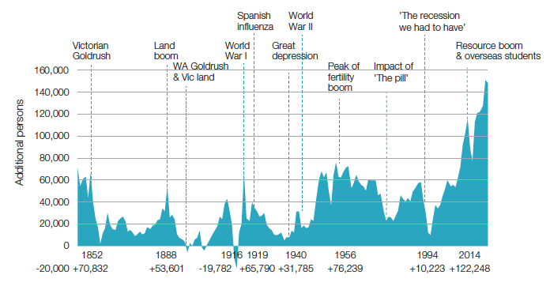
Source: ABS cat no 3105

Figure 2: Victorian population growth – metro / regional split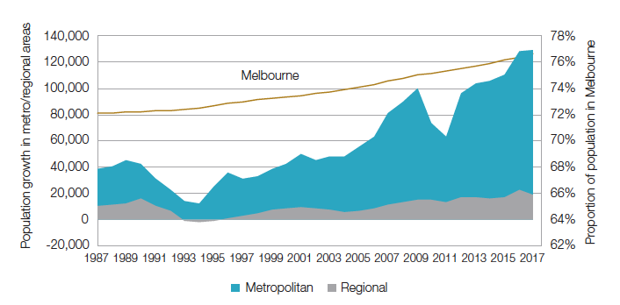
Source: ABS cat no 3218
Growing out – the role of the regions

Record population growth means a discussion about the role of Victoria's regions is more important than ever. While many regional centres are growing significantly, other locations are experiencing population decline. Both present challenges and opportunities. The extent to which regional growth can and should be encouraged, the level of infrastructure required to maximise regional development and reduce disadvantage, and whether the regions should be used to relieve pressure on Melbourne all need to be considered when planning for the future of the state.

Different places, different stories

Over the past year, we have developed profiles for each of Victoria's regions aimed at understanding their specific needs. These nine profiles highlight the diversity of the state and show that each of Victoria's regions has its own unique opportunities and challenges. The 2020 strategy will take account of this uniqueness and diversity to identify the top infrastructure priorities for each region to build on economic strengths and reduce disadvantage.

Geelong, Ballarat, Bendigo and AlburyWodonga are Victoria's biggest `regional hubs', and the outlook for their future is broadly positive. In terms of population, the regional hubs are growing fast and influencing growth in surrounding areas. By contrast, population is declining in other parts of regional Victoria, particularly rural areas.

Regional hubs have a relatively diverse industry structure and a high proportion of service sector employment compared to surrounding rural areas. As a result, they are more attractive to high-skilled workers and tend to be less susceptible to economic or environmental shocks than smaller towns and rural areas, which are more dependent on single industries. Regional hubs are likely to continue to draw working-age Victorians away from surrounding areas as they offer better prospects for more highly-skilled, betterpaid, jobs and better access to services.

The peri-urban areas of these regional hubs and Melbourne tend to benefit from growth in the centres to which they are linked. Peri-urban areas exhibit high relative socio-economic advantage, with some small pockets of relative disadvantage. While the major defining quality of peri-urban areas is that they are well-connected to an urban centre, often leading to high levels of commuting for work, some peri-urban areas are also growing as more people seek lifestyle changes and retirees look for rural lifestyles or environmental amenity.

The population in rural areas of Victoria is both ageing and declining (Figure 3). This is a long-term trend that is likely to continue. An ageing population is an increasingly dependent population, with fewer working age adults to support those who have retired from the workforce.

In terms of economic output, agriculture is the single most dominant industry in rural areas, and is growing. While this has supported prosperity in some parts of regional Victoria, it has not always been evenly spread, particularly as farms consolidate, grow larger and become more disconnected from rural towns. Reliance on agriculture for both employment and economic output can expose rural areas to major shocks. This could include shocks to farming practice (such as continued industry consolidation or automation) or wider ranging impacts such as drought or a changing climate.

Outside of the agriculture sector, regional Victoria is rich in diverse natural resources that present significant opportunities for further economic development, in particular solar, geothermal and wind energy, gold and mineral sands.

Important Aboriginal cultural and heritage assets are present across all of regional Victoria. These have deep historical and educational values, and also ongoing economic, social, environmental and spiritual value for Victoria.

In addition, parts of regional Victoria have high-value environmental assets such as the Great Ocean Road, the Grampians National Park and the alpine region. These areas tend to attract tourists and locals seeking lifestyle benefits, supporting accommodation and other service industries.

Figure 3: Projected population change in Victoria 2016-2031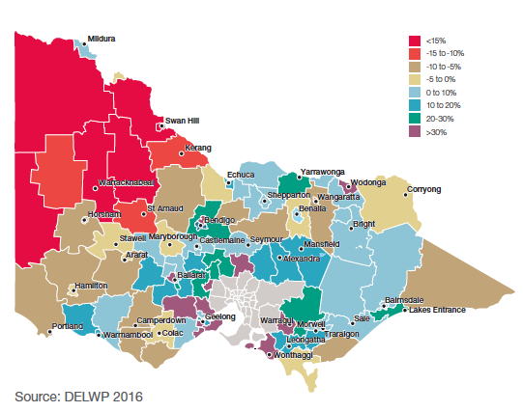

Source: DELWP 2016

Agriculture, regional Victoria and climate change – fortunes tied together

Employment and output in the agricultural sector are moving in different directions due to a trend toward fewer, larger farms and more capital-intense methods of production, including greater automation of farming practises. This leads to a situation in which farm productivity and output increase, but farms require a smaller workforce. As agricultural employment decreases, rural towns no longer benefit from employment and expenditure to the same degree. This can have flow-on impacts for the provision of services and infrastructure across regional Victoria.

The outlook for the agricultural sector and many parts of rural Victoria is heavily tied to the climate outlook and the potential impacts of climate change. The predicted impacts of climate change on the agriculture sector range from lower rainfall and reduced reliability of water resources for irrigated agriculture in some areas to more frequent and intense rainfall and flooding in others. At the same time, increasing year-round temperatures are likely to lead to longer fire seasons. These issues could have significant impacts on existing and planned infrastructure in regional areas, and these impacts are not likely to be uniform.

Regional Victoria's economic outlook

The outlook for the future of regional Victoria's economy is broadly positive. As Figure 4 shows, overall employment across regional Victoria is forecast to grow, particularly in service-based industries such as healthcare and social assistance, and education and training. However, employment in other, nonservice-based industries is projected to decline over the same period.

This analysis runs counter to the commonly held belief that the regions are declining because there are no jobs in the regions. In fact, one of the biggest challenges facing regional Victorian industries is labour and skills shortages, particularly in key industries, with a number of factors contributing to this challenge. Higher demand for new workers, growth in service-based industries, and increasing automation and capital use in other sectors, are expected to contribute to a shortage of skilled workers to fill more complex roles.

Infrastructure is a key element of fully realising regional Victoria's economic potential. Leveraging the already extensive road and rail freight infrastructure in regional areas, by improving access for high-productivity vehicles and supporting heavier freight rail operations, could support the development of additional mining and renewable energy resource activities. At the same time, the potential to harness renewable energy resources is heavily reliant on the availability of distribution infrastructure.

Improved transport links can also support growing industries in the economicallydiverse regional hubs. Fit-for-purpose transport infrastructure is essential in providing people access to key job and service destinations and supporting supply chains for specialist industries.

Figure 4: Forecast change in employment – regional Victoria
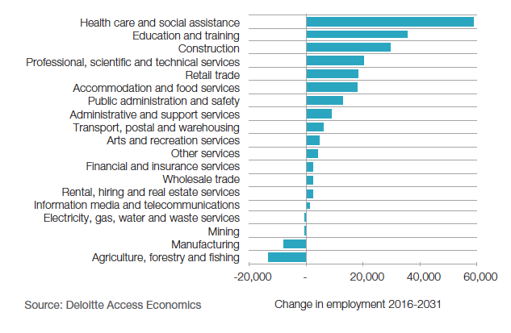
Source: Deloitte Access Economics

Disadvantage in regional Victoria

If regional Victoria's economic profile is complex, so are the needs of regional Victorians. Socioeconomic disadvantage in Australia is measured using an indicator developed by the Australian Bureau of Statistics, known as SocioEconomic Indexes For Areas (SEIFA). The SEIFA index is based on criteria related to income, housing and education. Many regional areas in Victoria exhibit clear and persistent disadvantage across a range of indicators, such as population health, early childhood outcomes and utilisation of mental health, drug and alcohol services.

On these measures, eight of the ten most disadvantaged Local Government Areas in Victoria are in regional Victoria including in many small towns and parts of regional centres. This pattern can be seen in Figure 5. In fact, the five LGAs with the highest total number of severely disadvantaged Victorians are in the regional hubs of Geelong, Latrobe, Bendigo, Ballarat and Shepparton.

Despite these challenges, all parts of regional Victoria have high levels of selfreported wellbeing and higher rates of volunteering compared to the Victorian average. Volunteering is an indicator of high levels of social capital and social cohesion. This is what many residents of rural communities describe as feeling part of the community, which is also why they say they prefer to live in rural areas.

Figure 5: Index of relative socioeconomic disadvantage for Victoria
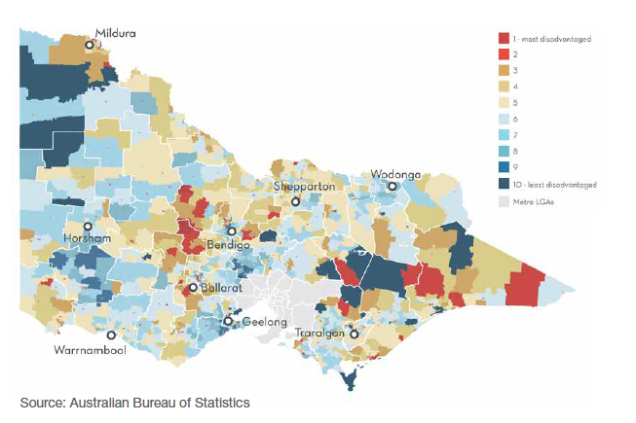
Source: Australian Bureau of Statistics
Regional development or decentralisation?

Historically, regional development policies in Victoria have often been seen as a means to relieve population pressures in Melbourne. As early as 1967, the Victorian Advisory Committee argued that the principal benefit of decentralisation was reducing the cost of metropolitan congestion. More recently, the Regional Australia Institute stated that a more balanced state settlement pattern would "assist in reducing stress on metropolitan Melbourne in terms of congestion costs".

A major challenge with decentralisation approaches in Victoria is the sheer scale of the task. Melbourne's population is projected to reach 8 million people by 2051, 3.2 million more people than today.

If even half of the growth projected for Melbourne to 2051 was diverted to regional areas Melbourne's population would still be around 6.4 million. At the same time, population of Victoria's regions would reach 3.7 million in 2051 compared to 1.5 million today. This is equivalent to an extra 65,000 people moving to regional Victoria every year between 2017 and 2051.

Infrastructure solutions for supporting major growth in regional Victoria would be different to those required for infill development in Melbourne or expansion on Melbourne's fringe. For example, regional cities offer smaller scale infrastructure that is often more difficult to leverage, have greater transmission costs to supply energy and water, and potentially greater environmental constraints on storm water and effluent discharge. We are currently researching the infrastructure constraints and costs in some major regional cities in order to assist in this comparison, but our work so far suggests these costs are important and should not be ignored.

In short, decentralisation would require a different infrastructure investment program that cannot be assumed to be a saving. At the same time, it would require a significant reversal of the longterm urbanisation trend that is happening in countries all over the world.

This is not to say that promoting growth in regional Victoria isn't a worthwhile policy goal. However, it is likely to be more productive to target investments in regional Victoria towards building on a region's competitive strengths, or reducing place-based disadvantage, rather than solely on relieving Melbourne's population pressures.

We will specifically look at these issues, and the infrastructure constraints to growth in Victoria's regional cities, in developing the new strategy. We will build on the work we have done developing regional profiles to identify priority infrastructure policies, reforms and investments that build on competitive strengths and help reduce place-specific disadvantage in regional Victoria.

What regional Victorians told us

As we developed profiles for each of the nine regions across Victoria, we held stakeholder workshops in each region to better understand the nuances of our data. Convened with the support of the Regional Partnerships, we used these workshops to review and test our profiles with key service, industry and government stakeholders. These workshops allowed us to learn more about the local issues from those who live and work in regional Victoria. It also ensured our profiles reflected the experiences of those in the regions and captured critical local insights that the data may have missed.

These workshops were attended by over 200 people. They were extremely valuable, providing rich information about the strengths and challenges facing regional Victoria, and the barriers for the role of infrastructure in addressing challenges and building on strengths.

Despite the diversity of Victoria's regions, some common themes emerged from our discussions:

- Inadequate digital and mobile network connectivity holds back industries (especially agriculture, tourism and education) and innovation.
- There are generally low levels of unemployment with many vacancies for a range of jobs, from highly skilled jobs (such as doctors and agribusiness managers) to lower skilled seasonal workers (such as hospitality workers or fruit pickers). However, there are a number of challenges in attracting and retaining skilled and seasonal workers, including access to appropriate housing.
- Infrequent and unreliable public transport from rural areas and small towns to larger urban centres and regional cities is a barrier for people needing to access health, education, services and jobs. This is a particular issue for people who do not drive, including young people, older people and people with disabilities.
- The potential impact of climate change on towns, coastal assets, tourism and agriculture need to be planned for, ensuring regions are resilient and adaptable to potential future scenarios.
- Tourism and agriculture are key strengths for most of Victoria's regions.
- Many regions can grow their renewable energy sectors (solar and wind) although there are a number of infrastructure barriers that prevent them reaching their potential.

The regional profiles, incorporating feedback from our stakeholder workshops, are available at infrastructurevictoria.com.au

Continuing our conversation with regional Victoria will be a priority as we develop the 2020 strategy.

Growing up – the future of Melbourne

As the state grows, we need to consider what kind of city we want Melbourne to be. While Melbourne is likely to remain a low density city by global standards there are opportunities to increase density to accommodate population growth. Increasing density will result in a different Melbourne than the one we know today. As there are likely to be trade-offs between density levels and infrastructure service levels, it is important to understand what concerns people have about high density, and what they like most about low density. The decisions made today about density will impact the shape and functioning of Melbourne for generations to come.

Melbourne's population and density

With a population of around 5 million, Melbourne is a relatively large city on a global scale (101st in the world) with a population greater than Berlin, Rome or Boston. However, when it comes to its urban footprint, Melbourne is the 29th largest city in the world by area – larger than cities with much bigger populations like Madrid (6.4 million), Toronto (6.6 million) and Mexico City (20.5 million). Melbourne has the biggest urban area in Australia by size, at 2,847 square kilometres. In fact, there are relatively few cities in Europe and North America that have a bigger urban footprint than Melbourne – including cities with populations that are much larger.

Melbourne's large urban footprint has allowed the city to evolve as a relatively low density city despite high population growth. Figure 6 shows some Australian and international comparisons. `High density' areas – which accommodate 100 or more people per hectare of land – will typically be characterised by multi-storey apartments, while `low density' areas are more likely to be dominated by detached homes on larger blocks of land. Many global cities have a greater proportion of higher densities than Melbourne, and even cities typically considered relatively low density – like Vancouver, Montreal and Los Angeles – also have higher relative higher proportions of their population living at higher densities than Melbourne.

Figure 6: Australian and international city population density comparison
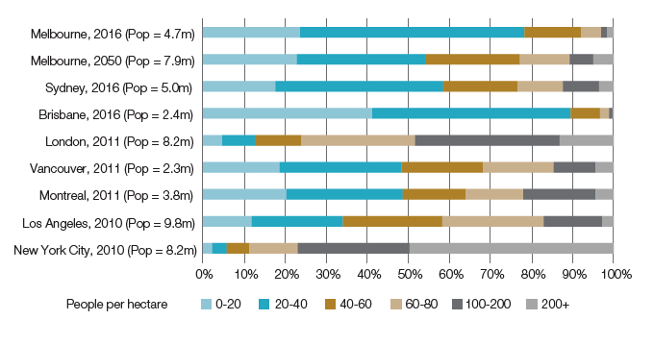
Source: SGS Economics and Planning, ABS Census Data

Within this overall low density, Melbourne does have pockets of high – and even very high - density in particular areas. The upshot of this is that Melburnians have different experiences of density depending on where they live. In 2016, the proportion of Melburnians living at population densities of over 100 people per hectare was 3.1%, or 145,000 people. The remaining 4.6 million lived at densities of less than 100 people per hectare, and 3.7 million live at densities of less than 40 people per hectare.

Figure 7 shows the parts of Melbourne where these different population densities can be seen, and illustrates the stark contrast in population density between inner Melbourne and surrounding areas.

This also shows that pockets of relatively higher density are emerging in the city's outer areas. This trend is accelerating with much of Melbourne's growth over the past two decades being accommodated in inner Melbourne and on the urban fringe in new growth areas.

By comparison, the proportion of the population of Sydney living at densities of more than 100 people per hectare is 13%, 10 percentage points more than Melbourne, making it relatively more densely populated (Figure 8).

Figure 7: Melbourne population density 2016
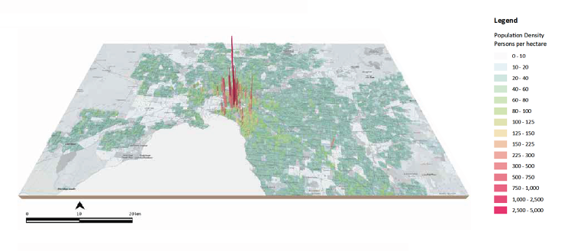
Source: SGS Economics and Planning, ABS Census data

Figure 8: Sydney population density 2016
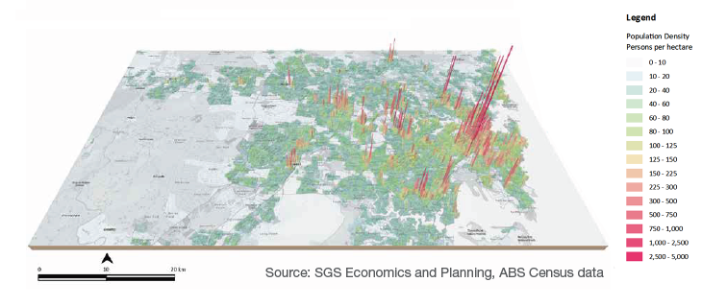
Source: SGS Economics and Planning, ABS Census data

Projections of future density

The sheer size of Melbourne's urban area and the dispersal of population across this area means that, even with the scale of population growth projected over the next 30 years, Melbourne will remain less dense than other cities with comparable populations.

Analysis undertaken by SGS Economics & Planning for Infrastructure Victoria was used to forecast population density for Melbourne at 2050 (Figure 9). This analysis suggests that, even at 8 million people in 2050, without any changes to current land use policy settings or controls, the majority of Melburnians are likely to be living at much lower densities than those living in Greater London today. In 2050, 54% of Melburnians are projected to be living at densities lower than 40 people per hectare (compared to 78% in 2016). In contrast, only 12% of Londoners currently live at densities this low. However population density in London is more evenly distributed (Figure 10). In fact, the overall population density for Melbourne in 2050 is more likely to resemble current-day Sydney, with a dense urban core and areas of relative density around key future transport and employment centres, such as Fishermans Bend, North Melbourne, and Box Hill.

Figure 9: Forecast population density for Melbourne – 2050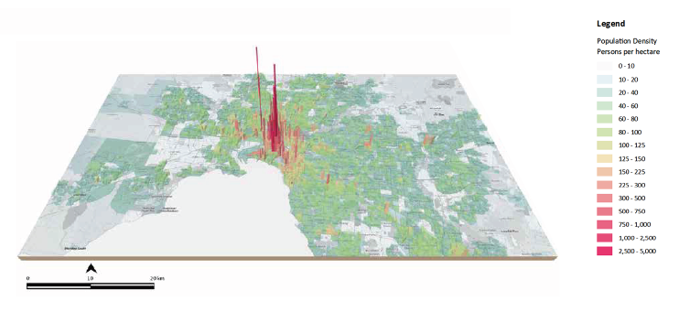
Source: SGS Economics and Planning

Figure 10: London population density 2011
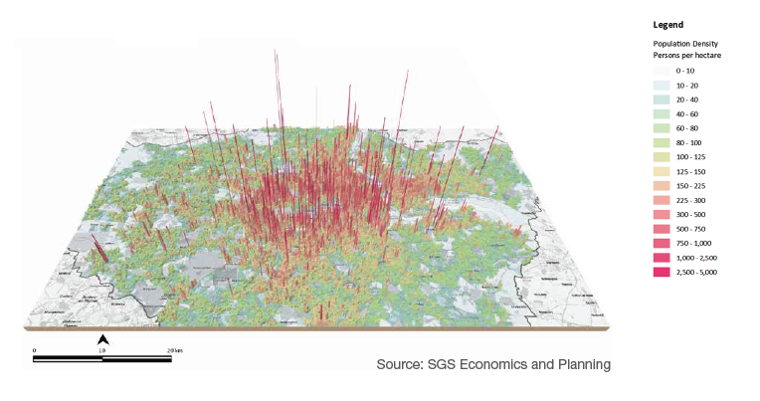
Source: SGS Economics and Planning

Understanding the trade-offs around density

These projections of density assume `business as usual' planning settings and controls. As Melbourne grows, the Victorian community will be faced with choices about the future shape of the city. These choices will ultimately require trade-offs, which could have long-lasting implications for the city and the state.

Melbourne's relatively low density delivers benefits for many of the people who live there. For those able to afford to live in much of Melbourne's south-east and parts of the north, good access to services and infrastructure is combined with the benefits of living in large, detached homes on big blocks of land. More broadly, low housing density means more land is available for leisure and recreation, while green wedges support recreation and better environmental outcomes.

High density can lead to a range of economic, social and environmental challenges. Evidence has shown that industrial pollution and vehicle emissions have degraded the quality of the air and water near cities. In addition, economic output and welfare per person may actually decrease as population and density increases due to the negative impacts of density, such as traffic congestion. Without the right policies in place, density can also lead to the loss of heritage and environmental amenity due to population growth increasing demand for land.

A shift towards higher density living, in at least parts of the city and state, could bring many benefits to Victorians. There is some evidence that Melburnians are seeking better access to high density living.

Figure 11 illustrates the relationship between preferred and actual housing stock, and the types of new housing added between 2001 and 2010. The existing stock in 2006 and new supply largely comprised detached dwellings, whereas the preference for semidetached housing was higher than the supply provided. This suggests relative density levels across the city – particularly as these relate to housing supply – are not meeting the needs or preferences of the people that live there.

Areas with higher population density are typically able to sustain greater levels of service provision, including infrastructure. For example, London's comprehensive mass transit system is sustainable because of the sheer number of people it is able to serve. This link between infrastructure and density goes both ways. As London's mass transit network has grown, it has enabled even greater population density and a more even distribution of population and jobs across the city. This in turn further supports its highly-utilised train and bus system. Parts of London with greater housing densities not only have a higher proportion of trips on mass transit (rail and underground), but also a greater mix of access to other transport modes including buses, walking and cycling.

In contrast, Melbourne has a relatively dense urban centre with radial lines of relative population density extending along transport corridors, interspersed with lower density areas which are largely car-dependent and lacking in mass transit. Melbourne's urban footprint is also 80% larger than London. The differences in the two cities' size and density reflect the difference in the underlying infrastructure of each and are a strong indicator of the trade-off between population density and infrastructure provision.

Evidence suggests this trade-off applies to a range of public services beyond just transport, as the costs of infrastructure and service provision can be spread over a larger user base.

Higher density cities can also reap the economic benefits associated with businesses concentrating in particular places, known as `agglomeration economies'. The economic benefits of workers and businesses being located close to each other come from knowledge sharing, increased innovation and greater competition. This can lead to increased productivity, higher wages, greater employment and increased output.

These attributes make cities the perfect place for growing industries. This is reflected in a shift towards largely knowledge-intensive service sectors in Melbourne. As Figure 12 shows, within Greater Melbourne, knowledge intensive industries such as financial and insurance services, professional, scientific and technical services, and health care and social assistance have all grown in importance over the past 20 years.

As growth continues, the trade-offs around density become more acute. Greater use of higher density living and working as the city grows could provide greater choice and better access to key infrastructure and services. As we develop the updated infrastructure strategy for Victoria, we will examine further the options and trade-offs of density to enable us to make recommendations to government about how it can influence the future shape of Melbourne.

Figure 11: Preferred versus actual housing stock
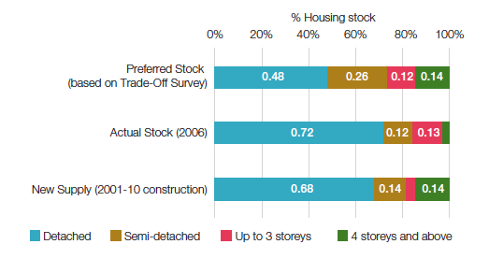
Source: Grattan Institute, 2011

Figure 12: Industry share of gross value added in Greater Melbourne, top five industries

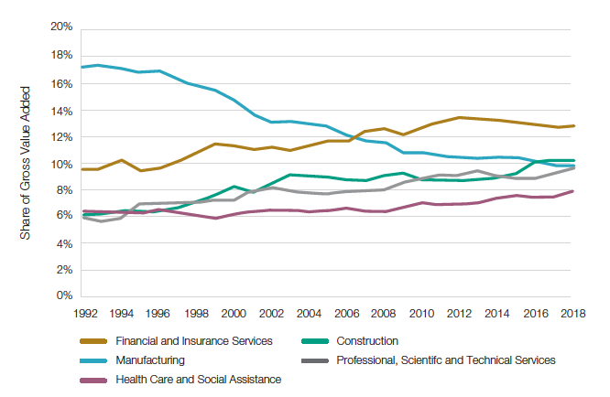
Source: NEIR, SGS Economics & Planning
Getting it right – infrastructure for a growing Victoria

Ensuring the right infrastructure is in place to support a growing and changing state is essential for Victoria's long-term prosperity. This means having the right infrastructure in the right place at the right time. Integrating infrastructure planning with land use is critical, but striking a balance between major new build projects and initiatives that reduce demand and get the most out of existing infrastructure is just as important. Achieving this balance will require an open conversation about the level of infrastructure people expect, the extent to which people are willing to pay more for better infrastructure and the trade-offs between the two.

Current state of Victoria's infrastructure

For many Victorians, the most visible signs of infrastructure `under pressure' are crowded trains and trams, and congested roads. Our analysis for Melbourne suggests that over the past decade not only have travel times increased, but the reliability of travel time has declined as parts of the network approach capacity. Despite significant capacity increases, our analysis suggests that road congestion will worsen in Melbourne in future, with average travel times per trip increasing by 12% from 2016 to 2051, despite trips actually becoming shorter.

Non-transport infrastructure will also feel the pressure of growth. In some parts of Victoria, rapid population growth is putting pressure on the capacity of infrastructure, such as water supply to meet community needs. Western Water, which serves a wide range of communities from smaller country towns like Woodend and Lancefield to the expanding urban centres of Melton and Sunbury, forecasts that demand will outstrip supply as early as 2021. Beyond this, the number of residential lots serviced by Western Water is forecast to almost quadruple by 2067, mostly in the high growth areas of Sunbury and Melton.

Health and human services are also feeling the strain. The Victorian Auditor General reviewed hospitals spending on assets compared to the rate at which these assets are used and found that in rural areas, these assets are not being replaced fast enough (Figure 13). At the same time, government is struggling to deliver adequate health services for young families in new growth areas, including Mitchell and Whittlesea. These areas also have comparatively poor green infrastructure, with low levels of tree canopy contributing to urban heat islands in these areas and posing public health and climate change risks.

While population growth pressures affect some parts of the state, others are struggling to maintain existing infrastructure with a declining revenue or population base. For example, when developing the first 30-year infrastructure strategy for Victoria, we heard from Mount Alexander Shire Council:

Council has responsibility for the maintenance and upgrade of 258 community buildings, 1,449 km of roads and 230 bridges. Despite strengthening our asset management systems over recent years, we are challenged within the current policy and funding environment to maintain high standards of infrastructure to achieve our vision of "a thriving community working together to create a sustainable and vibrant future".

Figure 13: Physical asset replacement indicator for public hospitals, 2012/13 to 2016/17
Hospitals | 2012-13 | 2013-14 | 2014-15 | 2015-16 | 2016-17 | Average
Metropolitan average | 1.05 (medium risk) | 1.35 (medium risk) | 1.51 (low risk) | 2.95 (low risk) | 0.82 (high risk) | 1.54 (low risk)
Regional average | 1.25 (medium risk) | 1.35 (medium risk) | 1.42 (medium risk) | 1.16 (medium risk) | 5.10 (low risk) | 2.06 (low risk)
Rural average | 1.46 (medium risk) | 1.21 (medium risk) | 1.03 (medium risk) | 0.63 (high risk) | 0.81 (high risk) | 1.03 (medium risk)
Small rural average | 0.76 (high risk) | 1.00 (medium risk) | 1.57 (low risk) | 0.78 (high risk) | 0.66 (high risk) | 0.95
Financial year average | 1.09 (medium risk) | 1.32 (medium risk) | 1.48 (medium risk) | 2.33 (low risk) | 1.74 (low risk) | 1.59 (low risk)

A ratio below 1.00 means that the hospital assets are being used faster than they are being replaced, while a ratio above 1.00 means that they are being replaced faster than they are being used.

Source: Victorian Auditor General

Getting the most out of our infrastructure

Increasing pressure on Victoria's infrastructure doesn't necessarily mean we need to continually build more. Consistent with the philosophy that underpins all of our work, we continue to advocate for a focus in the first instance on getting more out of existing infrastructure.

Much of this involves using the `non-build' policy levers available to government – such as pricing, regulation and governance arrangements – to make sure infrastructure settings are as efficient as they can be.

In the transport sector, this means looking at better ways of charging for transport to manage demand rather than building new roads, which can improve travel times in the short-term, but are likely to be ineffectual in the longer run.

Similarly in the water sector, there are opportunities to improve regulatory and governance arrangements to facilitate more efficient and timely supply augmentation decisions.

In the social sector, there are considerable opportunities across Victoria to make better use of existing infrastructure, such as sharing facilities like schools, unlocking underutilised land and rationalising or refurbishing community infrastructure that is no longer fit-for-purpose.

In order to get the best possible value from Victoria's infrastructure, the right policy settings must be complemented by smart decisions about where to accommodate growth and the type of infrastructure put in place to service this growth. Getting the right alignment between population and infrastructure means focusing on first accommodating growth where existing infrastructure can be leveraged. When new infrastructure is required, decision makers should have a strong focus on ensuring that investments complement current and future preferences around where people want to live and work.

Infrastructure costs in different development settings

Over the last year, we have conducted research into the cost of providing infrastructure using current delivery models in different development settings to support new housing. A copy of this report can be found on our website: www. infrastructurevictoria.com.au. Findings show that encouraging development in existing areas rather than newly established areas would likely be more cost effective in terms of infrastructure provision. In Melbourne, we found that the cost of infrastructure (excluding transport) in undeveloped areas can be two to four times higher than in established areas where the existing infrastructure has the capacity to support growth.

Where there is no or limited infrastructure capacity, the data is less reliable, but our analysis shows that it is still unlikely to be more expensive to support housing in established areas.

The major cost constraint to development in established areas is the cost and availability of land for multiple uses, such as schools and open space (including for sport and recreation). Recycling existing facilities to make them fit-for-purpose and the integration of schools and other public spaces and community facilities offers an opportunity to address this cost issue. Government may have to think differently about how to design and use this infrastructure to achieve the most value from the investment.

We also found that the cost of infrastructure supporting housing typically represents less than 20% of the total cost of providing a new dwelling (land and the house itself make up more than 80% of the cost). For most sectors (except transport), development of housing in both established and undeveloped areas can be supported by relatively low cost, incremental expansion of infrastructure. Development costs are only part of the cost considerations, as the cost of ongoing operation, maintenance, and replacement over the 30-year life cycle of the dwelling are an almost equally significant cost (Figure 14).

Other evidence shows that the Victorian Government spends approximately $50,000 on infrastructure for each new home in Melbourne's growth areas, while councils spend $38,000 per home. While developers contribute to this through the growth areas infrastructure contribution (GAIC) and mandatory developer contributions to local government of around $23,000 per average home, neither level of government recovers the full cost of infrastructure provision.

Figure 14: Average Melbourne infrastructure capital and operational costs per dwelling over a 30-year period (2018)
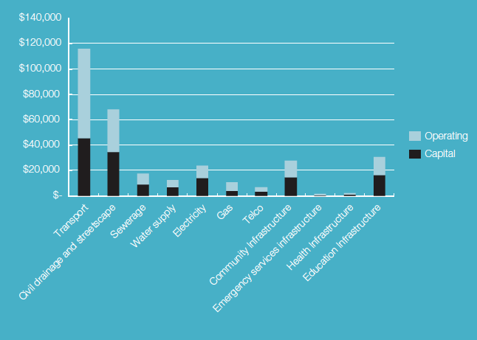

Defining land use and infrastructure integration

We see two important components of land use and infrastructure integration:

- Land use and infrastructure are interdependent components of complex urban and rural systems. They affect each other and the larger systems in which they exist. Land use and infrastructure integration combines the two for maximum benefit.

- Integrated land use and infrastructure planning is a process. It involves transparent, multidisciplinary planning and decision-making across portfolios. It achieves jointly developed, agreed, integrated outcomes. It includes integrated planning across different levels of government, collaboration with the private sector and engagement with communities.

We think integrated land use and infrastructure planning is an essential feature of effective urban and regional planning. It is particularly important in cities such as Melbourne that are experiencing high levels of population growth and change, where compact city form, housing affordability, high amenity, essential infrastructure and good connectivity are essential.

Melbourne's most recent metropolitan planning strategy, Plan Melbourne 2017-2050, identifies opportunities for improved integration of land use and transport planning, and broadly discusses integrated planning of other infrastructure sectors. The plan suggests that this approach could maximise public benefit, make services viable, bring economic benefits and provide certainty for development.

The benefits of land use and infrastructure integration, and integrated planning to achieve it, are hard to measure. Many variables influence the relationships between infrastructure and land use, and there is debate about how to measure their impact on cities. The value of all the variables together may be greater than their individual contribution. The benefits include:

- Optimising the task of infrastructure networks. This should lead to more efficient investment and can support people, employment and industries and their location choices.
- Supporting broader benefits such as higher productivity, greater social interaction, environmental and health benefits from reduced car dependence, improved mental health through contact with nature and reduced urban heat island effects.
- Reducing duplication of effort and subsequent cost across government.
- Supporting greater certainty for investment. The private sector, local government and communities would have more investment confidence with clearer state government policy direction about priority places, types of investment and when state infrastructure is likely to be provided or conditions for its provision.

Delivering integrated land use and infrastructure planning can be challenging. Traditionally, government is set up with departments and agencies focusing on specific portfolio areas, such as land use planning, transport, health and education. This allows specialisation of key service delivery functions, but creates challenges for integrated planning.

Integrated planning requires engagement, collaboration and sharing to reach agreement on desired outcomes and should be a `business as usual' activity. For example, London's strategic planning legislation requires the Mayor to develop a metropolitan plan, a transport plan and an environmental strategy – each plan subject to an integrated impact assessment which is publicly available.

The Victorian Government is already taking steps to better integrate infrastructure and land use through recent changes to the structure of departments and agencies. This includes the establishment of the Department of Jobs, Precincts and Regions, which will enable a greater focus on precinct development. We will build on this work already underway in the strategy update by looking at opportunities for further reform.

The importance of land use and infrastructure integration

Critical to getting the most out of our infrastructure as Victoria grows will be how successfully we can combine the location of infrastructure relative to housing, jobs and other services. This is known as `land use and infrastructure integration' and will be a key focus of our strategy.

How and where Victoria is growing is increasingly showing less integration between homes and jobs, leading to challenging patterns of demand on the state's infrastructure. Job growth tends to be concentrated in middle and inner areas, while population growth is accommodated mostly in the outer ring (Figure 15). Based on current growth patterns, over half (53%) of Melbourne's population is projected to live in the outer growth areas of Melbourne by 2050. By contrast, middle ring areas such as Monash, Kingston, Whitehorse, Brimbank, Moonee Valley, Glen Eira, Banyule, Maribyrnong and Boroondara are predicted to grow by half as much. Conversely, jobs and services will continue to be concentrated in inner and middle areas, with around two-thirds (66%) or close to 2.7 million metropolitan jobs expected to be located in these parts of Melbourne by 2050. This will have a significant impact on travel patterns, with more people needing to travel further for work.

This presents a significant challenge, but is not insurmountable. Decisions about new infrastructure investments and how these will impact on land use, and using planning settings to get more out of both new and existing infrastructure, could be critical.

Taking proactive steps to encourage density in specific areas, particularly those that are already well-serviced by transport and other services, offers an obvious opportunity to use infrastructure capacity more effectively. This delivers savings by avoiding additional investment in infrastructure, especially in transport which is the most expensive form of infrastructure supporting residential development. Plan Melbourne 20172050 explicitly identifies the need for metropolitan regions to adopt planning approaches that direct new residential development and greater population density to where there is transport capacity to optimise the value of this existing infrastructure.

Major public infrastructure projects can also change the shape of a city. An assessment of the land use impacts of CityLink found that it improved connectivity between Melbourne CBD and the north and south-eastern parts of Melbourne, leading to a significant increase in the number of households that now have better access to jobs and services (Figure 16).

A key focus of the 2020 infrastructure strategy will be on how Victoria can capture the benefits of population growth through integrated land use and transport planning by ensuring growth happens in areas that are best suited to accommodate it, and making better use of infrastructure already in place across Victoria.

Figure 15: Forecast dispersion of population and jobs growth
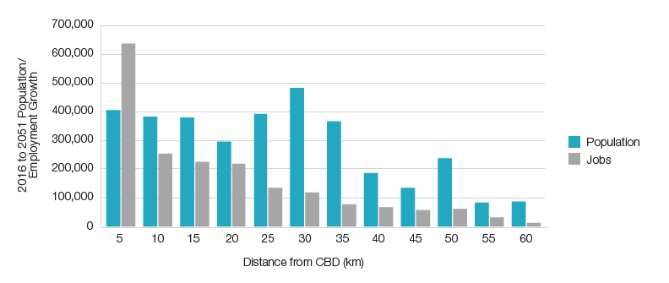
Source: SGS Economics & Planning

Figure 16: Household growth following CityLink
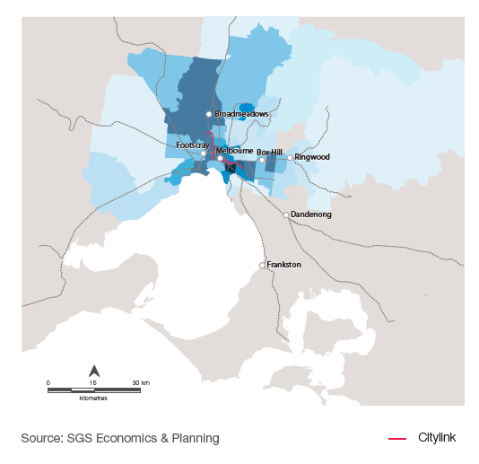
Source: SGS Economics & Planning
Join the conversation

Throughout this paper we have identified a number of issues that we will examine further as we develop the 2020 infrastructure strategy. We encourage you to share your thoughts in response to these issues, and the conversation starters identified on page eight, via email or through our social media channels.

Web: infrastructurevictoria.com.au
Email: enquiries@infrastructurevictoria.com.au
Facebook: facebook.com/infrastructurevictoria
Twitter: @infravic

There will be further opportunities for stakeholder and community input this year as we release research papers, technical reports and modelling outputs that will form the evidence base to underpin the strategy recommendations.

In early 2020 we will release the draft strategy for an eight week period of consultation, with formal submissions invited.

The final strategy will be delivered to Parliament in mid-2020.

Sign up to our mailing list via our website to keep up-to-date with all of our work as we update the 30-year infrastructure strategy for Victoria.

Sources

Aither (2019) Inter-regional assessment – an analysis of regional Victoria's strengths and challenges, Report for Infrastructure Victoria

Australian Bureau of Statistics (2014) Australian Historical Population Statistics, cat. no 3105.0.65.001, ABS, Canberra, available at https://www.abs.gov.au/AUSSTATS/ abs@.nsf/DetailsPage/3105.0.65.0012014?OpenDocument

Australian Bureau of Statistics (2016) Census of Population and Housing: Socio-Economic Indexes for Areas (SEIFA), Australia, cat. no. 2033.0.55.001, available at http://www.abs.gov.au/AUSSTATS/abs@.nsf/ DetailsPage/2033.0.55.0012016?OpenDocument

Australian Bureau of Statistics (2018) Australian Demographic Statistics, cat. no 310104, ABS, Canberra, available at http://www.abs.gov.au/AUSSTATS/abs@.nsf/ DetailsPage/3101.0Jun%202018?OpenDocument Australian Bureau of Statistics (2018b) Data by region, Australian Bureau of Statistics, available at http://stat.abs.gov.au/itt/r. jsp?RegionSummary&region=206041122&dataset=ABS_REGIONAL_ ASGS2016&geoconcept=ASGS_2016&measure=MEASURE&datasetASGS=ABS_ REGIONAL_ASGS2016&datasetLGA=ABS_REGIONAL_ LGA2017&regionLGA=LGA_2017&regionASGS=ASGS_2016

Australian Bureau of Statistics (2018c) Australian National Accounts: State Accounts, Australian Bureau of Statistics, available at https://www.abs.gov.au/AUSSTATS/abs@. nsf/ViewContent?readform&view=ProductsbyCatalogue&Action=Expand&Num=6.1
Bagshaw, E (2018) `Why Victoria is spending billions on infrastructure but still struggling to keep up', Sydney Morning Herald, available at https://www.smh.com.au/ politics/federal/why-victoria-is-spending-billions-on-infrastructure-but-still-strugglingto-keep-up-20181104-p50dx9.html

Carey, A, 2018 `Population pressure a fast growing concern for Victorian voters', The Age, June 17, available at https://www.theage.com.au/politics/victoria/populationpressure-a-fast-growing-concern-for-victorian-voters-20180614-p4zlh5.html

Deloitte (2017) Infrastructure Victoria Second Container Port Advice – Container trade forecasts for Victoria Demographia (2018) World Urban Areas 14th Annual Edition

Department of Environment, Land, Water and Planning (2016) Victoria in future 2016

Department of Environment, Land, Water and Planning (2017) Plan Melbourne 2017-2050

Department of Premier and Cabinet (2017) Victorian Infrastructure Plan

Enterprise LSE Cities (2004) Density and Urban Neighbourhoods in London Summary Report, London School of Economics

Giles-Corti, B, Ryan, K, & Foster, S (2012) Increasing Density in Australia: Maximising the Health Benefits and Minimising the Harm, National Heart Foundation of Australia

Hymel K, Small K, & Van Dender K (2010) Induced demand and rebound effects in road transport, Joint Transport Research Centre of the International Transport Forum and the OECD

Infrastructure Australia (2018) Future Cities: Planning for our growing population

Infrastructure Victoria (2018) Five Year Focus: Immediate actions to tackle congestion

Jackson, W J (2017) Australia state of the environment 2016: drivers, independent report to the Australian Government Minister for the Environment and Energy, Report for Department of the Environment and Energy

London's Economic Plan, London's Economic Plan and Major Industries, available at http://www.uncsbrp.org/

Lowe, P (2018) Demographic change and recent monetary policy, Reserve Bank of Australia

Lucas, C (2018) New population growth figures prove what Melburnians have long expected, The Age, September 21, available at https://www.theage.com.au/politics/ victoria/new-population-growth-figures-prove-what-melburnians-have-long-suspected20180920-p504z1.html

Lucas, C, Koziol, M, Hinchcliffe, J (2018) No tree change: Melbourne's population to soar, sucking growth out of regions, The Age November 22, available at https://www.theage.com.au/politics/victoria/no-tree-change-melbourne-s-populationto-soar-sucking-growth-out-of-regions-20181122-p50hq2.html

Mackay R (2017) Australia state of the environment 2016: heritage, Independent report to the Australian Government Minister for the Environment and Energy

Martinez-Fernandez, C, Weyman, T, Fol, S, Audirac, I, Cunningham-Sabot, E, Wiechmann, T, & Yahagi, H (2016) `Shrinking cities in Australia, Japan, Europe and the USA: From a global process to local policy responses'. Progress in Planning, 105(C), 1-48

Mayor of London (2014) London Infrastructure Plan 2050: Transport Supporting Paper

Mccrindle (2018) Melbourne reaches 5 million, available at https://mccrindle.com.au/ insights/blog/melbourne-at-5-million/

Melbourne and Metropolitan Board of Works (1954) Melbourne Metropolitan Planning Scheme Report

Nakamura, K. & Tahira, M (2008). Distribution of Population Density and the Cost of Local Public Services: The Case of Japanese Municipalities, Faculty of Economics, University of Toyama

Productivity Commission (2011) A `Sustainable' Population? -- Key Policy Issues, Roundtable Proceedings Regional Australia Institute (2016) Deal or No Deal? Bringing Small Cities into the National Cities Agenda

Regional Australia Institute (2018) Breaking the Myth – Regional jobs on the rise, available at http://www.regionalaustralia.org.au/home/2018/11/breaking-mythregional-jobs-rise/

Regional Development Victoria, About Regional Development Victoria, available at http://www.rdv.vic.gov.au/about-rdv/about-rdv

SGS Economics & Planning (2012) Long run economic and land use impacts of major infrastructure projects - Final Report, Report for the Victorian Department of Transport Planning and Local Infrastructure

SGS Economics & Planning (2018) Economic, Social & Environmental Profile: Inter-regional report, Report for Infrastructure Victoria

SGS Economics & Planning (2018) Melbourne functional economic region report, Report for Infrastructure Victoria

Spencer, A, Gill, J & Schmahmann, L (2015) Urban or suburban? Examining the density of Australian cities in a global context, State of Australian Cities Conference 2015

Spiller, M (2018) Shaping the Metropolis, in Tomlinson, R & Spiller M (eds.), Australia's Metropolitan Imperative, CSIRO Publishing, Clayton South, pp. 223-233

Smith, R (2018) Melbourne population to soar past Sydney within decade, News. com.au, April 23 , available at https://www.news.com.au/finance/economy/australianeconomy/melbourne-population-to-soar-past-sydney-within-decade/news-story/ e88a537f61de7b74c2897d102a40cc10

United Nations Department of Economic and Social Affairs (2014) The human right to water and sanitation, available at http://www.un.org/waterforlifedecade/human_ right_to_water.shtml United Nations Department of Economic and Social Affairs (2018), 68% of the world population projected to live in urban areas by 2050, says UN, available at, https://www.un.org/development/desa/en/news/population/2018-revision-of-worldurbanization-prospects.html

United Nations Statistics Division (2019) City population by sex, city and city type, Demographic Statistics Database, United Nations, available at, http://data.un.org/ Data.aspx?d=POP&f=tableCode%3A240#POP

United States Census Bureau (2010) Quick Facts, https://www.census.gov/quickfacts/ fact/table/newyorkcitynewyork/LND110210

Victorian Auditor-General's Office (2015) Regional Growth Fund: Outcomes and Learnings

Victorian Auditor-General's Office (2017) Effectively planning for population growth

Victorian Auditor-General's Office (2017) Results of 2016-17 Audits: public hospitals

Victoria Decentralisation Advisory Committee (1967) Report on the Selection of Places Outside the Metropolis of Melbourne for Accelerated Development

Victorian Skills Commissioner (2017) Mallee Regional Skills Demand Profile, available at http://www.vsc.vic.gov.au/wp content/uploads/2017/10/Mallee-Regional-SkillsDemand-Profile-PDF.pdf

Western Water (2017) Urban Water Strategy, available at http://www.westernwater. com.au/files/assets/public/documents/reference-documents/urban-water-strategy.pdf

Zhang, X (2016) The trends, promises and challenges of urbanisation in the world, Habitat International, 54(3), 241-252
About us

Infrastructure Victoria is an independent advisory body with three functions:

- preparing a 30-year infrastructure strategy for Victoria, which is refreshed every three to five years
- providing written advice to government on specific infrastructure matters
- publishing original research on infrastructure-related issues.

Infrastructure Victoria also supports the development of sectoral infrastructure plans by government departments and agencies. The aim of Infrastructure Victoria is to take a long-term, evidence-based view of infrastructure planning and raise the level of community debate about infrastructure provision. Infrastructure Victoria does not directly oversee or fund infrastructure projects.

This publication may be of assistance to you, but Infrastructure Victoria and its employees do not guarantee that the publication is without flaw of any kind or is wholly appropriate for your particular purposes and therefore disclaims all liability for any error, loss or other consequence that may arise from you relying on any information in this publication. You should seek appropriately qualified advice before making any decisions regarding your particular project.

Printed by Infrastructure Victoria

April 2019
© Copyright Infrastructure Victoria 2019

Except for any logos, emblems, trademarks, figures and photography, this document is made available under the terms of the Creative Commons Attribution 3.0 Australia licence. It is a condition of this Creative Commons Attribution 3.0 licence that you must give credit to the original author, who is Infrastructure Victoria.

This document is also available in PDF and accessible Word format at www.infrastructurevictoria.com.au.

ISBN 978-1-925789-24-9 (Print)
ISBN 978-1-925789-25-6 (PDF/Online/MS word)

Department of Environment, Land, Water and Planning (2016) Victoria in future 2016
Australian Bureau of Statistics (2014) Australian Historical Population Statistics, cat. no 3105.0.65.001, ABS, Canberra, available at https://www.abs.gov.au/AUSSTATS/abs@.nsf/ DetailsPage/3105.0.65.0012014?OpenDocument
Ibid.
Aither (2019) Inter-regional assessment – an analysis of regional Victoria's strengths and challenges, Report for Infrastructure Victoria
Ibid.
Ibid.
Australian Bureau of Statistics (2018c) Australian National Accounts: State Accounts, Australian Bureau of Statistics, available at https://www.abs.gov.au/AUSSTATS/abs@.nsf/ ViewContent?readform&view=ProductsbyCatalogue&Action=Expand&Num=6.1
Aither (2019) Inter-regional assessment – an analysis of regional Victoria's strengths and challenges, Report for Infrastructure Victoria
Ibid.
Ibid.
Aither (2019) Inter-regional assessment – an analysis of regional Victoria's strengths and challenges, Report for Infrastructure Victoria
Ibid.
Aither (2019) Inter-regional assessment – an analysis of regional Victoria's strengths and challenges, Report for Infrastructure Victoria
Regional Australia Institute (2018) Breaking the Myth – Regional jobs on the rise, available at http://www.regionalaustralia.org.au/home/2018/11/breaking-myth-regional-jobs-rise/
Aither (2019) Inter-regional assessment – an analysis of regional Victoria's strengths and challenges, Report for Infrastructure Victoria
Ibid.
Aither (2019) Inter-regional assessment – an analysis of regional Victoria's strengths and challenges, Report for Infrastructure Victoria
Australian Bureau of Statistics (2016) Census of Population and Housing: Socio-Economic Indexes for Areas (SEIFA), Australia, cat. no. 2033.0.55.001, available at http://www.abs.gov.au/AUSSTATS/abs@.nsf/DetailsPage/2033.0.55.0012016?OpenDocum
Aither (2019) Inter-regional assessment – an analysis of regional Victoria's strengths and challenges, Report for Infrastructure Victoria
Victoria Decentralization Advisory Committee (1967) Report on the Selection of Places Outside the Metropolis of Melbourne for Accelerated Development
Regional Australia Institute (2016) Deal or No Deal? Bringing Small Cities into the National Cities Agenda
Department of Environment, Land, Water and Planning (2016) Victoria in future 2016
United Nations Department of Economic and Social Affairs (2018), 68% of the world population projected to live in urban areas by 2050, says UN, available at, https://www.un.org/development/desa/en/news/population/2018-revision-of-world-urbanization-prospects.html
Australian Bureau of Statistics (2018) Australian Demographic Statistics, cat. no 310104, ABS, Canberra, available at http://www.abs.gov.au/AUSSTATS/abs@.nsf/DetailsPage/3101.0Jun%202018?OpenDocument
Demographia (2018) World Urban Areas 14th Annual Edition
Infrastructure Australia (2018) Future Cities: Planning for our growing population
SGS Economics & Planning analysis for Infrastructure Victoria
Zhang, X (2016) The trends, promises and challenges of urbanisation in the world, Habitat International, 54(3), 241-252.
Productivity Commission (2011) A `Sustainable' Population? – Key Policy Issues, Roundtable Proceedings
Mackay R (2017) Australia state of the environment 2016: heritage, Independent report to the Australian Government Minister for the Environment and Energy
Mayor of London (2014) London Infrastructure Plan 2050: Transport Supporting Paper
Spencer, A, Gill, J & Schmahmann, L (2015) Urban or suburban? Examining the density of Australian cities in a global context, State of Australian Cities Conference
Nakamura, K. & Tahira, M (2008) Distribution of Population Density and the Cost of Local Public Services: The Case of Japanese Municipalities, Faculty of Economics, University of Toyama
SGS Economics & Planning (2018) Economic, Social & Environmental Profile: Inter-regional report, report for Infrastructure Victoria
Infrastructure Victoria (2018) Five Year Focus: Immediate actions to tackle congestion
Western Water (2017) Urban Water Strategy, available at http://www.westernwater.com.au/ files/assets/public/documents/reference-documents/urban-water-strategy.pdf
Ibid.
Victorian Auditor-General's Office (2017) Results of 2016-17 Audits: public hospitals
Victorian Auditor-General’s Office (2017) Effectively planning for population growth
SGS Economics & Planning (2018) Economic, Social & Environmental Profile: Inter-regional report, Report for Infrastructure Victoria
Mount Alexander Shire Council (2016) available at https://yoursay.infrastructurevictoria.com.au/30-year-strategy/all-things-considered/submissions
Such as arterial roads, trains, buses. Local roads included in civil works
Infrastructure Victoria analysis of Infrastructure Provision in Different Development Settings
Spiller, M (2018) Shaping the Metropolis, in Tomlinson, R & Spiller M (eds.), Australia's Metropolitan Imperative, CSIRO Publishing, Clayton South, pp. 223-233
Department of Environment, Land, Water and Planning (2017) Plan Melbourne 2017-2050
London's Economic Plan, London's Economic Plan and Major Industries, available at http://www.uncsbrp.org/
SGS Economics & Planning (2018) Economic, Social & Environmental Profile: Inter-regional report, Report for Infrastructure Victoria
Infrastructure Victoria analysis of Infrastructure Provision in Different Development Settings
Department of Environment, Land, Water and Planning (2017) Plan Melbourne 2017-2050
SGS Economics & Planning (2012) Long run economic and land use impacts of major infrastructure projects - Final Report, Report for the Victorian Department of Transport Planning and Local Infrastructure

