Infrastructure Provision in Different Development Settings
  - Metropolitan Melbourne Volume 1 Technical Paper
APRIL 2019

About This Paper
This paper summarises Infrastructure Victoria's research findings on the capacity and relative cost of infrastructure to support further residential development in Melbourne. In looking at cost, we were interested in understanding orders of magnitude to guide strategic decision-making, rather than precise costings to inform investment decisions.

In reporting findings on infrastructure costs, we are only providing half of the story. The varied benefits and amenity of each development setting must also be considered along with costs to make balanced strategic decisions. We looked first at housing provision itself and the factors that influence where housing development takes place. We then looked at the infrastructure that supports housing to identify its capacity to support additional dwellings in the future, considering drivers of infrastructure demand, supply constraints and varying service levels. Finally we looked at cost, identifying the relative cost of each infrastructure element and the relative cost of providing infrastructure in different development settings. In considering the different development settings we focussed on comparing established areas where existing infrastructure can be leveraged against greenfield development settings.

Many varied factors affect the cost of infrastructure besides the development setting, but we have been able to identify typical cost ranges for infrastructure in different settings. Apportioning cost to transport and open space is more complex than other infrastructure elements, as service levels have a broader variance than other infrastructure and households have choice on how they use the infrastructure supplied. Considering transport, service levels vary significantly across Melbourne in relation to mode choices available, frequency of service and accessibility to multiple locations, whilst an individual household can choose between mode of transport and destination, where options exist. For this reason the report considers the relative cost of transport in the context of average levels of expenditure for Melbourne and does not identify cost ranges for different development settings. Benchmark allocations of open space have been developed on a per capita basis for greenfield areas, which can be applied to established areas, however the cost of provision would be prohibitive and the quality and usage of the space varies significantly across Melbourne. So while the report discusses issues relating to the provision of open space it does not provide open space infrastructure costs.

The paper does not incorporate forecasts of how service delivery and costs will change in the future. The modelling of future development settings in Melbourne will need to consider how the delivery of services and therefore costs could vary in the future, particularly in the energy, transport and water sectors.

The report only considers infrastructure and costs for Melbourne within the boundary of the urban growth corridor and does not reflect costs experienced in peri urban areas adjacent to Melbourne, or more broadly across Victoria. It also does not look at who bears the cost of infrastructure and when that cost is incurred, which can materially affect infrastructure outcomes.

Use of this paper
We undertook this research to build Infrastructure Victoria's evidence base regarding future urban growth options and to provide cost inputs into Infrastructure Victoria's modelling and scenario work. The paper has been made public in line with Infrastructure Victoria's value of openness and to make our evidence and analysis available for use by other parties.

Table of Contents
1. Summary: 5
2. Context of the report: 7
2.1 Why Infrastructure Victoria is looking at this: 7
2.2 There is not an upper limit to the capacity of a location to support additional dwellings: 8
2.3 The cost of infrastructure is influenced by many factors other than the development setting: 9
2.4 Infrastructure elements considered and costed: 9
2.5 Infrastructure elements not considered in detail or cost: 12
2.6 Four development settings were considered : 14
2.7 Four cost scenarios were considered: 17
3. Key findings on existing infrastructure constraints to increased residential developments: 19
3.1 Most existing infrastructure can be incrementally expanded so as not to constrain residential growth: 19
3.2 Transport infrastructure is seeing significant capital investment: 20
3.3 The water sector is moving towards an integrated water management approach, which offers the opportunity to support housing growth without further loading of central trunk infrastructure: 21
3.4 Water supply infrastructure is constrained to support growth in outer growth areas of Melbourne: 22
3.5 Sewerage infrastructure does not pose a significant constraint to growth as the existing system is well suited to incremental expansion or the adoption of localised treatment: 24
3.6 Stormwater drainage infrastructure provides highly varied outcomes across Melbourne with developments in greenfield areas delivered to meet a standard whilst development in established areas is generally designed to mitigate increased risk: 26
3.7 Electrical infrastructure does not pose a significant constraint to growth as the existing system is well suited to incremental expansion: 26
3.8 Gas infrastructure does not pose a significant constraint to growth : 27
3.9 Telecommunications infrastructure does not pose a significant constraint to growth: 28
3.10 Social infrastructure is under pressure to support increased residential development in all development settings, but subject to funding being available, can be developed so as not to constrain growth: 29
3.11 Other context: 30
4. Key Cost Findings: 31
4.1 Basis of cost analysis: 31
4.2 Transport infrastructure is the highest cost infrastructure element involving significant operational costs over a 30-year period: 35
4.3 Variation in operation maintenance and renewal (OMR) costs: 37
4.4 Capital cost findings across different development settings: 37
5. Consultation: 47
6. Terminology used in the Report: 48
7. Sources: 49

1. Summary
This paper summarises Infrastructure Victoria's research findings on the capacity and relative cost of infrastructure to support further residential development in Melbourne. The objectives of the research were to:
- identify existing infrastructure constraints on increased residential development, and whether this varies with location or development setting
- compare the relative cost of providing each infrastructure element in Melbourne
- where relevant, compare the relative cost of providing infrastructure in different development settings, in particular comparing established areas where existing infrastructure can be leveraged against greenfield development settings.

In undertaking this research, we developed an understanding of each infrastructure element and the potential for this infrastructure to constrain future housing growth. We then obtained cost data from recent project developments and studies undertaken in Melbourne, drawing from public realm reports, consultant cost databases and direct discussions with infrastructure service providers.

Infrastructure considered includes infrastructure in the development estate made up of roads, common spaces such as footpaths and reticulated utility services, utility provision to the development estate and social infrastructure required at a neighbourhood scale such as schools and community facilities. We have also provided data on the cost of the private dwelling itself (building and land), to give context to the costs of supporting infrastructure relative to the total cost of providing a new dwelling.

We found that the majority of infrastructure supporting residential development can be developed incrementally so as to not constrain anticipated housing growth in the near future and potentially for the next 15 years. The majority of infrastructure supporting residential development can be designed and delivered within a three to five-year period, enabling it to keep pace with housing development, subject to funding being allocated in a timely manner. Transport, open space and stormwater infrastructure in established areas are the three exceptions. High household growth in the future may place some existing infrastructure in local areas under pressure however, for all infrastructure elements.

Within Melbourne, the capacity of existing infrastructure to support residential development growth varies at different locations. Excluding transport and water sector infrastructure, the differences are predominantly due to whether the infrastructure is supporting housing in established areas or in growth areas. Transport and the water sector do differ. Previous transport infrastructure investments decisions have left a legacy of higher accessibility in the inner areas and towards the south and east. Melbourne's main water supply is located to the east and the city's topography influences water sector service provision. Stormwater infrastructure constructed in established areas prior to the 1970's has also been provided to a lower standard and the use of recycled water has only been adopted in a few locations outside of greenfield growth areas.

In looking at cost, we were interested in understanding orders of magnitude to guide strategic decision-making, rather than precise costings to inform investment decisions. This research has produced new evidence specific to Melbourne based on current day infrastructure provision, which generally confirms pre-existing literature, but provides greater certainty and depth of knowledge. Key findings from the new evidence include:

- Of all the infrastructure that supports housing, transport infrastructure costs have the largest capital and annual operational, maintenance and replacement costs over a 30-year period (the asset life of a dwelling).
- Land acquisition and construction within the dwelling boundary are more than 80% of the capital cost of supplying new dwellings, with infrastructure supporting the private dwelling contributing less than 20% of the cost.
- Excluding transport, infrastructure capital costs in greenfield areas can be two to four times higher than in established areas when existing infrastructure in established areas has the capacity to support growth. Infrastructure costs are influenced by many factors in addition to the development setting. Therefore infrastructure costs can vary significantly for different developments within the same development settings.
- Infrastructure capital costs vary significantly both within and across different development settings in Melbourne. However, the total cost of infrastructure supporting housing, excluding transport, typically ranges from being two to four times more expensive in greenfield areas than established areas. This is the case where the existing infrastructure in established areas has the capacity to support additional dwellings without major upgrade, augmentation or land acquisition for expansion.
- The civil and social infrastructure elements display the greatest variance both within and across different development settings.
- A significant cost in established areas is land acquisition for new schools, open space and community facilities when existing facilities can no longer accommodate population growth demand. Recycling existing facilities to make them fit for purpose, and the integration of schools and other public spaces and community facilities, offers an opportunity to address this cost issue. We will have to think differently about how we design and use this infrastructure in the future to achieve best value from the investment.
- Sewer, water and electricity capital costs are of the same order of cost relative to the total cost of a new dwelling, but typically more expensive in greenfield than established areas under traditional methods of delivery. This is primarily due to the requirement to build new reticulated services to and around greenfield development estates.
- Gas, telecommunications and emergency services infrastructure development costs are low relative to other supporting infrastructure in all development settings.

Across all infrastructure sectors, high levels of population growth forecast for Victoria are reducing infrastructure planning time horizons. The Victorian government's population projections have consistently revised their forecasts upwards over the last 10 years. As a result, some infrastructure sectors need to carry out further work to confirm service planning assumptions and the scale of upgrades to trunk infrastructure to support projected growth. Plans developed over 10 years ago which aimed to address demand over 20 or 30 years need to be updated as projected 30-year demand is now more likely to occur within the next 15 years. This issue is particularly pertinent to the water sector with its centralised supply/treatment facilities in Melbourne.

Section 2 provides the background and context to the research and Sections 3 and 4 present the findings on infrastructure capacity and cost, respectively.

Box 1: The infrastructure costs are only half the story...
In providing findings on infrastructure costs, we are only providing half the story that can inform decisions on infrastructure provision. The varied benefits and amenity of each development setting must also be considered with the cost to make balanced strategic decisions. In undertaking the research on current day costs, we are taking the first step to inform decision-making. Our findings can then be added to the analysis of future infrastructure scenarios and benefits analysis.

2. Context of the report

2.1 Why Infrastructure Victoria is looking at this
One of the top three recommendations in Infrastructure Victoria's 30-year infrastructure strategy published in 2016 was to increase housing density in established areas and around employment centres to make better use of existing infrastructure. The recommendation was informed by the findings of the SGS report, `Comparative costs of urban development: A literature review July 2016' (SGS 2016) and transport modelling by KPMG/ARUP/Jacobs (KPMG/Jacobs 2016) commissioned by Infrastructure Victoria.

The SGS report investigated the existing literature for comparative costs of infrastructure to accommodate population growth across different development settings in Australia. From the review, SGS determined that:
- There appears to be consistent and strong evidence that infrastructure can be provided at comparatively lower costs at infill locations because of the (varying degrees of) spare capacity within existing infrastructure systems.
- Conversely, infrastructure service provision to the greenfield case studies is more expensive because of the need for new physical `headworks' and community services.
- From the costs that could be compared within the texts considered, infrastructure provision to greenfield lots was found to cost approximately 2-4 times more than infill, depending on the capacity of existing infrastructure to support additional people.
- The literature found greenfield development costs to be reasonably consistent between Australian cities but that the cost of infrastructure at infill locations is much more difficult to ascertain due to the varying capacity of the existing systems.
- In comparing different greenfield settings, the literature demonstrates a very clear inverse relationship between density and infrastructure costs.

The SGS literature review was not wholly conclusive however as the existing studies were based on a narrow evidence base that is not specifically related to the current Melbourne context and does not fully reflect whole-of-life infrastructure costs. This project addresses these identified evidence gaps through gathering and presenting cost data from recent project developments and studies undertaken in Melbourne.

2.2 There is not an upper limit to the capacity of a location to support additional dwellings

This research's early objective was to identify whether the residential growth of existing suburbs is limited by their capacity to spatially accommodate more dwellings, or the capacity of infrastructure within existing suburbs to accommodate additional dwellings.

A range of factors influence the location of housing growth, its built form and density. Infrastructure capacity can also affect where new dwellings could be built.

Defining an upper capacity for the appropriate future amount of housing which can be accommodated within a location relies on a number of assumptions which may vary by place and time. In the recent past, planning policies' expectations of the scale of development was exceeded in some locations while under-development occurred in others. For example, the Box Hill activity centre structure plan defined development potential of up to 10 storeys, however the centre now has several developments exceeding 25 storeys and more large projects are under construction. Consequently, the concept of a location having an upper limit to accommodate more housing is less relevant than understanding where new housing is likely to occur. Victoria in Future 2016 (VIF 2016) projections show that dwelling numbers will increase across Melbourne, with areas currently experiencing high growth projected to continue to grow. This suggests that new types of higher density housing will be required in all locations.

The capacity of existing infrastructure to service housing growth may change over time due to factors such as shifts in demand, technology, user preferences and service expectations. For example, during the Millennium drought, Melburnians modified their water use, dramatically reducing demand for water. New computer modelling techniques also now allow providers to more accurately model how the water network will work, improving the infrastructure network's performance. Infrastructure has not changed but existing systems can support a larger number of users, and its capacity is effectively increased.

In assessing the extent to which existing infrastructure can support housing growth, we do not put an absolute value on the capacity of each infrastructure element. Rather we have identified whether the infrastructure:
- can adequately service current demand
- can be incrementally expanded to support population growth and
- has trigger points when significant infrastructure augmentation will be required.

Adopting an incremental approach to the expansion of existing infrastructure networks without taking a system wide outlook presents the risk that the capacity of the system will not be optimised for long term use, potentially limiting the ultimate development capacity of an area to support housing in the future or adding cost to future development. This is particularly relevant for the water sector which is moving to new infrastructure approaches that require greater integrated planning both across the water sector and with other urban infrastructure. This risk is noted, but not explored in detail in this report.

Information for all of the infrastructure elements is discussed further in Section 3 and the technical appendices to this report.

2.3 The cost of infrastructure is influenced by many factors other than the development setting
The cost of infrastructure provision is influenced by many factors in addition to construction labour and component costs. These factors include:
- the timing of a development: Both relative to other developments which use shared infrastructure and the construction staging of that shared infrastructure
- the sequencing of development: If land development is contiguous, infrastructure construction can efficiently progress to an adjacent development site
- master-planned or incrementally developed housing, where master-planned developments enable coordinated infrastructure delivery
- the mix of adjacent land uses, where homogenous uses increase peak demand on infrastructure: For example homes use water in the morning and evening, whilst manufacturing uses water during the day
- the amount of previous development in a region which uses spare capacity in existing infrastructure
- land ownership: The flexibility and ability to achieve a desired outcome for a development precinct is influenced by whether there are single or multiple land owners or government or private sector ownership
- infrastructure providers' cost recovery mechanisms and their influence on investment decisions
- site-specific variables such as ground conditions and topography.

A relative cost difference exists between constructing new dwellings in established areas and growth areas. Lower land costs and broad acre developments' economies of scale contribute considerably by lowering the relative costs of greenfield development compared with incremental infill.

2.4 Infrastructure elements considered and costed
This project focuses on the relative cost of infrastructure that supports residential development. We have defined and grouped infrastructure elements in Table 1 below. Details of the infrastructure sector structure, demand for and capacity of each industry element is provided in further details in the technical appendices to this report.

Apportioning cost to transport and open space is more complex than other infrastructure elements, as service levels have a broader variance than other infrastructure and households have choice on how they use the infrastructure supplied. Considering transport, service levels vary significantly across Melbourne in relation to mode choices available, frequency of service and accessibility to multiple locations, whilst an individual household can choose between mode of transport and destination, where options exist. For this reason the report considers the relative cost of transport in the context of average levels of expenditure for Melbourne and does not identify cost ranges for different development settings. Considering open space, benchmark allocations of open space have been developed on a per capita basis for greenfield areas, which can be applied to established areas, however the cost of provision would be prohibitive and the quality and usage of the space varies significantly across Melbourne. For this reason the report does not provide open space infrastructure costs, but only discusses issues relating to the provision of open space.

In comparing the cost of infrastructure in different locations, ideally we would be comparing infrastructure that provides the same service levels or outcomes at each location. Different benefits are however offered for some infrastructure in different locations and development settings, with details provided in Table 1 below. Analysis of alternative investment decisions should recognise and take into account these variances.

Table 1: Infrastructure definition adopted in this report

Infrastructure element | Definition
Dwelling | The land parcel and all infrastructure elements built within the dwelling site boundary, with the exception of civil works as defined below.  In a greenfield area the land cost relates to the undeveloped land value, while in existing areas the land cost reflects the infrastructure already available to the site (i.e. existing roads, services, facilities, etc.).
Transport infrastructure | Public transport, toll ways, freeways, arterial roads and local roads outside of the development estate.  Transport infrastructure within the development estate, such as road and pathways are considered as part of the development cost and are included under civil works.  Varied benefits: A high variance in service levels is provided across Melbourne, with higher service levels experienced in the inner areas and towards the south and east.
Civil works  (including stormwater drainage) | All earthworks, lot benching and retaining walls, transport and circulation infrastructure (including roads, pathways and nature strips) and landscaping within the development estate.  Stormwater drainage both within and external to the development estate is included in the civil works cost. Stormwater drainage has not been reported separately as a cost as development as it cannot be accurately separated from other civil costs.  Trenching for utility services and laying the utility services is excluded from civil works and included in utility infrastructure.  Varied benefits: Inadequate stormwater drainage infrastructure exists in localised pockets across all of Melbourne’s established areas, whereas in new greenfield areas stormwater systems are constructed to a higher standard offering greater benefits.
Utility infrastructure
Sewerage infrastructure | Sewerage infrastructure includes reticulation within the development estate, retail water corporation distribution networks and localised sewerage treatment facilities and the Melbourne Water sewerage trunk transmission network and treatment facilities. (refer section 4.1 cost assumptions discussion)  Consistent benefits: Some existing established areas of Melbourne are serviced by localised septic tank systems, however very few new dwellings will be serviced by septic systems.
Water supply infrastructure | Water supply infrastructure outside of a dwelling site’s boundaries includes the site water meter, the reticulation network within the development estate, the retail water corporation distribution network and localised recycled water treatment facilities, and the Melbourne Water trunk transmission network.  Reticulation networks include potable water supply networks and recycled water for non-potable use (“purple pipe”) networks in growth areas where they have been adopted. Costs have not been included for supplying or reticulating recycled water in established areas.  Water supply infrastructure, including additional augmentation such as the operation and construction of centralised desalination plants is not included. (refer section 2.5 Higher order infrastructure beyond the municipal level)  Varied benefits: Some new developments in greenfield areas and precinct scale brownfield developments adopt recycled water for non-potable use, requiring additional treatment and reticulation infrastructure.
Catchment Drainage | Major centralised drainage infrastructure that services multiple development sites such as retarding basins, wetlands and retention basins delivered under the authority of Melbourne Water as the catchment manager.
Electricity infrastructure | Electrical infrastructure outside of a dwelling site’s boundaries includes the site electricity meter, the conduit and cabling reticulated within the development estate, the distribution network infrastructure and the transmission network infrastructure.  Energy generation infrastructure is not included.  Consistent benefits: Minimum service levels are required across Melbourne at all locations.
Gas infrastructure | Gas network infrastructure outside of a dwelling site’s boundaries includes the site gas meter, the gas pipe network within the development estate, the distribution network infrastructure and the transmission network infrastructure.  Central gas production and storage infrastructure is not included.  Consistent benefits: Minimum service levels are required across Melbourne at all locations.
Telecommunication infrastructure | Fixed telecommunication infrastructure (telephone and internet services) to a dwelling including trenching, laying pits and conduits and running fiber or cabling.  Mobile communication network infrastructure is not included.  Varied benefits: Varied service levels are experienced across Melbourne with fibre to the premises typically being offered in greenfield developments or large scale developments in established areas. For other developments fibre to the node is typically adopted in established areas unless the household is willing to contribute to costs to achieve a higher service level.
Social infrastructure
Community infrastructure | Community facilities typically owned and operated by local government authorities including kindergartens, childcare facilities, multi-purpose community facilities, maternal child health facilities, playgroup spaces, home and community care facilities, meeting rooms, libraries, community arts centres, indoor aquatic facilities, fitness facilities, indoor recreation facilities. (Benchmark provision rates adopted from Australian Social and Recreation Research Pty Ltd (2008).)  Costs for open space parks and outdoor spaces are not included in the report due to the complexity of defining utility and benchmark provision rates for established areas.
Emergency services infrastructure | Facilities for Victoria Police, Fire, VIC SES & Ambulance. (Benchmark provision rates adopted from Australian Social and Recreation Research Pty Ltd (2008).)
Health infrastructure | Level 1 and 2 community-based health care facilities as defined by Care in your community (DHHS 2006) which service communities of under 100,000 people that do not have a requirement to be located in activity centres or co-located with major health facilities.
Education infrastructure | Primary and secondary government schools.  Tertiary education facilities have not been included as extensive infrastructure is not required to serve local communities. See Technical Appendix 2.5 for further information.  Varied benefits: Some schools in established areas do not conform with the current generic school specification adopted in growth areas schools due to the time period that they were constructed or the availability or cost of acquiring land. The flexibility to accommodate additional students and methods of delivering the curriculum are therefore different at these school sites.

2.5 Infrastructure elements not considered in detail or cost

Higher order infrastructure beyond the municpal level
Infrastructure provided across multiple local government areas, rather than local scale, is not part of the analysis. Social infrastructure excluded on this scale criterion include Level 3 and 4 community health facilities, hospitals, courts, prisons and tertiary educational facilities. Higher order infrastructure such as power generation and water provision that do not vary with development setting are also not included.

Private sector infrastructure
Infrastructure Victoria focussed on the cost of infrastructure to the community. Private sector infrastructure such as shopping centres and private schools were not included, although they are important infrastructure which support residential development.

Open space
Open space is required in urban areas to support passive and recreational activities and to support green and traditional infrastructure provision (such as reducing heat island effects and providing biodiversity corridors, flood ways and utility easements). Due to the complexity of the varied purpose, quality and use of open space however, we have not identified costs for different development settings. Open space provision varies considerably across Melbourne (VPA 2019). Within established areas, no consistent standard has been adopted for the quantity of open space which should be met. The quality, diversity and functionality of open space are important to achieve fitness for purpose. Determining the amount and type of open space that should be available, and how best to achieve this is important in generating community acceptance for additional housing development however. Increased density is likely to lead to more use of public open space. Conversely, areas with a large existing provision of open space may be better suited to dwelling increases, if the open spaces are of suitable quality, or can be converted or upgraded. Standards exist for growth areas (and larger urban renewal sites such as Fishermans Bend) and Precinct Structure Plans include detailed open space provision. However sequencing growth area development is the larger challenge in these settings. Timely access to open space consistent with growing community demand as an area develops and ongoing maintenance costs also require consideration. Benchmarking the cost of established area open space provision cannot be achieved in a meaningful way within the scope of this project. Nonetheless the Fishermans Bend Public Space Strategy (Planisphere 2017) demonstrates a high cost scenario where land needs to be acquired due to very limited availability of existing public space to service a new community. Planisphere (2017) estimated that providing public space for the precinct's 80,000 future residents and 60,000 future jobs would cost $1.5 billion ($1.2 billion land acquisition and $300 million in improvement costs). This equates to $19,000 per resident or $11,000 per person living and working in the precinct.

Soil contamination
Soil contamination is a large cost for some developments, in particular brownfield developments, and can impact the financial viability of a development. Quantifying the cost of addressing soil contamination has not been included in the report as it typically relates to specific sites and locations, and costs cannot be readily generalised due to the variance in contaminants and the alternative responses available to address them. The issue is even more complicated for precinct scale developments where contaminants can spread from adjacent properties, impacting on shared infrastructure provision and costs.

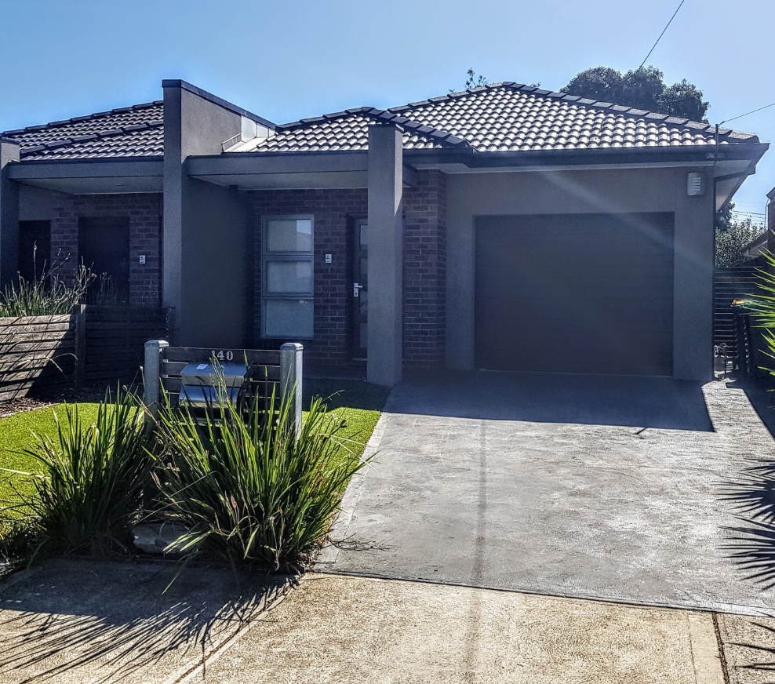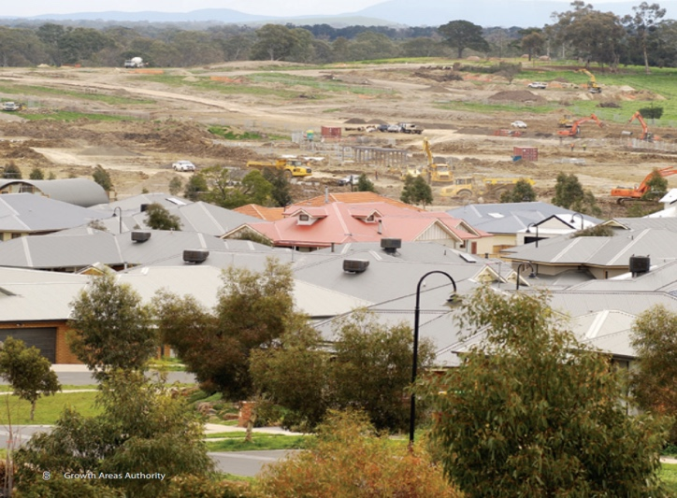
Greenfield Growth Area Development

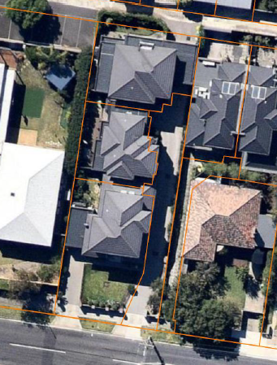 | 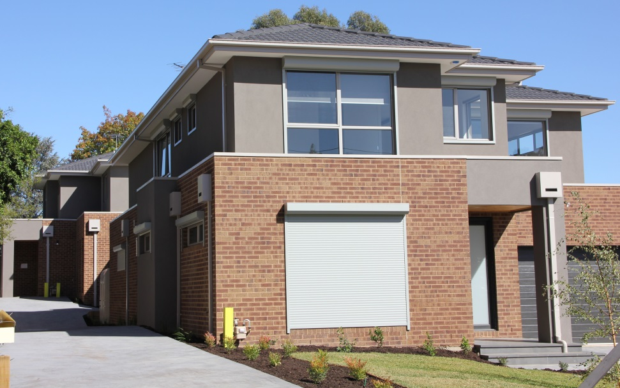
Small Scale Dispersed Infill Development in middle and outer established areas (SSID)
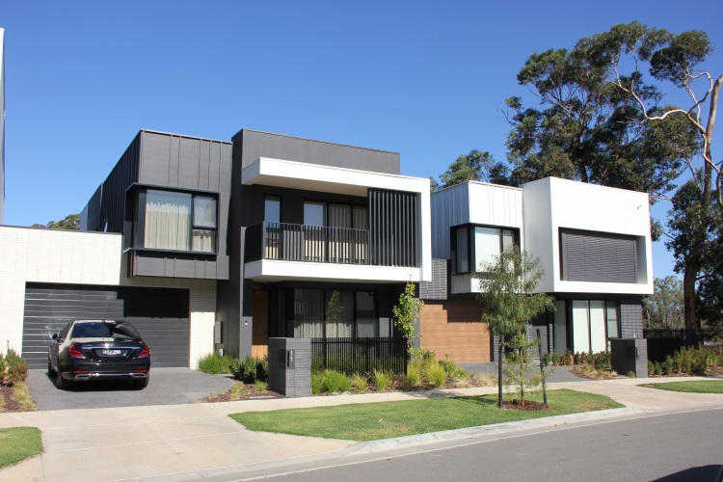 | 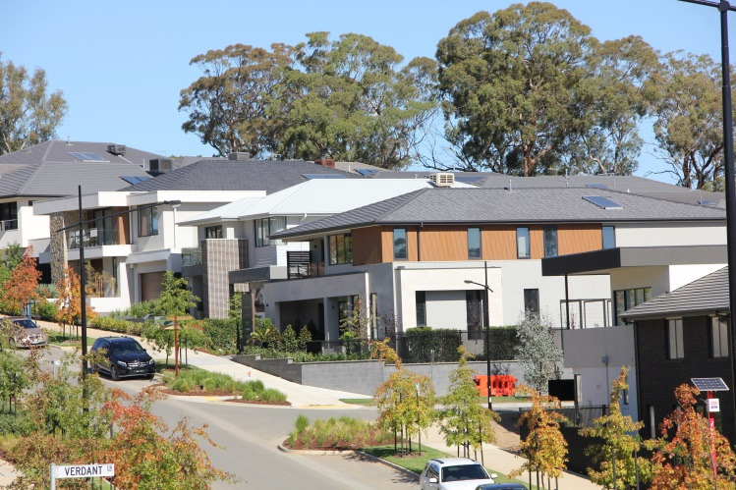
Precinct Scale Brownfield in middle and outer established areas (PSB)

2.6 Four development settings were considered
The following development settings were selected as they combine different development settings and locations. The development settings were chosen as they represent the most common types of residential development currently occurring in Melbourne.

Greenfield Growth Area Development (Greenfield) – Growth areas
Undeveloped land identified for residential or industrial/commercial development, on the fringe of the urban area typically with a residential site density between 10 and 20 dwellings per net developable hectare.

Small Scale Dispersed Infill Development (SSID) – Middle established areas
Residential sites where the building stock is near or has ended its useful life and land values make subdivision (between two and 10 lots) and redevelopment attractive.

Precinct Scale Brownfield Development (PSBD) – Middle and outer established areas
Large single sites or areas usually within the established areas of cities which are no longer used for their previous purpose and are available for redevelopment. Some urban renewal precincts include large parcels of land owned by the government or by a single private owner. Developments may consist of detached, semi-detached or attached residential development estates of one to four storeys. Residential site densities typically range between 20 to 80 dwellings per hectare.

High Density Development in inner areas (HDD) – Inner established areas
Residential flats and apartment buildings of 10 or more storeys. The cost figures provided in this report relate to individual high density developments in established areas, rather than high density brownfield precinct developments such as the inner

Melbourne Arden and Fishermans Bend precincts. In the case of inner Melbourne brownfield precincts additional costs are incurred in repurposing existing infrastructure, such as rerouting services or transferring roadways from and industrial use to rights of way for active transport. Cost savings can also be made through the economy of scale of adopting precinct-wide new infrastructure. Data was not obtained by Infrastructure Victoria to incorporate high density brownfield precinct developments in this report.

Further details of each locational setting are provided in Figure 1 and Box 2.

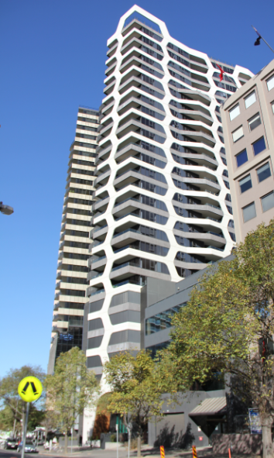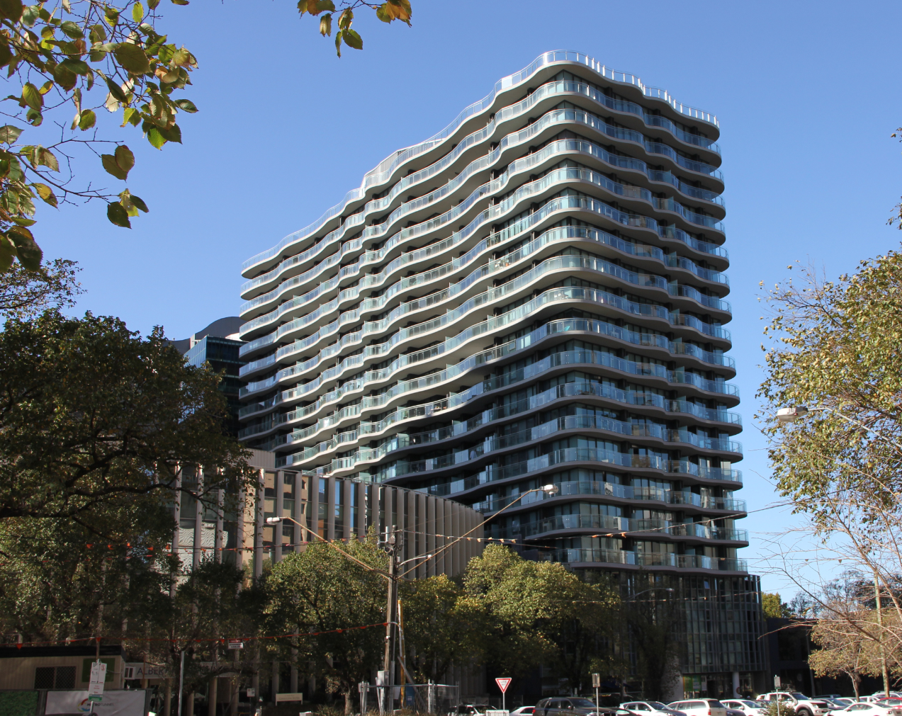
High Density Development in inner areas (HDD)

Figure 1 Melbourne urban areas

Box 2: Location settings
Established areas – regions within Melbourne where urban development first occurred more than two decades ago, which includes inner, middle and outer established areas. Growth areas – broad hectare, greenfield locations in the outer regions of Melbourne designated within Plan Melbourne and local government planning schemes for large scale transformation from rural to urban use. The development of these areas is planned at a precinct scale and housing development typically occurs in stages.
Inner areas – includes the municipalities of Melbourne, Port Phillip and Yarra City, consistent with Plan Melbourne regions.

2.7 Four cost scenarios were considered
As many factors influence the costs of development, the cost ranges presented in this report provide a range of representative costs typically experienced in different development settings in Melbourne. They do not document the full extent of costs that could be experienced in these development settings. Infrastructure sector experts' professional judgment informed our representative infrastructure case studies providing a spectrum across which costs typically vary. We did not choose specific case study sites but identified different urban contexts for each infrastructure element that best displays cost variances.

Table 2 presents the cost scenarios in different development settings, categorised as greenfield and established areas.

For the first three cost scenarios, we assumed that existing infrastructure in established areas has the capacity to support growth through incremental expansion, without requiring major upgrade of utility trunk infrastructure or provision of new social infrastructure. This is likely for the majority of infrastructure elements in the near future and potentially for the next 15 years depending on how the city develops. We present a low, medium and high cost case study in this context to show how costs can vary due to factors within the development precinct or in connecting the development precinct to existing infrastructure. An upper limit fourth scenario assumed existing infrastructure did not have the capacity to support additional population growth, in which case existing utilities required a significant upgrade (rather than incremental expansion) and full provision of social infrastructure would be required.

In the greenfield development setting all cost ranges assume that full provision of social infrastructure would be required, as often no existing social infrastructure exists within a new precinct. We acknowledge however that there are cases where a greenfield precinct is adjacent to existing development and is able to share some community facilities.

Table 2: Cost scenarios considered
Cost scenario | Greenfield treatment | Established area treatment
- Low cost with established area infrastructure capacity to support growth | Low level of the cost spectrum adopted for costs within the development estate. No requirement to augment existing utility infrastructure outside the development estate. Full provision of social infrastructure. | Low level of the cost spectrum adopted for costs within the development estate. No requirement to augment existing utility or social infrastructure outside the development estate. | Assumes existing infrastructure has the capacity to support growth
- Medium cost with established area infrastructure capacity to support growth | Medium level of the cost spectrum adopted for costs within the development estate. Partial requirement to augment existing utility infrastructure to connect the development estate. Full provision of social infrastructure. | Medium level of the cost spectrum adopted for costs within the development estate. No requirement to augment existing utility or social infrastructure outside the development estate, with the exception of schools. Allowance has been made for increasing the capacity of existing schools by the provision of additional classrooms.
- High cost with established area infrastructure capacity to support growth | High level of the cost spectrum adopted for costs within the development estate. Requirement to extend existing utility infrastructure to connect the development estate. Full provision of social infrastructure. | High level of the cost spectrum adopted for costs within the development estate. No requirement to augment existing utility or social infrastructure outside the development estate, with the exception of schools. Allowance has been made for increasing the capacity of existing schools by the provision of additional classrooms.
- High cost without established area infrastructure capacity to support growth  (i.e. providing the upper level costs for all infrastructure) | High level of the cost spectrum adopted for costs within the development estate. Requirement to extend existing utility infrastructure to connect the development estate and augment existing infrastructure. Full provision of social infrastructure. | High level of the cost spectrum adopted for costs within the development estate. Requirement to augment existing utility infrastructure outside the development estate. Full provision of new social infrastructure. | Assumes existing infrastructure must be upgraded to support growth

3. Key findings on existing infrastructure constraints to increased residential developments

3.1 Most existing infrastructure can be incrementally expanded so as not to constrain residential growth

We found that the majority of infrastructure supporting residential development can be developed incrementally so as to not constrain anticipated housing growth over the next 15 years in Melbourne. The majority of infrastructure supporting residential development can be designed and delivered within a three to five-year period, enabling it to keep pace with housing development, subject to funding being allocated in a timely manner. Transport, open space and stormwater infrastructure in established areas are the three exceptions. Transportation cannot efficiently be upgraded incrementally in many instances, requiring large scale upgrade projects to increase capacity, which require considerably longer lead times to implement. Within established areas, no consistent standard has been adopted for the quantity of open space which should be met and consequently we are unable to confirm capacity of open space to support growth across Melbourne. Inadequate stormwater drainage infrastructure exists in localised pockets across all of Melbourne's established areas and at these locations a challenge already exists to support existing housing prior to additional dwellings being added. New dwellings in these locations are therefore provided so as to not increase stormwater discharge from the site, however the cost and spatial requirements to address this can be a constraint on development.

Within Melbourne, the capacity of existing infrastructure to support residential development growth varies at different locations. Excluding transport and water sector infrastructure, the differences are predominantly due to whether the infrastructure is supporting housing in established areas or in growth areas. Transport and the water sector do differ. Previous transport infrastructure investments decisions have left a legacy of higher accessibility in the inner areas and towards the south and east. Melbourne's main water supply is located to the east and the city's topography influences service provision. Stormwater infrastructure constructed in established areas prior to the 1970's has been provided to a lower standard.

This study considers the varied costs of infrastructure in different locations with different development types in Melbourne, based on current practices. Future infrastructure service provision could vary significantly with technological advances and climate change as two significant disrupters. Over 30 years, the infrastructure sectors likely to experience change or disruption in the future are:

- The transport sector – through the introduction of autonomous and electric vehicles.
- The water sector (sewer, water supply and stormwater management) – climate change and population growth are likely to place pressure on water supplies and drive broader adoption of integrated water management approaches in the future.
- The energy sector – adoption of localised and centralised forms of renewable energy generation and the wide scale adoption of zero emission vehicles may change the distribution and transmission network demand profiles and requirements.
- The telecommunications sector – new telecommunication technologies will develop rapidly and data transfer requirements are likely to increase.
The health and education sector – new technologies could change the way these government services are delivered.
We discuss each infrastructure element in more detail in the following section of the report and provide spatial representation in Figure 2.

3.2 Transport infrastructure is seeing significant capital investment
Many varied factors affect the cost of infrastructure besides the development setting, but we have been able to identify typical cost ranges for most types of infrastructure in different settings. Apportioning transport infrastructure costs is more complex than most other infrastructure elements, as service levels have a broader variance than other infrastructure and households have choice on how they use the infrastructure supplied. Service levels vary significantly across Melbourne in relation to mode choices available, frequency of service and accessibility to multiple locations, whilst an individual household can choose between mode of transport and destination, where options exist. For this reason the report only considers the relative cost of transport in the context of average levels of expenditure for Melbourne and does not identify cost ranges for different development settings. The capital and operational costs for additional transport, both historic and forecast investment, have been considered at a metropolitan level.

As Melbourne continues to grow, so has the total amount of investment in transport infrastructure and services. Over the past 10 to 15 years, transport investment has been largely incremental, building off a high base of designed and existing capacity. However as this designed capacity has begun to be filled through incremental capacity upgrades (such as investments in widening existing road corridors) or through better use of existing infrastructure (such as running additional rail services through purchasing additional rolling stock) Melbourne, as with other cities in Australia has reached a point where step changes in transport investment are being made and/or planned to meet growing demand for travel.

This can be seen through recent major transport investments, such as Melbourne Metro Rail Tunnel, where in order to continue to provide additional rail services a new major transport project, requiring a new corridor is required, on a scale which has not been built in several decades. This is not isolated to public transport, with major planned road investments such as West Gate Tunnel and North East Link representing a step change of a size that is above historic projects, reflecting the rate and scale of growth in travel demand.

In addition to considering investment trends over the past 10 to 15 years we have examined a projection for the potential future development of the transport network, developed by the Department of Transport (DoT). This "Reference Case Network" has been created in order to provide a realistic potential forecast of transport network development for planning purposes given a set of assumptions, such as the Victoria in Future population projections. While the figures contained in this report are built from investment over the past 10 years, our examination of the Reference Case Network suggests these figures may be conservative. The recent uptick in transport investment may be a better indication of future sustained levels of high investment, especially to support a "business as usual" future.

3.3 The water sector is moving towards an integrated water management approach, which offers the opportunity to support housing growth without further loading of central trunk infrastructure
The Victorian water industry is adopting a more integrated approach to delivering water services to create more sustainable and liveable communities. Integrated water management (IWM) brings together all facets of the water cycle to maximise social, environmental and economic outcomes. Planning is more integrated across the three subsectors of water supply, sewerage and stormwater management, and can enable localised treatment and reuse of water resources. The industry is working to develop cost effective solutions for established areas, however currently the greatest opportunities to obtain the benefits of IWM in a cost effective manner exist in greenfield developments or large scale brownfield precinct developments where completely new infrastructure systems are required. In growth areas for example, the Metropolitan Retail Water Corporations have the authority to mandate that residential developments provide a second water reticulation system for nonpotable water, commonly called a `purple pipe' system, enabling new infrastructure responses. The extent of these mandated areas is indicated in Figure 2.

The capacity of established area water and sewer trunk and distribution infrastructure to support additional growth in established areas is dependent on several factors. Growth can be supported in multiple ways and will be influenced by future water use patterns and the effects of climate change. The existing water infrastructure has the capacity to support growth with incremental expansion in the short term, but high levels of population growth are bringing forward the time at which that capacity may be exceeded. The industry has started to investigate this issue in more detail, in parallel with adopting an integrated water management approach.

The majority of the water sector infrastructure in Melbourne has been constructed to suit traditional delivery methods where, water supply, sewerage and stormwater management are serviced by separate centralised infrastructure systems. The scale of the system is well suited to ongoing incremental expansion to support growth in the short term, however as the capacity of the system to support growth is used up, adopting IWM approaches in greenfield and precinct scale developments may become more cost effective.
16 Infrastructure Provision in Different Development Settings

3.4 Water supply infrastructure is constrained to support growth in outer growth areas of Melbourne
The Department of Environment, Land, Water and Planning and water businesses have undertaken scenario-based planning to determine water supply and demand profiles for the next 50 years, due to the many varied factors that have an influence. This analysis indicates that dependant on which scenario eventuates, Melbourne may require a new supply of water by 2028 or alternatively our current water supplies may be sufficient beyond 2065. Potential sources of additional supply identified by Infrastructure Victoria in the 2016 30-year infrastructure strategy include:
- 50GL Victorian Desalination Plant expansion
- new desalination plant
- increased use of recycled water for potable substitution
- broader scale rainwater, stormwater and wastewater harvesting to reduce use of potable supplies and treat for potable use
- water grid optimisation
recycling of water for direct potable use.
As Melbourne's water supply system is interconnected, a water supply shortfall will impact most locations within the metropolitan area equally. The exception is areas serviced by Western Water. Western Water's water supply comes from within its existing catchment with an allocation from Melbourne Water, provided since 2004. The Melbourne Water allocation does not however allow for any supply from the desalination plant (Melbourne Water 2018a). In drought periods Western Water's supply shortfall risk is therefore higher than the other Melbourne retail networks.

Based on Victoria in the Future 2016 (VIF 2016) population forecasts, by 2050 provision of additional dwellings will be constrained in particular in locations (shown in Figure 2) requiring a significant augmentation of the existing infrastructure, rather than just incremental expansion. This could be managed by increased adoption of recycled water in localised treatment facilities in greenfield areas, an upgrade of the Melbourne Water trunk network, or a combination of both. There is not a defined trigger point, as the timing of these works will depend on whether centralised or localised approach is taken, the volume of supply water available, and the rate and location of population growth. The major responses that could support growth area expansion with traditional water supplies are:
augmentation of the Greenvale Reservoir (the major water supply point for the western suburbs and the northern growth
- areas)
- provision of new water storages and trunk infrastructure in the northern growth area
- augmentation of the water supply to the south east growth area.

Water distribution networks will also be able to be incrementally expanded to support growth with the need for upgrades of existing infrastructure in established areas increasing over time.

(Sources for this section Melbourne Water 2014b, 2017b, 2017c).

Figure 2 – Spatial distribution of dwelling growth and infrastructure across Melbourne

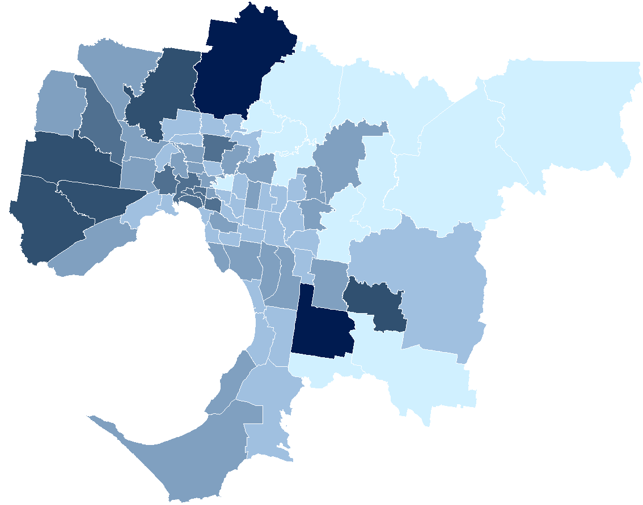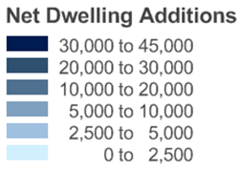
VIF2016 – Projected dwelling change (net additional dwellings) by Victoria in Future Small Area (VIFSA), 2016 to 2031
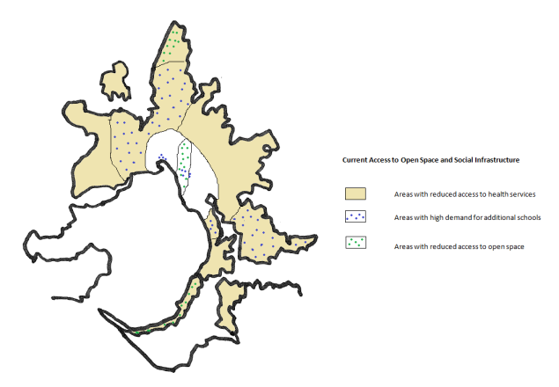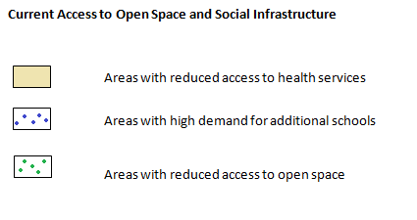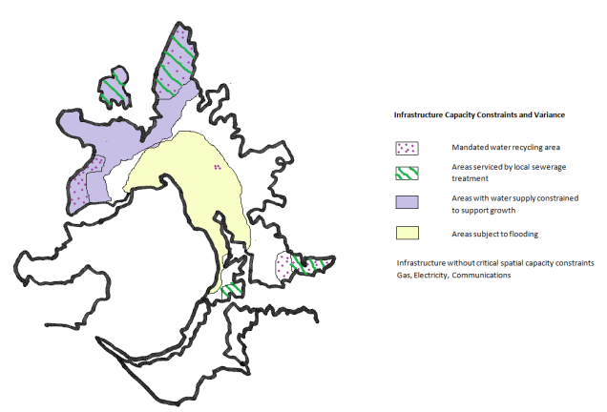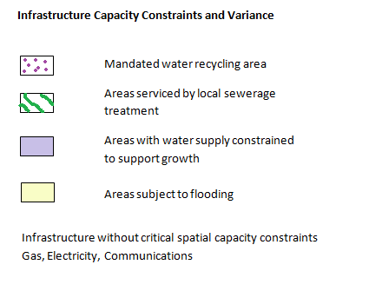
Areas with low accessibility to health services by car or public transport

3.5 Sewerage infrastructure does not pose a significant constraint to growth as the existing system is well suited to incremental expansion or the adoption of localised treatment

The water authorities have recently released a long term sewerage strategy (Melbourne Water 2018c). Over the long term, water businesses will need to invest in new and upgraded sewerage infrastructure to cater for:

- Climate change – rising sea levels impacting existing treatment plants, warmer weather and more severe storm events impacting on the performance of the system and drier conditions increasing the need for environmental watering.
- A growing population – increasing at a rapid rate.
- A changing urban environment – transitioning from suburbs with large backyards to a mix of high and medium density along with sprawling suburbs on the fringe of the city.
- Increased demand for recycled water for many purposes.
- New approaches to how we deal with waste – moving towards a circular economy.
- New technology, increasing affordability of safe, micro-scale alternatives for water supply and sewage treatment, and how we build, monitor and maintain the sewerage system.
- The impact of changing industries and emerging contaminants – changing the composition and treatment requirements of sewage.
- Replacing ageing assets.
Changes in regulations and environmental standards
The sewerage system has multiple components including the sewerage collection system (or network), treatment, winter storage of effluent and effluent and biosolids release or reuse. The Melbourne metropolitan retail water corporations' reticulated sewage collection systems take sewage from households, commercial and industrial premises and transfer 90% of it to the Melbourne Water-operated transfer system and treatment plants. The remaining 10% is serviced by treatment plants operated by the Melbourne metropolitan retail water corporations in the regions highlighted in Figure 2 (MW 2017a).

Projected population growth can be supported at most locations in Melbourne through the incremental expansion of the sewerage transfer and treatment system.

Melbourne Water's centralised treatment plants have the capacity to support Melbourne's projected population growth for the next 30 years with incremental augmentation. The treatment plants' design and large scale are well suited to this approach. The majority of sewage is likely to continue to be treated by these centralised plants, however a portion will be treated in standalone treatment facilities in the vicinity of new developments. The adoption of central or local treatment will be determined by the particular conditions at each location, based on a full assessment of the costs and benefits. The ability to discharge treated effluent into the local waterway system or distribute effluent for reuse as a recycled water supply will limit local treatment. Limitations on central treatment are the cost of extending the existing network or undertaking upgrades in established areas to the existing trunk infrastructure.

The sewer collection and transfer network is predominantly designed to deal with dry weather flows and contain wet weather flows under a gravity fed system. During wet weather additional water enters the system, increasing the volume of sewage above dry weather flow levels, creating higher volumes of sewage to be transferred and treated. Where the gravity system can no longer support peak wet weather flows, the system can be supplemented with local detention storages, pumped systems or expanded by augmentation of the gravity fed system. Sewer networks in established areas typically have the capacity to absorb the projected increased population. As the system capacity is limited by wet water flows and new developments provide improved pipework that should reduce stormwater infiltration, new developments should be able to be accommodated in principle. Increased loads on the system due to population growth will however at some stage exceed the capacity of the existing system. In large redevelopment precincts such as Fishermans Bend, precinct-wide solutions will be adopted to economically deal with the additional sewer loads. The most economical approach will be taken for the region based on integrated water management principles, considering the options of linking in to the Melbourne Water transfer and treatment system or providing localised solutions.

Outer growth areas are not as readily serviced by existing sewerage infrastructure and will require new treatment facilities or extended connections to the Melbourne Water system. In western growth areas, a link into the Melbourne Water system is currently the most economical solution, however this could change in the future. In the northern and south eastern growth corridors, localised systems may be more economical due to their remoteness from treatment facilities and the topography. This new infrastructure can be planned and implemented within a timeframe required to support demand.

Some areas in Melbourne's outer established areas still have septic tank systems which are not connected into a reticulated system. Water authorities are reviewing options for optimising performance and mitigating risks of the septic tank systems with local communities. Reticulated systems are costly to install and operate in these locations due to the terrain and lack of access to trunk infrastructure. Upgrades are mainly required to service existing customers rather than supporting expansion as densification is not typically targeted in these locations.

(Sources for this section Melbourne Water 2014b, 2017b, 2017c, 2018b, 2018c).

3.6 Stormwater drainage infrastructure provides highly varied outcomes across Melbourne with developments in greenfield areas delivered to meet a standard whilst development in established areas is generally designed to mitigate increased risk

Stormwater drainage is required to protect property from flooding and to maintain water quality and biodiversity standards in receiving waters under fluctuating rainfall conditions, whether these are urban rivers and creeks or the bays. Inadequate stormwater drainage infrastructure exists in localised pockets across all of Melbourne's established areas constructed prior to the late 1970's, after which time improved stormwater drainage standards were introduced.

Flooding resulting in property damage does not affect all of the established area, but there are 232,000 properties at risk of flooding across Melbourne, with affected areas shown in Figure 2. Some areas are subject to a higher frequency of events (Melbourne Water Flood Mapping and Planning Schemes 2015 Fact Sheet). Due to the substantial cost and impracticality of an infrastructure response to rectify the risk of flooding in established areas, Melbourne Water has adopted non-infrastructure approaches to deal with the existing risk, including information provision, communication of potential incidents, insurance and careful management of new development.

Addressing water quality and biodiversity standards in waterways involves several parties and consequently the approach to address this in established areas is evolving, with climate change effects presenting a compounding risk in the future. In the interim, in established areas, developments are required to adress flood risk through the built form of the development and not increase flood risk to the area, as opposed to meeting the same broader outcomes required in greenfield growth areas.

3.7 Electrical infrastructure does not pose a significant constraint to growth as the existing system is well suited to incremental expansion
The electricity transmission and distribution network infrastructure in Melbourne is generally able to accommodate future demand through incremental expansion. The electrical distribution infrastructure is designed in an integrated manner, with the assets interconnected through a mesh-like system. Stakeholders have not identified in any large long term constraints which could make development in different geographical locations across Melbourne more challenging or costly. Existing system redundancy is not as strong in some specific locations, particularly where the network is less extensive (generally in outer metropolitan Melbourne). Locations with low redundancy will be addressed by the distribution companies over time as part of their asset planning process.

The following findings are based on discussions with experts from the service provider organisations and are informed by their professional judgement:
- In general, the relatively integrated nature of the infrastructure within each distributor’s network enables augmentation in locations with limited supply. This is more readily achieved in locations with higher density as the distances between substations is less and more options can be accessed. Greenfield locations have fewer alternative solutions to meeting new demands as fewer substations exist.
- Each service provider noted locations where higher levels of demand are currently forecast than the existing system is designed to accommodate. For example, demand in locations at the edge of the urban growth zone currently experiencing higher than average growth levels is not offset by corresponding declines in industry and locations such as the Mornington Peninsula and Phillip Island have peak demand due to seasonal populations. However, this information changes frequently as a result of new developments (or closures) and upgrades occurring. Each distribution business captures these changes in their forecasting work and addresses the issue in their asset planning.
- More redundancy exists in Melbourne’s Central Business District which provides greater system supply security. This is in part a response to sub-transmission (supply to city) issues that occurred in 2007 and 2009, which are now rectified.
- Within Metropolitan Melbourne, the distribution network generally has sufficient capacity for expected demand and the system’s versatility allows for transfer of energy if needed. It should be noted that some parts of the network require additional capacity due to increased demand from large infill developments, expanded existing or new large electricity consumers. Other challenges for the distribution systems include:
  - Larger scale projects such as precinct scale or large brownfield developments take time which requires additional lead time for planning upgrades. Developments such as data centres are energy intensive but can be accommodated if planned at least two years ahead.
  - Incremental growth such as new low-rise apartment or multi-dwelling townhouse developments is more challenging to plan for and deliver, especially as the trigger for network upgrade is not one single large scale development. High, rather than medium density developments can be easier to implement as they are required to accommodate their own dedicated substations on site, rather than share substation infrastructure with other developments.
  - Land availability for upgrades/additional substations and distribution line easements is an increasing problem in all development settings and requires better integrated planning.
  - System management due to the reduced variability in demand across customers. As a greater proportion of users are residential customers requiring electricity at the same times, the infrastructure must deliver the daily demand in higher volumes over a shorter time period.
  - Adoption of localised and centralised forms of renewable energy generation and the wide scale adoption of zero emission vehicles may change the distribution and transmission network demand profiles and requirements.

3.8 Gas infrastructure does not pose a significant constraint to growth
Gas differs from other utilities as it is not an essential service and is not required to be connected to every dwelling.

Stakeholders have advised that gas services are currently adequate across Melbourne and future demand can be serviced through incremental system expansion. The Western Outer Ring Main (WORM) project has been accepted in the regulators access arrangement for the period 2018 to 2022, and on its completion, the project will provide the `missing link' in the Victorian Gas Declared Transmission System (DTS) servicing Melbourne (Apa 2017). Constraints on growth in Melbourne are then unlikely to be caused by transmission system infrastructure if current usage patterns do not alter significantly. The transmission system's configuration will also enable an increase in dwellings to be serviced at any location across Melbourne within the urban growth boundary. With the state-wide gas distribution mains upgrade nearing completion and several industrial facilities closing, the distribution network has some additional redundancy. Therefore no major constraints exist in the system to make development in different development settings or geographically across Melbourne significantly more problematic or costly.

Key issues identified by stakeholders as impacting the ability to service growth in demand for gas services include:
- completion of the distribution system upgrade to a high pressure system
- distance from the development location to the transmission system supply point or `city gate'.

3.9 Telecommunications infrastructure does not pose a significant constraint to growth
The Australian government is currently delivering the National Broadband Network (NBN) across the country through NBN Co., which will provide telecommunications services to all premises. Prior to completion in 2020, the Commonwealth Government has developed policies to outline how telecommunications services are to be delivered as the rollout proceeds.

NBN Co. determines the infrastructure solution to connect each dwelling based on the existing infrastructure to which a new dwelling is to be connected. The dwelling owner can request a higher service level if they are willing to pay an additional contribution. The internet service level provided depends on the infrastructure solution adopted; fibre to the premises (FTTP) is the highest level of service. Typically an FTTP solution is available in greenfield areas, while established areas have a fibre to the node (FTTN) solution using existing copper networks to reduce costs. As technology continues to develop, technical solutions other than FTTN for established areas are developing which will facilitate improved service levels.

Developers are currently required to organise basic voice and internet service telecommunications infrastructure in new developments in Victoria. The developer is responsible for negotiating with a network or service provider to provide the telecommunications infrastructure to the development estate. They must also lay communication pits and conduits for a telecommunications network or service provider to run cabling to connect each dwelling. Prior to statutory certification of a completed subdivision, all dwelling lots must be either connected to or certified as ready for connection to telecommunication services. Internet services do not have to be connected at completion of a dwelling however, if the NBN is not already available at the development estate. In this instance temporary connections must be provided by Telstra to enable basic voice calls to be made from new dwellings by a technology determined by Telstra including fibre, copper cable or wireless.

(Sources for this section: Australian Government 2017, Department Transport, Planning and Local Infrastructure 2013)

3.10 Social infrastructure is under pressure to support increased residential development in all development settings, but subject to funding being available, can be developed so as not to constrain growth

School infrastructure

Since 2011, Victoria has experienced rapid population growth. Victoria in Future 2016 (VIF 2016) projects that Victoria's school-aged population (five to 17-year-olds) will increase by approximately 90,000 students (or nearly 10%) between 2017 and 2022. Parent choices also affect demand for individual schools. Currently, 52% of government primary school enrolments and 53% of government secondary school enrolments come from outside the local school catchment (VAGO 2017).

Stakeholders have advised that new schools can be developed within five years, from starting to plan to opening a school. Schools can therefore be incrementally provided to support growth subject to funding being made available. Acquiring new land for schools in established areas where existing schools do not have the capacity for growth and staging school development to support growth are the main planning challenges. Relocatable buildings are utilised to facilitate staging school developments and fluctuating student numbers.

Based on VIF 2016 projections to 2031, all of Melbourne's established areas will need increased school capacity by 2031. Use of surplus public land and existing school sites with space to expand can keep the cost of established area school infrastructure similar to costs in greenfield areas, however Infrastructure Victoria has not analysed the availability of land for this purpose and recognises that obtaining suitable land can be challenging.

Community social infrastructure: Health, community and emergency services
Victoria's health system will have to expand to meet future growth demands, however this can be done incrementally. Victoria's existing health services are not geographically aligned with current or projected demand for services. Existing services are concentrated in the inner south and east of Melbourne, resulting in unmet demand in Melbourne's outer areas. People have to travel to services, particularly from the western and northern metropolitan growth areas. Past decisions about the location of health infrastructure investment and workforce issues resulted in this concentration (Travis DG, 2015). Existing literature identifies demand for additional health service in outer areas, particularly in the north and west (DHHS, 2016 and VAGO 2017a).

In established areas, population growth can often be supported by existing infrastructure already constructed for these purposes. Where the existing facilities do not have the capacity to service growth, they can potentially be expanded. Other underutilised facilities such as local government spaces or community halls could be adapted to meet changing community needs, including becoming technology enabled. Where these options are not available, land will need to be acquired by state and local government, which is costly in established areas.

Community social infrastructure can be developed within five years, from initially starting to plan the facility to opening. Community social infrastructure can therefore be incrementally provided to support growth subject to funding being made available.

3.11 Other context

Expansion beyond the urban growth boundary has not been considered in this report
This report has considered the infrastructure issues within the urban growth area of Melbourne but has not analysed infrastructure issues relating to peri-urban areas beyond the metropolitan area's urban growth boundary (UGB). Discussions with utility providers highlighted that Melbourne's infrastructure networks are typically planned only to service areas within the UGB. Trunk infrastructure extending to the perimeter of the UGB is therefore unlikely to have additional capacity to service peri-urban residential growth. Future peri-urban growth may therefore be unable to leverage the economies of scale and preexisting investment in Melbourne's utility infrastructure in the future.

Infrastructure planning horizons are being brought closer due to high levels of population growth.
Across all infrastructure sectors, high levels of population growth forecast for Victoria are reducing infrastructure planning time horizons. The Victorian government's population projections have consistently revised their forecasts upwards over the last 10 years. As a result, some infrastructure sectors need to carry out further work to confirm service planning assumptions and the scale of upgrades to trunk infrastructure to support projected growth. Plans developed over 10 years ago which aimed to address demand over 20 or 30 years need to be updated as projected 30-year demand is now more likely to occur within the next 15 years. This issue is particularly pertinent to the water sector with its centralised supply/treatment facilities in Melbourne.

Effective use of public land is a key factor in addressing a shift to higher residential densities
The availability or lack of public land in established areas to support open space use, recreational use and green and traditional infrastructure provision (such as flood ways and utility easements) is a critical issue. As established area infrastructure capacity to support growth is absorbed by population growth, this issue will become more urgent for Melbourne. The effective and efficient use of public land is a key factor in shifting to higher residential densities. Community attitudes towards how space is used will need to shift to most effectively leverage the space that we have.

For example, land acquisition costs for schools in inner Melbourne can be double to triple a greenfield school site. The Department of Education and Training is trialling new models of higher density school construction and adopting shared spaces to address this issue. As established area infrastructure capacity diminishes with population growth, this issue will become more significant for Melbourne. Land transfers between different levels of government and across departments within the same tier of government could lead to land being used more efficiently, noting that there are costs and transaction issues involved.

Responding to changing standards and community expectations will impact on costs in the future

Emerging issues of changing standards or community expectations for new/expanded infrastructure may be different from historic provision in established areas and this may materially affect costs, in many cases increasing the relative cost of established area development compared to greenfield development. Examples of where this could be experienced include:

- requirements for gas pipeline protection works to be provided for major development near existing trunk gas infrastructure
- more stringent drainage requirements arising from the need for increased environmental controls requiring on-site solutions to be adopted
- localised infrastructure solutions such as sewerage treatment and energy generation plants requiring land to be acquired.

4. Key Cost Findings

4.1 Basis of cost analysis

The relative costs of different infrastructure elements in relation to each other and to different development settings are provided in this section of the report. More detailed information on each infrastructure element and a high level cost summary is available in the technical appendices.

The paper uses the following inputs:

- Infrastructure costs incurred by developers within a development estate description and cost data provided by technical consultants (SMEC).
- Utility (water sector, gas and electricity) cost to augment the existing network and provide new development connections obtained from utility service providers. Service provider information included information in pre-existing public reports (listed in Section 5), confidential reports and cost data and cost estimates for the scenarios proposed, based on the professional judgement from technical experts within the utility organisations consulted.
- State government infrastructure costs (transport, community, health, education and emergency services) obtained from reports in the public realm, confidential sources and technical consultant cost estimates as noted in the table below.

Where we have used data assembled for other purposes, interpretation of the findings is kept at a high level. This approach is summarised in Table 3 below. Refer to the notes accompanying the table for qualifications on cost data confidence.

Table 3: Cost data sources
Infrastructure element | Cost source | Confidence in cost data
Dwelling | Capital Cost Data  Data provided by Charter Keck Kramer on average land acquisition costs across Melbourne  Dwelling data provided by Rider Levett Bucknall (RLB) based on industry  data bases  Operation Maintenance and Replacement (OMR) Cost Data  Not applicable | High  High
Transport infrastructure | Capital Cost Data and OMR Data  Average Melbourne data calculated from Victorian State Budget Papers for the years 2009/10 to 2016/17 | Mod
Civil works | Capital Cost Data  SMEC data assembled from civil contractor tenders and development cost plans  Operation Maintenance and Replacement (OMR) Cost Data  SMEC benchmark rates based on percentage of capital cost | High  Mod
Stormwater  (cost included in civil works item) | Capital and OMR Cost Data  Within the development estate : Data assembled from consultant cost database (SMEC 2018)……………………………………………………………………………………………….  Outside fo the development estate : Melbourne Water Essential Services Commission (ESC) water price proposal……………………………………………………………………… | High  Mod
Sewerage & water supply infrastructure | Capital Cost Data  Average Melbourne data:  SMEC data within the development estate  Essential Services Commission (ESC) water price proposals for retail water  corporations (10-year period) and Melbourne Water (5-year period)  Development Setting Costing:  SMEC data within the development estate  Case study data and feasibility analysis reports provided by water corporations  Operation Maintenance and Replacement (OMR) Cost Data  ESC water price proposals for retail water corporations (10-year period) and Melbourne Water (5-year period)  Average Melbourne data:  Development Setting Costing: | High  Mod  High  Mod  Mod  Low
Electricity infrastructure | Capital Cost Data  Average Melbourne data:  SMEC data within the development estate  Australian Energy Regulator (AER) access arrangement proposals for electricity distribution (8-year period 2009-2016) and declared shared network providers  (5-year period 2017-2022)  Development Setting Costing:  SMEC data within the development state  Case study data and feasibility analysis reports provided by electrical  distribution companies  Operation Maintenance and Replacement (OMR) Cost Data  Australian Energy Regulator (AER) access arrangement proposals for  distribution (8-year period 2009 -2016) and declared shared network  providers (5-year period 2017-2022)  Average Melbourne data:  Development Setting Costing: | High  Mod  High  Mod  Mod  Low
Gas infrastructure | Capital Cost Data  Average Melbourne data:  SMEC data within the development estate  Australian Energy Regulator (AER) access arrangement proposals for gas  distribution and transmission providers (10 year period 2017-2022)  Development Setting Costing:  SMEC data within the development estate  Case study data and feasibility analysis reports provided by gas  distribution companies  Operation Maintenance and Replacement (OMR) Cost Data  Australian Energy Regulator (AER) access arrangement proposals for  distribution (8-year period 2009 -2016) and declared shared network  providers (5-year period 2017 -2022)  Average Melbourne data:  Development Setting Costing: | High  Mod  High  Mod  Mod  Low
Telecommunication infrastructure | Capital Cost Data  Infrastructure within the development – pits and conduits: SMEC cost data base  Fibre and network connection : NBN full year results 2017  Operation Maintenance and Replacement (OMR) Cost Data  SMEC benchmark rates based on percentage of capital cost | High  Mod  Low
Community infrastructure | Capital Cost Data  RLB estimates based on benchmark area provision rates in different locations  Operation Maintenance and Replacement (OMR) Cost Data  SMEC benchmark rates based on percentage of capital cost | High  Mod
Emergency services infrastructure | Capital Cost Data  Rider Levett Bucknall estimates based on benchmark area provision rates  in different locations  Operation Maintenance and Replacement (OMR) Cost Data  SMEC benchmark rates based on percentage of capital cost | High  Mod
Health infrastructure | Capital Cost Data  Rider Levett Bucknall estimates based on benchmark area provision rates  in different locations  Operation Maintenance and Replacement (OMR) Cost Data  SMEC benchmark rates based on percentage of capital cost | High  Mod
Education infrastructure | Capital Cost Data  Obtained from Victorian State Budget Papers with land values  confidentially advised  Operation Maintenance and Replacement (OMR) Cost Data  Benchmark rates based on percentage of capital cost | High  Mod

Notes accompanying Table 3:

- For the upper limit fourth cost scenario (as described in Table 2), the confidence in cost data is low as there are many varied factors affecting what infrastructure solution may be adopted.
- The categorisation of high, mod and low confidence in cost data for the purposes of this report has been determined as follows:
  - High: The infrastructure response is well defined and the costs have been developed from a cost data base.
  - Mod (moderate): The infrastructure response is less well defined and the costs have been developed from a limited sample of costs, requiring professional judgement on the interpretation or the costs have been compiled for a different purpose and there is some risk of error in their interpretation as an average figure for Melbourne.
  - Low: The costs have been compiled from limited information or the costs have been compiled for a different purpose and there is risk of error in their interpretation to different development settings.
- Refer to the technical appendices for details on how cost data was verified for each infrastructure element.

Cost assumptions
Where possible, costs are based on existing developments completed in the last five years, from existing cost data bases or from feasibility studies. The costs represent actual infrastructure cost and do not include costs incurred by a given party applied through fees and levies. While service providers may recover a part of their infrastructure provision costs from a developer or dwelling owner, this is not reflected in our reported costs. The costs exclude overheads such as finance and insurance costs, but include incurred costs such as consultancy fees and supplier margins.

Infrastructure costs are presented including the dwelling and land costs, which reflect the total cost to a household for a new dwelling. Land costs in established areas incorporate previous infrastructure investment.

Infrastructure Victoria identified both the capital cost and the ongoing operational, maintenance and renewal (OMR) cost for infrastructure. All of the infrastructure elements have different design lives. We therefore chose a 30-year period for recurrent OMR costs as it represents the average lifecycle of a dwelling that it services. Determining the OMR cost for different development settings is challenging. The way costs are recorded does not allow accurate tracking to a user and networked infrastructure costs cannot be easily apportioned to a user. We have therefore looked at OMR costs at a system or a Melbourne average level to determine their relative magnitude to capital costs.

For OMR costs, we used actual costs incurred where available and benchmark figures when actual costs were not available. Due to the varied age and condition of infrastructure within existing infrastructure networks, the OMR costs have not been developed theoretically adopting a life cycle cost analysis process. Instead for transport and utilities actual expenditure that is being applied to OMR has been adopted, drawn from access agreements, price proposals and budget papers. For social infrastructure benchmark annual cost allowances have been adopted. No discounting of future years' OMR costs are included.

We considered the OMR costs of the infrastructure to transmit and distribute the service, but not the additional cost of generation or provision as this is not impacted by the urban form. Therefore we have not included electricity generation costs, gas production costs, or the water desalination plant provision and operation costs. For the sewerage system we have included sewerage treatment costs as treatment occurs at both centralised and localised plants and varies the cost of infrastructure provision in different settings. We include the costs of maintaining transport infrastructure and operating the rolling stock, including staffing and energy costs.

The `base case' is a greenfield development against which we compare the costs for a generic household in different locations. We assumed a three bedroom dwelling and used community infrastructure greenfield benchmarks for supply per dwelling at all locations. A free standing dwelling was assumed as the greenfield development, a single storey three bedroom unit in the small scale infill development and a three bedroom apartment in the brownfield development and high density development. We note that this will not necessarily reflect actual demand due to the varied demographic mix experience in different development settings, it will however provide a comparative cost basis.

We have used the Australian Social & Recreational Research Pty Ltd's 2008 Planning for Community Infrastructure in Growth Areas (AS&RR 2008) to provide benchmark rates for health, community and emergency services infrastructure in all development settings. AS&RR developed the document for greenfield areas. Adopting a standard supply provision across all development settings allows this project to make equitable cost comparisons. We note that this will not reflect actual demand due to the varied demographic mix experienced in different development settings. It will however provide a comparative cost basis.

4.2 Transport infrastructure is the highest cost infrastructure element involving significant operational costs over a 30-year period

Figure 3 and Table 4 show the average cost of each infrastructure element per dwelling in Melbourne (refer to Table 3 for sources). The costs are reflective of current day service delivery methods and costs, rather than reflecting how services may be delivered in the future 30-year period.

Capital costs are only part of the total costs as recurrent costs for ongoing operation maintenance and replacement over the 30-year life cycle of the dwelling are an almost equally significant cost as shown in Figure 3 below.

Figure 3: Average Melbourne Infrastructure Capital and Operational, Maintenance & Replacement (OMR) costs considered over 30 years – reported as $2018 per dwelling
Source: Infrastructure Victoria analysis

Table 4: Average Melbourne Infrastructure Capital and Operational, Maintenance & Replacement (OMR) costs considered over 30 years ($2018 per dwelling)
Cost  ($2018) | Transport | Civil - Drainage and streetscape | Sewerage | Water supply | Electricity | Gas | Telco | Community infrastructure | Emergency services infrastructure | Health infrastructure | Education infrastructure
Capital | 45,700 | 35,000 | 9,800 | 6,800 | 14,200 | 3,800 | 3,600 | 14,600 | 800 | 1,200 | 16,400
30-year OMR | 70,350 | 34,000 | 8,400 | 6,000 | 9,500 | 7,000 | 3,300 | 13,200 | 700 | 1,100 | 14,800
30-year OMR as a % of capital | 154% | 96% | 85% | 88% | 67% | 190% | 90% | 90% | 90% | 90% | 90%

Transport has the highest cost of all infrastructure elements with the OMR costs over a 30-year period exceeding the capital cost. The transport cost presented represent expenditure over the past 10 years, and our examination of projected future development of the transport network suggests the capital figures may be conservative as noted in section 3.2.

Civil costs are the next largest. Relative to the other infrastructure elements, the costs of telecommunications, emergency services and community health infrastructure are not sizeable. Increased master planning and alternative funding mechanisms could result in cost savings in established area developments with multiple owners, however the potential cost increases will not change the order of magnitude of these infrastructure costs.

Publically available data was used for transport, utility and social infrastructure costs. Social infrastructure costs included in Figure 3 and Table 4 conservatively represent the cost to provide that infrastructure in a greenfield setting, assuming no existing infrastructure is in place to meet demand. Civil costs were not available on a Melbourne wide basis and consequently a representative cost was developed, adopting the medium cost values and assuming 35% of growth is in greenfield development and 65% of growth is in established areas, consistent with VIF 2016.

4.3 Variation in operation maintenance and renewal (OMR) costs
The OMR costs for social infrastructure, (including community, emergency services, health and education), use an industry benchmarked rate applied to the capital cost of the social infrastructure. The OMR cost does not vary as social infrastructure has a similar building form in most development settings. High density development in inner areas are the exception as multilevel buildings are more likely and have higher capital and OMR costs.

Over a 30-year period utility OMR costs are approximately equal to the capital cost of the investment. Not all OMR costs vary with urban form but relate to several components of a networked system. For example, reticulation infrastructure (such as pipelines) are influenced by urban form, but centralised infrastructure such as IT control systems, substations and treatment facilities are influenced by service volumes, rather than urban form. High level information in the utility access arrangements and price proposals show that OMR costs relating to urban form represent approximately 40% to 70% of the total OMR costs. OMR costs for reticulated networks are typically decreasing in new developments compared to the costs presented in this report as new developments are adopting more resilient infrastructure. Two examples are pipework being utilised in new developments is made of 80-year design life materials compared to ceramic pipework, and underground rather than overhead power lines are now adopted. Consideration of relative OMR costs for utilities is therefore less important than capital costs when comparing the costs of infrastructure in different development settings.

The water and sewerage costs in Figure 3 and Table 4 reflect traditional delivery methods. In the future, different infrastructure responses may be developed and OMR costs may increase. Existing sewage reticulation and transmission networks predominantly flow by gravity and provide a low energy solution with significant economies of scale. New systems are likely to have increased costs. For example, energy costs may increase if reticulation is required to be pumped. Similarly, for drainage infrastructure where wetlands and open retarding basins are adopted in lieu of closed stormwater drains, different maintenance regimes may be required, resulting in additional operational costs.

4.4 Capital cost findings across different development settings
Transport has not been included in this analysis as it is not appropriate to apportion transport costs outside the development to a particular development setting, as discussed in Section 2.4 of this report.

Capital costs vary in greenfield and established areas, with civil and social infrastructure displaying the greatest variance
Costs for infrastructure vary in greenfield and established areas as displayed in Figure 4 and Table 5 which show the costs variance of different infrastructure elements across the four development settings under different conditions.

The lowest figure represents Scenario 1 (low cost with established area infrastructure capacity to support growth) and the highest cost represents Scenario 4 (high cost without established area capacity to support growth), as defined in Table 2. Refer to the technical appendices for further details of each infrastructure element's costs.

Figure 4 shows the extent of variation experienced across the various infrastructure elements and settings, displaying why it is hard to apply benchmark costs to different development settings and locations. The data does however give an understanding of the quantum of costs and which infrastructure elements have costs that vary substantially, most notably civil, education and community infrastructure.

Civil costs vary significantly in different developments due to the variance in site specific issues including the geology and topography of the development site, the flood risk and extent of storm water management required (in particular the need to retain stormwater within the development) and varying design requirements dictated by whether the roads will remain as private assets owned by an owners corporation or be transferred to become local government assets.

Education and community infrastructure costs vary in established areas from zero cost where existing facilities can support growth to the upper limit, where new facilities are required and have large land acquisition costs in inner areas, resulting in multistory construction. Higher land acquisition cost can double to triple the cost of a new school in inner Melbourne compared to a greenfield school. In relation to the construction cost of multi-storey dwellings (excluding land), Slattery 2018 states: "Considering all the factors outlined, from planning efficiencies to more complex construction, we believe the additional cost would be in the order of 60%." Established area land acquisition costs can be reduced by accessing publicly owned land such as existing school sites or co-locating educational facilities with parks and other recreational facilities. The cost of an established area school utilising publicly owned land could be approximately equal to a greenfield school. The benefits can be reduced for established area sites however as they may have less expansion capacity and outdoor recreational space than a greenfield site. The Department of Education and Training is currently adopting this approach to leverage existing recreational facilities in Melbourne, which involve complex negotiations and funds transfer between local and state government.

Figure 4: Varied capital costs of infrastructure supporting new dwellings in greenfield and established areas ($2018 per dwelling)
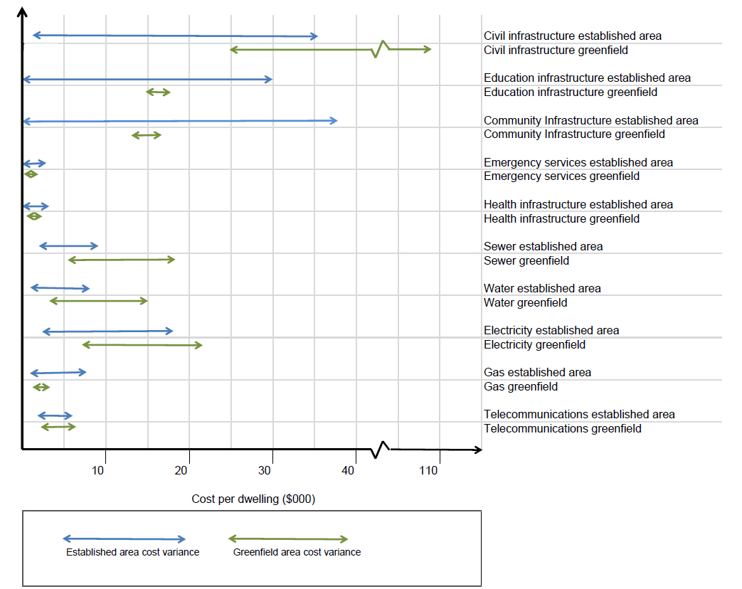
Source: Infrastructure Victoria analysis

Table 5: Capital costs of infrastructure supporting new dwellings in greenfield and established areas ($2018 per dwelling)
Infrastructure sector | Established area |  | Greenfield
 | Low | High | Low | High
Civil Infrastructure | $1,900 | $41,100 | $24,600 | $107,000
Education infrastructure | 0 | $29,300 | $14,900 | $17,600
Community infrastructure | 0 | $38,500 | $14,600 | $18,100
Emergency services infrastructure | 0 | $1,500 | $800 | $800
Health infrastructure | 0 | $2,400 | $1,200 | $1,200
Sewerage | $2,500 | $9,200 | $6,300 | $23,200
Water | $1,000 | $7,900 | $4,100 | $15,500
Electricity | $2,300 | $17,000 | $7,500 | $21,200
Gas | $1,700 | $8,400 | $2,800 | $3,400
Telecommunication | $2,400 | $5,500 | $3,000 | $6,000
Education facility costs are for government schools and do not include non-government schools' infrastructure costs which can vary significantly. If all Melbourne students were accommodated in government schools, greenfield growth area government school provision costs would increase by approximately 60%. The cost in established areas would vary based on land acquisition costs.

Sewerage, water and electricity costs are of the same order of cost as each other, but more expensive in greenfield areas due to service reticulation costs in new developments, particularly when recycled water systems are adopted. The water costs listed include adoption of recycled water systems in the greenfield setting, but do not include recycled water in the established area setting. Costs are lower where established area existing services have the capacity to support growth without augmentation than costs for greenfield development. However costs in established areas can be equivalent to greenfield areas where upgrades are required as the works are undertaken in operational environments requiring system disruptions and traffic management without the economy of scale achievable in greenfield developments.

In greenfield areas, including the dual pipe system for potable and recycled water supply (commonly known as the `purple pipe' system) effectively doubles the water supply reticulation network cost compared to a greenfield development with potable water only.

The capacity of electricity infrastructure outside of a development estate varies the associated electrical costs. The electricity network is more incrementally managed and expanded in contrast to the gas or water networks. Therefore similar developments in similar development settings can have considerable cost differences due to the varied level of surplus capacity in the local network feeding a development.

Gas and telecommunications infrastructure have lower costs relative to other infrastructure elements and show little variance. Provision must be planned, but the infrastructure provision does not need to be considered in detail when planning neighborhood scale urban development alternatives.

Dwelling cost (including land acquisition) is the largest item at over 80% of a new dwelling's capital cost in all development settings

Figure 5 shows the capital infrastructure costs of a new dwelling across the four development settings considered, excluding transport. As shown in Figure 5, the land and construction costs for a dwelling are over 80% of the total capital cost. The chart only shows medium cost scenarios, however the result is similar across all cost scenarios for each development setting with the exception of the greenfield high cost infrastructure scenario, where the land and dwelling cost percentage can reduce down to approximately 60%. It is likely that for the high cost greenfield scenario development would be delayed until infrastructure costs reduced or land values rose. The diagram shows that the capital cost of the dwelling has a very large influence on housing affordability for individual households. The infrastructure costs need consideration however, as cost recovery occurs from both the household and government investment and these infrastructure costs represents a large part of public sector expenditure.

Figure 5: Infrastructure capital cost per dwelling ($2018) for infrastructure elements in different development settings

Source: Infrastructure Victoria analysis

Civil Works are the next big capital cost items
Figure 6 excludes the dwelling cost data to demonstrate the relative costs of infrastructure that supports new dwellings. Civil works are the next largest capital costs, at approximately 20 to 50% of greenfield settings' capital costs, excluding the dwelling cost. These are also a large component of established area development costs, ranging from 40% to 50%, with the exception of high density developments where costs are spread over a large number of dwellings.

Figure 6: Capital cost per dwelling ($2018) for infrastructure elements in different development settings – excluding transport and dwelling cost

Source: Infrastructure Victoria analysis
Infrastructure capital costs vary significantly both within and across different development settings in Melbourne
Figure 7 shows how the capital cost of infrastructure varies significantly both within and across different development settings in Melbourne. The total cost of infrastructure supporting housing, excluding transport, typically ranges from being two to four times more expensive in greenfield areas than established areas. This is the case where the existing infrastructure in established areas has the capacity to support additional dwellings without major upgrade, augmentation or land acquisition to support expansion. This comparison excludes transport costs which would increase the variance further, but we have not quantified this variance for the reasons discussed in section 2.4. The infrastructure elements that significantly contribute to this variance are the civil costs (a predominantly privately funded cost) and the social infrastructure costs (a public cost).The additional cost range of two to four has been determined by comparing the lowest cost scenario in each setting as a lower limit and the highest cost in each setting as the upper limit.

Just as importantly, this diagram shows how infrastructure capital costs can vary:
- by at least double within a given development setting; and
- in an extreme case, being equal in greenfield and established areas, when the greenfield costs are at the low end of the range and established area costs are at the high end of the range.

Figure 7: Capital cost for infrastructure elements in different development settings where established area infrastructure has the capacity to support additional dwellings ($2018 per dwelling)
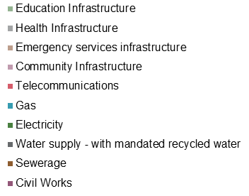
Factor of 4 – high cost scenario
Source: Infrastructure Victoria analysis

Even when established area infrastructure does not have the capacity to support growth, total infrastructure capital costs are unlikely to be more expensive than greenfield areas.

Figure 8 is similar to Figure 7, however the civil costs have been removed and Scenario 4 (high cost without established area infrastructure capacity to support growth, "High no system capacity") has been added. By removing the civil costs, no private costs borne by the household are displayed and all utility costs and public infrastructure costs excluding transport are displayed.

The established area total infrastructure cost is approximately equal to the greenfield cost for Scenario 4 in a high density setting and less for all other scenarios. The main cost variants between established areas and greenfield areas are the social infrastructure costs relating to education and community infrastructure.

The provision of education and community infrastructure in greenfield areas is a significant cost in all scenarios, as new facilities are required. In established areas The provision of education and community infrastructure in greenfield areas is a significant cost in all scenarios, as new facilities are required. In established areas:
- the low scenario assumes the existing schools and community facilities have the capacity to accommodate growth, requiring no additional infrastructure or cost;
- the medium and high scenarios assume that existing community facilities can accommodate growth, whilst the schools require provision of additional relocatable classrooms on existing school sites; and finally
scenario 4, the high no system capacity scenario assumes that full provision of schools and community facilities are required, as per a greenfield location. The cost of community facilities allows for land purchase and construction in all locations. The cost of schools for middle and outer regions assumes that new buildings are required, but existing government land can be utilised for school grounds, whilst the inner region costs allow for land purchase and construction – a significant cost.
Figure 8 costs are highlighted as being of low confidence, as infrastructure responses to undertake major augmentation in established areas have not been modelled or costed at a detailed level and are influenced by many factors.

Figure 8: Capital cost for infrastructure elements in different development settings where established area infrastructure (excluding transport) does not have the capacity to support additional dwellings ($2018 per dwelling)
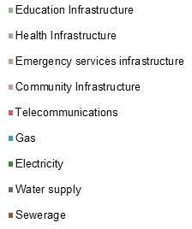
Source: Infrastructure Victoria analysis

5. Consultation
Infrastructure Victoria consulted with the following organisations during the preparation of this report:

- APA Group
- AusNet Services
- Australian Gas Networks
- CitiPower
- City West Water
- Devlopment Victoria
- Jemena
- Melbourne Water
- Multinet Gas Networks
- Powercor
- South East Water
- The Fishermans Bend Taskforce
- The Victorian Planning Authority
- United Energy
- Victorian Department of Education and Training
- Victorian Department of Environment, Land, Water and Planning
- Victorian Department of Health and Human Services
- Victorian Department of Jobs, Precincts and Regions
- Victorian Department of Transport
- Western Water
- Yarra Valley Water

6. Terminology used in the Report
Development Estate
This is the total development estate in which a dwelling is located. In a greenfield growth area this is the entire development area being delivered by a developer and forming part of a precinct development plan. Infrastructure elements in a greenfield development estate include roadways, community facilities, streetscape and dwellings. In a high density development this is the total site on which a high density development is located and includes infrastructure elements such as dwellings, carparks and internal and external site infrastructure and common spaces within the site boundary.
Dwelling Site Boundary
This is the boundary of an individual property on which a dwelling is located. For a high density development it is the areas within the individual apartment.
Greenfield Growth Area Development (Greenfield)
Undeveloped land identified for residential or industrial/commercial development, on the fringe of the urban area typically with a residential density in the order of 10 and 20 dwellings per net developable hectare.
High Density Development in inner areas (HDD)
Residential flats and apartment buildings of 10 or more storeys.
Precinct Scale Brownfield development (PSBD) – medium density
Large single sites or areas usually within the established areas of cities which are no longer used for their previous purpose and are available for redevelopment. Some urban renewal precincts include large parcels of land owned by the government or by a single private owner. Developments may consist of detached, semi-detached or attached residential development estates of one to four storeys. Dwelling densities typically range between 20 to 80 dwellings per hectare.
Small Scale Dispersed Infill Development (SSID)
Residential sites where the building stock is near or has ended its useful life and land values make subdivision (between two and 10 lots) and redevelopment attractive.
Development setting
Development settings considered in this report include greenfield growth areas, small scale infill developments in middle and outer established areas, precinct scale brownfield developments in established areas and inner city high density development

7. Sources
Apa Group, Victorian transmission system access arrangement submission, 2017
Australian Government, Department of Communications and the Arts, Telecommunications in new developments a guide for industry, April 2017
Australian Social and Recreation Research Pty Ltd (AS&RR), Planning for Community Infrastructure in Growth Areas, 2008
Infrastructure Victoria, 30-Year Infrastructure Strategy, 2016
KPMG/Arup/Jacobs, Preliminary demand modelling and economic analysis, Infrastructure Victoria final report, 2016
Department of Environment, Land, Water and Planning, Victoria in Future 2016 Population and Household Projections to 2051, 2016
Department of Health and Human Services (DHHS), Victorian Statewide system design, service and infrastructure plan for Victoria’s health system stakeholder discussion paper, 2016
Department Transport, Planning and Local Infrastructure, Advisory Note 49, Amendment VC81, Revised June 2013
Melbourne Water, Corporate Plan 2017/18 to 2021/22, 2017a
Melbourne Water, 2018/19 Desalinated Water Order Advice Summary of Technical Analysis March 2018, 2018a
Melbourne Water, Melbourne Sewerage Strategy Discussion Paper, 2018b
Melbourne Water, System Strategy, 2017b
Melbourne Water et al, Water for a Future-Thriving Melbourne, 2017c
Melbourne Water, Melbourne Sewerage Strategy, 2018c
NBN Co.,NBNC Co. Full year Results, 2017
Palm M et al, Project 30,000 Producing social and affordable housing on government land, 2018
Planisphere, Fishermans Bend Public Space Strategy, 2017
SGS Economics and Planning, The current and future state of Victoria: A spatial perspective, 2016
SMEC, Infrastructure Provision in Different Development Settings: Metropolitan Melbourne – Costing & Analysis Report, 2018
Travis, DG, Travis review: Increasing the capacity of the Victorian public hospital system for better patient outcomes, final report, 2015
Victoria Auditor General’s Office (VAGO), Effectively planning for population growth, 2017a report
Victoria Auditor General’s Office (VAGO), Managing School Infrastructure, 2017b
Victorian Planning Authority, Metropolitan Open Space Network Portal, http://planvic.maps.arcgis.com/apps/MapJournal/index.html?appid=8965d9701575408e8ea7f59772e82e10, accessed Jan 2019
About us

Infrastructure Victoria is an independent advisory body, which began operating on 1 October 2015 under the Infrastructure Victoria Act 2015.
Infrastructure Victoria has three main functions:

- preparing a 30-year infrastructure strategy for Victoria, which is refreshed every three to five years
- providing written advice
to government on specific infrastructure matters
- publishing original research on infrastructure-related issues
Infrastructure Victoria also supports the development of sectoral infrastructure plans by government departments and agencies.

The aim of Infrastructure Victoria is to take a long-term, evidence-based view of infrastructure planning and raise the level of community debate about infrastructure provision.

Infrastructure Victoria does not directly oversee or fund infrastructure projects.

This publication may be of assistance to you, but Infrastructure Victoria and its employees do not guarantee that the publication is without flaw of any kind or is wholly appropriate for your particular purposes and therefore disclaims all liability for any error, loss or other consequence that may arise from you relying on any information in this publication. You should seek appropriately qualified advice before making any decisions regarding your particular project.

Printed by Infrastructure Victoria

March 2019

© Copyright Infrastructure Victoria 2019

Except for any logos, emblems, trademarks, figures and photography, this document is made available under the terms of the Creative Commons Attribution 3.0 Australia licence. It is a condition of this Creative Commons Attribution 3.0 licence that you must give credit to the original author, who is Infrastructure Victoria.

This document is also available in PDF and accessible Word format at www.infrastructurevictoria.com.au

