Infrastructure Victoria’s 2019 Recycling infrastructure interim report - submission
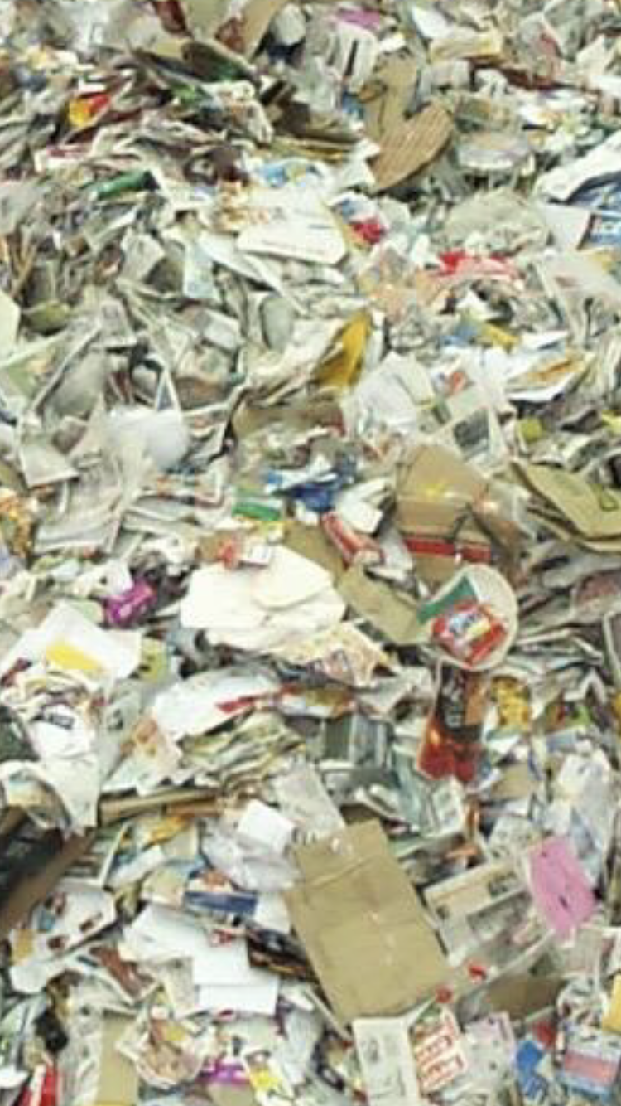

Composed by Patrick Keating

Intro
It’s no secret that the local and global recycling industry are struggling in the wake of the implementation of China’s National Sword Policy, and that kerbside recycling as we know it and associated infrastructure has clearly become obsolete and in need of drastic change. With the attention of the public, government and private sector firmly anchored on our industry, we find ourselves in an economic and environmental juncture - a serious opportunity to reform kerbside recycling collection and establish a viable recycling industry and circular economy here in Victoria. I urge not just Infrastructure Victoria, but all key stakeholders, to work together and utilize this golden opportunity to establish a viable reprocessing industry and source-separated kerbside recycling system.

About me
I write this submission from the perspective of an employee with a passion and direct involvement in the waste industry. I’ve had a keen interest in the waste industry since I was a young child. Since then, I have dedicated countless hours to researching and corroborating information on all aspects of the waste industry. I have been involved in the waste industry in a formal capacity for a number of years, courtesy of my employment as an offsider/labourer/yard maintenance staff member with an Australian-owned waste management company, responsible for domestic waste collections in the eastern suburbs of Melbourne. As such, I have both a unique perspective of somebody on the front line, and somebody with a deep passion and intricate knowledge of the industry.

As my submission is an individual one, the views and ideas presented are my own, and I indemnify my employer from any consequences or risk incurred as a result of my submission. All figures are stated in good faith, and sources have been listed where possible.

My contention
Councils, governments and collection contractors should work together to implement a two bin source-separated kerbside recycling program, consisting of two separate bins for Paper and Cardboard and Bottles/Containers respectively, as a precursor to the development of a sustainable reprocessing industry and circular economy in Victoria. This will lead to creation of cleaner material streams for reprocessing, reduced glass breakage, ease of logistics/implementation and efficiently utilise current MRF and recycling infrastructure. In addition to this, I support all other listed recommendations made.

Feedback criterium
Have we identified the right outcomes for Victoria to aim for, and have we identified the most effective actions for the Victorian Government to aim for?

1.1
The need for a source separated recycling system outlined in the report (as opposed to the current commingled system) is to be commended and is a strong aim/goal for Victoria, and should act as an immediate precursor to the development of a circular economy in Victoria.

1.2
However, the “five bin” source-separated collection system publicised in the interim report is inefficient, likely to be a logistical nightmare, and will incur significant capital cost associated with the purchase of new bins and new collection vehicles for 5 streams. Attempting to have 5 bins on each nature strip across suburbia on collection day will not work, and logistically will require more trucks on the roads, increasing traffic/congestion and vehicular emissions, a negative externality. Also, many of the 5 streams can effectively be collected together with minimal cross contamination, eg. metals and plastic. Whilst it has been commented that the 5 bin system is currently working in Wales, there are a number of discrepancies between Wales implementation in Australia. Firstly, the need for 5 crates as is the case in Wales will require inefficient manual handling/emptying, which goes against the directives of the OH&S Act of 2004 which outlines a desire to move away from manual handling within the waste industry. Secondly, the housing stock in Wales is significantly different to Australia and is composed mainly of higher density flats/units side by side, in contrast to Australia where it’s predominantly the typical spread out low density “quarter acre” housing. This would cause great collection difficulty here in Australia. Thirdly, waste processing infrastructure in Wales is already configured for the specific 5 stream separation - in Australia, processing infrastructure is not configured to these 5 streams, which would require significant capital to upgrade/establish new facilities to meet this standard. This is a wasted cost when you consider there are alternate systems to the “5 bin” system which require less bins, and can be implemented with little to no change to current processing infrastructure.

1.3
Introducing “dual stream” recycling - where households instead separate their recycling into two easy to identify streams - one blue lidded 240L bin for Paper/Cardboard, and another yellow 240L bin for Bottles/Containers (Metal, Glass, Plastic, Aluminium), collected Fortnightly. This system should be strongly investigated by Infrastructure Victoria and stakeholders over the 5 stream system for it’s simplicity, minimal alteration to existing infrastructure, and ability to generate clean material streams for secondary reprocessing - one of the main objectives of the report. Originally, most councils in Victoria also utilised the dual stream system when recycling was introduced in the 70’s/80’s, and Paper and Bottles streamed recycling is still undertaken by several councils across Australia, such as the Northern Beaches and Ku-Ring-Gai councils in NSW, and the District Council of Barunga West in SA. The ability of this system to stand the test of time proves its simplicity and effectiveness. The Paper and Bottles titles given to the two respective bins are easy to identify and self-explanatory for residents - assisting to reduce contamination levels and “wishcycling” presently observed in the generic “recycling” stream. This will lead to cleaner material streams available for reprocessing.
1.4
With the present “Commingled” single bin Recycling system collected Fortnightly, capacity is constantly raised as an issue by householders, and this is supported by the fact that garbage bins across Melbourne contain 23% recyclable material, on average. (Source : 2014 Kerbside garbage bin audit, Metropolitan Waste and Resource Recovery Group). Implementation of the dual stream system will provide additional capacity to householders to recycle more, to the tune of an additional 240 litres per week (double). This would target the objectives listed of improving pre-sorting of residual waste prior to waste-to-energy treatment through providing additional capacity to householders to remove recyclable waste from the residual waste stream, and ensure a higher volume of materials can be recycled and hence reprocessed for use in the circular economy.
1.5
The Paper and Bottles streamed system is also advantageous over other source separated systems currently being trialled in areas such as the City of Yarra and Macedon Ranges Shire, which involves the addition of a fourth bin for Glass only, and continuing the current “Comingled” Recycling bin for Paper, Plastics and Metals. Whilst this system is a step in the right direction, it is not nearly as practical or efficient as the Paper/Bottles streaming system. This system would also require significant new infrastructure to process the glass, unlike the Paper/bottles system which could effectively use current infrastructure. The“Glass Only” bin is likely to see significant breakage of the pure glass feedstock as it is tipped into trucks by hydraulic lifters, regardless of compactor settings/configuration. This breakage of the glass is likely to limit the potential end use of glass due to it’s size and state to lower-level reuse options such as roadbase, etc. In contrast, the Bottles stream contains other plastic and metal containers, which can provide cushioning to the glass against breakage during emptying and compaction in trucks, allowing it to be repurposed into higher level re-use options such as bottle making. Once again, this shows how the Paper and Bottles separation method would provide a cleaner feedstock of material for recycling and reprocessing.
1.6
The Paper and Bottles separation method requires minimal alteration to collection schedules and logistical planning and also efficiently uses current recycling/MRF infrastructure - another stated objective of the Infrastructure Victoria report
The dual stream method only requires the addition of 1 extra bin, a blue lidded bin as per Australian Standards for Paper/Cardboard recycling. The current Yellow lid “commingled” recycling bin would hence become the Bottles recycling bin. Both bins would be collected by separate trucks, but could be delivered to existing commingled MRF’s (utilising current infrastructure) for sorting and tipped into separate sheds/piles in the sorting shed. After being tipped into separate piles, each respective stream could be run through the commingled MRF separately (ie. paper stream sorted first, then bottles) to remove cross-contamination, and then allow each material stream to be separated into their respective material group utilising the current MRF equipment and set-up. Anecdotal evidence from co-workers suggests that this was the case at almost all MRFs in the 1990’s and early 2000’s, such as the Visy Heidelberg site and the former Lilydale MRF. This illustrates how a Paper/Bottles source separated recycling system would achieve the stated objective of efficiently utilising current infrastructure.
1.7
In summary, implementation of a Paper and Bottles source separated kerbside recycling system would achieve the stated objectives of efficiently utilising current infrastructure, creating cleaner material streams for reprocessing and improving pre-sorting of residual waste for energy recovery and as such, act as a precursor to the development of a sustainable reprocessing industry in Victoria (another objective I strongly support).
1.8
I strongly support the Waste-to-Energy objective outlined in the report - whilst modern day landfills are well managed, capture energy and effectively contain wastes that cannot be recycled or composted, a far more optimal usage for these resources is to convert them into energy, and in doing so reduce greenhouse gas emissions and increase the supply of renewable energy into the national grid. By providing direction and certainty regarding the Victorian Government’s stance on Waste-to-energy for Residual Waste, stability will be provided to the private sector to allow them to efficiently plan and invest in the costly infrastructure required.

1.9
I also support the aim of improving source separation of food organics - currently, there is very minimal incentives and support for councils and businesses alike to transition to collecting FOGO or food organics separately in the face of significant community resistance/reluctance to change. Government could potentially support councils by introducing a statewide education campaign to educate the community on the benefits of FOGO and hence break down restraining forces faced by councils. In doing so, this may improve the willingness of councils, households and businesses to involve themselves in the FOGO system.
1.10
I also support the aim to better enable use of reprocessed/recycled material in industry - obviously it’s easy to collect and process material, the difficulty faced by the waste management sector has been in finding an end use for processed material. By legislating percentages of recycled material to be used in construction materials and packaging, Infrastructure Victoria and the Government can ensure that reprocessed material is efficiently used here in Victoria and likewise, support the development of a circular economy in our state.

Which, if any, of the initiatives implemented in Wales would you like to see applied in Victoria?

(See section 1.2 in previous section)

What do you think of the market design opportunities proposed to improve waste sector outcomes and efficiency?

2.1
I support the market design opportunities proposed to improve outcomes in the industry. In addition to this, by attracting new businesses/players into the industry and increasing competition in specific areas, we are likely to see improved outcomes, service delivery and pricing. However, this must be managed sustainably with respect to the market and industry.

Where do you think government should focus their efforts to increase recycling and resource recovery? (for example, through setting targets, promoting consistency or funding local councils?

3.1
As outlined before, the government should focus their efforts on the objectives listed in the report, in addition to pursuing the implementation of a paper/bottles source-separated recycling system for households as a precursor to the development of a sustainable reprocessing industry in Victoria.

3.2
Government also needs to effectively set targets for MSW diversion for councils and percentages of recycled material to be used in construction and packaging, to facilitate optimised resource recovery outcomes and the development of reprocessing and a circular economy in Victoria. By promoting consistency (eg. Australian Standards for Bin colours), confusion in regards to waste and resource recovery operations can be minimised.

Which materials or infrastructure types present the most opportunity in your region?
4.1
Within the Melbourne metropolitan region, the FOGO (Food Organics and Garden Organics) stream presents a significant opportunity to improve recovery and hence divert it away from landfill. With almost half of the average garbage bin comprised of organic FOGO material, government, the private sector and councils alike can see a convincing amount of material redirected away from landfill and repurposed into soil conditioner/compost to be returned to the environment.

What is a legislative barrier or enabler that you have encountered when trying to use recycled materials?

N/A, individual submission

Thank you for listening to my input/feedback, and I hope it can translate into meaningful change to improve Victoria’s waste and resource recovery sector!

