Transporting Melbourne’s Recovery: Immediate policy actions to get Melbourne moving
  - January 2021

Executive summary

The COVID-19 pandemic has impacted how Victorians make decisions for when, where and how they travel. Lockdown periods significantly reduced travel around metropolitan Melbourne and regional Victoria due to travel restrictions and work-from-home directives.

As Victoria enters the recovery phase towards a COVID Normal, our research suggests that these travel patterns will shift again – bringing about new transport challenges.

Prior to the pandemic, the transport network was struggling to meet demand with congested roads and crowded public transport services. The recovery phase adds additional complexity to managing the network, as the Victorian Government will need to balance competing objectives such as transmission risks, congestion and stimulating greater economic activity.

Governments across the world are working rapidly to understand how to cater for the shifting transport demands of their cities – specifically, a disruption to entire transport systems that were not designed with such health and biosecurity challenges in mind.

Infrastructure Victoria’s research is intended to assist the Victorian Government in making short-term policy decisions to balance the safety and performance of the transport system with economic recovery. The research is also designed to inform decision-making by industry and businesses as their workforces return to a COVID Normal. It focuses on how the transport network may handle returning demand and provides options to overcome the crowding and congestion effects, while also balancing the health risks posed by potential local transmission of the virus. Balancing these impacts is critical to fostering confidence in public transport travel, thereby underpinning and sustaining Melbourne’s economic recovery.

The options outlined in this paper are designed for practical short-term implementation but also deliver ongoing benefits for government, industry and commuters including better use of infrastructure, and safer and more reliable journeys. The options are based on enhanced transport modelling, mobility data, case studies and evidence from cities throughout Australia and New Zealand.

The options put forward look across all modes of transport including private, public and active transport (such as walking and cycling). These options do not treat these respective modes in isolation. Overcoming the challenges of a return to travel and guiding Victoria’s recovery means that policymakers must manage the constraints of the transport system through a wide lens to guard against unintended consequences. This means exploring options like workplace policies and safe public transport travel regulation, pricing mechanisms, greater collaboration between all levels of government and business, in addition to enhancing infrastructure service levels.

We have taken a scenario modelling approach, looking at a range of potential transport outcomes under COVID Normal scenarios, as well as COVID Normal with Reform scenarios that include behaviour change which could be achieved with policy intervention. The COVID Normal scenarios outlined below are designed to simulate a period where there are limited cases of COVID-19 in the community. They are characterised by the lack of a vaccine, low community transmission of the virus and minimal government intervention.

Category | Scenario name | Description
Pre-COVID-19 | Base | The Base year, pre-COVID-19 – this used the latest 2018 validation of the Melbourne Activity and Agent Based Model (MABM).
COVID Normal | Core | COVID-19 modelling run with ‘most expected’ adjustments to work from home (WFH), car preference, domestic and international travel/students.
 | Dialled-Up | COVID-19 modelling run with even greater adjustments to WFH, car preference, domestic and international travel/students.
COVID Normal with Reform | Active Uptake | A forced shift of trips to/from/within Inner Metro region to active modes (walking & cycling) – using Core scenario as the foundation scenario.
 | Flexible Work | Greater flexibility in work activity start times and a forced shift to even greater WFH levels – using Core scenario as the foundation scenario. In this scenario, the arrival window for commuters to begin work was widened from 8am-10am to 7am-11am.

Our transport modelling is also highly dependent on the assumptions used to simulate the COVID Normal recovery period scenarios. Based on level of severity, these assumptions include:
- Work from home levels of between 10% to 20%, resulting in commuter travel reduced to between 80% to 90% of usual levels.
- A decrease in public transport mode share between 37% to 55% and a smaller increase in car share mode, based on changing user preferences.
- Reduced airport travel and international student population.

Results from the COVID Normal scenarios with minimal reform or government intervention depict a challenging recovery period. Under these scenarios, the modelling represents a transport network dilemma. That is, a significant shift away from public transport increases private vehicles on the road network and, without further policy intervention, the assumed COVID Normal level of working from home is not enough to offset congestion impacts for Inner Metro (including Melbourne City, Port Phillip City and Yarra City local government areas).

Transport challenges largely emerge towards the inner areas of Melbourne, where there is limited road and public transport capacity. For example, average road speeds during the morning peak fall by up to 30% across Inner Metro under the COVID Normal scenario.

Despite working from home, falling public transport patronage and a shift to private vehicles causing the increase in congestion for inner Melbourne, up to a quarter of morning peak train services experience high patronage, providing limited opportunity to physically distance onboard services, with over two in five seats occupied. The result is that both roads and public transport in inner Melbourne still experience high traffic and patronage volumes during the morning peak.

Shifting demand at peak times between the two is ineffective, as both options lead to undesirable road congestion and health risk outcomes if public transport demand cannot be shifted to off-peak times when ample physical distancing can be achieved. Large improvements in capacity are also very challenging to implement in the short-term. Our previous recommendations to help alleviate this challenge were presented in Fair Move – Better Public Transport Fares for Melbourne. This new research complements Fair Move, providing intervention options in addition to public transport fare reform.

The options outlined in this report address how government can best enable a return to higher levels of economic activity and productivity, while limiting road congestion and providing safer public transport services. The COVID Normal with Reform scenarios are illustrative approaches to demonstrate potential improvements that the Victorian Government can implement to address these challenges.

The changes we modelled in the COVID Normal with Reform scenarios were an increase in active transport use within the inner city and greater levels of flexibility in when, and where, Victorians work.

The Active Uptake scenario demonstrated how an increased share of commuting cyclists and pedestrians could assist in dampening the road and public transport congestion and physical distancing challenge by switching to active travel:

- Up to a 50% increase in active mode share for Inner Metro, shifting trips away from at-capacity roads and public transport.

The Flexible Work scenario established the peak spreading and network efficiency benefits from having commuters work with more flexible start and end times, as well as additional increases in the proportion of the workforce continuing to work from home:

- Further increases to working from home levels – up to 25%.
- Greater flexibility in work hours allowing workers to start work either earlier or later in the day. The original arrival window for commuters in MABM to begin work was widened from 8am-10am to 7am-11am.

These reform scenarios translate to increasingly favourable network performance and ample room for physical distancing. For example, Flexible Work helps to reduce patronage on morning peak train services. This results in over 90% of morning peak train services operating with ample space for physical distancing by commuters, equivalent to patronage levels of around two in five seats occupied. This density level on trains is largely consistent with current public health advice of staying 1.5 metres away from others while travelling and in venues.

Our modelling has shown that greater levels of flexible work, consisting of levels of working from home of around 25% and more flexible work times, result in congestion levels in Inner Metro close to pre-COVID-19 levels (a reduction of over 100,000 delay hours compared to COVID Normal), and much lower congestion across the rest of Melbourne. Our modelling also shows that an increase of over 142,000 cycling trips each day to, from and within Inner Metro, when combined with greater walking trips, results in a reduction of 40,000 delay hours for Inner Metro road congestion.

While the flexible work and active transport uptake scenarios each make a significant contribution to reducing road congestion and public transport crowding, our modelling shows that if implemented alone they are unlikely to be sufficient to address these challenges. The modelling we have conducted for the purposes of this research and Fair Move demonstrates the individual effects of flexible work, active transport uptake and greater off-peak public transport use. A combination of these interventions is likely to be necessary to manage congestion and enable physically distanced public transport use in the Inner Metro area.

We know that achieving these behaviour changes (greater active transport, increased workplace flexibility and greater off-peak public transport use) will require policy and operational interventions. As such, we have identified a number of options for the Victorian Government to continue or consider implementing in the short-term, including:

Government directives and guidance:
Option: Continue to monitor physical distancing levels of public transport and provide clear directives on mandatory use of masks, as well as responses such as distinct signage for physical distancing with increased staffing for enforcement or assistance in managing capacity limits to support safe travel.
Purpose: Directives such as mandatory wearing of masks and capacity guidance on public transport can support safer and more confident travel.

Pricing Mechanisms:
Option: Consider implementing permanent off-peak public transport fares across all modes.
Purpose: Off-peak fares complement flexible work incentives and can incentivise commuters to travel during quieter times of the day.
Option: Remove the Free Tram Zone (FTZ).
Purpose: This measure will reduce crowding and the associated health risks in inner Melbourne while also encouraging the uptake of active transport options, particularly walking.
Option: Develop incentive schemes to encourage greater uptake of active transport to work.
Purpose: Greater uptake of active transport takes pressure off roads and public transport, improving congestion, reducing pollution and lowering health risks.

Infrastructure provision:
Option: Monitor crowding and patronage levels of new off-peak public transport service improvements – revising scheduling to best support peak spreading.
Purpose: Increasing capacity through running additional services using the excess capacity of the system in off-peak times (underutilised infrastructure and rolling stock), increasing capacity on the network for flexible work and greater physical distancing.
Option: Larger, more permanent separated cycling corridor upgrades should be delivered wherever possible and they can be complemented by pop-up bike lanes.
Purpose: Safer cycling infrastructure supports greater uptake of active transport, taking pressure off roads and promoting sustained behaviour changes, particularly in inner Melbourne.
Option: Support local government to re-allocate parking and road space for pedestrians and economic activity
Purpose: Active transport has the capacity to take the pressure off roads and incentivise sustained mode shift, particularly in inner Melbourne. City of Melbourne commissioned research also shows increasing walking connectivity by just 10% would increase the value of the city centre economy by $2.1 billion a year, given the face-to-face connections fundamental to the retail and knowledge economies.

Government collaboration and leadership in flexible work
Option: In addition to continued regulation to ensure workplaces remain safe, provide government leadership and nudges towards greater flexible work through processes, public campaigns, collaboration with industry and the use of the VPS as an example of best practice.
Purpose: While private incentives for working from home exist, government can encourage higher rates by highlighting employers’ Occupational Health and Safety (OHS) responsibilities plus reduced transmission risk and the wider social benefits of working from home. Government should also collaborate with employer peak bodies, industry and unions to promote flexible work hours and other flexibility practices using the public service as an example.

Encouraging these behaviour changes should begin immediately to build upon the changes already being observed. The COVID-19 pandemic has brought about significant transport disruption.
Government should use this time to recalibrate the transport network in Victoria and avoid locking in inefficient and high-risk travel behaviours that create congestion and crowding, and risk public health.
Proactive intervention will ensure that Melbourne recovers with improved, safer and more efficient travel behaviours, which will support and sustain economic recovery and benefit all Victorians.

Table of Contents

Executive summary: 02

1 Introduction: 08
  - COVID-19 Research Program: 08
    - Context: 08
    - Timeframe and Objectives: 08
    - Methodology: 09

2 If we don’t make a change: 10
2.1 Modelling a COVID Normal Melbourne: 10

    - Introduction to the transport model: 10
    - Research summary and assumptions: 11
  - Modelling transport and COVID-19: 25
    - Summary of adjustments and MABM runs: 25
    - Results from MABM pandemic scenarios – problem definition: 26

Improving transport in the COVID Normal: 42
3 Reform with COVId-19: 42
3.1 The policy dilemma: 42
3.2 More flexible work: 43
3.2.1 Greater levels of working from home: 43
3.2.2 Greater flexibility in working hours: 45
3.3 Greater active transport: 47
3.4 What we modelled: 48
3.4.1 More flexible work: 48
3.4.2 Active transport uptake: 49
3.4.3 Modelling change summary: 50
3.5 The impact of change: 51
3.6 Policy options: 64
3.6.1 Regulation: 66
3.6.2 Pricing mechanisms: 67
3.6.3 Transport infrastructure improvements: 74
3.6.4 Government collaboration and leadership: 81

4 Victoria beyond recovery: 84
4.1 Looking beyond recovery: 84

Appendix: 85
About us: 86

Introduction

Infrastructure Victoria’s research program into the transport impact of COVID-19

Our COVID-19 research program seeks to solve the diverse transport and economic challenges brought about by the pandemic. This report focuses on immediate intervention options to respond to emerging transport challenges as Greater Melbourne emerges from strict lockdowns into a COVID Normal recovery phase. It is a period still awaiting a vaccine but with minimal community transmission of the virus as Victorians embrace the easing of restrictions.

1.1 COVID-19 Research Program

1.1.1 Context

Infrastructure Victoria initiated an extensive modelling program to understand the behaviour changes and key disruptions to industries caused by the COVID-19 pandemic. This report forms the first component of our research, examining the short-term impact of behavioural changes from the pandemic, specifically on Melbourne’s transport network.

It explores scenarios of how we expect travel demand to shift across the network in the short term, as well as policy ideas and reform opportunities that will assist Melburnians to move around safely and efficiently, facilitating the state’s economic recovery.

Infrastructure Victoria’s research is intended to assist the Victorian Government in making short-term policy decisions to balance the safety and performance of the transport system with economic recovery.

It focuses on how the transport network may handle returning demand and provides options to overcome the crowding and congestion effects, while also balancing the health risks associated with local transmission of the virus. Balancing these impacts is critical to fostering confidence in public transport travel, thereby underpinning and sustaining Melbourne’s economic recovery.

Future components of this modelling program will focus on medium and long-term transport, land use and infrastructure impacts caused by COVID-19 and will be made available in 2021.

1.1.2 Timeframe and Objectives

While Victoria’s experience of lockdowns and work-from-home directives reflected the immediate policy response to the pandemic, this research focuses on the subsequent recovery period. Acknowledging Victoria’s success in overcoming the second wave in October and the subsequent easing of restrictions, the Victorian Government has clearly signalled it intends to carefully manage the recovery to minimise transmission risks. Our short-term impacts research has been designed to inform these recovery efforts over the next 12 to 18 months.

The COVID Normal recovery period is defined as a situation where Victorians are living with limited cases of COVID-19 within the community. It is characterised by the lack of a vaccine and low community transmission. Old freedoms have returned with eased restrictions and many Victorians are able to return to their workplaces. It is a period in which Infrastructure Victoria expects uncertainty to remain, but with fewer health risks to Victorians’ everyday lives, enabling greater freedom of movement in how we work, travel and socialise.
Our research focuses on the following objectives:

- Safe travel – policies to minimise the health risk from COVID-19 for Victorians using the transport network, especially on shared modes like public transport.

- Congestion and crowding – policies to manage increased congestion on roads and to limit crowding on public transport, as travel demand returns in the recovery phase.

- Long-term benefit – policies to promote efficient travel behaviours, supporting a more balanced transport network during the recovery and beyond.

Infrastructure Victoria’s approach to developing policy options aims to meet each of these three objectives. We examined all modes, times and locations across Greater Melbourne to fully understand how best to balance getting Melburnians and visitors back onto the transport network while ensuring safe travel.

Methodology
Our work explores transport challenges in the COVID Normal era, complementary policy options and the benefits to Greater Melbourne. To assess the transport network under a COVID Normal scenario, our approach utilised transport modelling to simulate expected travel behaviours in Victoria’s recovery phase, based on COVID-19 impacts research and how other cities have rebounded in their recovery periods. The results from the modelling were then analysed and some COVID Normal alternative scenarios were developed, demonstrating the benefits of potential alternate paths the Victorian Government could take to manage demand and support beneficial behaviour change.

2. If we don’t make a change

COVID-19 impacts research and insights from our transport modelling

To determine reform opportunities, we need to account for the significant travel behaviour shifts brought about by the pandemic and accurately simulate a shift to COVID Normal. Between 10% to 20% of the workforce continues to work from home while public sentiment shifts away from public transport and a strong preference for private vehicles is emerging.

2.1 Modelling a COVID Normal Melbourne

2.1.1 Introduction to the transport model

Transport modelling can demonstrate the benefits and implications of policy and infrastructure changes to the transport network. One of the models we use at Infrastructure Victoria is the Melbourne Activity and Agent Based Model (MABM). Our previous work using the MABM has involved scenarios for autonomous and zero emissions vehicles, road and parking pricing and public transport fares reform.

0Infrastructure Victoria ran modelling of previous scenarios and policy interventions using travel demands across Greater Melbourne from the pre-pandemic era. COVID-19 and related government interventions (like the risk of virus transmission on public transport or work-from-home directives) have had a large impact on demands. To analyse the impacts of COVID-19 and the reform options to manage Victoria’s recovery phase, we recalibrated the model to better reflect a world disrupted by the pandemic. Recalibration of the model was applied to a 2018 base year of the MABM.

We worked with Veitch Lister Consulting (VLC) to develop a list of potential disruptions and adjustments to the MABM to best represent the changing COVID-19 context. As discussed in Section 1.1.2 of this report, our target was to model Melbourne’s recovery phase over the next 12 to 18 months – the transition into COVID Normal.

We developed two scenarios with different levels of change severity: a COVID-19 Core scenario and a Dialled-Up scenario. The Core scenario forms the most accurate representation of Melbourne’s recovery we could predict, while the Dialled-Up scenario represents larger travel behaviour change and economic disruption. The two scenarios assist in understanding the range of potential future outcomes. Our analysis compares both Core and Dialled-Up scenarios with the 2018 base year, known as the Base scenario.

2.1.2 Research summary and assumptions

Both qualitative and quantitative data sources were reviewed to define the Core and Dialled-Up scenarios. Sources included Apple and Google mobility data, transport department patronage figures, Victorian Integrated Survey of Travel and Activity (VISTA) survey results and Australian Bureau of Statistics (ABS) figures, alongside various reports from organisations and academics.

To make plausible assumptions about what Melbourne’s recovery could look like, Infrastructure Victoria analysed trends from other cities around Australia and New Zealand at varying stages of lockdown and recovery. Conclusions were drawn based on pre-lockdown baseline levels, the initial shock of COVID-19 lockdowns and trends from eased restrictions. Recovery trends in some cities where restrictions had been rolled back significantly were also analysed. At the time of our research, Perth, Brisbane and Auckland could be considered as being in recovery phases. Cities like Sydney, where the first wave of COVID-19 was flattened and restrictions eased, were also useful when attempting to make predictions about Melbourne’s recovery.

The research looked at the following areas:
- increase in working from home
- changing preferences for travel by car, public transport and active transport (walking and cycling)
- limited airport travel and international student levels
fuel prices, income levels and commercial vehicle traffic.

Many figures showing timelines in the following sections use 14 March 2020 as a baseline reading. This is consistent with the approach of the ABS and allowed our consultants, VLC, to construct seven-day moving averages for each research area.

Details of each adjustment are below. Alternatively, the full research log can be found in the supporting VLC COVID Modelling for Infrastructure Victoria slide deck.

Employment adjustments – working from home

Working from home (WFH) represents one of the largest impacts for transport demand. This was reflected in adjustments we applied to the 2018 Base scenario. Significantly, it not only has an impact on working households’ travel to and from work, but also smaller occasional trips for shopping, school pickup or recreational and social activities that are often tied to a work commute.

By using Google location data from both private residences and workplaces, working from home appears to have persisted even after restrictions and lockdowns were eased. This is evidenced in Auckland, Perth and Brisbane where levels of residential activity continue to trend around 5% above baseline levels.

This pattern is shown in Figure 1. Note the large adjustment in Auckland activity from March through to May due to stricter lockdowns in New Zealand.

Lockdowns led to large increases in residential activity

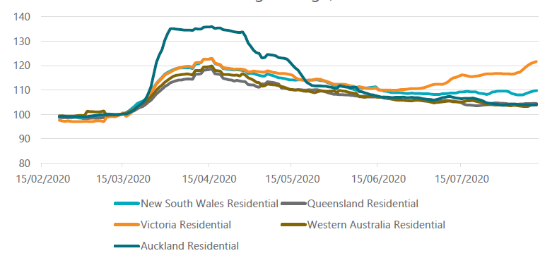
Workplace activity % (14 March=100)
Figure 1. Google location data from residences (14 March = baseline, seven-day moving average) – VLC analysis

Lockdowns led to large declines in workplace activity
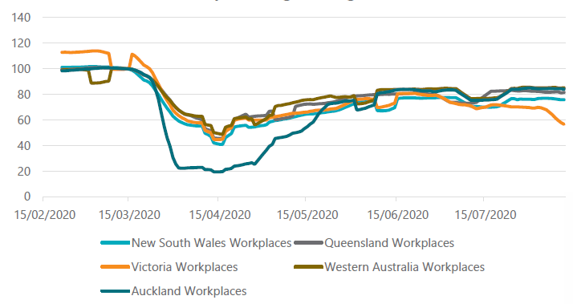
Workplace activity % (14 March=100)
Figure 2. Google location data from workplaces (14 March = baseline, seven-day moving average) – VLC analysis

With adjustment to account for external factors like school holidays and their impacts on private residences and workplaces, Google data suggests that workplace activity is likely to recover to between 80% to 90% of pre-COVID-19 levels in the recovery phase.

It also demonstrates how activity in Victoria’s workplaces fell to almost 40% of baseline levels during the first full lockdown, before rebounding up close to 80% of baseline levels post-lockdown (prior to the second wave).

Workplace activity is likely to recover between 80% to 90% of pre-COVID-19 levels

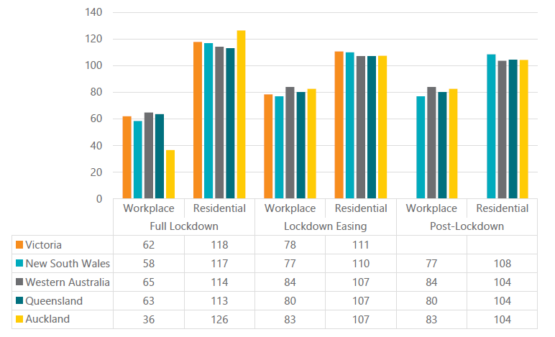
Workplace/residential activity % (14 March=100)
Figure 3. Google data – Workplace and residential location data across the COVID-19 time period as a percentage of pre-lockdown, VLC analysis

While the data demonstrates working from home levels reflect health directives enforced by various governments, there is also a growing number of workers who are choosing to continue to work from home, even as post-lockdown restrictions ease (see Auckland and Perth as examples).

Based on the experiences in other cities, we modelled workplace activity recovering between 80% to 90% of usual levels in Melbourne (or alternatively, a 10% to 20% reduction in commuter travel).

As the MABM covers the Greater Melbourne spatial region, analysis was required to determine which individuals – and subsequently, which locations – were impacted by the working from home adjustments. Firstly, to ensure that working from home adjustments reflected the appropriate occupations, Dingel and Neiman’s occupation research in the U.S. assisted in filtering which occupations could work from home, removing those occupations that couldn’t from the analysis.

Survey data from the Department of Jobs, Precincts and Regions (DJPR) was used to determine the difference between pre and post-COVID-19 working from home levels relevant to each occupation.

To make up a 10% to 20% reduction in commuter travel as noted earlier, the DJPR survey then assisted in determining the proportion of each occupation to work from home to achieve this reduction target.

As every agent in the MABM population has attributes like occupation and household location, we were able to identify the location of workplaces that would be most likely to retain working from home arrangements post-lockdown.

The reduction in trips in both scenarios is shown in Table 1 and the destination of trips that were subsequently removed from the model is shown in Figure 4. This shows that a large proportion of trips removed from the network (as a direct result of higher levels of employees working from home) are trips to the Melbourne central city.

The other peak represents trips to Melbourne Airport and will be discussed in a following subsection.

Table 1. MABM – Working from home trip adjustments
 | Core scenario | Dialled-Up scenario
Working from home (WFH) trip adjustment | Commuter travel reduced to 90% of usual levels (i.e. 10% WFH) | Commuter travel reduced to 80% of usual levels (i.e. 20% WFH)

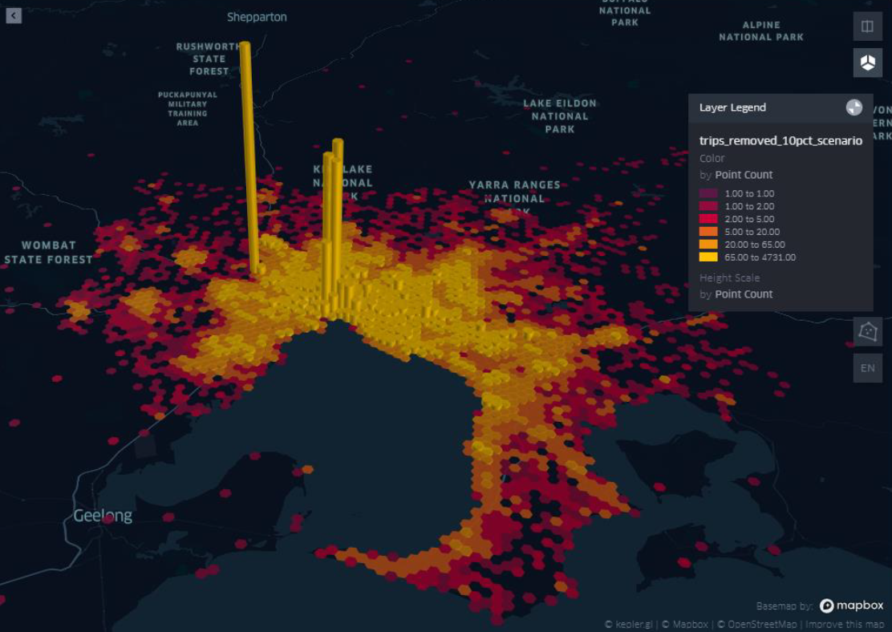
Melbourne Airport (Tullamarine)
Melbourne CBD
Figure 4. MABM – Removed trips by destination, VLC analysis

Changing preferences for transport modes

While restrictions have had a general dampening effect on the volumes of people travelling on Victoria’s transport network, there has also been a change in the preferences of commuters when it comes to choosing between public transport, private vehicles, active modes and other shared forms of mobility.

Infrastructure Victoria observed how COVID-19 affected the demand for public transport and roads in major cities by using publicly available mobility data from Google and Apple, as well as VLC’s mobility data for public transport.

In the comparison of cities and public transport data, found in Figure 5, cities with very low levels of COVID-19 cases (or none at all) like Auckland, Perth and Brisbane still experience a plateauing of public transport patronage well under baseline levels. Most of these cities ultimately reach within 70% of baseline public transport levels.

Notably, Melbourne also saw a similar initial plateaued recovery in public transport patronage before dropping again, coinciding with Victoria’s second COVID-19 wave and associated lockdowns. This suggests that even as Melbourne enters a COVID Normal era, public transport patronage will not return to pre-pandemic levels in the short term.

In comparison, the use of private vehicles also dropped sharply during initial lockdown periods, however usage recovers strongly in many cities during their recovery period (Figure 6).

This indicates a higher preference for private vehicles in a COVID Normal world. The strong preference for private vehicle travel should not only be attributed to those that once drove returning to their commutes. Rather, it may also be a combination of both returning drivers and travellers who previously used other modes, such as public transport.

Public transport experiences large patronage declines and fails to fully recover

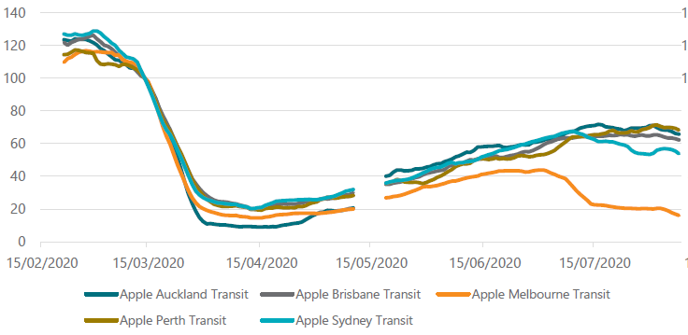
Public transport volumes % (14 March=100)

Figure 5. Apple transit data – Impacts of COVID-19 on public transport volumes – city comparison (14 March = baseline, seven-day moving average), VLC analysis

Driving is more resilient compared to public transport, fully recovering in many cities to pre-COVID-19 levels
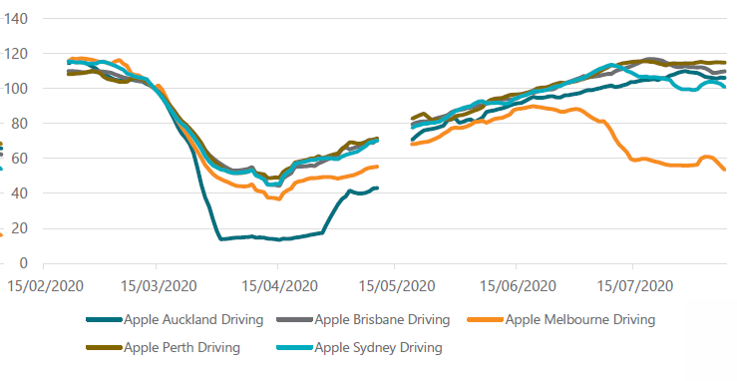
Car volumes % (14 March=100)
Figure 6. Apple transit data – Impacts of COVID-19 on car volumes – city comparison (14 March = baseline, seven-day moving average), VLC analysis

Perth’s transport rebound
In a recent analysis by Perth-based motoring organisation and insurance company RAC, traffic volumes on Perth’s main roads in November 2020 were up to 18% higher than pre-pandemic levels.
Comparing this with Infrastructure Australia’s (pre-COVID-19) expected traffic increase of 32% by 2031 in the 2019 Australian Infrastructure Audit suggests that over half of the projected traffic growth occurred in 2020 alone.
Given Perth’s success in largely suppressing the COVID-19 pandemic, Perth’s Public Transport Authority states that patronage has hovered around 70% of pre-COVID levels, climbing to around 78% in October.
To support the rebound, the RAC continues to advocate improved efficiency and accessibility across public transport services. Incentives include bus priorities, off-peak public transport fare discounts as well as investment in active transport alternatives such as walking and cycling.
Active transport was also analysed to determine the impact of COVID-19 on active transport mode share. Compared with 2018 VISTA, the COVID-19 VISTA survey (Department of Transport 2020) indicated the number of recreational and shopping trips by active mode increased, while work trips by active mode and public transport fell.

Table 2 also shows that for most jurisdictions, the share of active travel has fallen from pre-lockdown levels throughout various lockdown periods of the pandemic (see following paragraph for explanation of Table 2).

Therefore, many increases seen in active travel are largely due to recreational and shopping activities. For our modelling, we have assumed no change in active trips. Much of the congestion and crowding in the MABM are as a result of work trips during the AM and PM peaks, as opposed to recreational and social active trips which are taken outside the peaks.

There is also a technical challenge here where trips generally cannot adjust to active modes in the current version of the MABM, compared to the allowed substitution between car and public transport. This means that the mode share of active trips is largely fixed within the model.

Table 2 shows the mode share across cities, across lockdown time periods. This was derived using the starting mode share from household travel surveys for each city, and then adjusting based on growth or decline as observed from Apple mobility data for the subsequent phases. Table 3 then compares how mode share for car and public transport (PT) from Table 2 varies between time periods.

Table 2. Implied mode share across cities and time period, VLC analysis
 | Pre-lockdown |  |  | Full lockdown |  |  | Easing lockdown |  |  | Recovery
 | Car | PT | Active | Car | PT | Active | Car | PT | Active | Car | PT | Active
Melbourne | 72% | 10% | 18% | 81% | 4% | 15% | 81% | 5% | 13% | - | - | -
Sydney | 70% | 12% | 18% | 79% | 6% | 15% | 79% | 8% | 14% | - | - | -
Brisbane | 83% | 6% | 10% | 89% | 3% | 8% | 88% | 4% | 8% | 88% | 4% | 8%
Auckland | 63% | 9% | 28% | 58% | 5% | 37% | 69% | 6% | 25% | 69% | 6% | 24%
Table 3. Change in mode share across cities and time period, VLC analysis
 | Change in car | Change in PT | Comparison
Melbourne | +13% | -50% | Easing vs. Pre-lockdown
Sydney | +13% | -33% | Easing vs. Pre-lockdown
Brisbane | +6% | -33% | Recovery vs. Pre-lockdown
Auckland | +10% | -33% | Recovery vs. Pre-lockdown

Table 4 summarises the changes in mode attractiveness for private vehicle, public transport and active modes that we targeted in the MABM. Overall, public transport is estimated to remain at depressed levels for some time, as experienced in cities like Brisbane, Perth and Auckland.

Private vehicle travel is also estimated to be more attractive to travellers than prior to the pandemic, largely due to commuter’s apparent concerns with public transport. The Core scenario is based on the observed trends from Auckland with an increase of 10% in car mode share and a decrease of 33% in public transport mode share (Brisbane is also similar).

The Dialled-Up scenario exacerbates these shifts, using values similar to Melbourne as restrictions eased following Stage 1 restrictions: an increase of around 15% in car mode share (similar to Sydney) and a decrease of 50% in public transport mode share.

As all mode shares are dependent on each other, public transport mode share was the primary adjustment with the resultant car mode share also shown in the table below.

These percentage changes in mode share are targets – the actual changes in mode share represented in the MABM will vary based on Melbourne’s specific mode split between car, public transport and active modes.

Table 4. MABM – targeted changes to mode attractiveness
 | Mode | Core scenario | Dialled-Up scenario
Percentage targeted change in mode share | Car | 10% increase | 15% increase
 | Public transport | 30% decrease | 50% decrease
 | Active modes (walking & cycling) | No change | No change

Airport travel and international students

COVID-19 has also impacted international and domestic travel markets (and subsequent travel within Greater Melbourne associated with airport trips). These changes for airport and regional/interstate travel were also reflected in MABM.

The substantial impact of lockdowns and border closures was experienced around April and May with monthly total airport passengers at less than 10% of baseline levels for all Australian cities. VLC’s location-based services data also confirms this, showing that from mid-March airport travel in Australian cities declined by more than 80% (Figure 7).

Even Brisbane, with little-to-no active COVID-19 cases and a relaxation of restrictions, has still only returned to around 30% of pre-COVID-19 airport travel levels. Part of this is explained by Brisbane residents still having few available destinations to travel to, considering international travel bans, lockdowns in other states, border restrictions and quarantine requirements.

Looking across the Tasman Sea to Auckland, more airport travel suggests conditions are on track to improve, driven almost entirely by the New Zealand domestic market, as seen in Figure 8.

During the week of March 14, airport travel declines by over 80%

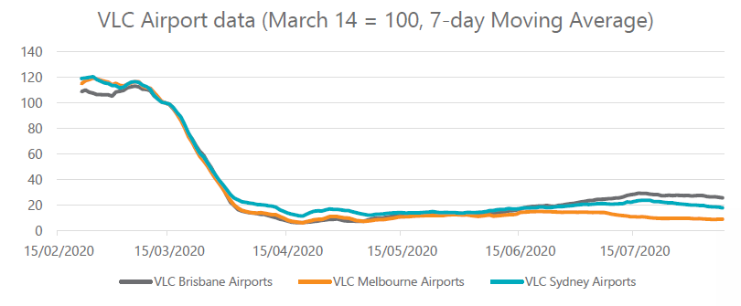
Airport passenger volumes % (14 March=100)
Figure 7. Airport passenger volumes (March 14 = baseline, seven-day moving average), VLC analysis

BITRE places monthly total airport passengers at less than 10% during May for all major Australian cities

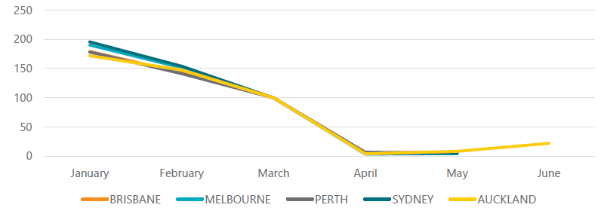
Airport passenger volumes % (14 March=100)
Figure 8. Bureau of Infrastructure and Transport Research Economics (BITRE) Total airport passenger volumes – city comparison (March 14 = baseline, seven-day moving average), VLC analysis

International student numbers in Melbourne are also highly dependent on international travel. Border restrictions like caps on international arrivals have impacted the international student market.

Approvals of international student visas have declined nationally by around 20% (comparing FY18-19 with FY19-20) and Victoria’s enrolments have declined 19% relative to 2019 levels.

A report by the Mitchell Institute at Victoria University highlights an even more dramatic picture, stating that in April 2020, just 30 international students arrived or returned to Australia, compared to over 46,000 in April 2019.

To reflect these reductions in international students we used data from the Mitchell Institute report to identify the areas most affected by a reduction in international student volumes, before removing a certain percentage of individuals representing international students.

Table 5 shows a summary of how we adjusted individuals and trips within the MABM to reflect the impacts of COVID-19 on airport travel and international student levels in Victoria’s recovery. The Core scenario reflects an optimistic return to domestic travel, predicting a rebound back to 50% of baseline airport travel levels. The Dialled-Up scenario represents a slower recovery, rebounding to 30% of baseline levels, similar to what Auckland is currently experiencing.

In the absence of further information, and while highly uncertain (and dependent on various government approvals), a best-case return for international students represented a 20% reduction in the recovery for the Core scenario, compared to a larger, more pessimistic 60% reduction in the Dialled-Up scenario.

Table 5. MABM – targeted changes to airport travel and international student levels
 | Core scenario | Dialled-Up scenario
Airport travel | 50% decrease in passenger volumes | 70% decrease in passenger volumes
International students | 20% reduction in student levels | 60% reduction in student levels

Other considerations – with no short-term adjustment

As part of the short-term impact analysis, other areas to explore that could be adjusted in the MABM include fuel prices, agent income (and in turn, people’s willingness to pay for travel) and freight vehicle volumes. These, however, were proven to either remain relatively stable according to data from Melbourne and other cities or lacked sufficient evidence to suggest any adjustment was required, according to VLC analysis.

While COVID-19 caused an initial drop in travel demand and fuel use, fuel prices have remained relatively steady between BITRE low and medium fuel cost estimates. Therefore, no change to fuel costs was implemented.

For adjustments to agent income, ABS employment and wage data shows changes to be less than 10%, while data by industry shows large fluctuations. Any change to agent income could also overlap with agent travel choices as their willingness to pay for travel could change, resulting in unintended additional shifts in mode preference within the MABM.

For example, an agent who originally took public transport to work may now find driving a more attractive option for their commute, despite higher costs. As with fuel, not enough evidence was found to support a change in income for individuals within the MABM.
Finally, although general sentiment appears to suggest that increased reliance on online shopping and delivery is likely to have resulted in an increase in commercial freight, the little publicly available local data on commercial traffic remains inconclusive.

Transurban’s recent industry report, Urban Mobility Trends from COVID-19 shows an initial spike of large vehicle traffic volumes on toll roads mid-April 2020, returning to steady levels through May 2020 onwards.

Therefore, no changes to freight volumes were applied in the model. In the meantime, as the logistics and freight industries manage their own specific COVID-19 challenges, any mechanisms and policy options to support improved traffic flow will also have direct benefits to delivery operators who share the roads.

The COVID Normal transport modelling scenarios represent the problem definition and the target of future policy intervention. Changing travel preferences cause large congestion problems on roads in inner Melbourne while public transport services provide limited opportunity to physically distance, despite reduced total trip numbers influenced by working from home.

Modelling transport and COVID-19

2.2.1 Summary of adjustments and MABM runs

Once all adjustments, summarised below in Table 6, were applied to the MABM, the new Core and Dialled-up scenarios designed to represent Victoria’s recovery phase were modelled.

Unlike traditional transport models that measure ‘trips’ across the day, the unit of analysis for the MABM was actual modelled individuals. As the model simulates travel across Greater Melbourne, it considers the characteristics and behaviours of individuals and how their travel may change, now bound by the additional COVID-19 recovery parameters.

Table 6. MABM – summary of COVID-19 scenarios, compared with the Base scenario
 | Core scenario | Dialled-up scenario
Private vehicle (change in mode share) | 5% increase (10% target) | 7% increase (15% target)
Public transport (change in mode share) | 37% decrease (30% target) | 55% decrease (50% target)
Working from home adjustment | Commuter travel reduced to 90% of usual levels (i.e. 10% WFH) | Commuter travel reduced to 80% of usual levels (i.e. 20% WFH)
Airport travel | 50% decrease in passenger volumes | 70% decrease in passenger volumes
International students | 20% reduction in student levels | 60% reduction in student levels

Results from MABM pandemic scenarios – problem definition
The Core and Dialled-Up scenarios present a diverse range of transport network safety, congestion and crowding challenges.

The problem is also spatially diverse across Greater Melbourne and varies depending on the time of day. The following analysis draws comparisons between the Core and Dialled-Up (COVID-19) scenarios and the Base (pre-COVID-19) scenario.

All figures from Figure 9 to Figure 26 are output results from the MABM.

Modelling general travel patterns before and after the pandemic
Prior to the pandemic, Melburnians used private vehicles as the main mode of transport with remaining trips balanced between active and public transport modes, as shown in Figure 9.

The Base scenario is displayed as the inner ring within Figure 9. This reliance on private vehicles is skewed even further in the COVID-19 Core and Dialled-up scenarios (middle and outer rings, respectively) where preference for private vehicles is increased (caused by individuals shifting away from public transport), and is also influenced by the general decrease in overall trip numbers as a result of working from home and reduced airport and international student levels.

The net result of all the Core and Dialled-Up scenario adjustments applied to the MABM can be found in Figure 10. For the Core scenario, it shows an expected drop in public transport trips (influenced by changing user preferences), however, a comparatively smaller increase in car trips.

There are two competing factors that lead to a low net change for car trips: (1) a change in preference causes an initial drop in public transport trips and increase in car trips and (2) an overall decrease in trips covering all transport modes as a result of working from home and reduced airport/international student travel.

Figure 10 shows the combined result of these adjustments in the middle (Core scenario) and outer (Dialled-Up scenario) rings.

In the Core scenario, the working from home adjustment has reduced the original number of car trips across the network. However, due to changing preferences, many people have shifted from public transport to cars (over 81,000 people) which offset the original working from home decrease, causing an overall increase in car trips.

Figure 9. Mode share in Greater Melbourne for each scenario

Figure 10. Changes in trips across Greater Melbourne from Base year to COVID-19 scenarios

From a health and traveller safety perspective, a decrease in public transport usage is welcome – the fewer users on crowded public transport services (mostly during peak times), the lower the risk to public health. For cars, however, despite the lower virus transmission risk of individuals travelling in their own vehicles, this change in travel behaviour and increase in trips causes a rather large congestion problem with its own public health implications such as air pollution and inactivity. How these additional car trips are distributed across Greater Melbourne results in an even larger problem, as the following section explains.

The spatial distribution of car trips

The spatial distribution of where these car trips increased (red) and decreased (blue) across a 24-hour time period are shown in Figure 11 and Figure 12.

Inner Melbourne car volume increases

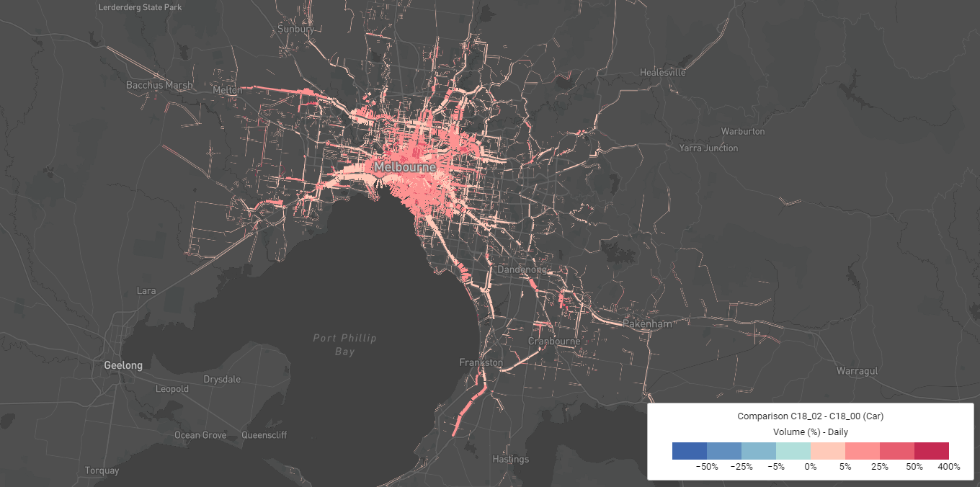
Figure 11. Base vs. Core scenario – car volume increase (daily)

Outer Melbourne car volume decreases

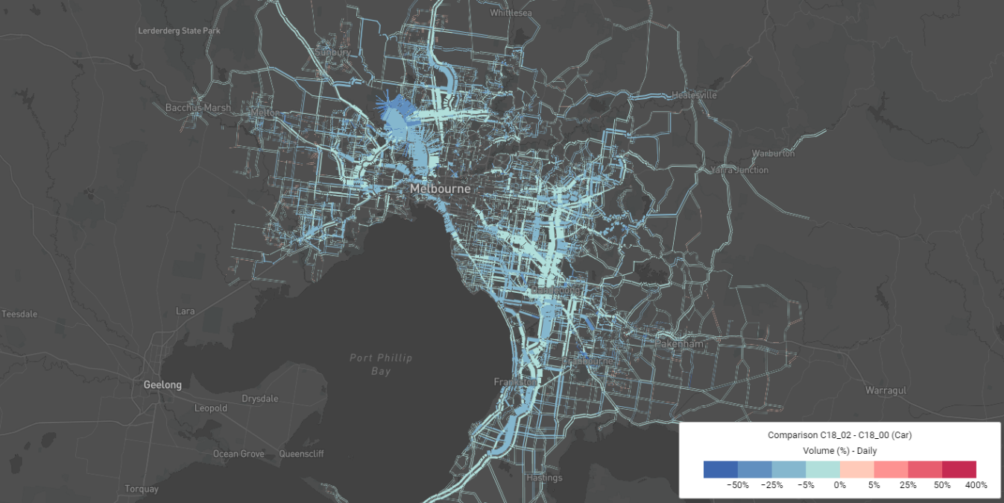
Figure 12. Base vs. Core scenario – car volume decrease (daily)

Figures 11 and 12 show that the increase in car usage is largely driven by travellers in inner and middle areas of Melbourne. This is likely due to the overall higher level of access and coverage of public transport services in these areas, compared to outer Melbourne.

As a result of travellers now preferring to drive (almost 100,000 additional car trips in Inner Metro alone), former public transport users in inner and middle Melbourne have shifted onto the road network, resulting in a large increase in road volumes within inner Melbourne.

The result for outer Melbourne is different and is largely dominated by the working from home effect and less impacted by the shift away from public transport. Many of the trips occurring in the outer areas of Melbourne were already on the road network, so a change in user preference towards private vehicles has little impact other than reducing the total number of vehicle trips.

Working from home adjustments for those areas cause an overall net decrease in commuter trips, leading to an overall decrease in road volumes for middle and outer Melbourne.

The Inner Metro congestion problem on roads is expected to get worse

With working from home adjustments reducing the amount of vehicle travel in outer parts of Melbourne, our modelling suggests road congestion problems during the COVID-19 recovery will be largest in the Inner Metro (including Melbourne City, Port Phillip City and Yarra City local government areas, see Appendix for map of regions).

Two road network performance indicators used for this type of analysis are vehicle kilometres travelled (VKT) and vehicle hours travelled (VHT).

VKT represents the total number of kilometres travelled in cars – the higher the VKT, the more travel there is in terms of road coverage.

VHT represents the total number of hours travellers are spending in their cars. VHT can also be a good indicator of network speeds: a poor performing road network would most likely see an increase in VHT.

By combining VHT and VKT, and analysing the changes from pre-COVID-19 levels to the Core scenario (as shown in Figure 13) we can compare how the Inner Metro road network performs with other regions in Greater Melbourne.

Each dot on the plot represents a region of Greater Melbourne, while the diagonal dotted line represents the congestion crossover point. Any region above/left of the dotted line is experiencing higher VHT growth in comparison to VKT, i.e. more time spent on the road for each kilometre of travel on average. Put simply, greater levels of congestion.
Improved congestion
Worsening congestion
Inner Metro
*Each dot represents a region of Greater Melbourne
Figure 13. Difference in vehicle hours travelled (VHT) and vehicle kilometres travelled (VKT), Core scenario vs Base scenario

While most regions fall close to the dotted line, representing minimal or no change in car travel patterns, the Inner Metro region sits right at the top of the scatter plot, representing far more time spent in cars on the road, despite minimal additional kilometres travelled.

Network performance is especially poor during the AM peak, where despite an almost 30% increase in VHT, the total distance travelled by cars reduces, signalling greater congestion problems.

Average vehicle speeds in Inner Metro tell a similar story (shown in Figure 14). In the Core scenario, the average speed of vehicles during the morning peak reduces by almost 25%. For context, applying a road pricing congestion cordon around the inner CBD has the opposite impact, resulting in up to a 25% average speed increase.

Figure 14. Change in average vehicle speeds for Inner Metro COVID-19 scenarios compared with pre-COVID-19 levels

Figure 15: Average vehicle speeds Inner Metro across all scenarios and time periods

The types of car trips driving change

After establishing how increased travel by private vehicle causes the greatest congestion problem in Inner Metro, the final element to determine is the types of trips driving this change. Both Core and Dialled-Up scenarios are analysed here, with similar results.

Across Greater Melbourne, the net result is that short trips increase the most compared to the Base scenario, as shown in Figure 16. Despite increased levels of working from home, the Dialled-Up scenario still maintains a small increase in short trips via private vehicle despite larger drops in medium and longer distance trips.
This analysis is also supported spatially in Figure 17 where the changes in the volume-to-capacity ratio (V/C) between the Base scenario and Core scenario are shown on all major roads.

While many of Melbourne’s freeways and toll roads (Tullamarine Fwy, Eastern Fwy, Monash Fwy) record decreases in V/C, or reduced congestion, many of the inner main and local roads experience large increases, with some even exceeding design capacity, suggesting large increases in localised short trips.

Figure 16. Greater Melbourne trip length distribution – comparison with Base scenario

Road network performance between COVID-19 Core and Base scenarios

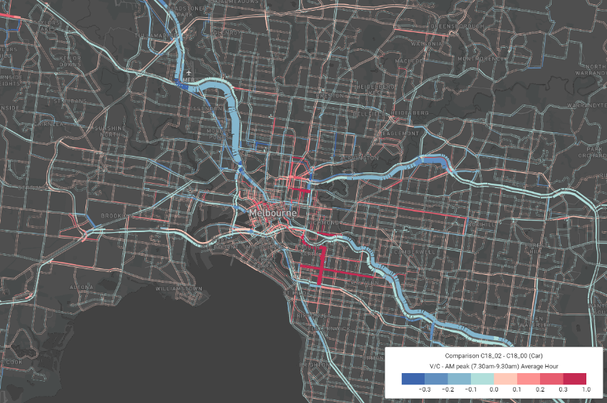
Figure 17. Base vs. Core scenario – car V/C, AM peak

Instead of looking at the net trip distribution result across Greater Melbourne, focusing on car trips from, to and within the Inner Metro region uncovers an even larger problem: an increase of all trip types, as shown below in Figure 18.

Figure 18. Inner Metro trip length distribution – comparison with Base scenario

Ultimately, while the net result of trip length types across Greater Melbourne demonstrates minimal change or a reduction in medium and long trips (for both Core and Dialled-Up scenarios), this actually hides the fact that car travel is not only increasing in Inner Metro for local trips, but also increasing for trips coming into and exiting the city centre.

An overview of challenges facing public transport

In the Core and Dialled-up scenarios, public transport patronage is significantly reduced due to the greater preference for private vehicle over public transport and due to the working from home adjustments. Similar to roads, the Inner Metro region is most affected, showing the largest patronage declines.

This is a result of Inner Metro’s original high public transport usage (Figure 19), along with higher working from home levels (Figure 20). As an example of the magnitude of this shift, Inner Metro train boardings in the Core scenario during the PM peak alone are reduced by 43,000 passengers (29% reduction), equivalent to around 30 of Melbourne’s X’Trapolis trains full of commuters at crush load.

Figure 19. Public transport mode share (origin) by region

The majority of working from home jobs were located in the Melbourne CBD

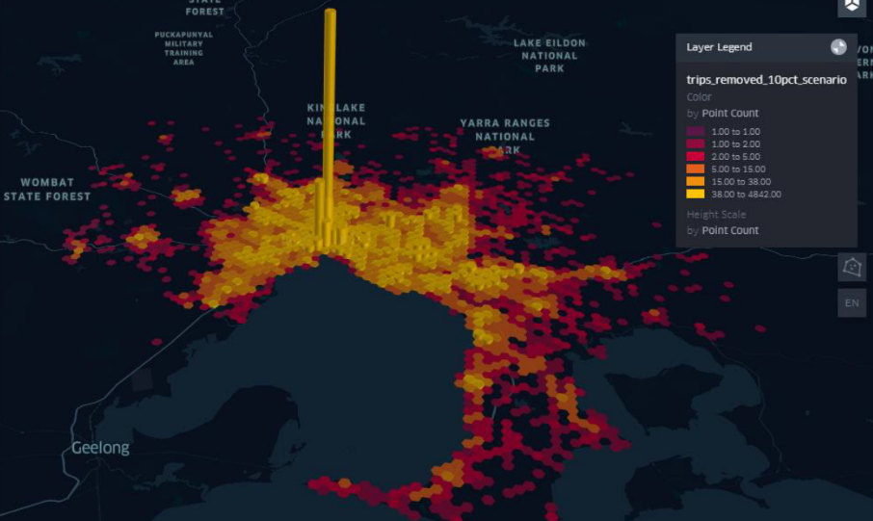
Figure 20. Workplace locations that commuters once travelled to, now working from home

The effect on other modes of public transport is similar. The COVID-19 Core scenario reduces overall patronage by 39% while the Dialled-Up scenario reduces patronage by 58%.

Figure 21 below shows the boarding trends for train, tram and bus throughout a typical weekday for each scenario. While train patronage forms sharp peaks during the morning and afternoon, tram patronage is spread across wider peaks, along with a third smaller rise during the lunch period.

Trams also carry the most passengers of all modes between the peaks, most likely associated with the types of trips they service – typically a higher proportion of social, recreational and shopping trips, as opposed to the largely work-based trips on trains. In the Dialled-Up scenario, peak tram patronage is reduced to such an extent that the interpeak levels are close to the AM peak level, flattening the distribution significantly.

Figure 21. Boardings for each mode across the day (boardings per 15min interval)

Figures 22, 23 and 24 show the result of these boarding trends spatially for train, tram and bus in the AM peak. Blue lines represent a decrease in passenger volumes, while the thickness of each line represents the actual number of passenger reductions for each public transport link.

As expected, train trips experience large declines in patronage (over 25% along many lines) while tram routes take an even greater percentage reduction on many inner-city route sections, with some declines of more than 60%. Bus services also have reductions in patronage across key routes, including the Doncaster Area Rapid Transit services, Dynon road bus services, the SkyBus Melbourne Airport route as well as the Monash University 601 direct shuttle service.

Train patronage decreases across all lines

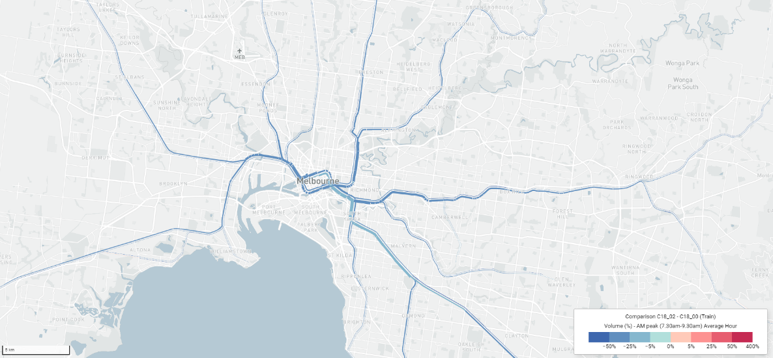
Figure 22. Comparison of passenger volumes for train, for AM peak, Core comparison vs. Base

Tram patronage decreases across all routes

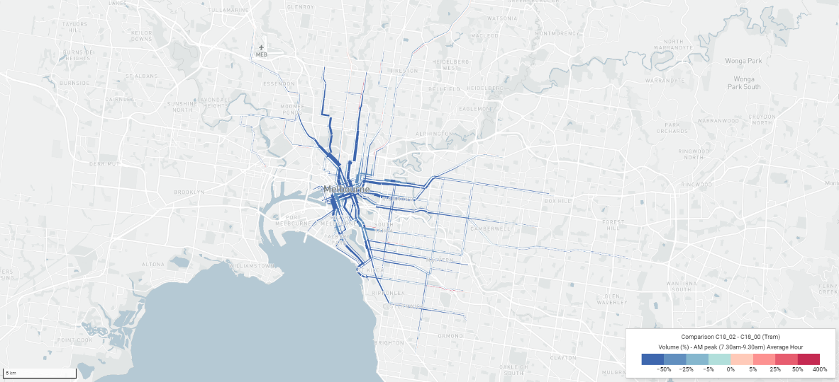
Figure 23. Comparison of passenger volumes for tram, for AM peak, Core comparison vs. Base

Bus patronage decreases across most routes

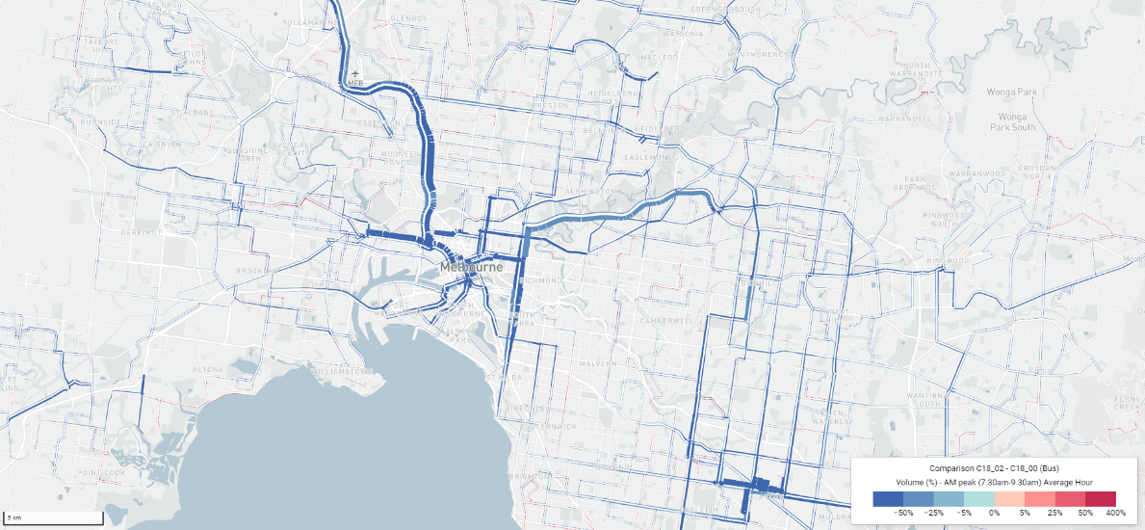
Figure 24. Comparison of passenger volumes for bus, for AM peak, Core comparison vs. Base

Public transport capacity challenges

Unlike the road network, where the impact of increased congestion is longer and more variable travel times for drivers, the impact of crowding on public transport is related to an actual or perceived higher COVID-19 transmission risk.

Returning to crowded pre-COVID-19 patronage levels during Victoria’s recovery phase (assuming a vaccination is still unavailable) may heighten infection risk, especially if community transmission persists. Therefore, allowing ample space on public transport services so that commuters can easily physically distance is a desirable outcome.

Infrastructure Victoria has undertaken analysis to explore how much spare capacity is available on public transport services under the various modelled scenarios. Figure 25 shows the proportion of train services with more than 60% of seated capacity vacant (Capacity A – light & dark bars combined), derived as an illustrative level that provides ample room for physical distancing by commuters.

Consistent with physical distancing directives from public health advice, this analysis follows a general limit of staying at least 1.5 metres away from others. Within indoor settings, such as on public transport, this 1.5 metre linear distance between commuters is roughly equivalent to the two square metre density rule Victorians will have experienced when visiting dining and retail venues.

At this density, commuters should have ample space to physically distance while travelling. We have also shown the proportion of train services which provide twice this level of physical distancing, where there is 80% of seated capacity still available (Capacity B – dark bars).

These levels provide a practical way of visualising the level of crowding on public transport. At 60% of vacant seated capacity (Capacity A), two in five seats are occupied. At 80% of vacant seated capacity (Capacity B), one in five seats are occupied.

Train capacity analysis only includes services during the AM peak, and outbound services during the PM peak, as services running in the counter peak direction are typically uncrowded. The AM peak is defined by services operating 7.30am to 9.30am and PM peak defined by services operating 4.30pm to 6.30pm.
Services with over 60% of seated capacity vacant
Services with over 80% of seated capacity vacant
Figure 25. Train service seated capacity levels (Capacity A and B) available to physically distance, by time period

In the Core scenario during the AM peak, around three quarters of train services are at patronage levels of two in five seats occupied or less (Capacity A).

With even more generous space for physical distancing (Capacity B), the capacity challenge becomes most acute – just over a quarter of AM peak train services are available at this level of patronage.

In the Dialled-Up scenario, train capacity results are generally improved (shown in shades of purple), representing even more services operating at generous physical distancing capacities. Many services have enough capacity to maintain ample levels of physical distancing (Capacity A), particularly in non-peak periods. Alternatively, using more generous space for physical distancing (Capacity B), just under half of AM peak services have patronage levels available with this level of spare capacity. Adding further services to the non-peak periods would assist in enabling greater physical distancing.

Figure 26 shows tram capacity using the same physical distancing proxies as train (Capacity A and Capacity B).

The AM peak appears to have more room than train, however across all time periods there are still services which do not have Capacity A or B levels of physical distancing. One of the challenges with peak public transport usage is that there is little flexibly in adding more services, especially on major tram corridors such as the Swanston Street/St Kilda Road routes.

While there is some flexibility in spreading demand into non-peak periods, this is also limited for trams in some areas – such as the Free Tram Zone – as these services experience higher patronage levels at most times of the day.

Figure 26. Tram service seated capacity levels (Capacity A and B) available to physically distance, by time period

Flow-on effects – considering the transport network as a system

It is clear that Melbourne’s transport network, especially within the inner city, will face significant challenges in moving Melburnians safely and efficiently if demand returns to estimated levels.

The major problem faced is that roads are becoming increasingly congested and there remains little available capacity on the public transport network to easily physically distance. A solution cannot focus on public transport, roads or parking in isolation.

The pandemic has disrupted the whole transport system and so a similarly proportionate network-wide response is required to assist in Melbourne’s transport recovery.

Improving transport in the COVID Normal

Policy scenarios to help manage transport challenges in the face of the pandemic and the recovery phase

3. Reform with COVID-19

The problems identified in our COVID-19 transport modelling present a dilemma for Melbourne’s road and public transport network. This cannot be solved by shifting people between the two modes or adding infrastructure capacity, which in most cases is fixed in the short run.

Our proposed solutions centre around further encouraging unconstrained modes, such as walking and cycling, as well encouraging greater work flexibility to manage demand.

3.1 The policy dilemma

Infrastructure Victoria’s transport modelling analysis in Section 2.2 presents a dilemma for Melbourne’s transport network. The Core scenario mapped out the impacts of a 10% reduction in overall commuting trips due to working from home. This was not large enough to offset the increase in car congestion in the Inner Metro area due to the significant shift away from public transport, with vehicle speeds falling by 24% in the AM peak.

Despite the fall in public transport usage, public transport services remained overcrowded for the purposes of enabling physical distancing. Given the lower levels of density in the outer suburbs of Melbourne, much of the congestion and crowding is isolated to Inner Metro with minimal impact to the outer suburbs.

These issues result in a policy dilemma in which both roads and public transport in inner Melbourne are over capacity. Without any further policy changes (including recommendations from our previous public transport fare reform research Fair Move – Better Public Transport Fares for Melbourne), shifting demand between road and public transport is ineffective as both options are undesirable and there is very limited scope for increasing capacity in the short term on either mode.

So how can government best enable a return to higher levels of economic activity and productivity while limiting the impact on road congestion and providing safe public transport services? Two potential mechanisms to achieve this were identified and modelled:

1. more flexible work (Section 3.2)
2. increased active transport (Section 3.3).

3.2 More flexible work

One potential solution to mitigate these impacts is to encourage greater flexible working arrangements in jobs and industries where this is possible. These flexible working arrangements would primarily be made up of:
- greater levels of working from home
- greater flexibility in working hours.
Flexible working also has potential benefits outside the transport system. Greater levels of working from home should enable a greater proportion of offices to achieve higher levels of physical distancing.

Greater working from home, combined with flexible working hours, will assist in tackling issues such as how to get workers safely to high-rise office areas with existing elevator systems and end-of-trip facilities.

Greater levels of working from home
The initial impact of the pandemic caused many people to work from home. By early June 2020, 25% of paid workers in Victoria reported that all their work had been performed remotely, and 39% reporting a mix of in-person and remote work.

The rate was higher for Melbourne city centre workers, with 41% reporting that they performed all work remotely. Notably, 81% of respondents said the experience of working from home had positively changed the way they think about managing work/life flexibility.

The research contained in Section 2.1.1 shows that these high levels of working from home are not likely to persist once restrictions are eased. While many jobs can be done from home, some roles will be less productive when the worker is not working from the traditional workplace, or when not able to at least work some of the time at the workplace (which is the stated preference of employees).

Dingel and Neiman (2020) classify occupations as to whether they can be conducted from home based on the average responses to a set of two U.S surveys on occupational activities and the context within which they are conducted.

Occupations were classified as not able to be conducted at home if they involved physical activities; direct contact with the public, equipment or premises; were hazardous; involved a lot of walking/running; or wore specialised protective/safety equipment. All other occupations were assumed to be able to be conducted from home.

The classification of Dingel and Neiman (2020) has been applied to Australian data by three sets of authors in Table 7.

Table 7. Summary of the number of Australians that can work from home, various authors
Author | Type of Estimate | Percentage
Coates et al (2020) | Australia | 39%
Stratton (2020) | Victoria | 42%
Stratton (2020) | Australia | 41%
Ulubasoglu and Onder (2020) | Australia | 38%

These estimates suggest that up to 40% of the workforce could work from home based on their occupational characteristics, though not all of them necessarily productively. These estimates provide a kind of upper bound on the productive levels of working from home and show that higher levels of working from home than the 10% modelled in the Core scenario are achievable.

While places such as Auckland and Perth have rebounded to around 84% of commuting (See Figure 3), these cities had short lockdowns and quick recoveries, while forced working from home was much more prolonged in Sydney and Melbourne.

This may have enabled a greater number of people to adapt and work productively from home (the coordinated and persistent change to working from home has forced firms and employees to overcome many of the previous barriers and costs to working from home).

As a comparison, Sydney’s rate of workplace commuting has been 77% during the recovery period (See Figure 3), though it also had a greater risk of infection from the workplace than Perth or Auckland, which had zero community cases during the same period.

Once the health risks have been addressed, the priority is then encouraging working from home for those occupations where it is both possible and productive to do so.

Just because work can be conducted from home doesn’t mean this is necessarily the most productive way to work, or that it offers the broader benefits valued and attributed by workers or employers, including connectedness. The private market can be expected to balance the benefits from greater working from home with any losses.

There are inbuilt benefits for both employers and employees from greater working from home. These include potentially lower office space and other business costs for employers, and reduced commuting time and travel expenses for employees.

There is also research that shows some jobs or employees are more productive when working from home, and employers are able to attract talent from a wider geographical area, further increasing productivity.

While reduced travel times may not directly benefit employers and firms, it greatly increases the productivity of employees and the broader economy. Even if working was slightly less productive from home, the significant productivity benefits from the avoided commute could outweigh this.

To achieve the largest reduction in commuting costs, working from home must also be distributed across the working week. While working from home may be desirable, especially on Mondays and Fridays, there would be minimal congestion and crowding benefits to the transport network if all workers were to select these days to work from home - crowding and congestion would continue to persist on Tuesdays, Wednesdays and Thursdays.

With a relatively even distribution of working from home across the week, these reduced commuting costs are able to be shared with firms in one way or another (for example, through an increase in available labour hours, access to a larger labour market, a more flexible workforce, or through increased consumption).

Given these private benefits, it is likely that many firms that have been able to function productively from home will retain flexibility in work location. However, given the external costs in congestion and crowding on public transport outlined in Section 2.2 (including associated public health risks), there may be some scope for further government policy to encourage more businesses to adopt flexible work and more people to work from home.

Greater flexibility in working hours
As discussed in Section 2.2, the greatest congestion and public transport crowding issues arise in the AM and PM peaks. If people were able to shift their commutes into off-peak periods there would be less road congestion impacts, as well as greater safety in the use of shared office building facilities, such as elevators and end-of-trip facilities.

Greater flexibility in working hours is also reliant on the connecting trips that commuters make, such as dropping off children at childcare or attending fitness clubs and gyms, before and after work. Additional flexibility of these complementary services or facilities would maximise uptake of flexible work practices.

A BehaviourWorks survey identified a range of factors that might impact people’s ability to shift their time of public transport use. The results are contained in Figure 27.

Shifting public transport times – survey results

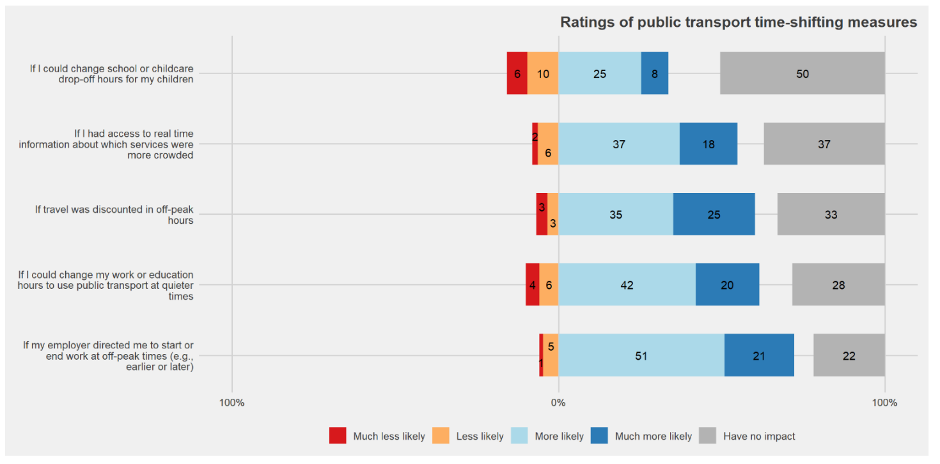
Figure 27: Time-shifting measures (Survey by BehaviourWorks for Infrastructure Victoria. Originally published in Fair Move: Better Public Transport Fares for Melbourne, Infrastructure Victoria)

The first thing to note about the survey is the proportion of people who say they would be impacted by these measures is quite high, demonstrating a general willingness to shift times under the right circumstances.

This may have been due to the timing of the survey, which was conducted during COVID-19. Drawing from insights prior to COVID-19, Infrastructure Victoria’s survey of peak time drivers in 2018 found that 1 in 4 said that they could change their time of travel and 1 in 3 also suggested they could change their mode of travel.
While the network is more congested across all time periods during the recovery phase (see Figure 13), there is more capacity in the interpeak and off-peak periods than the AM and PM peaks.

This can be demonstrated by the average speeds experienced in the Core Scenario (see Figure 14 and Figure 15), showing lower levels of road congestion outside the peaks.

Public transport experiences similar capacity constraints, with lower levels of crowding in the off-peak periods (see Figure 25 and Figure 26). Crucially, few new services can be added in the peak periods to allow for greater physical distancing because the network is at capacity, while new services can be added to boost capacity with relative ease in the off-peak periods.

3.3 Greater active transport

While greater flexibility in working arrangements will help reduce or spread demand across both roads and public transport, another solution is to move people away from these congested networks and into active transport.

Active transport has the benefits of not being at capacity, is conducted in the open air (with its lower associated virus transmission risk) and provides broader health benefits. It also presents a way to bring people back to Melbourne’s city centre to encourage greater economic recovery without the negative impacts related to private vehicle or public transport use.

As demonstrated in Figure 16, the greatest increase in car trips were short trips of less than 5km. This appears to have had a marked impact on Inner Metro, where total vehicle kilometres in the AM peak was down, but time spent commuting by car was up significantly (Figure 13), likely demonstrating the local road network’s inability to handle local demand.

These short, local trips are perfect candidates to be replaced with active transport, where the average trip lengths are typically short (around 5km for bicycle trips and significantly shorter for walking).

The City of Melbourne has long argued for greater active transport in Melbourne and set a target in its transport strategies (2012 and 2019) to increase the mode share of active transport significantly by 2030 (Figure 28). The current pandemic presents the perfect opportunity to achieve long-term improvements in transport mode while targeting short-term issues related to COVID-19.

Current and forecast growth and target mode share in the City of Melbourne
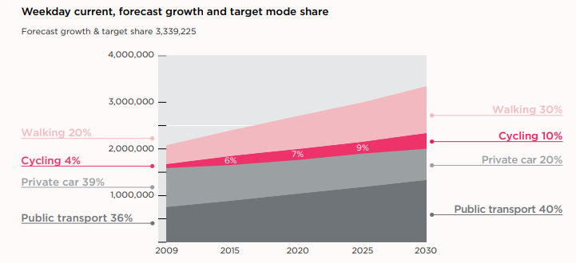
Figure 28: City of Melbourne current and future mode share targets (includes trips to, within and from the City of Melbourne) Source: City of Melbourne Bicycle Plan

What we modelled

More flexible work
We have modelled an increase in working from home from 10% in the Core scenario to 25% in the Flexible Work scenario. This is close to the levels of work from home suggested by the Google mobility data for Sydney, which showed commuting levels at 23% below baseline during the recovery period (Figure 3).

To approximate the impact of increased flexibility in working hours, we increased the time window in the MABM for individuals’ work start times before they start to incur a penalty. In the Core and Dialled-up scenarios, workers shift their start anytime from between 8am-10am without any cost to them.

Movement outside this window (for example to avoid congestion) came at a cost. In the Flexible Work scenario, this time period was widened to be from 7am-11am, providing greater flexibility in start times at no penalty.

The MABM also considers connecting trips such as dropping children off at childcare and appointments. This means that while some people benefit from shifting work start times, others that have prior or post-work commitments may continue to travel at standard work hours.

When people shift time periods in the model, they also have the opportunity to shift modes, and do so based on their individual costs and benefits of each mode (e.g. fuel, parking, fares).

Active transport uptake
To simulate greater active transport, we focussed on an increase in active transport in trips to, from and within Inner Metro.

Using the target growth in active transport mode share over the period between 2009-2030 from the City of Melbourne Transport Strategy (Figure 28), we set a similar total active transport increase in the mode share from the Core scenario to the Active Uptake scenario – a target increase of 66.7% in the total mode share for active transport in Inner Metro.

This target was to be made up of walking and cycling trips that started or ended in Inner Metro. The target followed the proportions outlined by City of Melbourne targets, namely two-thirds of the increase should be from walking trips and one third from cycling trips. As stated earlier in the report, the technical challenge in MABM limits the ability for individuals choosing to shift to walking and cycling.

As an exercise to explore the network benefits of an increase in active modes, individuals were manually adjusted in the model onto active forms of transport to make up the specified targets. We defined walking trips as those that are relatively short, with 80% being no more than 1km in length, 15% no more than 1.5km and 5% no more than 2km. Cycling trips were 1 to 8.7km in length, and an average distance of 4.4km.

We found that there were not enough short trips taken by public transport and private vehicle to meet the target for walking, so an increase of only half of the walking target was modelled.

The final increase in active trips within the MABM which started or ended in Inner Metro was 123,400 walking trips and 142,204 cycling trips (taken from 1.83 million car and public transport trips) – an increase of just under 50% in active trips. This increased active mode share to 42% of all trips in the Inner Metro, followed closely by car at 40% and public transport at 18%.

Modelling change summary
Table 8: Modelling scenarios overview
 | Flexible Work scenario | Active Uptake scenario
Private vehicle (change in mode share) | 5% increase | 5% increase
Public transport (change in mode share) | 37% decrease | 37% decrease
Working from home adjustment (and flexible work hours) | Commuter travel reduced to 75% of usual levels (i.e. 25% WFH).  The original arrival window for commuters in MABM to begin work was also widened from 8am-10am to 7am-11am – an extra hour on each shoulder. | Commuter travel reduced to 90% of usual levels (i.e. 10% WFH)
Airport travel | 50% decrease in passenger volumes | 50% decrease in passenger volumes
International students | 20% reduction in student levels | 20% reduction in student levels
Active trips | No change | Removed 265,500 trips that started or ended in Inner Metro from public transport and private vehicles and switched them to active transport trips (50% increase in total active transport trips to/from Inner Metro).

Note: Both Flexible Work and Active Uptake scenarios are based on the COVID-19 Core scenario, with additional adjustment.
Increased active transport helps to reverse the Inner Metro trend towards private vehicle use, avoiding higher levels of congestion. Working from home continues to be one of the most significant forms of demand management – improving road and public transport conditions as Melbourne enters COVID Normal.

The impact of change – modelling results
The Core and Dialled-Up scenarios in the previous section established what transport during Victoria’s recovery out of COVID-19 could look like.

This section analyses the results of the Active Uptake and Flexible Work scenarios, designed to demonstrate how we can further strengthen the efficiency and safety of the transport network aiding Victoria’s recovery. Table 9 below summarises all MABM runs analysed in this paper.
Table 9. Summary of model runs using the MABM
Category | Run name | Description
Pre-COVID-19 | Base | The Base year, pre-COVID-19 – this used the latest 2018 validation of the MABM.
COVID Normal | Core | COVID-19 run with ‘most expected’ adjustments to WFH, car preference, domestic and international travel/students.
 | Dialled-Up | COVID-19 run with even greater adjustments to WFH, car preference, domestic and international travel/students.
COVID Normal with Reform | Active Uptake | A forced shift of trips to/from/within Inner Metro region to active modes (walking & cycling) – using Core scenario as the base.
 | Flexible Work | Greater flexibility in work activity start times and a forced shift to even greater WFH levels – using Core scenario as the base.

Most comparisons in the upcoming section, unless otherwise specified, compare the Active Uptake and Flexible Work scenarios back to the Core – COVID-19 scenario.

All figures from Figure 29 to Figure 41 are output results from the MABM.

Active Uptake and the shift away from cars

As a result of the Active Uptake scenario, there was a large shift away from cars (and some public transport use) towards active modes. While the Core COVID-19 recovery scenario demonstrated a large increase in car trips within the Inner Metro region, Figure 29 shows the reversal of this trend, reducing the number of car trips and turning those car trips that are suitable into cycling and walking trips, as well as some public transport trips.

This results in an increase of active mode share to 42.5% in the Inner Metro (from 30% in Core). As shown in Figure 30, this makes active transport the most popular way to travel in Inner Metro. Later sections discuss how such a shift to active modes benefits the transport network.

Figure 29. Inner Metro region Active Uptake scenario (outer ring) compared to Core scenario (inner ring)

Figure 30. Inner Metro region Active Uptake scenario (outer ring) compared to Base scenario (inner ring).

Changing trips with Flexible Work

The greatest impact from the initial COVID-19 Core assumptions was the working from home adjustment, resulting in over 220,000 work trips no longer taking place. The Flexible Work scenario increases working from home rates, reducing commuter travel by 25% from the pre-COVID-19 Base.

Figure 31 below shows how these removed commuter trips were distributed across Greater Melbourne. The flexible work scenario also allows people to begin or end work earlier or later than they normally would, and the impact of this is further discussed in the following sections.

Figure 31. Removed trips from the network in Core and Flexible Work scenarios, by region

Road benefits of the COVID-19 scenarios

As highlighted in the previous section in Figure 13, analysis of VKT and VHT (vehicle kilometres travelled and vehicle hours travelled) provides insight into traffic flow. During the COVID-19 recovery much of the network’s congestion remained static, except for the congestion challenge in Inner Metro which becomes much more acute.

Figure 32 below provides a similar comparison, this time looking at the improvements that Active Uptake and Flexible Work scenarios can make on road congestion, when compared to the pre-COVID-19 Base scenario.

While both Active Uptake and Flexible Work scenarios remain on the ‘worsening congestion’ side of the diagonal divider (representing more time spent on the road for each kilometre of travel compared to Base, on average) they are still an improvement from the impacts in the Core scenario.

For example, the AM peak in the Flexible Work scenario reduces VHT by 16% while also reducing VKT by 12% from the Core Scenario. Stated simply, while neither Active Uptake nor Flexible Work return road congestion back to pre-COVID-19 levels in Inner Metro, they significantly improve upon congestion levels expected in the COVID-19 recovery.

A direct comparison between the Core scenario and improvements found in the Active Uptake and Flexible Work scenarios is shown in Figure 33. In almost all time periods of the day, a reduction in VKT is accompanied with an even greater reduction in VHT.

This suggests that on average, users are spending less time on the road in Inner Metro for each kilometre of travel compared to the Core scenario. The Flexible Work scenario has the largest impact on AM peak car usage, with up to 30% reductions in total vehicle hours travelled within Inner Metro.

The impact of Active Uptake is more stable across the day with peak congestion improvements similar to interpeak and off-peak improvements.

Figure 32. Difference in vehicle hours travelled (VHT) and vehicle kilometres travelled (VKT), Base scenario vs. multiple COVID-19 scenarios for Inner Metro

Figure 33. Changes in VKT and VHT in Inner Metro for Active Uptake and Flexible Work scenarios, compared to Core

Spatially, the results from the Active Uptake scenario are largely consistent with the congestion benefits outlined earlier.

The white circle in Figure 34 highlights the localised reductions in car volumes during the AM peak for the Active Uptake scenario. It is important to note that changes in the Active Uptake scenario focus solely on Inner Metro.

One additional observation to highlight is the unintended increase on some arterials and freeways heading into inner Melbourne such as Queens Road and the Eastern Freeway.

There are two possible explanations for this. (1) As traffic volumes in Inner Metro initially reduced, some travellers in middle and outer regions now gain an incentive to drive and save on travel time commuting to the city, given improved traffic flows and (2) a decrease in local Inner Metro congestion means that those who continue to drive in Inner Metro have faster and more direct connections to utilise (as local bottlenecks and congestion hotspots experience improved traffic flow) meaning that a selection of major arterials experience an increase in volumes.

Active Uptake scenario targets Inner Metro car volumes – but has a limited impact on the wider network

Active Uptake scenario targets Inner Metro car volumes – but has a limited impact on the wider network

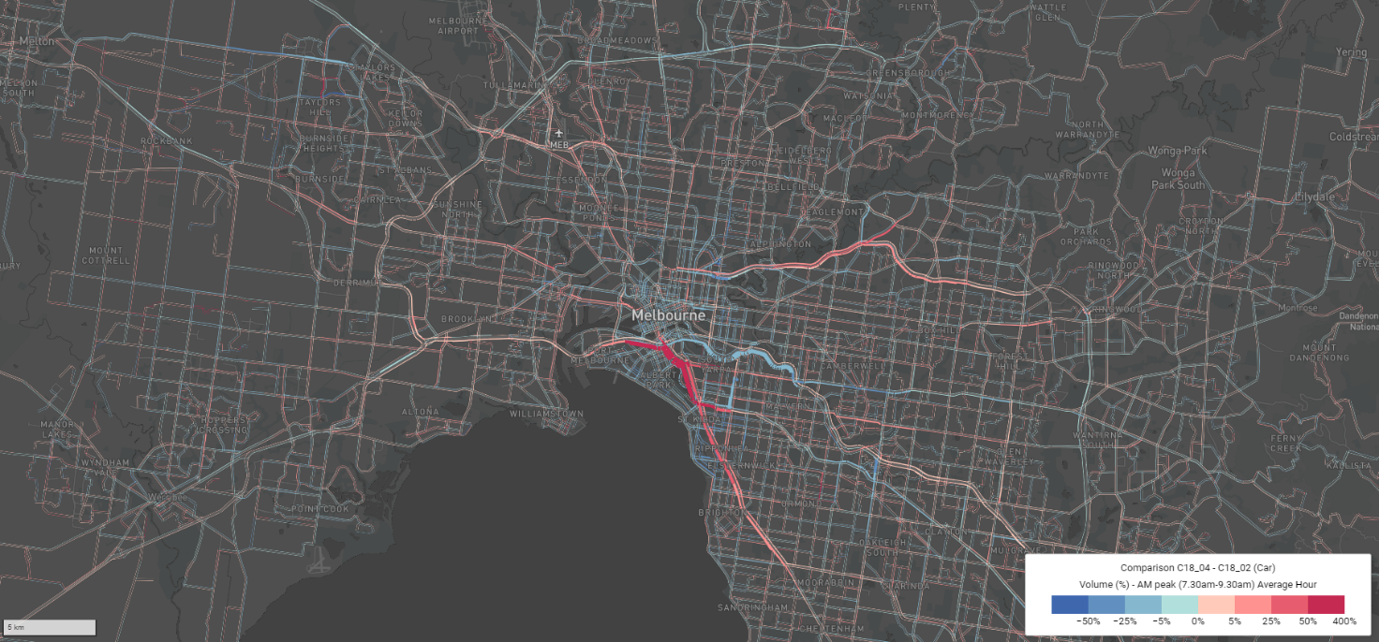
Figure 34. Comparison of AM peak car volumes, Active Uptake scenario vs. Core

Figure 35 below shows the impact on the road network as a result of the Flexible Work scenario. As expected, there is a general reduction in traffic volumes across the whole of Greater Melbourne due to an increase in working from home (which also impacts a large proportion of Inner Metro, given its higher employment density). Flexible arrival hours for work can also lead to drivers shifting to off-peak periods, further contributing to volume reductions during the busiest periods of the day.

Flexible work has widespread impacts on reducing car volumes across the network

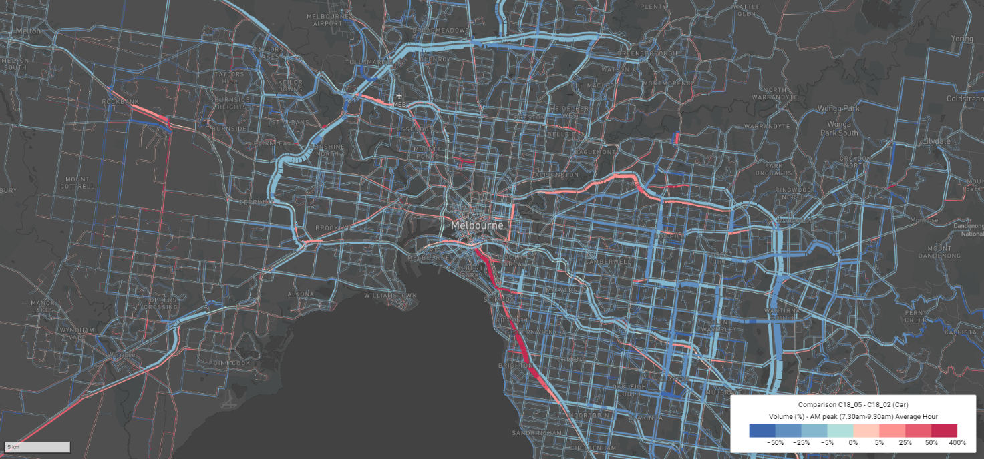
Figure 35. Comparison of AM peak car volumes, Flexible Work scenario vs. Core

One final measurement of road network performance is change in delay hours – the total amount of time that drivers spend in congestion. In Figure 36 below, the line represents delay hours for the Inner Metro.

The dots on the far right represent the network improvements (reduction in delay hours) associated with each policy intervention (labelled). While all scenarios improve upon the Core scenario levels of delay, the Flexible Work scenario also provides one of the biggest opportunities to reduce road delay hours across Greater Melbourne to levels far below what we would have experienced pre-pandemic, achieving reductions of more than 45%.

Figure 36. Total delay hours for modelled scenarios - Inner Metro

Allowing individuals greater flexibility in their work arrival times

The following analysis looks at the time commuters begin their work ‘activity’ in the Flexible Work scenario, as shown in Figure 37. In this scenario, the original arrival window for commuters in MABM to begin work was widened from between 8am-10am and changed to 7am-11am – an extra hour for each shoulder.

The slight decline from Base to Core scenarios is explained by some 220,000 work trips removed as working-from-home trips, discussed in the previous section. The Flexible Work line (light purple) represents the work activity count of the Flexible Work scenario – a clear spread of the morning peak.

Not only is there increased working from home in the Flexible Work scenario, removing some 560,000 work trips from the Base scenario, people also have greater flexibility in their arrival time leading to a proportion of travellers choosing to commute earlier in the morning. In the Core scenario around 80,000 individuals began work at 7am, while in the Flexible Work scenario this more than doubles to 200,000 workers starting at 7am.

For further context, around 15% of the Greater Melbourne workforce begins between 7am-8am in the Core Scenario. With flexible work practices, this increases to 27% of the Greater Melbourne workforce beginning between 7am-8am.

Figure 37. Work activity start time for Base, Core and Flexible Work scenarios

What are the transport benefits of flexible work practices?

Analysis of VISTA 2018 data conducted by Infrastructure Victoria shows that an overwhelming proportion of train trips are for work-related purposes.

This is supported in the boardings comparison shown in Figure 38 where there are huge reductions in peak train boardings due to higher levels of working from home (a reduction of around 8,000 boardings every 15 minutes in the morning peak and close to 6,000 in the afternoon peak).

Consistent with seeing greater flexibility in work start times there is also a large increase in early morning train boardings between 6:00 and 6:45am. In addition to the shift to early morning work starts, there is also a likely shift to later work activity starts, leading to an increase in late morning train boardings.

This late start is not directly observed in the data, likely because the impact is masked by the reduction in trips due to increased working from home.

Figure 38. Train boardings across the day, Active Uptake/Flexible Work scenarios vs. Core scenario – 15min intervals

Increase active mode travel and the impact on public transport patronage

Unlike the Flexible Work scenario, which exclusively targets work trips (and by proxy, a large proportion of train trips), the Active Uptake scenario targets a selection of all types of trips if they are of a suitable length to either walk or cycle.

Train patronage for the Active Uptake scenario shown in Figure 38 reveals patronage drops of around 1,000 to 2,000 boardings every 15min in the AM and PM peaks.

Tram patronage is particularly impacted by active transport in the interpeak period, with a reduction in tram trips by up to 1,500 boardings per 15 minutes across Greater Melbourne (Figure 39) – equivalent to around seven new E-Class trams at full capacity.

Figure 39. Train and tram boardings across the day Active Uptake/Flexible Work scenarios vs. Core scenario – 15min intervals

Overcrowding on metropolitan trains and trams

In both Core and Dialled-Up scenarios, physical distancing and public transport levels continued to remain a challenge for a return to actual or perceived safety when using the network.

This is improved in the Active Uptake and Flexible work scenarios. Figure 40 and Figure 41 show capacity of train and tram services for the Core, Active Uptake and Flexible Work scenarios. These figures should be interpreted in the same way as Figure 25 and Figure 26, found earlier in the paper – the charts help to provide a practical way of visualising levels of crowding on train and tram services.

Capacity A provides ample space for physical distancing and is represented by the light and dark bars combined, Capacity B provides twice the level of physical distancing as A, represented by the dark bars only.

As discussed earlier, the Flexible Work scenario reduces the number of train services above these illustrative physical distancing patronage levels, especially benefiting the morning peak. In fact, using Capacity A, over 90% of AM peak train services in the Flexible Work scenario continue to provide ample room for physical distancing.

The analysis also suggests that many interpeak and off-peak train services will also have enough capacity for additional passengers. For trams, the impact of the Active Uptake and Flexible Work scenarios are largely similar.

Both interventions slightly improve tram service crowding levels, though starting from a smaller base as a far smaller proportion of tram services originally exceeding illustrative physical distancing capacities compared to train services. For buses, while there is limited data on physical distancing limits, the Active Uptake scenario has minimal impact on bus patronage while the Flexible Work scenario reduces total bus patronage by around 14%.

Figure 40. Train service seated capacity levels (Capacity A and B) available to physically distance, by time period

Figure 41. Tram service seated capacity levels (Capacity A and B) available to physically distance, by time period

Overall, an aggregated view of the network presents an optimistic message – with over 90% of all morning peak train services operating with some level of physical distancing, equivalent to two in five seats occupied.

While there are still some peak travel challenges, this is where additional policy options like regulation, additional pricing mechanisms and infrastructure provision can come into play. These are discussed in the following section.

Policy options are designed to be practical enough for short-term implementation while capable of delivering sustained long-term benefits. Across all categories of directives and guidance, pricing and infrastructure provision, the options complement each other if implemented together while also working as individual options to support the transport network.

Policy options
The previous section demonstrated the benefits to Greater Melbourne of increased active transport and flexible work arrangements.

While the Flexible Work and Active Uptake scenarios each make a significant contribution to reducing road congestion and public transport crowding, our modelling shows that if implemented alone, they are unlikely to be sufficient to address these challenges.

The modelling we have conducted for the purposes of this research and Fair Move – Better Public Transport Fares for Melbourne demonstrates the individual effects of flexible work, active transport uptake and greater off-peak public transport use. A combination of interventions that encourage flexible work, active transport uptake and greater off-peak public transport use is likely to be necessary to manage congestion and enable physically distanced public transport use in the Inner Metro area.

We know that achieving these behaviour changes (greater active transport, increased workplace flexibility and greater off-peak public transport use) will not be easy and cannot be achieved without policy and operational interventions. As such, we have identified a number of options for the Victorian Government to continue or consider implementing in the short term. Table 10 provides a summary of each option with an individual purpose, the subsequent subsections discuss each category in detail.

Government directives and guidance:
Option: Continue to monitor physical distancing levels of public transport and provide clear directives on mandatory use of masks, as well as responses such as distinct signage for physical distancing with increased staffing for enforcement or assistance in managing capacity limits to support safe travel.
Purpose: Directives such as mandatory wearing of masks and capacity guidance on public transport can support safer and more confident travel.

Pricing Mechanisms:
Option: Consider implementing permanent off-peak public transport fares across all modes.
Purpose: Off-peak fares complement flexible work incentives and can incentivise commuters to travel during quieter times of the day.
Option: Remove the Free Tram Zone (FTZ).
Purpose: This measure will reduce crowding and the associated health risks in inner Melbourne while also encouraging the uptake of active transport options, particularly walking.
Option: Develop incentive schemes to encourage greater uptake of active transport to work.
Purpose: Greater uptake of active transport takes pressure off roads and public transport, improving congestion, reducing pollution and lowering health risks.

Infrastructure provision:
Option: Monitor crowding and patronage levels of new off-peak public transport service improvements – revising scheduling to best support peak spreading.
Purpose: Increasing capacity through running additional services using the excess capacity of the system in off-peak times (underutilised infrastructure and rolling stock), increasing capacity on the network for flexible work and greater physical distancing.
Option: Larger, more permanent separated cycling corridor upgrades should be delivered wherever possible and they can be complemented by pop-up bike lanes.
Purpose: Safer cycling infrastructure supports greater uptake of active transport, taking pressure off roads and promoting sustained behaviour changes, particularly in inner Melbourne.
Option: Support local government to re-allocate parking and road space for pedestrians and economic activity
Purpose: Active transport has the capacity to take the pressure off roads and incentivise sustained mode shift, particularly in inner Melbourne. City of Melbourne commissioned research also shows increasing walking connectivity by just 10% would increase the value of the city centre economy by $2.1 billion a year, given the face-to-face connections fundamental to the retail and knowledge economies.

Government collaboration and leadership in flexible work
Option: In addition to continued regulation to ensure workplaces remain safe, provide government leadership and nudges towards greater flexible work through processes, public campaigns, collaboration with industry and the use of the VPS as an example of best practice.
Purpose: While private incentives for working from home exist, government can encourage higher rates by highlighting employers’ Occupational Health and Safety (OHS) responsibilities plus reduced transmission risk and the wider social benefits of working from home. Government should also collaborate with employer peak bodies, industry and unions to promote flexible work hours and other flexibility practices using the public service as an example.

Regulation
The Victorian Government has limited work activity by industry throughout the COVID-19 pandemic. This has proved an effective way to limit the amount of people travelling and congregating for work and has succeeded in protecting Victorians’ health and safety during COVID-19.

It is likely that many physical distancing restrictions, such as the number of people allowed to work in a specific area, will continue well into the recovery period. These restrictions will continue to play a role in reducing the demand for commuter travel, improving safety on public transport and reducing congestion.

Our policy options do not focus on these regulations, which aim to protect community health and safety, but they do have a strong link to Victoria’s transport networks. Our advice focuses on other policies which either incentivise or discourage the overuse of the road or public transport network at times when they are at capacity.

As discussed in Section 3.2.2, there are already a number of incentives for both employers and employees to encourage greater work from home in the short term. These include lower office-related costs for employers, reduced commuting time and travel expenses for employees, and the reduced risk of illness, which benefits all parties.

Public transport regulation

One area in which health and safety overlaps strongly with the transport network is physical distancing on public transport, and this is an area in which regulation should be considered.

In May 2020, NSW adopted a campaign to reduce overcrowding on public transport that included clearly marked places to sit and stand, published capacity limits on services, as well as additional staff to assist in monitoring limits on trains. Bus drivers were advised not to stop if they were already carrying the safe limit of people. Touch points were reduced by enabling doors to automatically open and close when they previously needed to be pressed. Real time capacity monitoring was also made available at stations as well as on-trip planning and third-party apps.

In a similar move, the Victorian Government has also commenced trials of similar technology to encourage physical distancing and improve commuter confidence in taking public transport.

By using data from the myki ticketing system, passenger counters and Bluetooth sensors, real-time crowding information will be available to commuters via the PTV app.

Further, continuing to make mask wearing compulsory on public transport will lower the risk of infection and may enable higher safe capacity limits, making people feel safer on public transport services. Research shows that the risk of infection is made up of many complex factors and that physical distancing can be adapted and used alongside other strategies to reduce transmission, such as mask wearing.

Figure 40 has shown that some services (6% of train services in the AM peak) continue to operate at levels of patronage that provide limited space to physically distance, even under the Flexible Work scenario with the illustrative limit of two in five seats occupied.

Mask wearing, combined with off-peak fares, visual cues and staff that assist people to physically distance will reduce the risk regarding services that are modelled to still face physical distancing challenges (typically select services between 8-9am).

These kinds of policies could improve the level of overcrowding on public transport and reduce the number of services that lack physical distancing across all modelled scenarios.

Pricing mechanisms

Off-peak fares
Our modelling has shown that flexible work can enhance public transport safety and reduce road congestion. Figure 37 showed the positive impact of people choosing to shift their start and finish times, reducing crowding and congestion.

Encouraging people to move time periods is a viable way of enabling more people to make their trip safely on public transport services, moving people away from the peak periods where crowding is most prevalent. If people spread their travel across public transport services it may also decrease the difficulty in any enforcement of physical distancing on public transport and limit the number of people who shift to private vehicle, reducing road congestion.

Apart from the natural incentives for people to shift time period (such as reduced road congestion and higher levels of physical distancing on public transport), public transport fares policy can play a strong role in incentivising people to shift their travel and work times.

A BehaviourWorks survey showed that 60% of people are more likely to shift their time of travel if an off-peak discount is applied (Figure 27). Notably this was greater than the impact on decision-making from potential changes to child drop-off times and the ability to see real-time data on the level of crowding on public transport services.

Infrastructure Victoria’s paper Fair Move: Better Public Transport Fares for Melbourne, demonstrated that there are not just short-term COVID-19 benefits from off-peak pricing for public transport, but longer-term benefits which will improve the efficiency of the network.

COVID-19 presents an opportunity to seize work and commuting behaviour changes and lock in those benefits for the future. Modelling in Fair Move showed that off-peak fares, combined with a range of other public transport pricing reforms, reduced peak train boardings by 30,000 trips, and increased off-peak usage by 100,000 trips.

We found that off-peak discounts should be significant and well publicised if they are to make the greatest difference. Our modelling in Fair Move was based on a 50% off-peak discount.

Combined with the recent trial for people to see the levels of crowding on certain services via the Public Transport Victoria (PTV) app, off-peak fares would help people consider shifting their travel times to enable safer and cheaper travel. This would assist in encouraging the greater work flexibility seen in our modelling results, and Figure 37 in particular.

Recognising recent December announcements of temporary off-peak fares across the public transport network, the Victorian Government should also begin monitoring the impact and adjust levels of discounts applied based on desired patronage. Consideration should also be given to permanent implementation of off-peak fares.

Suspend or remove the Free Tram Zone
Figure 26 demonstrated that there is likely to be insufficient physical distancing on tram services during the recovery period, and our Active Uptake scenario relied on an increase of 123,400 walking trips within or to and from Inner Metro each day. A way to help achieve greater physical distancing on tram services and encourage greater active transport is to suspend or remove the Free Tram Zone.

Removal of the Free Tram Zone was not modelled as part of the COVID-19 modelling program so that the network benefits from Flexible Work and Active Uptake scenarios could be clearly distinguished in the modelling results. Infrastructure Victoria already modelled removal of the Free Tram Zone in an earlier report, Fair Move: Better Public Transport Fares for Melbourne.
Trams have traditionally carried large numbers of people within inner Melbourne, often under very crowded circumstances. The Free Tram Zone itself includes the busiest tram corridor in the world − a corridor that is already at capacity with a service in each direction every 60 seconds at most times of the day.

The Department of Transport has stated that there are 35 million trips per year in the Free Tram Zone, which has increased from only 18.5 million trips before the zone became free.

Yarra Trams states that patronage increased by 30% alone in the first year of the Free Tram Zone’s introduction, resulting in significantly increased crowding and discomfort, despite adding over 60 new large trams and a small number of additional platform stops.

This historical data suggests that by removing the Free Tram Zone, millions of trips will return to active transport, and this will in turn create greater room on existing services for improved physical distancing.

Such a move would not only prove highly beneficial in the short term but would also provide long-term benefits in efficiency and safety, as outlined in Infrastructure Victoria’s Fair Move report. It would also support the large shift to walking for short trips, as modelled in the Active Uptake scenario.

The reduction in crowding from the suspension or removal of the free fare is important for those who are taking longer trips, carrying items or who have mobility issues.

Crowding on trams in the Free Tram Zone hinders access for older Victorians, people with a disability, pregnant women and parents with prams and young children − the same people that have the greatest need to access trams in and around the CBD.

Making a good or service free is well known to result in a large increase in demand for a good or service, with a zero price often serving as a focal point that signals to consumers that the good or service has a substantially higher benefit than even a very low price.

This becomes particularly problematic in an era in which additional consumption of tram services carries an increased risk of infection and represents a negative externality to society. In cases where a good carries a negative externality, those goods should be taxed or increased in price to account for the negative side effects of use. Keeping the Free Tram Zone free does the opposite, encouraging people to over-consume a good that has negative impacts on society during a pandemic.

Incentives to encourage people to cycle
There are significant benefits to the transport network from a shift to active transport. Our modelling included an increase of over 142,000 cycling trips each day to, from and within Inner Metro. Combined with greater walking trips, this resulted in a reduction of 40,000 delay hours for Inner Metro road congestion (Figure 36).

However increasing cycling, particularly for commuting, has previously proven difficult. A transformation in how people commute, choosing active transport over car and public transport, will not happen without significant investment and effort. As a first step people need to feel safe, as discussed in Section 3.6.3.

In addition to a network that more safely accommodates cycling, another initiative to encourage cycling would be to provide a financial incentive to people, such that they are rewarded for choosing active transport over private car or public transport.

Multiple countries in Europe have schemes in which people are paid a per kilometre rate to ride their bikes to work, rather than use public transport or drive. While no such scheme currently exists in Australia, the Bicycle Network has called for one to be introduced.

Such schemes usually involve a tax deduction for the employee or employer to incentivise people to ride to work. This may take the form of a payment for riding to work, or reduced costs in cycling related expenses such as bicycle purchases, maintenance and clothing.

In a Victorian context this could be a discount on the payroll tax (or direct payment) for those employers whose employees are paid an allowance to ride to work and have made arrangements with their employer to do so. It could also simply be a payment from the government provided directly to employees who commute by bicycle.

The deduction or payment would be related to the number of trips made by bicycle, or the number of kilometres travelled and be passed on to employees. Such a scheme could be administered through employers, and additional requirements for eligibility could include suitable end-of-trip facilities so that those riding their bikes to work have access to secure parking and change facilities.

Another option is to reimburse a proportion of equipment-related expenses used for commutes.

Given the external costs of congestion from reduced road use (approximately $1.20 per vehicle kilometre in the case of traffic removed by Melbourne Metro), and the considerable cost to government of adding new trips to public transport (estimated to be roughly $14 a trip for train and $4 for tram during the AM peak), some level of financial incentive for cycling would be beneficial to commuters, government and taxpayers.

At a time when public transport crowding is also unsafe, such a payment would be even more justified, and may help people make the shift to active transport.

An unknown is how responsive people will be to such a scheme in Victoria. A scheme that does not attract many new cyclists and simply pays existing ones will be of limited value.

Such a scheme would also need to be accompanied by safe cycling routes, as research indicates this is of greatest importance in encouraging cycling. A small or large-scale trial combined with evaluation would test the impact of such a program.

A large-scale trial may put cycling to work front and centre in people’s minds when they are already exploring other ways of commuting due to the pandemic and assist in achieving short-term behavioural change that may have lasting benefits.

Research conducted using financial incentives, gamifications and rewards via an app found that the frequency of cycling did increase, most markedly with financial rewards. This means a rewards program can not only encourage new people to commute to work by cycling, but also increase the frequency of cycling for those that already ride.

The study also shows there is scope to reward people not just with financial rewards alone, but also through other motivations such as a sense of achievement.

Incentivised cycling around the world

There are a range of countries that offer cycling incentive schemes, including Belgium, the Netherlands, Italy and the UK. These range from incentive schemes that provide rewards the more you cycle, or that provide significant savings on cycling equipment used to cycle to work.

Belgium
The oldest cycling incentive scheme was started in 1999 in Belgium. It currently provides 23 eurocents per kilometre for those cycling to work, paid by the employer, and this can then be claimed as a deductable by the employer. The payment is provided at the end of the month in the employees’ pay slip and is tax free.

The scheme is part of a broader commuting cost tax deduction policy that is seen in multiple countries throughout Europe. In Belgium this also includes the deduction of the full public transport fare for work commutes, and private car use up to a cap of €380 a year.

Cycling commuters can be reimbursed an uncapped rate of €0.23 per kilometre, and employers can claim this as a tax deduction. While the scheme would be even more effective in attracting active transport in the absence of the deductions for car and public transport, other European nations have no such scheme for cyclists while still subsidising the commutes by other modes of transport. This makes Belgium one of the most generous cycling schemes in Europe.

The cycling related expenses tax deduction arrangements are also generous in Belgium, with a 120% tax deduction for employers on all costs linked to cycling, including the purchase of bikes, maintenance and bike accessories for employees, and even end-of-trip facilities related to the use of bicycles (bike parking, shower installations, etc.).

Importantly, employees are not taxed on any benefits they receive through the employer.
Between 2011 and 2015, the scheme saw an increase of around 30% in users and has increased the distance cycled by 50%. This equates to over 400,000 people (9% of the country’s workforce) involved in the program.

It should be noted that the high rate of cycling is not seen throughout Belgium, and is much higher in some places and lower than others, as depicted in Figure 42.

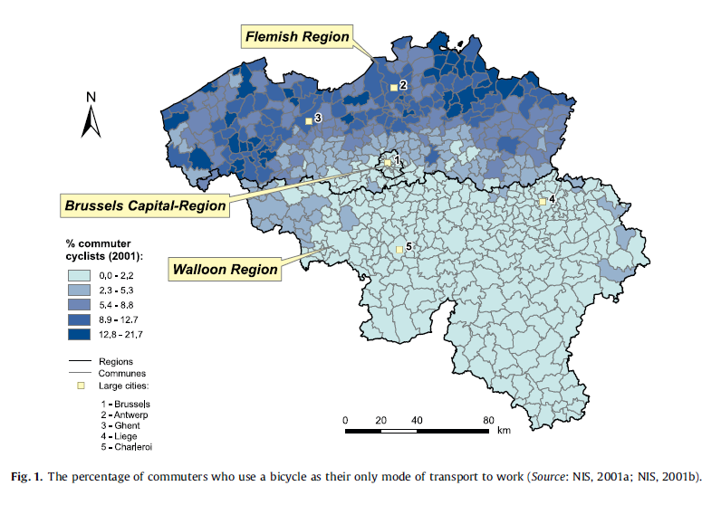

Figure 42: Percentage of commuters who use their bicycle as their only mode of transport to work
Source: G. Vandenbulcke, I Thomas et al. Mapping bicycle use and the risk of accidents for commuters who cycle to work in Belgium, Transport Policy, Volume 16, Issue 2, 2009, pp 77-87.

Research has found that there are a range of factors at play for the difference in cycling rates with Belgium, including safety, topography, culture and the availability of public transport. Researchers also found that the rate of cycling was higher in dense urban areas, but lower in major cities (such as Brussels).

This underscores the importance of safe cycling infrastructure for inner Melbourne in the success of a push to increase cycling, and that there are a range of factors that play into individuals’ decisions to commute via bicycle.

The UK

In the United Kingdom the government has worked with employers to offer tax deductions for the purchase of cycling equipment used to ride to work. The programme is named Cyclescheme, or the Cycle to Work Scheme.

The cycle to work scheme is a tax-free, salary sacrifice benefit currently offered through employers who may loan cycles and various items of cycling equipment to employees, with the intention of promoting both more environmentally friendly commuting and health benefits associated with cycling. This enables most commuters to save between 25-40% (depending on their tax bracket) of the cost on bicycle equipment and clothing.

A 2016 research paper based on a survey of 13,000 users of the scheme concluded that around 65% of users increased the amount of cycling they did once they joined the scheme, by an average of around 30min per day. This not only has significant congestion benefits, but also health benefits as well.

Transport infrastructure improvements

Off-peak public transport service improvements

The results from our modelling shows that despite large shifts away from public transport, there are still likely to be undesirable levels of crowding on many services, even those in off-peak periods (Figure 25 and Figure 26).

Our option to introduce off-peak fares is designed to increase off-peak use, in exchange for lower levels of peak usage. Without increased services in off-peak periods to accommodate the additional patronage from the peak, off-peak fares could have a limited overall positive impact in the short term.

Adding additional services to the peak period is very difficult, because many of those networks are at capacity and may require new rolling stock or large-scale infrastructure such as signalling, line duplication or tunnelling to accommodate new services. This is the main reason why shifting people into the off-peak periods is desirable, and why we have highlighted off-peak fares as a good policy response to overcrowding.

As off-peak services attract greater patronage, they will also become more crowded. Unlike peak services however, there is the rolling stock and large-scale infrastructure available to increase off-peak services with relative ease. An increase in train trips during the peak costs around $12 per trip to accommodate in expanded infrastructure alone, while off-peak services have no additional infrastructure cost associated with them.
While there will still be costs involved in adding new services (such as electricity, wages and maintenance), this money will be well spent in enabling people to travel by public transport more safely and also contribute to reducing road congestion.

Expanding off-peak services will also have the effect of improving the user experience. One of the current downsides to off-peak services is the infrequency in run times, often resulting in long wait times at stops and stations. Increasing off-peak service frequency will therefore improve the service quality and attractiveness of off-peak services.

NSW has added over 250 train services and 3,100 bus services each week to increase capacity by around 60,000 people for trains and 37,000 on buses. The majority of these services were added outside the peak period.

From 31 January 2021, Melbourne will also be following in similar theme, adding an extra 280 metropolitan train services to the network. Patronage on these services should continue to be monitored, revising scheduling to best support peak spreading.

Further, an alternate option of improving off-peak services can be done through reshaping the bus network. While recent announcements from the Victorian Government refer to improved timetabling across 320 suburban bus routes to better integrate with connecting trains, additional bus services have the potential to increase the overall capacity of the public transport network – especially in the short term.

This strategy would also be complemented by the relatively low capital cost of buses, bus priority and a good range of additional premium, connector and local bus services.

Safer cycling routes

Victoria has a significant untapped market for cycling if the right infrastructure was in place. In Melbourne alone, Infrastructure Victoria’s past modelling has estimated that around 204,000 daily car and public transport peak hour trips could be cycled or walked.

The proliferation of e-bikes is also creating new opportunities for cycling, significantly reducing the physical effort required to commute by bicycle and increasing the distance people are willing to ride. In the U.S, e-bike sales increased by 80% between 2016 and 2017, and imports in Australia are reported to have tripled over three years, while still lagging well behind the adoption rate in other places such as Europe.

With these emerging forms of active mobility and greater interest in walking and cycling, the situation is well suited to leveraging this momentum for a sustained shift to active modes in Victoria’s recovery.

However, the number one barrier for people who could cycle to inner Melbourne, but don’t, is safety. This is a long documented, common and persistent issue across many jurisdictions.

Australian research has consistently shown that perceptions of safety and environmental factors, including disjointed cycling infrastructure, remain the biggest barriers to increased uptake of cycling.

Perceived risk is an important determinate for whether or not people will ride their bikes, and the evidence suggests that simply providing allocated road space alone is not sufficient to reassure the majority of potential cyclists.

The City of Melbourne has conducted research based on how confident people are to ride on different types of roads. The results are represented in Figure 43.

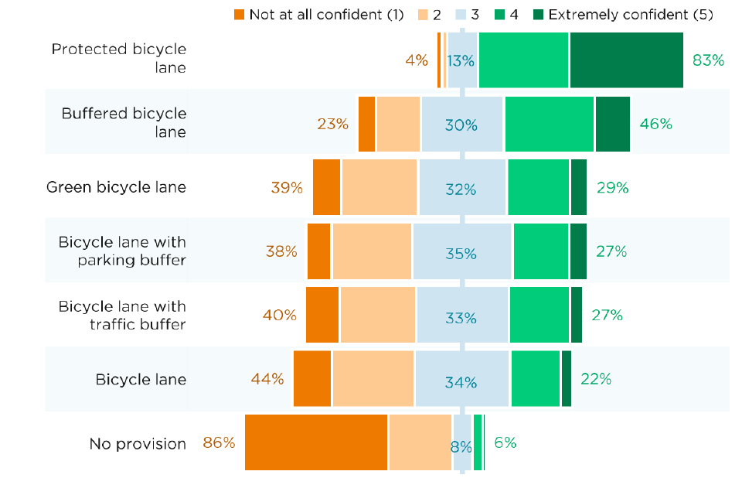

Cycling confidence levels relative to degree of separation in midblocks
Figure 43: Rating of confidence by infrastructure type. Source: City of Melbourne Transport Refresh, Cycling Background Paper

These results are echoed in real-world examples which show the sharp drop in confidence the more intermingled the bike traffic is with the road traffic (Figure 44).

Confidence of riders using different forms of cycling infrastructure

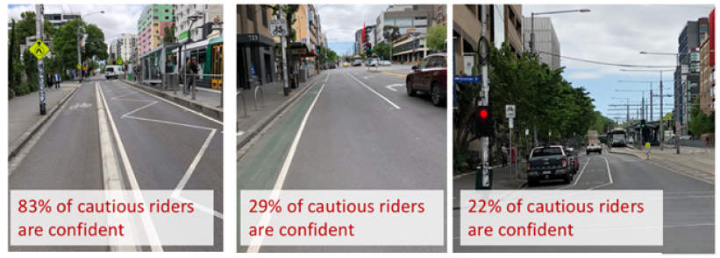
Figure 44: Rating of confidence by infrastructure type in real world locations. Source: City of Melbourne Transport Refresh, Cycling Background Paper

The Victorian Government has announced funding for 100km of pop-up bike lanes to help ease congestion and provide an alternative to public transport for those living closer to the CBD.

The level of separation of cycling from traffic and parked cars will be a limiting factor on the program’s success. Most cyclists fear being ‘doored’ by a stationary car.

The pop-up bike lanes should also not slow progress on much needed permanent infrastructure improvements for cycling infrastructure. These initiatives should complement each other.

Pop-up bike infrastructure may also serve to trial how people respond to improved protection on particular routes. The government could prioritise and fast-track implementation of Strategic Cycling Corridors by creating permanent low-stress, high quality, separated cycle ways.

Based on separate analysis by the Institute for Sensible Transport, RACV and Infrastructure Australia, the five highest priority corridor results are:
- Clifton Hill to Windsor via Chapel St
- Brunswick East to Birrarung Marr
- Batman to Elsternwick via St Kilda Rd (combining and expanding two routes, Upfield to CBD and CBD to Elsternwick)
- Preston to CBD
- Coburg to St Kilda East.

Chapel St and St Kilda Road were singled out in the Institute for Sensible Transport’s study due to serious cyclist injuries and deaths.

Major Road Projects Victoria’s current timeline for implementation of the St Kilda Road separated bike lanes (priority 3) is 2025. Based on the available data and demand, Infrastructure Victoria considers that there is significant merit to fast-tracking funding and implementation of strategic cycling corridors.

It is also imperative that the infrastructure separates cyclists from traffic as much as possible. A lack of physical separation will result in poor uptake of the cycling infrastructure.

Any fast-tracked implementation of strategic cycling corridors should also accommodate emerging transport needs such as e-scooters and e-bikes. On current timelines, it is likely that the mass uptake of personal mobility devices will precede the completion of the strategic cycling network.

Now is the time to ensure these corridors are implemented to maximise their benefit to the community and minimise risks to vulnerable road users.

Once people arrive in Melbourne’s city centre via bicycle, it is also important that they are able to get around easily. There are still a number of bike lane links that are missing in the CBD area, with very few protected cycle ways (as demonstrated by Figure 45).

Quality of bicycle facilities vary across the Melbourne CBD
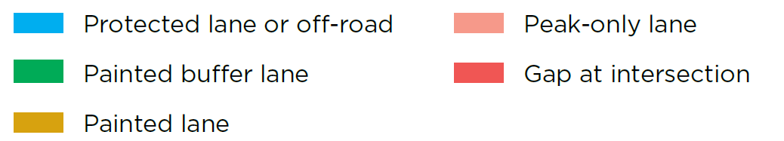
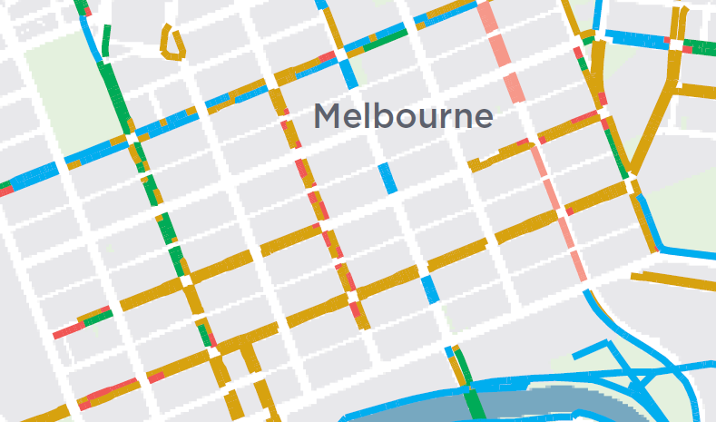

Figure 45: Cycling infrastructure in inner Melbourne. Source: Adapted from the City of Melbourne’s 2030 Transport Strategy

It may also be beneficial to lower road speed limits, particularly in pop-up bike lane areas or on roads where less physical separation between cars and cyclists is achieved. Evidence shows that lower speeds result in less serious injuries and less likelihood of death for pedestrians and cyclists, and may encourage greater active transport.

Finally, a campaign to encourage greater cycling to work (perhaps combined with some incentives as per Section 3.6.2) would help promote greater commuting by active transport.

This could include providing information that helps people feel more confident to ride, including planning a trip using safe routes, resources on the rules of the road for cyclists, cycling safety tips and the benefits to individuals and society of using greater active transport for commuting.

While much of this is currently available online, there is no central point for all this information. The government could partner with stakeholders for maximum impact, including the City of Melbourne, Bicycle Network Victoria, Transport Accident Commission and the Amy Gillett Foundation.

Cycling investment pays off internationally

Copenhagen, London and Seville demonstrate that sustained investment in cycling infrastructure can lead to more cycling trips, outpacing growth in other transport modes.

Copenhagen has invested in 150 kilometers of quality cycle superhighways since 2012, with plans for further expansion in the next 25 years. Since the network has been installed, cycling has increased by 23%, with cyclists covering 400,000 kilometers each day.

121,000 fewer sick leave days are taken each year due to better health from cycling.
London’s Cycling Superhighways, a full separate cycle lane through Central London, and Quietways, have supported increased cycling with a doubling in cycling as a mode share from 1.2% in 2000 to 2.5% in 2018.

Between 2006 and 2007, Seville, Spain delivered 80 kilometres of fully separated bicycle lanes. The lanes re-purposed car parking space and were built on the same level as footpaths in both directions. The network has been expanded since, creating a 180-kilometre cycle networking in the city, resulting in a significant increase in cycling.

Greater access for pedestrians
Greater levels of walking trips (as shown in the Active Uptake scenario) may result in high levels of crowding on footpaths, with past consultation by the City of Melbourne showing that the number one complaint for walking experience in Melbourne was overcrowding.

This issue may be particularly acute during the pandemic, where people’s proximity to one another will be at the top of their minds.

The Victorian Government could support the City of Melbourne to continue to free up greater space for walkers, including the use of parking spots or changing the mix of road and pedestrian traffic on specific routes. This could include streets that prioritise foot traffic or even sectioning off some streets only for public and active transport use.

The government could assist by optimising state-controlled roads (e.g. Flinders, William, Victoria and Spencer streets) to best enable traffic flow around roads that are more heavily allocated to active transport.

City of Melbourne commissioned research also shows increasing walking connectivity by just 10% would increase the value of the city centre economy by $2.1 billion a year, given the face-to-face connections fundamental to the retail and knowledge economies.

The government could also provide funding for road space allocation works on state-declared and council-managed roads, including temporary line markings, physical separation devices, signage and intersection works.

Government collaboration and leadership
Our modelling has shown that greater levels of flexible work, consisting of levels of working from home of around 25% and more flexible work times, result in congestion levels in Inner Metro close to pre-COVID-19 levels (a reduction of over 100,000 delay hours – see Figure 36), and much lower congestion across the rest of Melbourne.

This reduction is still well inside the estimates for those who can work from home (Section 2.1.2), with the greatest proportions of workers able to work from home being professionals, managers and administrative workers (approximately just over half of which were deemed able to work from home).

Our original forecasts for Victoria showed an estimated reduction of between 10-20% for the levels of work from home. Figure 3 showed that Victoria already had returned to only a 22% reduction in commuter activity in the lockdown easing phase, before the second wave.

Again, it is important to acknowledge that not all workers have flexible work options to work from home and vary their start and finish times. By incentivising those commuters that can adjust to travel at an alternate time, we can also create better, more reliable trips and allocate capacity for those who have no choice and must commute during the peak.

While health regulations such as physical distancing restrictions and workplace safety requirements will play a role in maintaining a level of work from home, governments can also impact behaviour by what are described as ‘nudges’ – messaging or changes in presentation that can alter people's behaviour in a predictable way without forbidding options or significantly changing their economic incentives.

As an example, while there are government regulations on the environment, many people do more than is required by law because they consider the wider implications of their actions, and because of the standard set in social norms.

This could take the form of workplaces to opt-in to returning their staff to the office and logging employee attendance through support such as government campaigns around the benefits of increased working from home, accreditation for flexible workplaces, and collaboration with peak bodies, industries and unions to encourage greater working from home.

Through mechanisms such as these, the government could keep the social benefits of greater workplace flexibility at the front of people’s minds, as well as appealing to the significant number of natural incentives for both employers and employees (such as lower office-related costs for employers and reduced commuting time and travel expenses for employees, plus the mutual benefits of the reduced risk of illness and transmission to close contacts).

Government can also highlight best practice and use the public service as an example to other employers. This action would also make a measurable difference to greater flexible work in the CBD, as just over 4% of employees (20,000 people) in the City of Melbourne are Victorian public servants.

New South Wales is leveraging its influence to encourage a return to the CBD but doing so in a way that encourages flexible work by staggering start times and rotating days in the office. It hopes that encouraging public servants back to the office will help Sydney’s recovery.

It is equally valid to encourage greater working from home and flexible work hours, as this would be to the overall benefit of society.

Ultimately, there is likely a wide range of other incentive programs and mechanisms as short-term options available to government and industry to promote flexible working arrangements.

Infrastructure Victoria’s modelling highlights the importance of adopting such practices and demonstrates the transport benefits flexible work can achieve.

Further detail on how specific implementation is conducted has broader workplace impacts and will most likely require discussion between government, employers and employees. While detailed assessment of these broader workplace impacts is beyond the scope of this research, our work clearly demonstrates that there is an important relationship between transport infrastructure use and flexible work practices.

Victoria beyond recovery

Looking beyond recovery
Infrastructure Victoria’s next research report will consider the longer-term implications of COVID-19. One reason to expect changes once the pandemic subsides is that many Victorians have tried alternative ways of doing things, such as buying goods online or choosing telehealth appointments, and discovered they preferred doing it this way.

Some Victorians have also developed new skills, such as learning how to videoconference and use collaborative software and have been able to productively work from home. These developments could have significant implications for the future Victorian economy and transport network.

In our future research and modelling work, we will highlight what are likely to be the largest changes as a result from COVID-19 and analyse their economic, transport and land use implications. These changes will likely include:

- greater working from home
- greater use of online retailing of goods
- greater remote consumption of services such as health and education
- greater automation
- more remote business-to-business transacting.

We will use Infrastructure Victoria’s Victorian Land Use and Transport Integration (VLUTI) model to estimate the size of these effects and their impacts across different parts of Victoria.

The VLUTI is a model which integrates the Department of Transport’s Victorian Integrated Transport Model (VITM) with a spatial computable general equilibrium model to capture the interactions between transport and macroeconomic outcomes for Victoria.

The VLUTI model enables an examination of the outcomes for economic output, employment and transport resulting from the changes to the structure of the Victorian economy as a result of COVID-19.

Appendix

Spatial regions in MABM

When referring to spatial results from the MABM runs, we use the following Infrastructure Victoria (IV) Region boundaries which are made up from groupings of local government areas (LGAs).

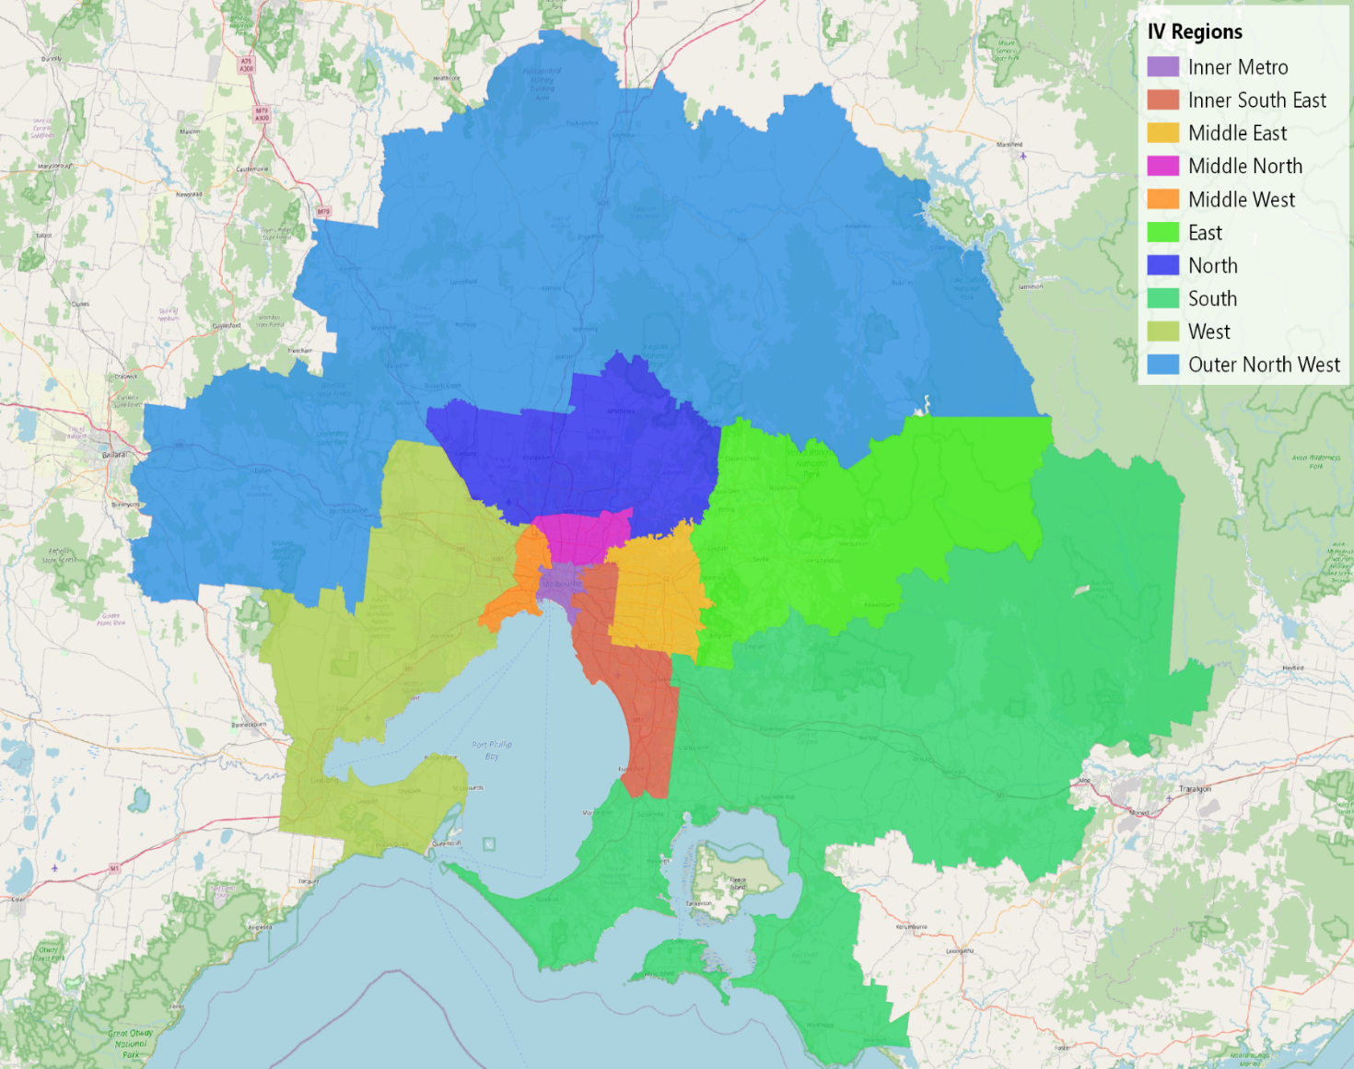

Time periods in MABM
Our modelling results are classified into four time periods:
- AM Peak, 7.30am – 9.30am
- Interpeak, 9.30am – 4.30pm
- PM Peak, 4.30pm – 6.30pm
- Off-peak, 6.30pm – 7.30am (next day).

About us

Infrastructure Victoria is an independent advisory body, which began operating on 1 October 2015 under the Infrastructure Victoria Act 2015.

Infrastructure Victoria has three main functions:

- preparing a 30-year infrastructure strategy for Victoria, which is refreshed every three to five years
- providing written advice to government on specific infrastructure matters
- publishing original research on infrastructure-related issues.

Infrastructure Victoria also supports the development of sectoral infrastructure plans by government departments and agencies.

The aim of Infrastructure Victoria is to take a long-term, evidence-based view of infrastructure planning and raise the level of community debate about infrastructure provision.

Infrastructure Victoria does not directly oversee or fund infrastructure projects.

This publication may be of assistance to you, but Infrastructure Victoria and its employees do not guarantee that the publication is without flaw of any kind or is wholly appropriate for your particular purposes and therefore disclaims all liability for any error, loss or other consequence that may arise from you relying on any information in this publication. You should seek appropriately qualified advice before making any decisions regarding your particular project.

Printed by Infrastructure Victoria

January 2021

© Copyright Infrastructure Victoria 2021

Except for any logos, emblems, trademarks, figures and photography, this document is made available under the terms of the Creative Commons Attribution 3.0 Australia licence. It is a condition of this Creative Commons Attribution 3.0 licence that you must give credit to the original author, who is Infrastructure Victoria.

This document is also available in PDF and accessible Word format at www.infrastructurevictoria.com.au

ISBN 978-1-925632-68-2 (pdf/online/MS word)

https://s3.ap-southeast-2.amazonaws.com/hdp.au.prod.app.com-participate.files/3115/2280/6517/Transport_Strategy_Refresh_-_Discussion_paper_walking.PDF
Infrastructure Victoria’s research on transport pricing policy found in Fair Move: Better Public Transport Fares for Melbourne and Good Move: Fixing Transport Congestion provides an extensive list of transport reform recommendations, covering short, medium and long-term time periods.
At the time of modelling, a draft 2018 base year of the MABM was the most suitable and up-to-date version of the model to select from. Other alternatives include a previous 2016 base year, or 2031 base year. The draft 2018 base year updated (where possible): network links, transit schedule and capacities and improved accuracy of the synthetic population.
For example, see ABS Weekly Payroll Jobs and Wages in Australia: https://www.abs.gov.au/statistics/labour/earnings-and-work-hours/weekly-payroll-jobs-and-wages-australia/latest-release. 14 March 2020 also falls prior to many COVID-19 restrictions coming into force in Australia.
Google provides Community Mobility Reports aimed to provide insights into the shifts from COVID-19 across spatial and temporal categories: https://www.google.com/covid19/mobility/
See VLC COVID Modelling for Infrastructure Victoria – slide 31 for detailed information.
These estimates also follow research observations presented by Currie and Hensher in AITPM Webinar: Travel Post COVID-19. https://www.aitpm.com.au/events/past-events/travel-post-covid-19-alternative-views-from-leading-academics-october-2020
Dingel and Neiman (2020), How many Jobs can be Done at Home? https://bfi.uchicago.edu/wp-content/uploads/BFI_White-Paper_Dingel_Neiman_3.2020.pdf
See VLC COVID Modelling for Infrastructure Victoria for detail on how the DJPR survey was incorporated in the analysis.
See KPMG Arup Model Calibration and Validation Report for further detail on the population synthesis process. https://www.infrastructurevictoria.com.au/wp-content/uploads/2019/04/KPMG-MABM-Validation-Report-December-2017.pdf
VLC’s COVID-19 Mobility Trends Dashboard provides indexed numbers of mobile devices across average weekday for varying categories. See: https://explore.veitchlister.com.au/covid-19-dashboard/
See VLC COVID Modelling for Infrastructure Victoria for details of analysis from COVID-19 VISTA July survey (Department of Transport 2020)
RAC media release: https://rac.com.au/about-rac/media/media-releases/november-2020/perth-traffic-growing-12-times-faster-than-forecast
Infrastructure Australia, Perth travel estimates: https://www.infrastructureaustralia.gov.au/sites/default/files/2019-08/Urban%20Transport%20Crowding%20and%20Congestion%20-%208.%20Greater%20Perth.pdf
Perth Public Transport Authority media release: https://www.pta.wa.gov.au/news/media-statements/wa-public-transport-patronage-bouncing-back-from-covid-19
COVID-19 VISTA is different to normal VISTA data. The survey was altered in May 2020 due to COVID-19 travel restrictions and could no longer be administered through direct contact with households. Survey participants were recruited directly via CATI and social media, rather than from an established sample frame. Statistics are based on adjustments at the person level to the reflect age group and gender distributions for Melbourne SA4s rather than the normal weighted process.
https://www.homeaffairs.gov.au/research-and-statistics/statistics/visa-statistics/study
https://internationaleducation.gov.au/research/International-Student-Data/Pages/InternationalStudentData2020.aspx
https://www.vu.edu.au/sites/default/files/issues-brief-international-students-covid.pdf
https://www.sbs.com.au/language/english/update-south-australia-ready-to-welcome-international-students-as-soon-as-pilot-plan-gets-pm-s-approval
See https://www.bitre.gov.au/publications/2019/prices-for-petrol-and-gasoline-modelling-a-global-phenomenon and https://www.aip.com.au/pricing/ULP/VIC/melbourne
See ABS employment and wage data: ABS 6160.0.55.001, Weekly Payroll Jobs and Wages in Australia, Week ending 11 July 2020, https://www.abs.gov.au/statistics/labour/earnings-and-work-hours/weekly-payroll-jobs-and-wages-australia/latest-release
https://theconversation.com/more-online-shopping-means-more-delivery-trucks-are-cities-ready-67686
This assumption may also change in Infrastructure Victoria’s medium to long-term COVID-19 modelling projects, based on emerging trends of the freight and logistics industries.
25, By applying WFH adjustments, we reduced work and business trips by around 240,000 in the Core scenario and 485,000 in the Dialled-up scenario.
See Good Move: Fixing Transport Congestion, Infrastructure Victoria
Volume-to-capacity ratio (V/C) is a method of measuring the levels of congestion on a road given the traffic volume and capacity of the road. A V/C of 1.0 indicates that a road is operating at 100% capacity.
See Fair Move: Better Public Transport Fares for Melbourne, Infrastructure Victoria
See DHHS – What we know about coronavirus (COVID-19): https://www.dhhs.vic.gov.au/what-we-know-about-coronavirus-covid-19
These capacity percentage ranges are similar to capacity limits enforced in NSW (https://www.nsw.gov.au/news/public-transport-to-double-capacity) and approximate a two and four square metre rule for 60% and 80% of vacant seated capacity, respectively.
We did not apply the same analysis to bus services as their routes are often complex and encounter localised levels of crowding varying between different segments of individual routes. Bus patronage is also poorly reported for such granular analysis, leading to inconsistencies between modelled patronage and reality.
BehaviourWorks Australia (15 June 2020), Survey of COVID-19 Responses to Understand Behaviour (SCRUB) Technical report - Wave 4
NBC Co., 26 May 2020, ‘Australian COVID-19 Behavioural Change Survey: 8 in 10 experiencing better work/life flexibility’ https://www.nbnco.com.au/corporate-information/media-centre/media-statements/behavioural-change-survey
Worker Productivity during Lockdown and Working from Home: Evidence from Self Reports https://www.iser.essex.ac.uk/research/publications/working-papers/iser/2020-12.pdf
A survey by Boston Consulting Group found for people who can work from home, the most popular model is a hybrid, working 2-3 days a week from home across a five-day week with differences of opinion on the optimal split of time between home and office. People aged 60+ who can work remotely had the strongest preference for a model with 81-100% of time spent on remote work. See Boston Consulting Group, (23 June 2020) Personalisation for your people, https://www.bcg.com/en-au/capabilities/people-organization/personalisation-for-your-people.aspx
Dingel and Neiman (2020), How many Jobs can be Done at Home? https://bfi.uchicago.edu/wp-content/uploads/BFI_White-Paper_Dingel_Neiman_3.2020.pdf
The Influence of Working from Home on Employees' Productivity: Comparative document analysis between the years 2000 and 2019-2020. See also: https://www.iser.essex.ac.uk/research/publications/working-papers/iser/2020-12.pdf
https://theconversation.com/have-we-just-stumbled-on-the-biggest-productivity-increase-of-the-century-145104
See Five Year Focus: Immediate actions to tackle congestion, Infrastructure Victoria (2018), https://www.infrastructurevictoria.com.au/wp-content/uploads/2019/04/Five-year-focus-Immediate-actions-to-tackle-congestion-April-2018.pdf
VISTA 2018, Infrastructure Victoria analysis
https://www.melbourne.vic.gov.au/parking-and-transport/transport-planning-projects/Pages/transport-strategy.aspx
https://www.melbourne.vic.gov.au/parking-and-transport/cycling/Pages/bicycle-plan.aspx
In MABM, model run outputs are the result of many iterations simulating a typical workday – a process designed to allow individuals to optimise their day based on the transport they use and the time of day they travel. At the end of the day, individuals are presented with a ‘score’ based on the choices they made in the given iteration. A penalty for arriving to work too early/late would reduce that ‘score’ meaning that in a following iteration, an agent may try to avoid the penalty by adjusting their travel.
The one assumption to note here is that to accommodate greater levels of active transport, road space reallocation measures have the potential to reduce the capacity of a road, resulting in potentially higher levels of congestion. While this was not explicitly modelled in the MABM, any significant road space adjustment would require further detailed traffic flow analysis and modelling.
See Infrastructure Victoria, Fair Move: Better Public Transport Fares for Melbourne, p. 30
https://s3.ap-southeast-2.amazonaws.com/hdp.au.prod.app.com-participate.files/3115/2280/6517/Transport_Strategy_Refresh_-_Discussion_paper_walking.PDF
https://www.transport.nsw.gov.au/news-and-events/media-releases/extra-safety-measures-as-school-returns-full-time and https://www.transport.nsw.gov.au/node/11046
https://www.news.com.au/lifestyle/health/health-problems/new-social-distancing-rules-on-trains-trams-buses-as-restrictions-ease/news-story/3f96d482a9bfe11210792444198098c7
https://transportnsw.info/news/2020/helping-you-maintain-physical-distancing-on-public-transport
https://www.theage.com.au/national/victoria/real-time-data-on-public-transport-crowding-being-trialled-20201005-p56265.html
https://www.cebm.net/covid-19/what-is-the-evidence-to-support-the-2-metre-social-distancing-rule-to-reduce-covid-19-transmission/
Infrastructure Victoria (2020), Fair Move: Better Public Transport Fars for Melbourne, available from www.infrastructurevictoria.com.au
https://www.theage.com.au/national/victoria/real-time-data-on-public-transport-crowding-being-trialled-20201005-p56265.html
https://www.premier.vic.gov.au/building-train-network-future
Langdon, Naomi and Russell Degnan (2017), Why can’t we just? The challenges of transforming Melbourne’s tram network into a modern, efficient, accessible light rail network, Conference paper at the 2017 Australian Institute of Traffic Planning and Management Conference. Available at https://www.aitpm.com.au/2017-transport-planning-streampresentations
Transcript: legislative council economy and infrastructure committee Inquiry into Expanding Melbourne’s Free Tram Zone Melbourne –Thursday, 9 July 2020 – DOT testimony.
Free Tram Zone Inquiry submission, Keolis Downer, 2020. See: https://www.parliament.vic.gov.au/images/stories/committees/SCEI/Free_Tram_Zone/Submissions/S387_-_Yarra_Trams_Redacted.pdf
Travellers Aid (2020), Submission to the Inquiry into Expanding Melbourne’s Free Tram Zone.
Gal MS, Rubinfeld DL (2015) ‘The Hidden Costs of Free Goods: Implications for Antitrust Enforcement’, New York University Law and Economics Working Papers 403: 1-58. See p. 9, the “free effect”.
Referred to as a Pigovian tax.
https://discerningcyclist.com/2020/01/cycling-to-work-schemes-other-countries/
https://www.bicyclenetwork.com.au/newsroom/2019/04/11/pay-to-ride-to-work/
Estimating the Social Marginal Cost of Public Transport, CIE June 2020 – p. 68
Fair Move: Public Transport Fares Reform Technical Report – sections 4.3.2 and 4.3.3
Transport Strategy refresh, Background paper, Increasing the Use of Bicycles for Transport – City of Melbourne May 2018 and RAC WA Cycling survey 2015, https://www-cdn.rac.com.au/-/media/files/rac-website/car-and-motoring/survey/cycling-survey-2015.pdf?la=en&modified=20160622120003&hash=68B550A39C10E1032D4AB1846E953651AB01868F
Incentivizing Commuter Cycling by Financial and Non-Financial Rewards https://www.mdpi.com/1660-4601/17/17/6033/pdf
https://fr.reuters.com/article/us-belgium-bicycles-idUSKCN18E1D0
Commuting subsidies in Belgium, Implementation in the PLANET model – Federal Planning Bureau, working paper Oct 2016, https://www.plan.be/uploaded/documents/201610281153130.WP_1611_11354.pdf
Ibid.
Commuting: Who Pays the Bill? Overview of fiscal regimes for commuting in Europe and recommendations for establishing a level playing-field, European Cyclists’ Federation, Oct 2014
http://www.goodbikes.be/tax-rules-for-bikes.html – per km trip reimbursement is tax deductable at 100%.
https://www.worldcyclingalliance.org/advocacy/tax-breaks-for-bike-commuters-a-european-trend/
G Vandenbulcke, I Thomas et al. Mapping bicycle use and the risk of accidents for commuters who cycle to work in Belgium, Transport Policy, Volume 16, Issue 2, 2009, pp. 77-87.
Impact of the Cycle to Work Scheme, Evidence Report, Institute for employment studies – June 2016
https://help.cyclescheme.co.uk/article/40-how-are-cycle-to-work-savings-made
Impact of the Cycle to Work Scheme, Evidence Report, Institute for employment studies – June 2016
Estimating the Social Marginal Cost of Public Transport, CIE June 2020 – tables 3.19 and 3.20
Fair Move: Public Transport Fares Reform Technical Report – sections 4.3.2 and 4.3.3
See the ‘Mohring effect’.
https://www.nsw.gov.au/news/public-transport-services-boosted-for-physical-distancing
https://www.premier.vic.gov.au/building-train-network-future
https://www.premier.vic.gov.au/building-train-network-future
Infrastructure Victoria (2018), Five-year focus – Immediate actions to tackle congestion, https://www.infrastructurevictoria.com.au/wp-content/uploads/2019/04/Five-year-focus-Immediate-actions-to-tackle-congestion-April-2018.pdf
https://bikesmakelifebetter.com/infographic-the-rise-of-e-bikes/
https://www.theguardian.com/lifeandstyle/2019/nov/06/e-bike-surge-in-popularity-in-australian-cities-but-experts-warn-of-risks
Transport Strategy refresh, Background paper, Increasing the Use of Bicycles for Transport – City of Melbourne May 2018
U.S. Department of Transportation Federal Highway Administration, National Bicycling and Walking Study, Case Study no. 1 Publication No. FHWA-PD-92-041
Bauman A., Rissel C., Garrard J., Ker I., Speidel R., Fishman E. (2008) Cycling: Getting Australia Moving: Barriers, facilitators and interventions to get more Australians physically active through cycling, Cycling Promotion Fund, Melbourne. https://www.researchgate.net/publication/235356404_Cycling_Getting_Australia_Moving_Barriers_Facilitators_and_Interventions_to_Get_More_Australian_Physically_Active_Through_Cycling
Transport Strategy refresh, Background paper, Increasing the Use of Bicycles for Transport - City of Melbourne, May 2018
Transport Strategy refresh, Background paper, Increasing the Use of Bicycles for Transport - City of Melbourne, May 2018
Media Release: SAFER CYCLING AND MORE ROUTES TO KEEP MELBOURNE MOVING, Wednesday, 7 October 2020
https://medium.com/crowdspot-blog/bikespot-2020-results-10b62d3e49d5
Victorian Planning Authority, Frequently Asked Questions: What is a Strategic Cycling Corridor (SSC)? (website: accessed 1 June 2020) https://vpa.vic.gov.au/faq/what-is-a-strategic-cycling-corridor-scc/
Bike Network Model – Inner Melbourne Case Study, Institute for Sensible Transport 2020
Note: Accurate as at March 2019. Some new lane investments have since taken place, including William Street and Exhibition Street.
https://www.bicyclenetwork.com.au/our-campaigns/low-speed/ and https://www.itf-oecd.org/sites/default/files/docs/speed-crash-risk.pdf
Office for Cycle Superhighways, Bicycle Account: Key Figures From the Cycle Superhighways in the Capital Region of Denmark, 2019, https://s23705.pcdn.co/wp-content/uploads/2019/12/Cycle-superhighway-bicycle-account-2019.pdf
Travel in London Report 12, London, Transport for London, p.37, http://content.tfl.gov.uk/travel-in-london-report-12.pdf
P. Walker, ‘How Seville Transformed Itself Into the Cycling Capital of Southern Europe’, The Guardian, 29 January 2015, www.theguardian.com/cities/2015/jan/28/seville-cycling-capital-southern-europe-bike-lanes
https://www.melbourne.vic.gov.au/news-and-media/Pages/Pedestrians-highlight-crowding-concerns.aspx
City of Melbourne Walking Plan
City of Melbourne, Transport Strategy Discussion Paper – Walking (https://s3.ap-southeast-2.amazonaws.com/hdp.au.prod.app.com-participate.files/3115/2280/6517/Transport_Strategy_Refresh_-_Discussion_paper_walking.PDF)
See VLC COVID modelling for Infrastructure Victoria for detailed information.
Thaler, R. H., & Sunstein, C. R. (2008). Nudge: Improving decisions about health, wealth, and happiness.
Nudging and pro-environmental behaviour, Nordic Council of Ministers -Oct 2016. As a local example, see recommendation 5 in our Advice on April 2020 Recycling and resource recovery infrastructure ‘Provide ongoing statewide and locally tailored behaviour change programs’. available from www.infrastructurevictoria.com.au
Estimate derived from employment numbers from https://vpsc.vic.gov.au/data-and-research/data-insights/data-insights-decade-public-sector-workforce-data/ and https://www.melbourne.vic.gov.au/about-melbourne/melbourne-profile/Pages/facts-about-melbourne.aspx (approximately 20,000 VPS workers out of 480,000 total workers)
NSW public service to lead office return Media release published: 4 October 2020, released by: The Premier of NSW https://www.nsw.gov.au/media-releases/nsw-public-service-to-lead-office-return

